
Patient Follow-Up & Tube Change Tracking
Training Guide
The app runs in your web browser. Nothing to install.
https://jaredstrider.github.io/first-medical/
What this system is for: every feeding-tube patient gets one shared profile with their tube history, documents and next change date. The system works out when each change is due and reminds the right people, so no patient is ever missed and no one has to keep their own spreadsheet.
Version note: the system currently contains demonstration patients only. Click anything you like. Nothing can break, and all demo data will be cleared before real patient information is loaded.

1. Signing in
- Open https://jaredstrider.github.io/first-medical/ in any browser, on your phone, tablet or laptop.
- Enter your email address and password, then press Sign in.
- First time here? Press New user? Create an account, fill in your full name, email and a password. Your account starts with no access to patients until an administrator assigns your role and region, so let Jared or your manager know once you have signed up.
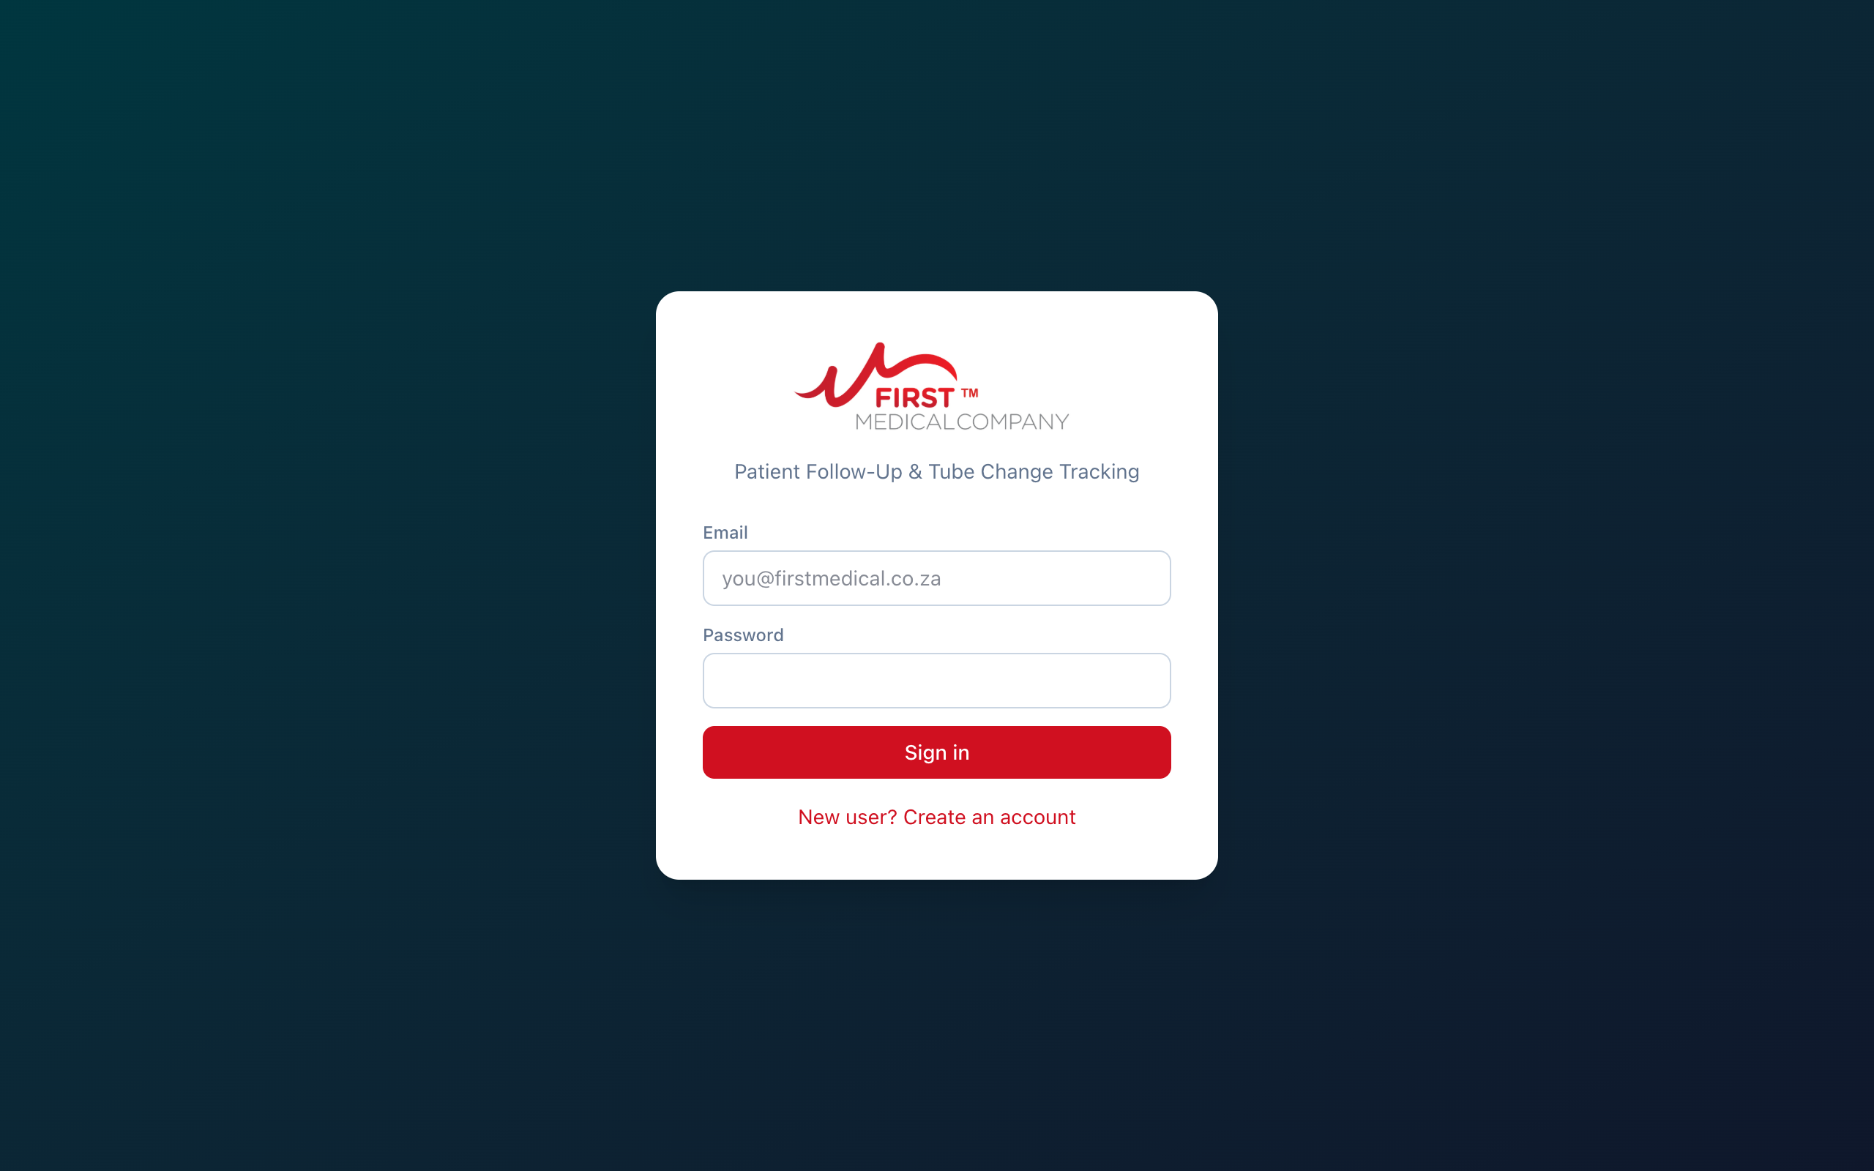
The sign-in screen
Training accounts for today: manager view: admin@firstmedical.test, CF view: cf@firstmedical.test. Password for both: FirstMed2026!

Who sees what
Role | What you can see and do
Clinical Facilitator | Your own assigned patients. Add patients, edit their details, log tube changes, upload documents.
Management / Admin | Every patient in every region, plus user management, regions, and reassigning patients between CFs.
Area Rep | View patients in your region and receive reminders. Reps cannot edit patient records.

2. The Dashboard
The Dashboard is the first screen after signing in. It answers one question: who needs a tube change soon?
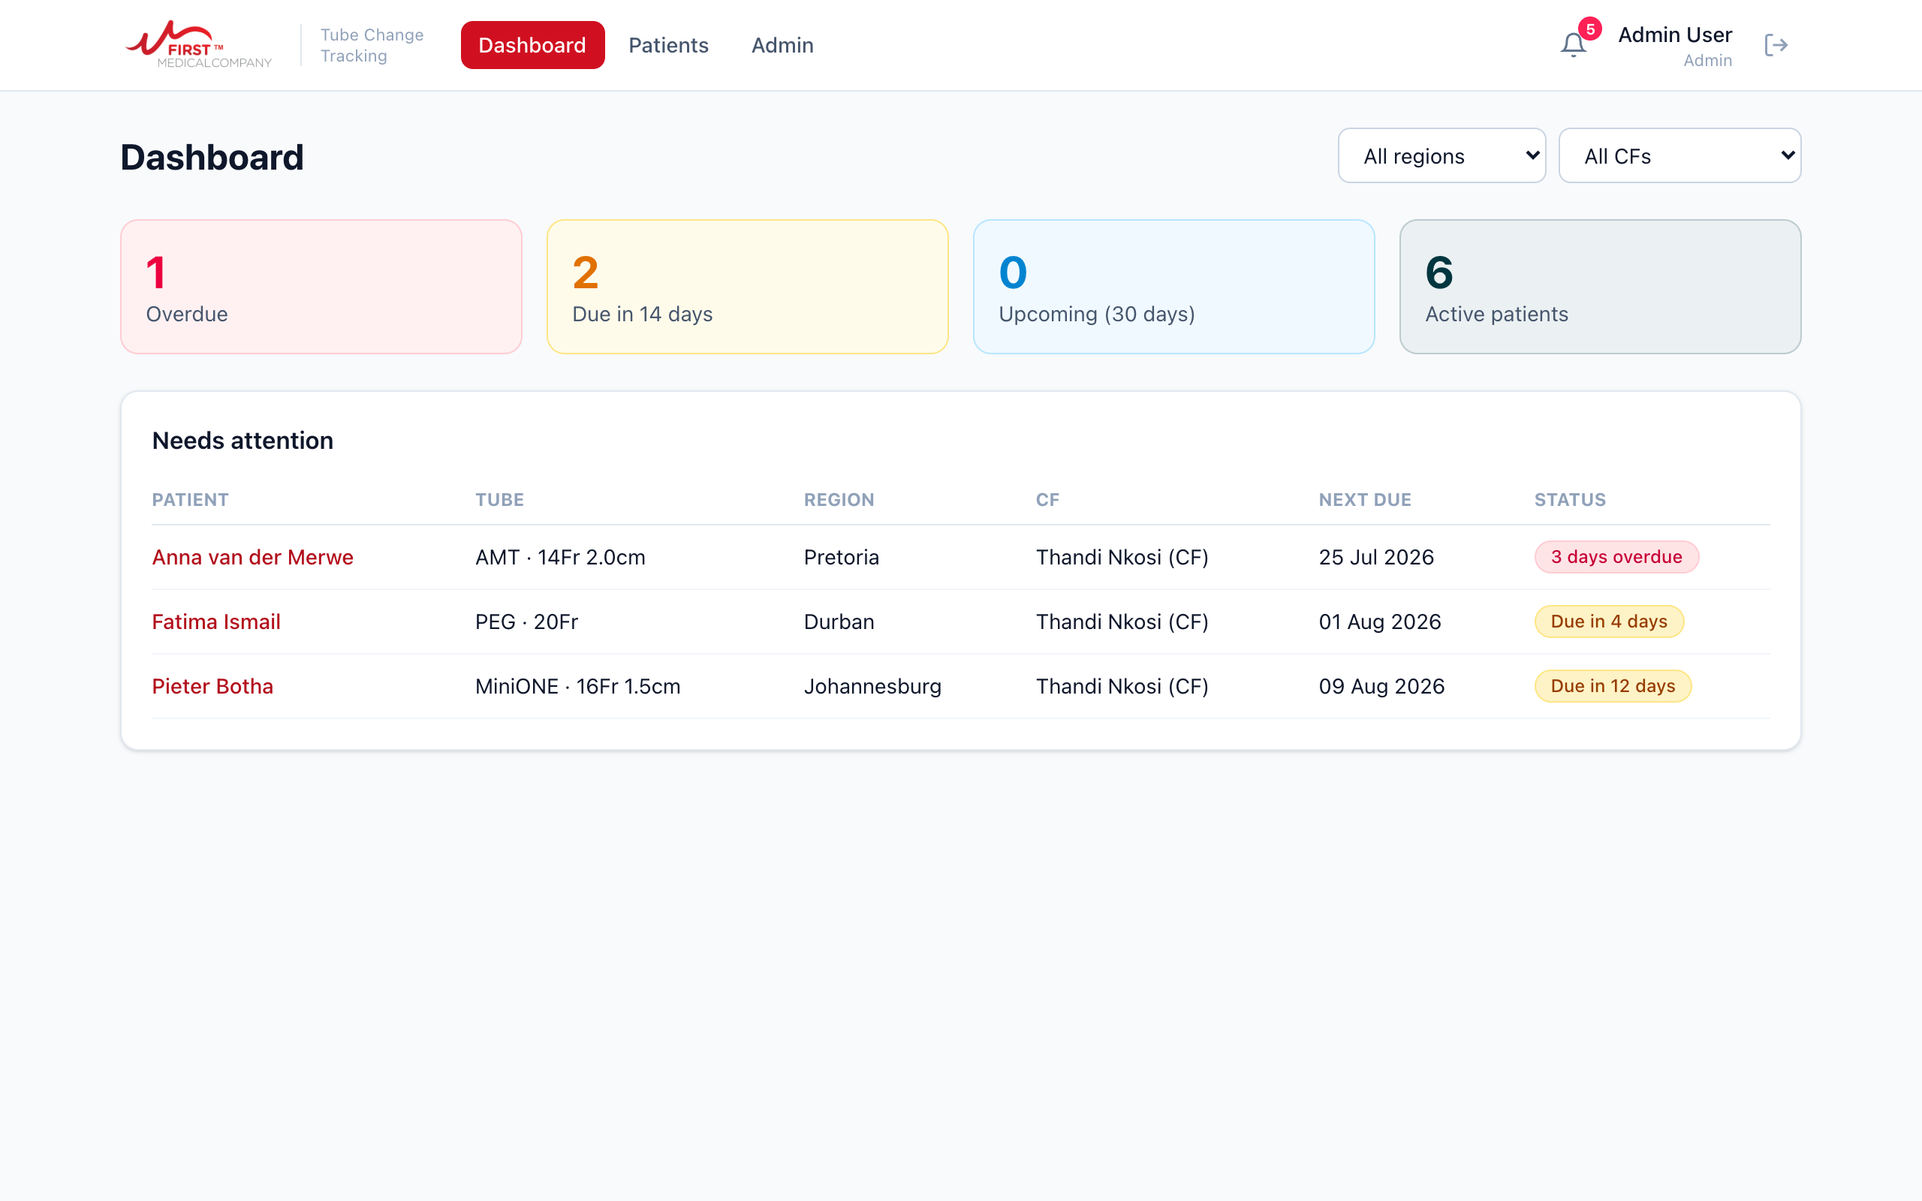
The Dashboard, viewed as a manager
The four blocks at the top count your active patients:
Block | Meaning
Overdue | The planned change date has passed. Act on these first.
Due in 14 days | A change is due within the next two weeks. Time to schedule.
Upcoming (30 days) | Due in 15 to 30 days. Nothing to do yet, just be aware.
Active patients | Everyone you look after who is currently active.

The Needs attention list below the blocks shows every patient in those first three groups, soonest first. Click a patient’s name to open their profile. Managers can narrow the list with the region and CF filters at the top right; CFs simply see their own caseload.
Tip: make the Dashboard your morning habit. If Overdue shows 0 and Due in 14 days is being worked through, you are on top of your caseload.

Notifications
The bell at the top right shows a red count when something needs your eye. The same reminders that go out by email appear here. Click an entry to jump straight to that patient, and use Mark all read to clear the count.
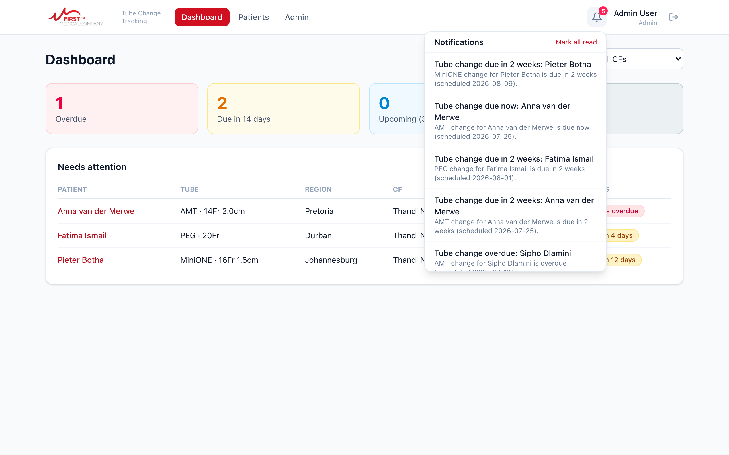
The notification bell, opened

3. Finding a patient
Open Patients in the top menu. Type any part of a name, reference number or hospital in the search box and the list narrows as you type. The status dropdown switches between Active, On hold, Discharged, Deceased, or all patients.
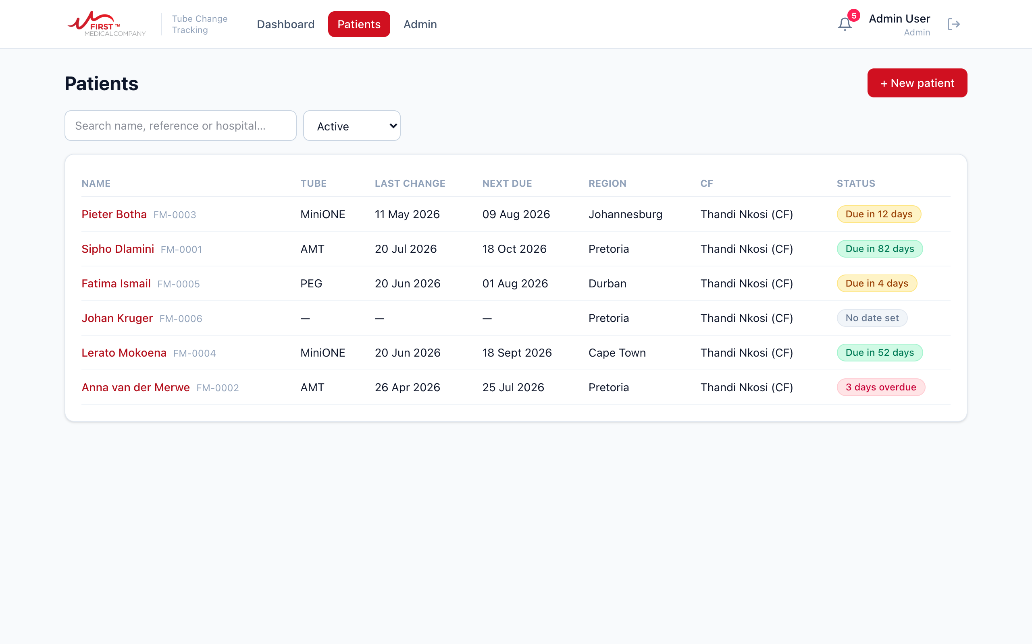
The patient list with search and status filter

4. The patient profile
Click any patient to open their profile. Everything about the patient lives here: their details, the current tube, the full change history, and their documents.
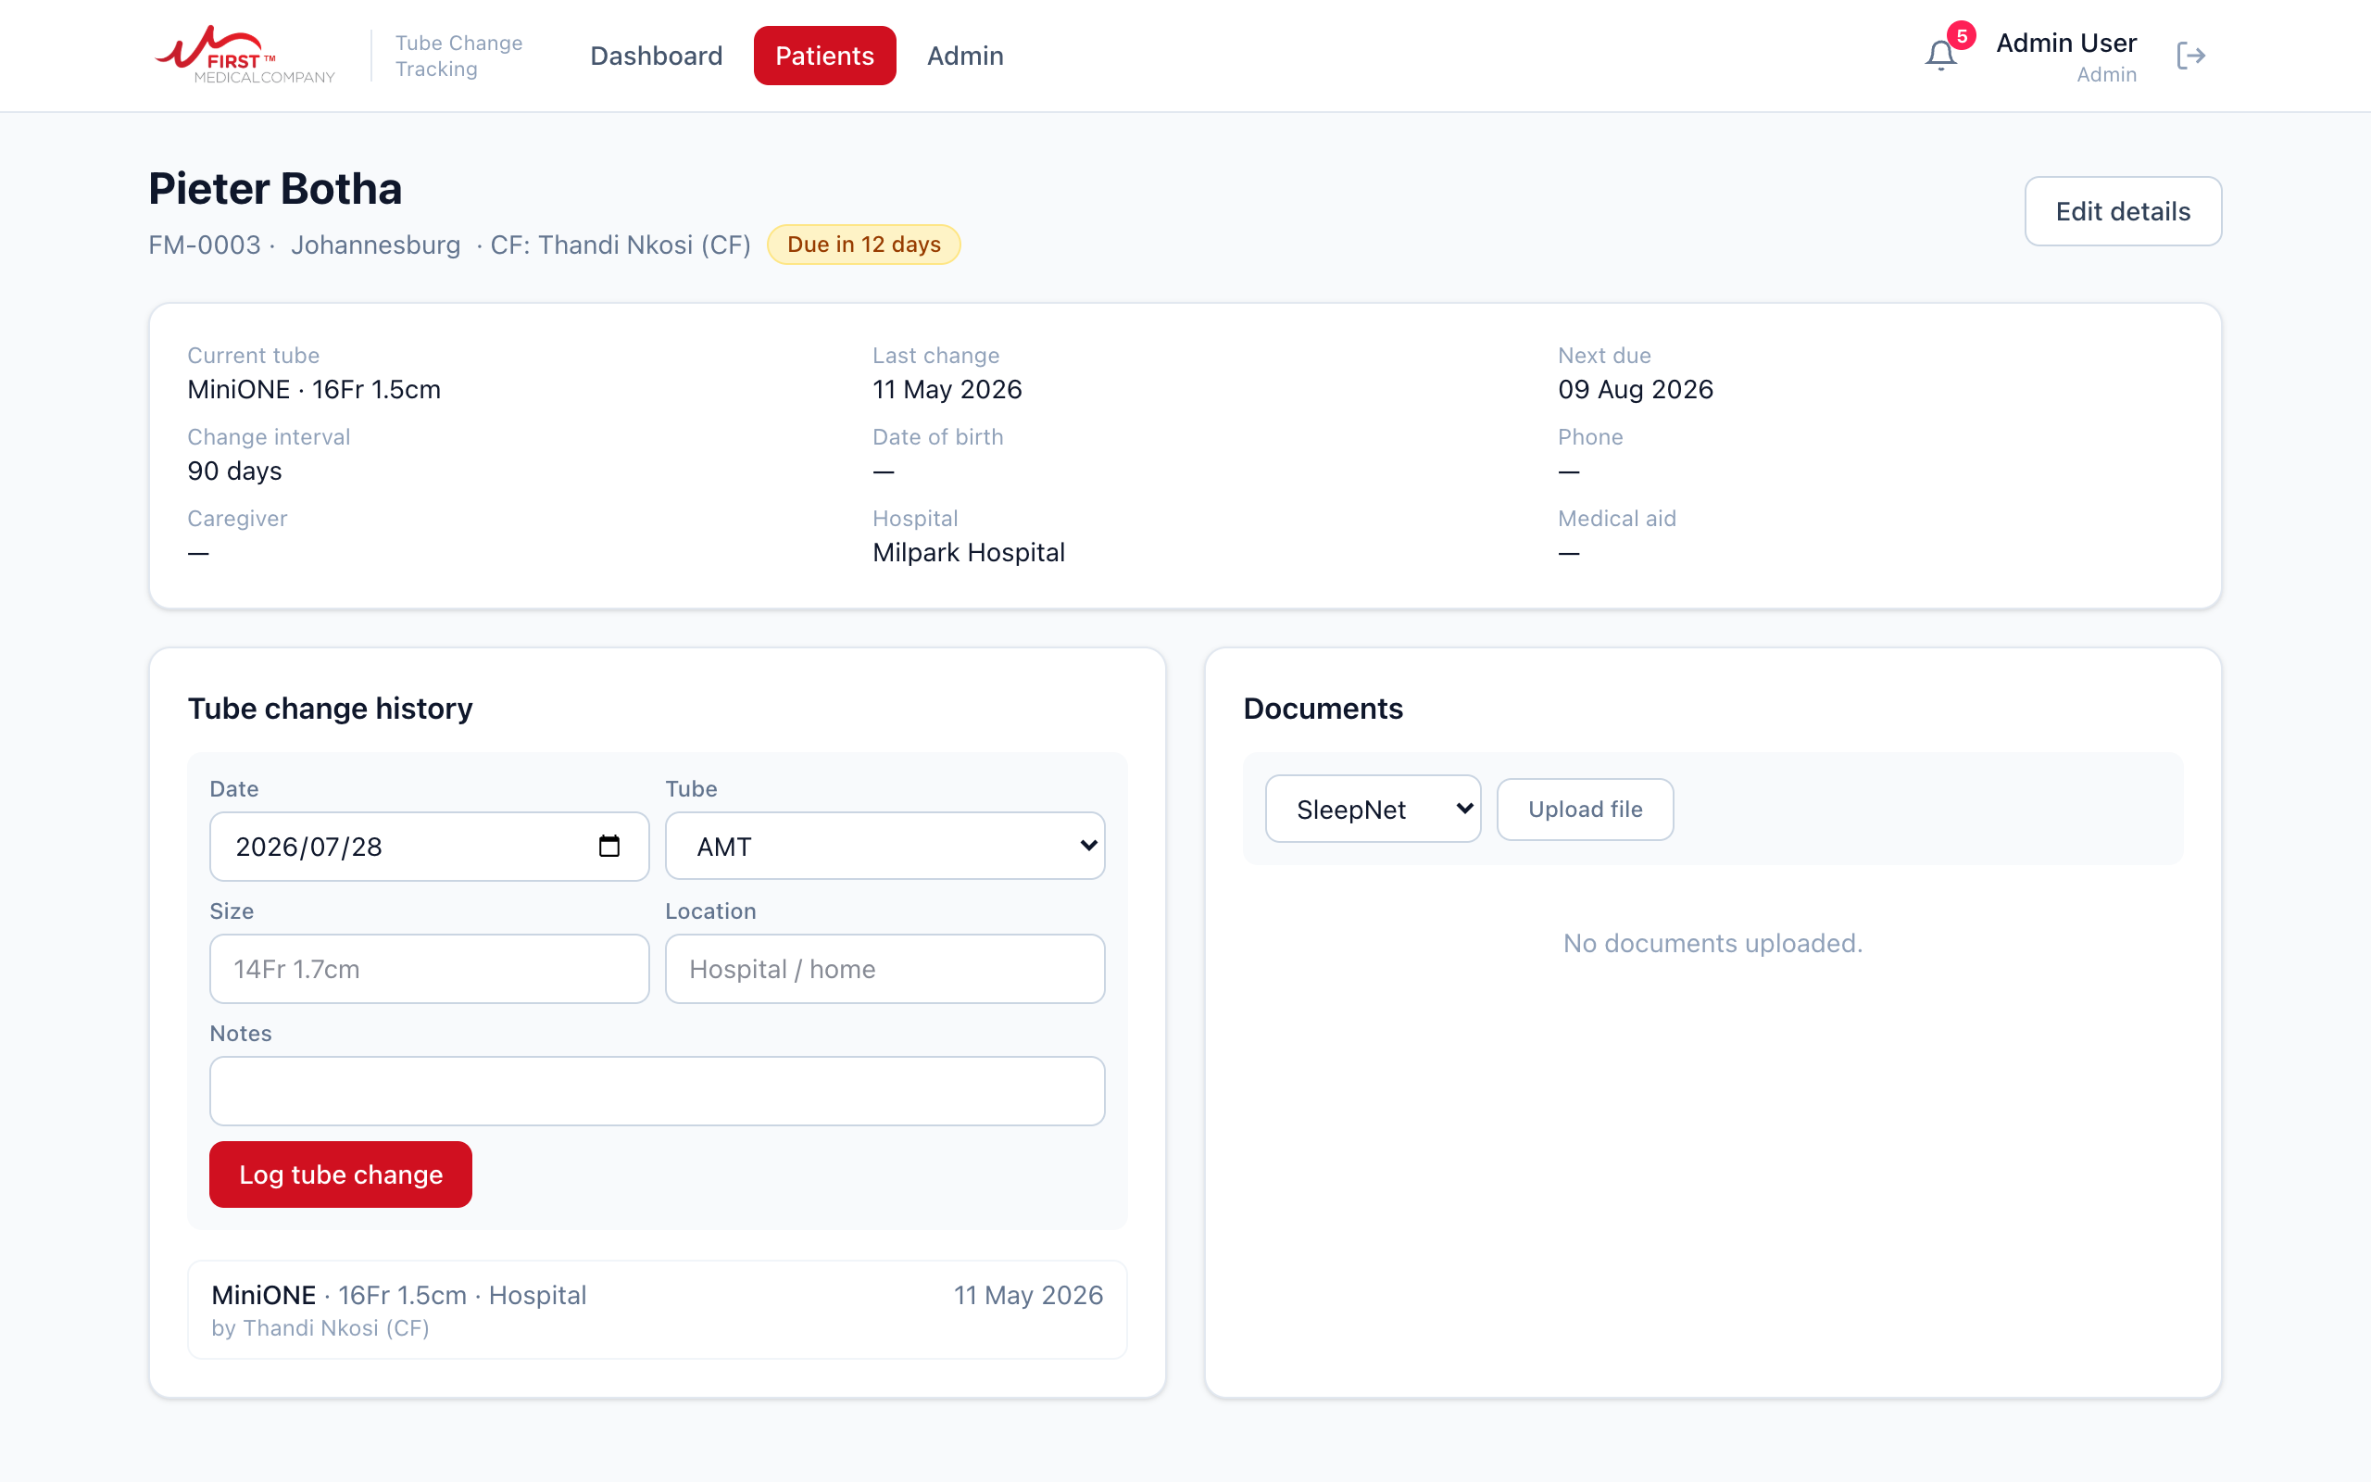
A patient profile
The coloured badge next to the patient’s name is the same traffic light used everywhere in the app: red = overdue, amber = due within 14 days, blue = due in 15 to 30 days, green = on track.

Logging a tube change
This is the most important action in the whole system. Log every change on the day it happens.
- Open the patient and find the Tube change history box.
- Check the date (it is set to today), pick the tube type (PEG, MiniONE or AMT), and fill in the size and where the change was done.
- Press Log tube change.
The next due date updates itself. A PEG insertion books the first button conversion 6 weeks out. A MiniONE or AMT change books the next change 3 months out. You never have to work out dates by hand, and the change is added to the history with your name on it.

Editing details and adjusting the schedule
Press Edit details at the top right of the profile to change any patient information. Three fields matter most:
- Next due (override): set a specific date when the doctor has booked one, or when a patient needs their change earlier or later than usual.
- Change interval (days): if this patient is on their own rhythm, for example every 60 days instead of 90, set it here once and all future dates calculate from it.
- Status: set patients to On hold, Discharged or Deceased when they leave your care. Only Active patients appear on the Dashboard and receive reminders.
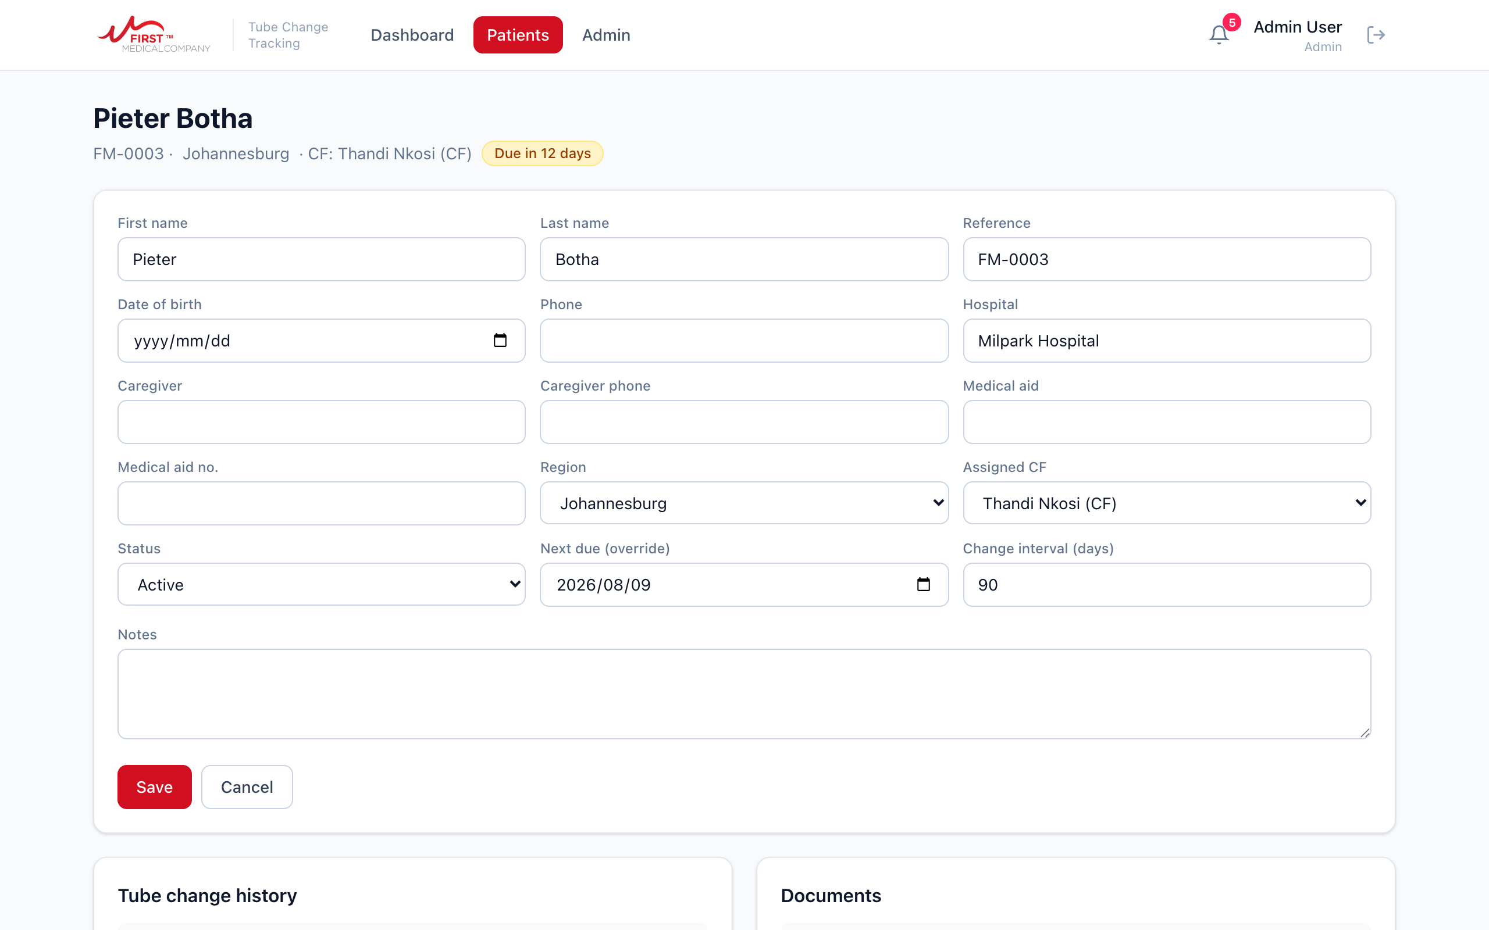
The edit form, with the schedule fields on the bottom row

5. Adding a new patient
Press + New patient on the Patients page.
- Fill in the patient’s details. Only first name and last name are compulsory, but the more you capture, the more useful the profile. Include the caregiver’s details for child patients.
- Under Current tube, record the tube the patient has right now and the date it was placed. This is what starts the reminder schedule, so fill it in whenever you know it.
- Press Create patient.
CFs are automatically the assigned CF for patients they create. Managers can assign any CF using the dropdown.
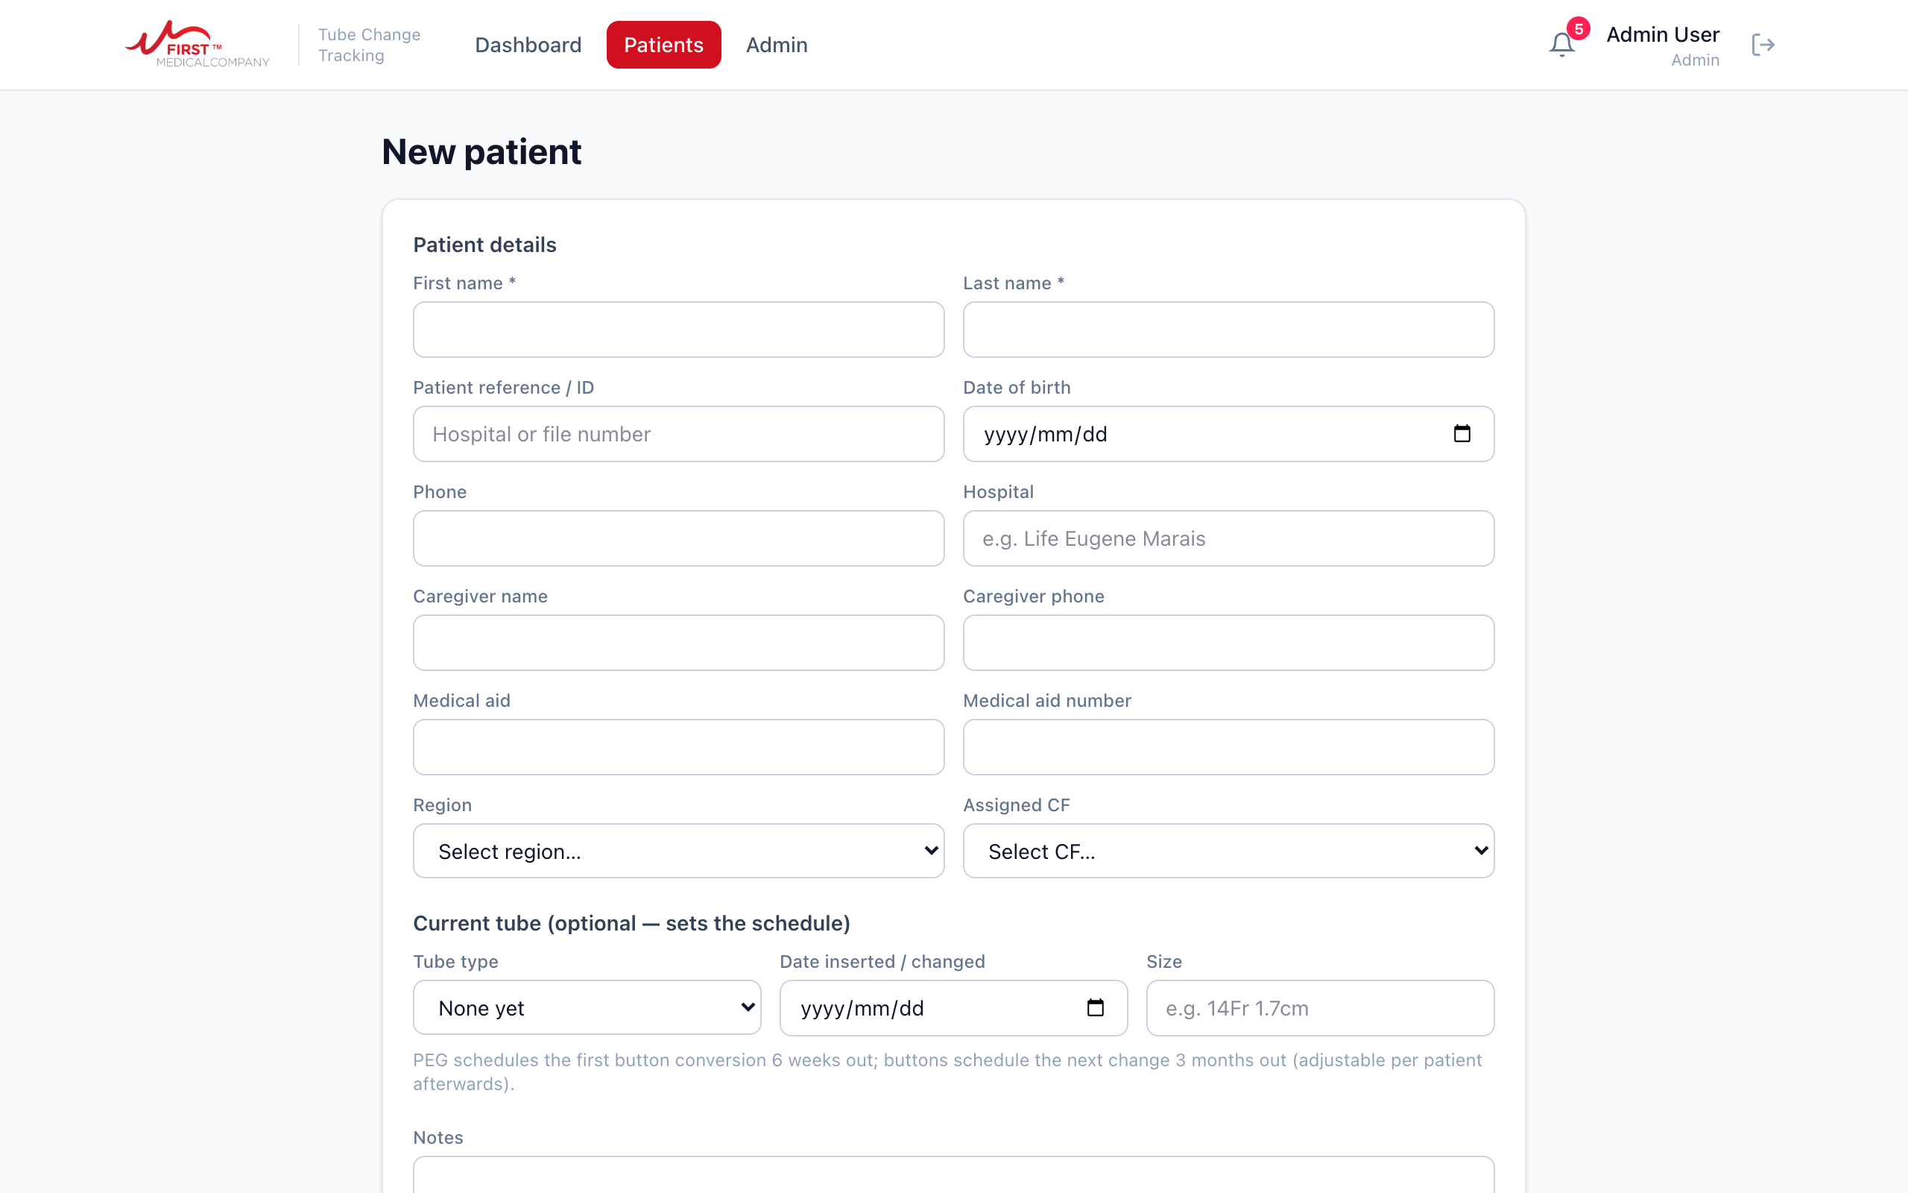
The new patient form

6. Documents
Each patient profile has a Documents box. Use it for SleepNet forms, claim forms, consent forms and any other paperwork, so the documents live with the patient instead of in someone’s inbox.
- Choose the document type from the dropdown (SleepNet, Claim form, Consent or Other).
- Press Upload file and pick the file: a photo of a signed form taken with your phone works perfectly.
- To read a document later, just click its name. For privacy, the link it opens works for 5 minutes; after that, click the name again.

7. Reminders: how the system chases so you don’t have to
Once a day the system checks every active patient and sends reminders as their change date approaches:
When | Reminder
14 days before the due date | A change is coming up. Time to schedule it with the patient.
On the due date | The change is due now.
7 days after the due date | The change is overdue. This one means act today.

Each reminder goes to the patient’s assigned CF, to management, and to the area rep for that patient’s region. Reminders appear under the bell in the app; email delivery is being connected and will use the same schedule.
Important: the reminders are only as good as the data. If a change is done but not logged, the system will keep chasing everyone about it. Log changes on the day.

8. Admin (managers only)
The Admin page manages people and regions.
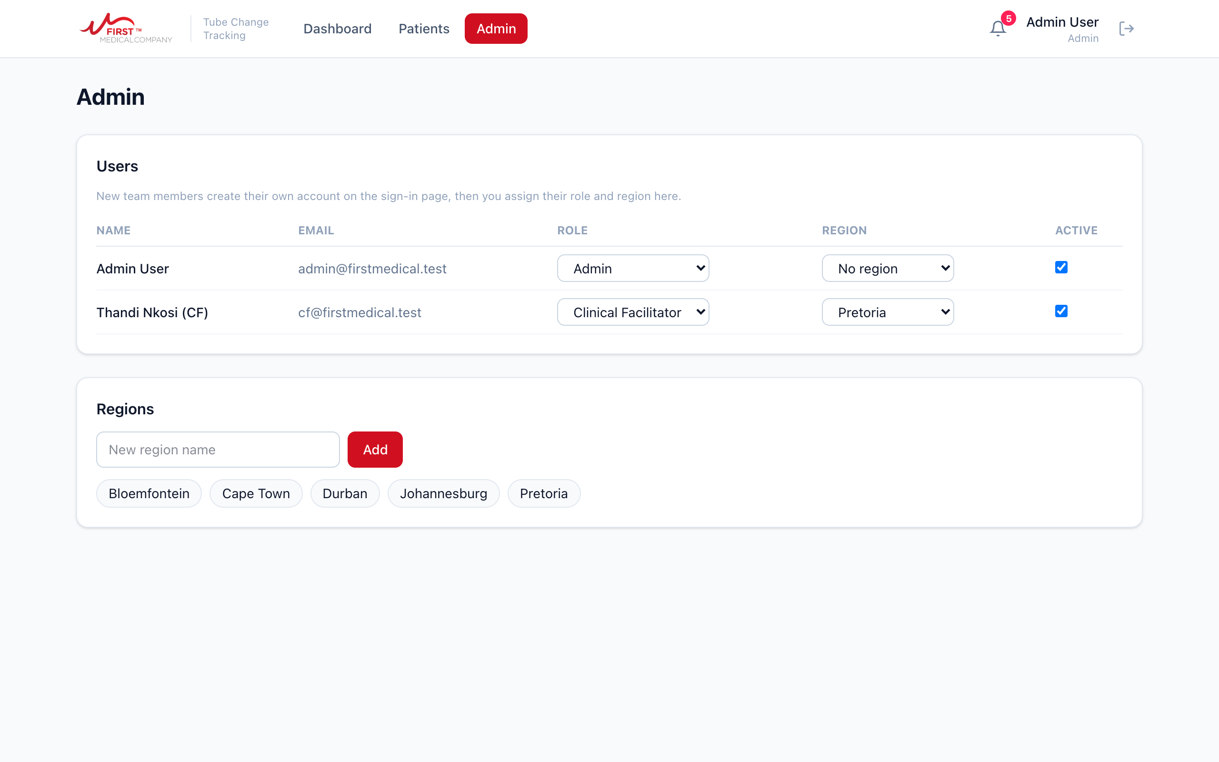
The Admin page: users on top, regions below
- New team members: they sign up themselves on the sign-in page, then appear in the user list. Set their role (CF, Area Rep or Admin) and their region, and they are working.
- Someone leaves: untick Active next to their name. They can no longer sign in, and nothing they recorded is lost.
- Regions: add new regions at the bottom as the business grows. Current regions: Pretoria, Johannesburg, Cape Town, Durban, Bloemfontein.
- Reassigning patients: open the patient, press Edit details, and pick a different assigned CF. Useful for leave cover and staff changes.

9. Using it on your phone
The app is built for phone use in the field. Everything works exactly the same, just stacked to fit the screen.
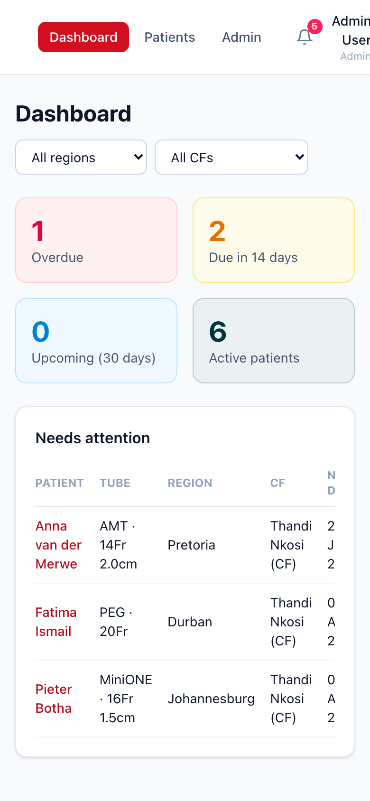
The Dashboard on a phone
Make it feel like an app: open the link in your phone browser, then choose Add to Home Screen (iPhone: Share button, then Add to Home Screen. Android: browser menu, then Add to Home screen). You get a First Medical icon that opens straight to the Dashboard.

10. Quick reference
I want to... | Do this
See who is due or overdue | Dashboard. Red first, then amber.
Find a patient | Patients, then type a name in the search box.
Record a tube change | Open the patient, fill in the Tube change history box, press Log tube change.
Move a due date | Open the patient, Edit details, set Next due (override).
Put a patient on their own interval | Edit details, set Change interval (days).
Add a patient | Patients, then + New patient.
File a SleepNet or claim form | Open the patient, Documents, Upload file.
Pause reminders for a patient | Edit details, set Status to On hold.
Add a new staff member | They sign up themselves; a manager sets role and region under Admin.
Check my alerts | The bell, top right.

If something goes wrong
- The page looks stuck or odd: refresh the page. Your data is saved on the server, refreshing loses nothing.
- You cannot see any patients: your account probably has no role or region yet. Ask a manager to check the Admin page.
- You logged a change with the wrong details: log it correctly and mention the mistake in Notes, or ask a manager to help correct it.
- Forgotten password or anything else: contact Jared on jaredvanh247@gmail.com.

