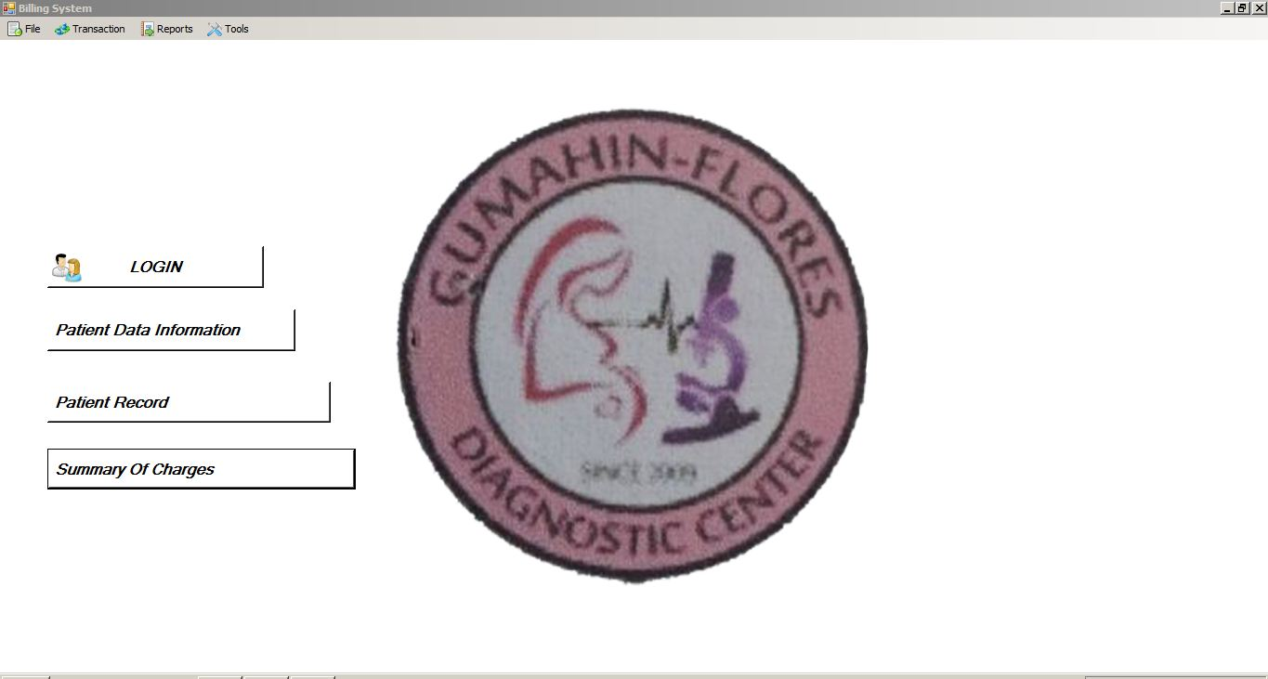

**GUMAHIN-FLORES**

**DIAGNOSTIC**

**CENTER**

**CHAPTER 1**

**Introduction**

Technology has never stopped advancing through

the years. Its new innovation helps to answer people question. Many people use these advantages in order to benefits themselves, by Using computer in their everyday life. The Gumahin-Flores Diagnostic Center helps their files computerized that make it easier for them to

locate the patient information and billing. The Proposed project for Gumahin- Flores Diagnostic Center is the best solution and Innovative answer for their needs and to make it

Easier for them to patient files.

**Purpose and Description**

The project proponent will provide the said clinic a Secure it’s of the files by recording every

Transaction And report.

**General Objectives**

* Perform an automatic computation in issuing patient’s bills and receipt.
* Easily locate and retrieve patient’s files and patient billing information.
* Generate computerized report such as documenting patient activity every day.

**Scope and Limitation**

The proposed project will provide Gumahin- Flores Diagnostic Center a computerized sales and billing system. This proposed system will show the flow of sales and can generate reports on sales and billing daily, weekly, monthly and annually.

**CHAPTER 2**

**Review of Related Literature**

This chapter includes the ideas generalization or conclusion methodologies and other. Those that include in this chapter help familiarizing information to the relevant and similar to the present studies.

**Foreign Literature**

Karim (2008) a literature review of medical record Keeping by foreign medical teams in sudden onset disasters. The object of this review was to look at one source (the Published literature of medical records used by foreign teams (FTMS) in sudden onset disasters (SODs).

**Local Literature**

Patient record systems as elaborated by Annals.org (1993), although an area of active research, are not in Widespread use. In June 1992,3% of Dutch general practitioners Had introduced computer-based patient records.Of these,70% had replaced the paper patient record with a

Computer-based record to retrieve and record clinical data during consultations. Possible reasons for the use of computerized patient record system include the nature of

Dutch general practice and the early and active role of professional organizations.

**CHAPTER 3**

**Technical Background**

**Project Conception**

Technology have made for the operation for the computer for Easy to locate the files and record of the patient such as in the Creation of data filling and retrieval. In this chapter; the project Discussed on how it was conceptualized.

**Project Statement**

The main concerned of developing this system is to improve their knowledge and skills through the computer based system their system consumes of wasting their time of checking and

evaluating the patient information.

**Project System**

The computerized patient information system provide faster and accurate the time in checking the record. The secretary of the clinic can log in and log out using the username and

password they can also view or research the information of the patient and print and gave it to the patient.

**Business Constraint**

**Schedule Issue**

The Gumahin-Flores is open eight hours a day from Monday-Friday 8am-5pm and four hours on Saturday and Sunday 8am12nn.

**Human Issue**

The internal specialist clinic all equipped in using the computer since the clinic has no computer already. It only requires one (1) Assigned personnel in making the report they have the

Problem for searching the patient information since they have No computer.

**Financial Issue**

The materials required in the study are already in the clinic the Information of the patient except for the computer because they don’t have a computer yet it is also depend on their

Budget approved for them to acquired the system.

**Technology Constraint**

Software is really hard in implementing the system since the clinic had no computer to access the file in the computer it would be difficult to install the system that’s why they need

that system in order to keep the record safe.

**Project Strategies**

First the team is searching a clinic that needs on system like Patient Information and Billing system we ask for the clinic Information of what are their difficulties that they encountered

Without having computer and we found out that the clinic is Need of Patient information and billing system that will help Them perform the transaction faster and computerized.

**Project Documentation and Communication**

The group holds the meeting once/twice a week to discuss about the assigned task keep on updating to every group Member and the development of the project we started on

August 2017 to September 30 2017 for the discussion of the project.

**Schedule Issue**

The Guhamin – Flores is open eight hours a day from Monday - Friday 8am – 5am and four hours on Saturday and Sunday 8am – 12nn.

**CHAPTER 4**

**METHODOLOGY**

Methodology is a term used to describe a process, technique or manner in which an action is performed. Under the development of system. It is also refers to the process will be taken to ensure that a system is effectively and efficiently developed

**4.1 Project Context**

This chapter covered the fields of research, study of design, and study of subject that collect data and research procedure.

This manual system takes a hard time in encoding the patient data and patient result. This propose system help to improve the knowledge of a person and lessen the time of reviewing and checking of the patient

The result of the study is a big help to the hospital so that they can encode the patient data automatically and lessen their time as well. Encoding using this type of application is giving error in delay in giving the result to the patient

**Research Design**

This research entitled “ patient Information and billing system” of Gumahin-Flores Diagnostic Center is a system project produce by C# and MySQL. The design was based on the data flow diagram.

**4.2 Requirements Specification**

The description below are the specification about the system that need to complied and run the system.

**Hardware Specification**

**People ware Specification**

**Secretary and Doctor requirements and Qualification**

System Administrator. The secretary and doctor is qualified to handle and operate the system.

**Analysis**

Relationship diagram is used also in Patient information and billing systemto present information and gather patient data that show relationship between people and the staff,this diagram use case is made up of set interaction between the system and the user.

**4.3.1 Use case Diagram**

**Secretary**

**Patient**

**Doctor**

**Gumahin-Flores Diagnostic Center**

**Patient Information and billing system**

**Figure2. Use Case Diagram of Gumahin-Flores Diagnostic Center flow Chart**

Use case diagram show the activities or process of patient information and billing system the patient will make or cancel appointment to the said clinic, request medication, and also pay the bill. The secretary will check the patient record and also Schedule the patient appointment and she/he is also allowed to cancel the appointment of the patient. The doctor will check the patient record and he or she is allowed to give the medication to the patient, and defer the bill.

**Context Diagram**

**Secretary**

**Give Personal Detail Take Payments**

**Ask for appointment Request for Appoinment**

Paymen t **Collect Personal Detail**

**Give appointment Appoinment Approved**

**Confirmation payments Give patient Details**

**Take that Prescrip**tion Confirmation Payments

Collect Patient Details Login Successfully

Login Successfully

Do login Do log in

Give Prescribe

Login

**Doctor**

**Patient**