Philippine Real Estate Websites
Design & UX Audit
Layout · Navigation · CTA Placement · Colors · Typography · Features · Strengths · Weaknesses — with recommendations for a new site
This report is a visual and structural audit of the eight leading Philippine real estate websites identified in the earlier competitive-landscape research: Lamudi Philippines, Dot Property Philippines, OnePropertee, Homes & Land Philippines, Hoppler, MyProperty.ph, RentPad, and Real.ph. Each site was visited live in July 2026, screenshotted, and reviewed against eight criteria: layout, navigation, CTA placement, colors, typography, features, strengths, and weaknesses. The report closes with cross-site patterns and prioritized recommendations for a new real estate site.

Lamudi Philippines
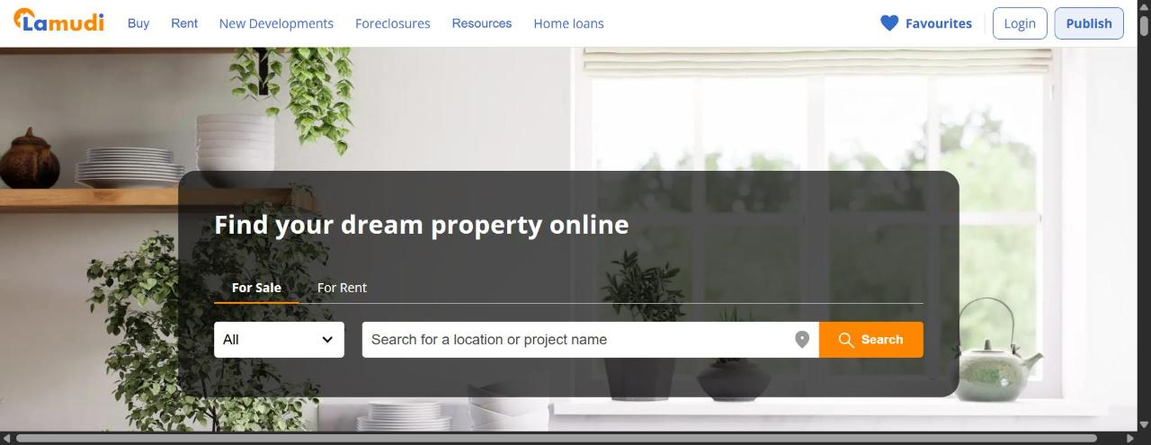
Lamudi Philippines — homepage hero (lamudi.com.ph)
Layout: Classic portal layout: full-width hero photo with a dark-tinted search panel overlaid, followed by a horizontal "Top Partners" developer-logo strip, featured/pre-selling property card grids, blog teasers, client testimonials, and an extensive multi-column SEO footer of city/property-type links.
Navigation: Six top-level items (Buy, Rent, New Developments, Foreclosures, Resources, Home loans) in a single uncluttered row, plus an icon-only Favourites link. Easy to scan at a glance.
CTA placement: Two-tier hierarchy: the hero "Search" button (orange, high contrast) is the clear primary action; "Publish" (blue outline, for agents/sellers) sits top-right as a visually secondary action next to "Login." Buyer intent is prioritized over seller/agent intent.
Colors: Disciplined two-tone system: blue for logo/nav/links, a single orange accent reserved for the primary CTA. Easy to scan, nothing competes with the Search button.
Typography: Rounded geometric sans-serif for headlines, clean system sans for listings and body copy; consistent size hierarchy throughout.
Features: For Sale/For Rent toggle, location & project autocomplete, property-type dropdown, developer/partner directory, featured & pre-selling carousels, neighborhood guides, blog, testimonials, and a huge SEO link footer covering nearly every province and property type.
Strengths
- Clear visual hierarchy with a single unmistakable primary CTA
- Two-color brand discipline makes the page easy to scan
- Partner logos and testimonials build trust quickly
- Footer link matrix likely drives significant organic search traffic
Weaknesses
- Enormous SEO footer (hundreds of links) adds page weight and looks overwhelming to a human scrolling to the bottom
- Seller/agent CTA ("Publish") is visually subordinate to buyer search, which may undersell that side of the marketplace
- Stock interior photography isn't localized to Filipino homes or people

Dot Property Philippines
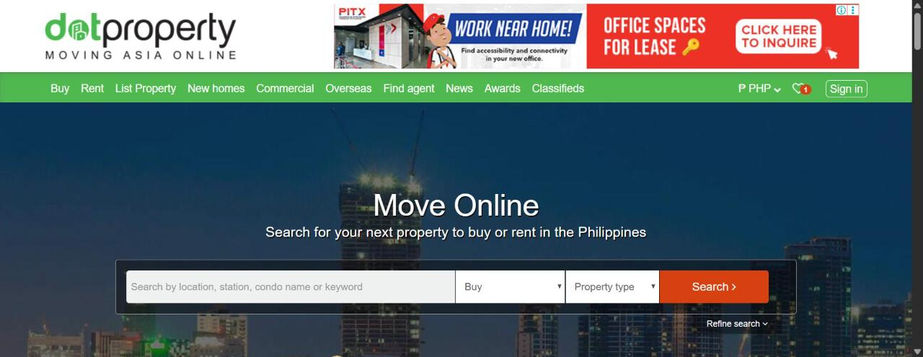
Dot Property Philippines — homepage hero (dotproperty.com.ph)
Layout: A paid ad banner sits directly under the logo before any navigation — above the fold. Below the green nav bar, a dark city-skyline hero holds the search card, and a second promo bar ("Upload your property") plus another ad banner appear before real listing content ("Properties of the month") is reached.
Navigation: Nine top-level items (Buy, Rent, List Property, New homes, Commercial, Overseas, Find agent, News, Awards, Classifieds) plus a currency selector and a notification-badged favourites icon — the busiest nav bar of the eight sites audited.
CTA placement: The hero "Search >" button (orange) is reasonably clear, but it competes with a second CTA ("Get started >") for sellers immediately below the hero, and then with ad-unit CTAs ("View Properties," "Explore Now") — more competing calls-to-action stacked above the fold than any other site reviewed.
Colors: Bright green nav/brand color, dark navy hero overlay, orange CTA buttons, red on ad units and the notification badge — five-plus colors visible in the first screen, noticeably busier than Lamudi's two-tone approach.
Typography: Plain system sans-serif (default Arial/Helvetica-style stack) throughout; the "Move Online" headline lacks the custom type treatment competitors use.
Features: Buy/Rent + property-type + location search with a "Refine search" advanced link, developer/agent directory, overseas property search across a regional network, news, awards, and classifieds sections.
Strengths
- Broadest stated feature set of the group (overseas search, classifieds, awards/news) signals content depth
- Visible ad monetization suggests real traffic value to advertisers/partners
Weaknesses
- Two paid ad banners plus two stacked promotional CTAs before organic content is the highest visual clutter of any site audited
- Nine-item nav plus a currency selector is top-heavy and harder to scan than competitors
- Dated, default-feeling typography

OnePropertee
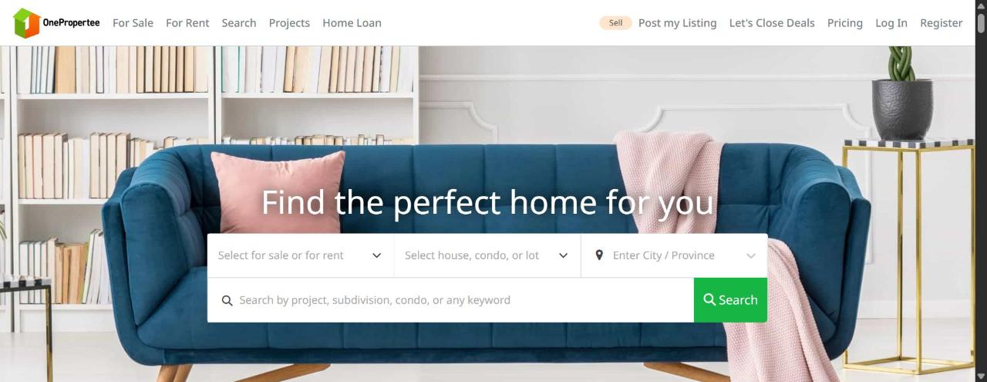
OnePropertee — homepage hero (onepropertee.com)
Layout: Editorial, lifestyle-led layout: a full-bleed high-quality furniture/interior photo sits behind the hero search widget, and scrolling reveals a clearly segmented "For Buyers" / "For Sellers" two-column journey using real people photography and short numbered step lists.
Navigation: Five lean primary items (For Sale, For Rent, Search, Projects, Home Loan), but the top-right holds six competing items (an orange "Sell" badge, Post my Listing, Let's Close Deals, Pricing, Log In, Register) — more visual weight on secondary actions than on primary navigation.
CTA placement: Green outline buttons are scoped contextually to each section (e.g. "Start my search" under the Buyers block) — good practice — but the six-item top-right cluster dilutes which single action is meant to be primary.
Colors: Neutral white background with a consistent forest-green accent for buttons, badges, and links. Warm-toned lifestyle photography (blush pink, navy, wood) instead of generic blue-corporate stock.
Typography: Bold, heavier-weight sans-serif headline against lighter body text — clear contrast and hierarchy; the most "designed" feeling of the free-listing-tier sites.
Features: Segmented sale/rent + property-type + city/province search plus free-text keyword search, an income-based affordability filter for buyers (a genuine differentiator), free unlimited listings with paid lead-boosts for sellers, auto-generated video ads/social images, seller mini-sites, and a stated ~295K active buyer base as social proof.
Strengths
- Warmest, most authentic lifestyle photography of the sites reviewed
- Clear dual-path storytelling for buyers vs. sellers
- Unique income-based affordability filter solves a real buyer pain point
- Low-friction, transparent free-listing model for individual sellers
Weaknesses
- Six-item top-right nav cluster creates decision paralysis about which CTA is primary
- The orange "Sell" badge reads like a promotional flag rather than a nav item — inconsistent styling language

Homes & Land Philippines
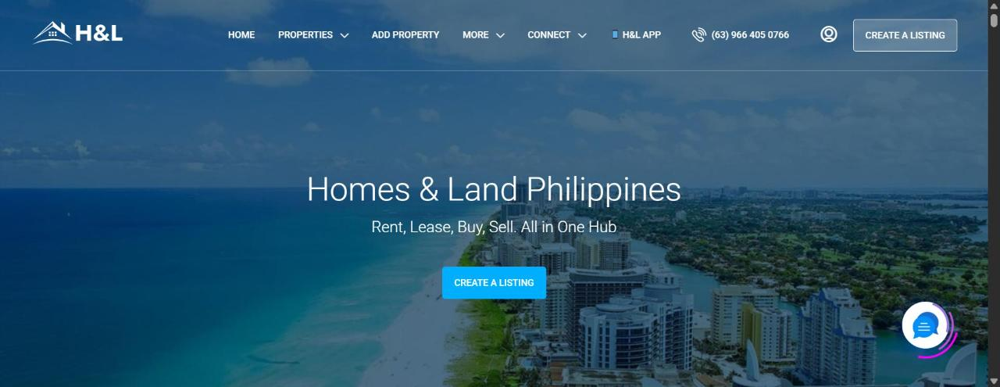
Homes & Land Philippines — homepage hero (homesandland.ph)
Layout: A full-bleed aerial coastal/skyline photo hero with centered text and a single CTA button — no search bar is visible above the fold. The actual property search widget (Looking For / Location / Property Size / Budget) only appears after scrolling past the hero and an intro paragraph with a decorative star divider.
Navigation: Home, Properties, Add Property, More, Connect (two with dropdowns), an "H&L App" badge, a phone number, an account icon, and a "Create a Listing" button — all floating on a transparent bar over the photo, which can hurt legibility depending on the image beneath.
CTA placement: The single primary CTA ("Create a Listing") appears twice above the fold, but it targets sellers/agents only — buyers have no visible way to search until they scroll. This is the most significant conversion gap found across all eight sites.
Colors: Deep navy-blue photo overlay with one bright cyan-blue CTA button; a floating chat bubble adds a second, slightly different blue that competes visually with the CTA.
Typography: Light-weight, generously spaced sans-serif headline — elegant, but lower-contrast against a busy photo background in places.
Features: Listings across residential, commercial, land/lots, farms, and islands; agent verification badges; a community forum; featured-listing upgrades; a live chat bubble; and a phone number placed directly in the header.
Strengths
- Aspirational, high-quality photography sets a premium tone
- Phone number in the header signals accessibility for less digitally-native users
- Genuinely free listings lower the barrier for individual sellers
Weaknesses
- No visible search bar above the fold — the single biggest UX gap found in this audit, given that most homepage visitors are buyers, not sellers
- Transparent nav over a photo can become illegible depending on the image
- CTA strategy over-indexes on sellers at the expense of the buyer journey

Hoppler
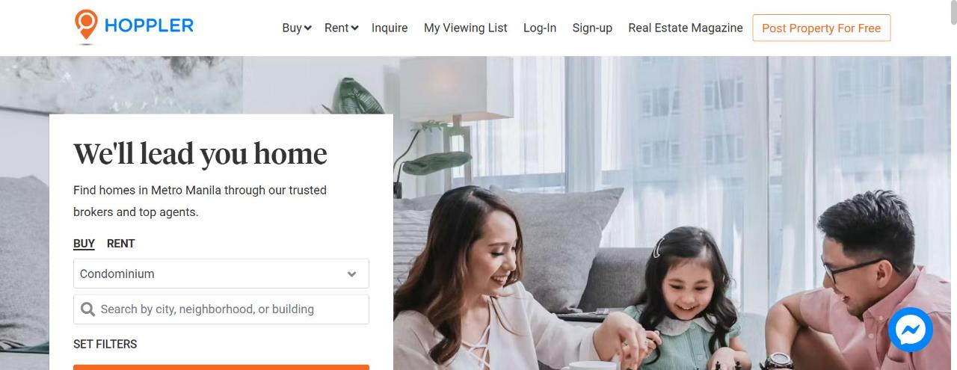
Hoppler — homepage hero (hoppler.com.ph)
Layout: Split-screen hero: the left third is a white card holding the headline and search widget, the right two-thirds is a large lifestyle photo of a real Filipino family in a living room. Reads closer to a modern consumer app landing page than a classic listings portal.
Navigation: Buy, Rent (both with dropdowns), Inquire, My Viewing List, Log-In, Sign-up, Real Estate Magazine — seven items kept manageable via dropdowns; "My Viewing List" is a distinctive saved-items feature surfaced directly in the nav.
CTA placement: A single outlined orange "Post Property For Free" button sits isolated top-right as the one clear secondary action against the primary buyer search in the hero — the cleanest CTA hierarchy of the eight sites audited.
Colors: White background, a blue location-pin logo mark, and orange as the sole accent color for the CTA and active-tab underline — a restrained two-color system similar in discipline to Lamudi's.
Typography: A serif display headline ("We'll lead you home") paired with sans-serif body and UI — the only site using a serif/sans mix, giving it a more premium, editorial, brokerage-led feel rather than a raw listings aggregator.
Features: Buy/Rent toggle, property-type dropdown, city/neighborhood/building search, a "Set Filters" link, in-house licensed brokers (a full-service commission model rather than pure listings), a rent-vs-buy calculator, neighborhood guides, real estate magazine content, and a Facebook Messenger chat widget.
Strengths
- Most premium, editorial visual identity of the group
- Authentic local photography (not generic stock) builds trust and relatability
- Cleanest single-primary-CTA hierarchy found in this audit
- Messenger integration matches how Filipino users actually contact businesses
Weaknesses
- Metro Manila–only inventory limits nationwide relevance
- The full-service brokerage/commission model likely means less raw listing breadth shown directly on-site than pure portals

MyProperty.ph
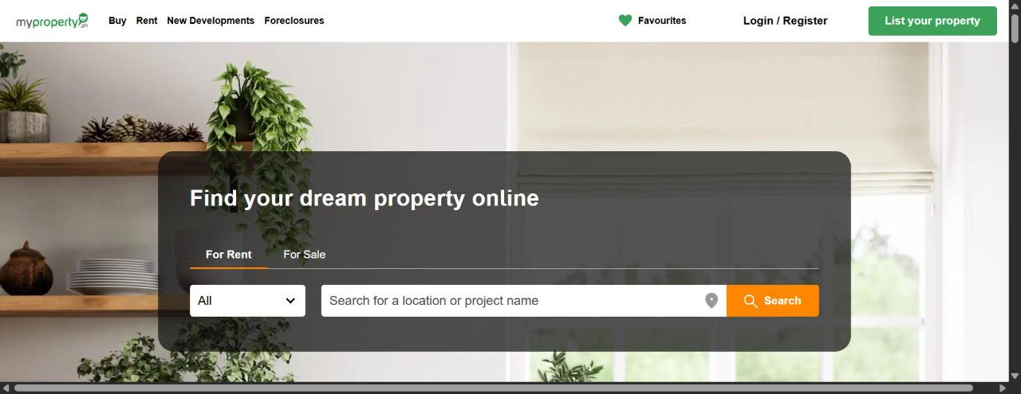
MyProperty.ph — homepage hero (myproperty.ph)
Layout: Near-identical template and copy ("Find your dream property online") and search-widget layout to Lamudi, simply re-skinned in green instead of blue/orange. This is strong visual confirmation of the two sites' shared ownership — Lamudi acquired MyProperty.ph in 2016.
Navigation: Buy, Rent, New Developments, Foreclosures — narrower than Lamudi's nav (four items vs. six); Login/Register is combined into a single link rather than Lamudi's two separate buttons.
CTA placement: Same pattern as Lamudi: an orange-accented hero search is primary, a green "List your property" button is secondary top-right.
Colors: Same layout/photography as Lamudi with the brand accent swapped to green throughout (nav text, active tab underline stays orange, primary CTA button green).
Typography: Identical type system to Lamudi.
Features: Buy, Rent, New Developments, Foreclosures search and browse — a narrower feature set than the parent Lamudi site.
Strengths
- Inherits Lamudi's clean, high-hierarchy design discipline at no extra design cost
Weaknesses
- Offers no distinct value proposition or visual identity versus its own parent brand — a visitor bouncing between the two sites would struggle to say why either is the better choice
- A cautionary example rather than a template: don't build a new site that reads as a reskin of a competitor's homepage

RentPad
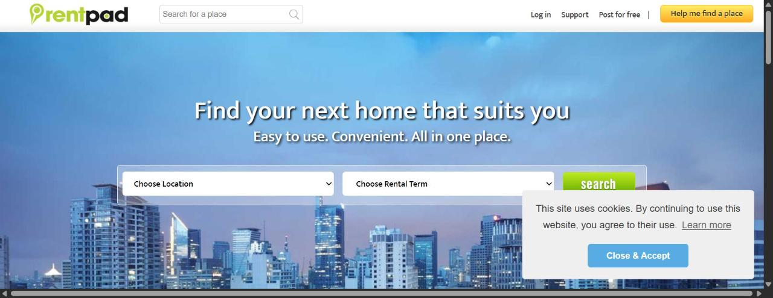
RentPad — homepage hero (rentpad.com.ph)
Layout: Search-first minimalism: a compact search bar is embedded directly in the top navigation bar itself, so search is reachable from anywhere on the site without scrolling. The hero below restates a simple two-field (location + rental term) search over a skyline photo.
Navigation: The leanest nav of all eight sites: just Log in, Support, and Post for free — appropriate for a single-purpose, rentals-only product.
CTA placement: One high-contrast amber/yellow "Help me find a place" button sits isolated top-right — a concierge-style CTA distinct from self-serve search, offering buyers a white-glove alternative alongside the primary search action.
Colors: Lime-green wordmark, sky-blue photo hero, and a single amber/yellow CTA button that pops hard against the cooler palette — a good example of reserving a warm color for exactly one action.
Typography: Bold, slightly rounded sans-serif headline, consistent with a modern consumer product rather than a classical real-estate portal.
Features: Rentals only (no "Buy" option at all — a deliberately narrow scope), location + rental-term search, and the "Help me find a place" concierge/assisted-search path.
Strengths
- Nav-embedded persistent search is arguably the single best interaction-design pattern found across all eight audits
- The concierge CTA offers a low-effort path for buyers who don't want to self-serve
- Tight rentals-only scope keeps the nav and page uncluttered
Weaknesses
- A cookie-consent banner overlapped and partially obscured the search button on load — a real, if minor, usability bug
- Rentals-only scope means it can't serve as a full template for a general buy/sell/rent marketplace

Real.ph
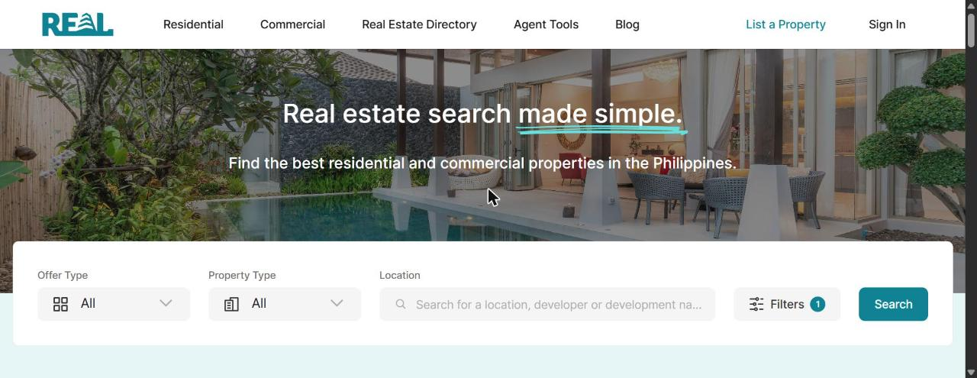
Real.ph — homepage hero (real.ph)
Layout: The most "product," SaaS-like layout of the eight: full-width upscale villa/pool photography, a bold headline with a hand-drawn-style underline accent, and an integrated filter-bar-style search card (Offer Type / Property Type / Location / Filters with a count badge / Search) sitting directly in the hero.
Navigation: Five clean items (Residential, Commercial, Real Estate Directory, Agent Tools, Blog); "List a Property" appears as a plain teal text link rather than a button, next to "Sign In."
CTA placement: The filled teal "Search" button is the only strong-contrast CTA on screen. Making "List a Property" a text link rather than a button is a deliberate choice that keeps visual noise low, at some cost to seller-side conversion.
Colors: A distinctive teal/turquoise brand color against white and photography — the least "generic real-estate blue/orange/green" palette of the eight, which helps brand recall.
Typography: A confident, large-scale sans-serif headline with a hand-drawn underline swash for emphasis — a branding touch not seen on any other site audited.
Features: Offer Type / Property Type / Location filters plus an expandable "Filters" panel showing an active-filter count badge, a Real Estate Directory (agent/developer listings), an "Agent Tools" section aimed at professionals, and a blog.
Strengths
- Most distinctive brand color in the category, avoiding the sea of blue/orange/green competitors
- Upscale photography and typography signal a premium, curated positioning
- The active-filter-count badge is a modern, useful UX touch
Weaknesses
- "List a Property" as a plain text link under-emphasizes the seller-acquisition funnel compared to sites using a full button
- Smaller apparent inventory/brand recognition than Lamudi or DotProperty means the design polish isn't yet matched by scale

Cross-Site Patterns: What Works and What Doesn't
- Search belongs in the hero, above the fold. Seven of eight sites put a real search widget directly in the hero; Homes & Land is the clear counter-example, and it is the single weakest UX pattern found in this audit.
- A disciplined, one-accent-color CTA system reads as more professional. Lamudi, Hoppler, RentPad, and Real.ph each reserve one accent color exclusively for the primary action; DotProperty and Homes & Land use four or more colors on the same screen and read as busier and more dated by comparison.
- One primary CTA beats several competing ones. Hoppler and RentPad each surface exactly one clear secondary action next to the primary search; OnePropertee's six-item top-right cluster and DotProperty's stacked promo bars dilute the hierarchy.
- Authentic local photography outperforms generic stock. Hoppler's real family photo and OnePropertee's editorial lifestyle shots read as more trustworthy and locally relevant than the staged interior stock used by Lamudi, MyProperty, and DotProperty.
- Persistent, always-reachable search (RentPad's nav-embedded bar) is a meaningfully stronger pattern than search confined only to the hero.
- Messenger/chat widgets that match local habits (Hoppler's Facebook Messenger integration) feel more native than a generic web chat bubble.
- Above-the-fold ad monetization visibly hurts perceived quality — DotProperty's ad banner before the nav is the clearest example of this trade-off.
- Large SEO footers (Lamudi's city/category link matrix) look overwhelming to a human but are a plausible organic-traffic driver — worth keeping, but visually de-emphasized below all real content.

How This Can Improve Your Planned Site
The following recommendations are prioritized roughly by expected impact, drawing directly on what separated the strongest homepages (Hoppler, RentPad, Real.ph) from the weakest patterns observed (Homes & Land's missing search, DotProperty's clutter, MyProperty's brand redundancy).
- Put a real, functional search widget directly in the hero, above the fold, on every device. This is Homes & Land's biggest miss and the clearest lesson from this audit.
- Pick one brand accent color and reserve it exclusively for your single most important action (search, or whatever your primary conversion is). Don't recolor secondary buttons the same color as the primary one.
- Cap the primary nav at 5–6 visible items; use dropdowns to hide secondary items instead of adding more top-level links (compare DotProperty's 9-item nav to Hoppler's 7-with-dropdowns).
- Limit the header to one primary CTA and at most one secondary CTA. Move tertiary actions (pricing, register, "let's close deals") into an account menu or dropdown instead of a flat row of buttons, as OnePropertee's six-item cluster illustrates.
- Use authentic local photography instead of generic stock interiors. A modest photo shoot of real target buyers/sellers is a visible differentiator most competitors are skipping.
- Consider a persistent, nav-embedded search box like RentPad's, reducing friction for repeat visitors browsing between pages.
- Segment the homepage narrative by user type (buyer vs. seller vs. agent), as OnePropertee does — but keep exactly one CTA per section instead of stacking several.
- If you plan to run ads or affiliate placements, keep them below the primary content fold. DotProperty's above-the-fold ad banner visibly undercuts trust and cleanliness.
- Add a Messenger/WhatsApp-style chat widget rather than a generic chat bubble — it matches how Filipino users already prefer to contact businesses.
- Don't skip a well-structured SEO footer even though it's visually unglamorous — Lamudi's link matrix is a plausible organic-traffic driver. Keep it small and muted, well below your real content.
- Avoid the default blue/green/orange real-estate palette if you want brand recall. Real.ph's teal stands out precisely because most competitors cluster around the same few hues.
- Fix the small usability details competitors missed: make sure cookie-consent banners never overlap a primary CTA (RentPad's bug), and that any nav floating over a photo stays legible at every scroll position (Homes & Land's risk).

Methodology & Caveats
- All eight sites were visited live via automated browser on July 29, 2026; screenshots reflect each homepage as rendered at that time and may change as the sites update.
- Screenshots capture the initial viewport (desktop, ~1280px wide); mobile/responsive behavior was not audited in this pass and would be worth a follow-up review before finalizing any design decisions, since Philippine web traffic skews heavily mobile.
- Assessments of "premium," "cluttered," etc. are qualitative design judgments, not user-tested metrics — treat them as a starting hypothesis, not a substitute for real usability testing with target users.
- MyProperty.ph and Lamudi's shared template is explained by common ownership (Lamudi acquired MyProperty.ph in 2016), noted in the earlier competitive-landscape research.

