System Development Specification
Version No. | Version Date | Changed Requested No. | Brief Description
1 | 2019-07-03 |  | Initial

IT Remark :

AP Executor | AP Manager |  | Developer | Development Manager
Program Development Specification
Program Description
Company NAME |  | TPV RU
Application Type  (subcomponent) |  | QA
Program Name |  | 1C FI (MO part: materials orders).
Program Type
Execution Method |  | Online
Remark:
Catalog
1. Requirement Explanation 2
2. Program Logic 3
3. Authorization Setting 20

System Development Specification

Requirement Explanation
  - Background Description
TPVC QA department needs to automate process of making and managing photos of Box ID on production line. Currently Photo are managed and searched manually what leads to big time consuming of QA Engineers and bad data accuracy. Modification of 1C mobile application is required. To add new module where Box ID is created and pictures are linked to BOX ID. It will help to quickly search and manage Box ID data and reports.
  - Development Purpose
Modify 1C FI Mobile version.
  - Function Description
Adjust new module in 1C Mobile.

Program Logic
- Current 1C Mobile.
- General view:
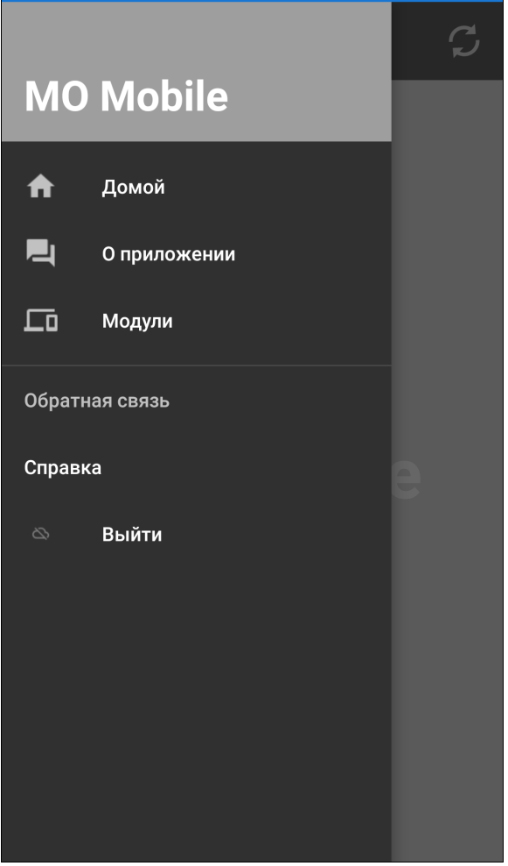

- Modules:
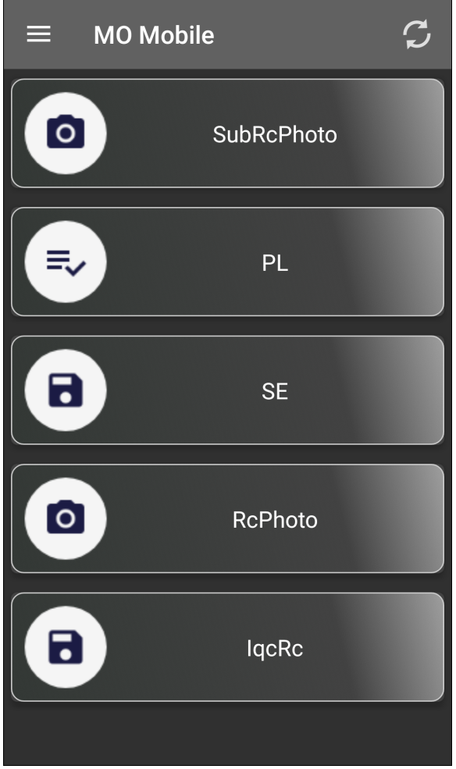
- Modules in details.
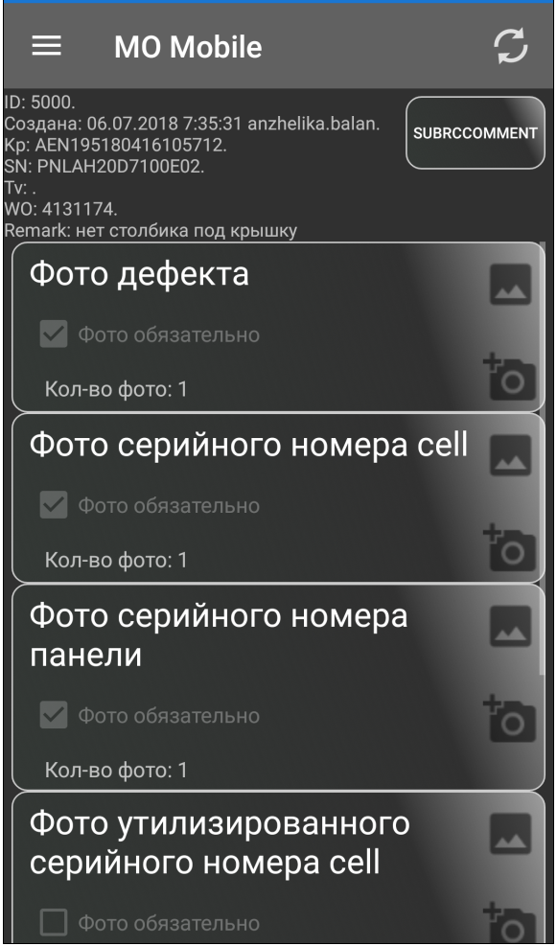
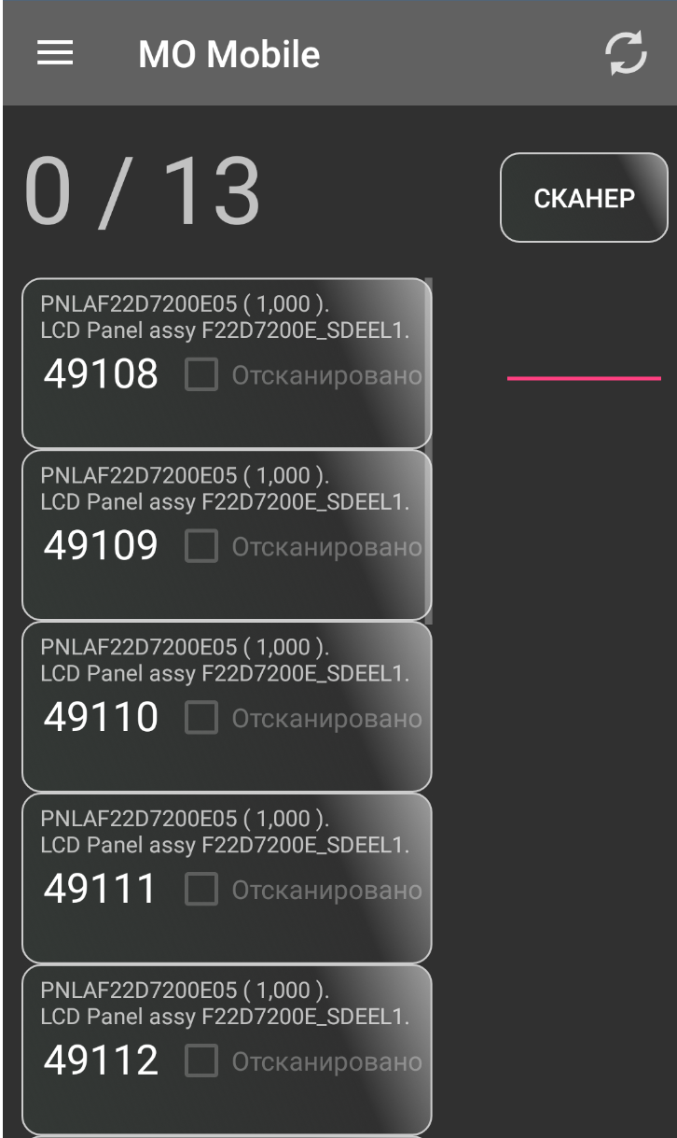
- Modification.
Add new Module “Box ID Photo”
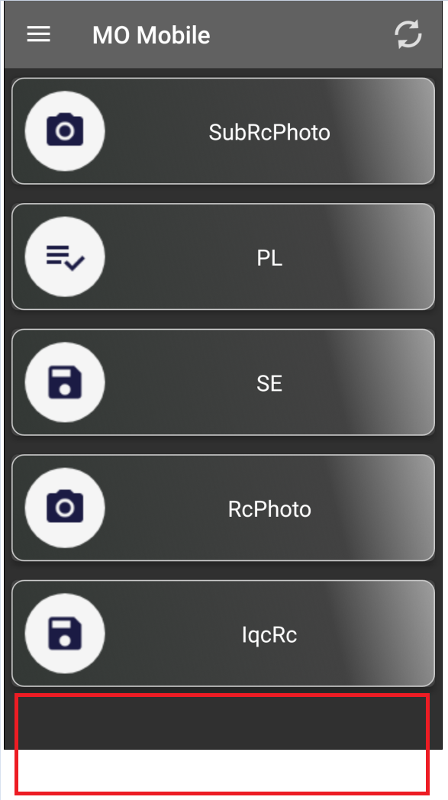
The purpose of module is to make photo with reference to Box Id.
Work Cycle is:
- Start.
- Specify Box ID number (Scan by Barcode Scanner-Camera).
- Make Photo. Save to 1C DB.
- End.

