User manual for software ALBEDO:
licence: GPL 3 compatibile
copyrights: Jerzy Cierniewski, Jarosław Jasiewicz and Adam Mickiewicz University in Poznań

The software Albedo is designed to calculate changes of diurnal albedo for any place, any surface and any time on the Earth. The application's main window is divided into two parts. The lower part contains a comprehensive toolbar that allows one to perform all analytical activities. The upper part presents results and allows one for a detailed inspection of results.

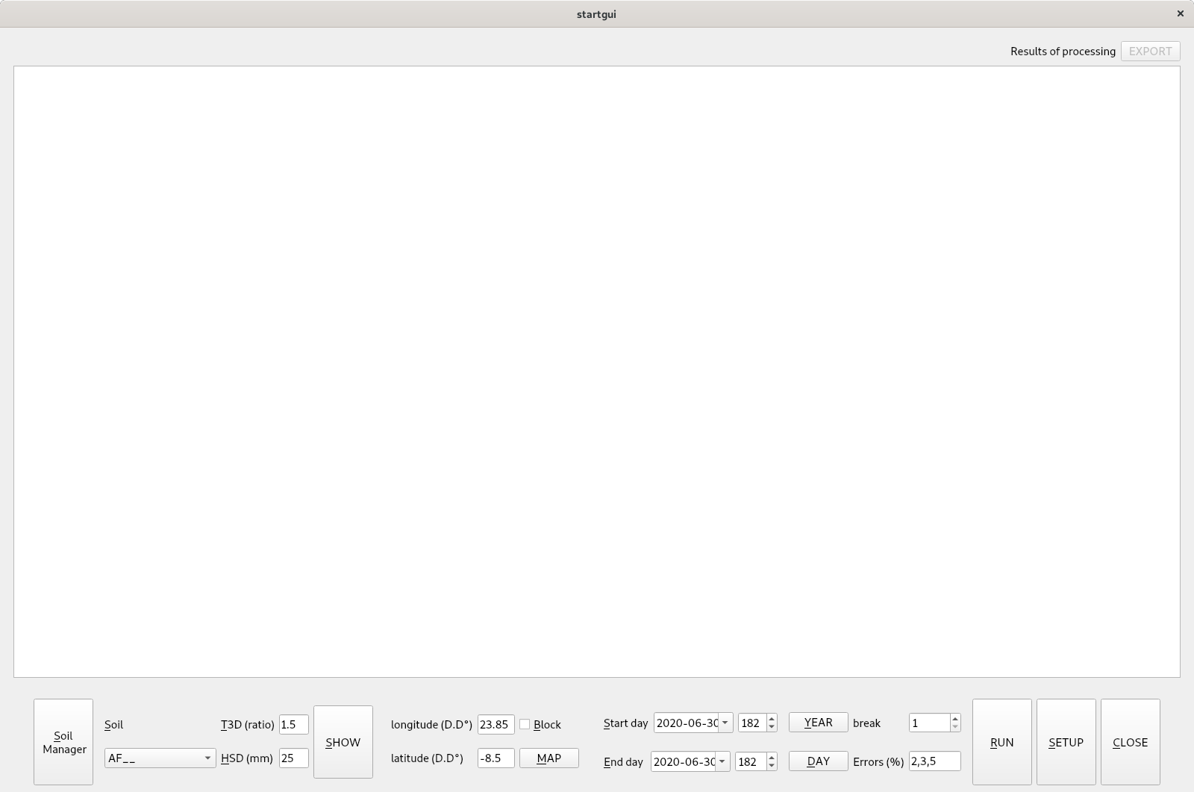Figure 1: Application's main window

Toolbar

Soil Manager:
open Soil Manager. See <Soil Manager> for details.

Soil Section:
Soil: selects soils from the list by soil name. Soil names are custom names managed by the user through soil Manager. When soil is changed and has geolocation, its coordinates are automatically pushed to the coordinate sections, where it can be altered by users. Soil list contains can contain all soils in soil database see: <soil database> or can contain limited selection managed through soil manager.

T3D field:
ratio between …. Accepts values between 1.005 and 3.5. If the input field contains the value out of range, a warning is raised, and value is changed to default (currently 1.5).

HSD (mm) field:
…. Accepts values between 0.3 and 100 mm. If the input field contains a value out of range, a warning is raised, and value is changed to default (currently 25mm).

Show button:
Show plot for location-independent albedo curve, where the x-axis contains solar zenith angle between 0 and 90, where 0 means zenith and 90 means sunrise position. Albedo curve takes a45 parameter from soil database as well as T3D and HSD from soil parameters and uses formula presented in: (Cierniewski….) <Formuła>.
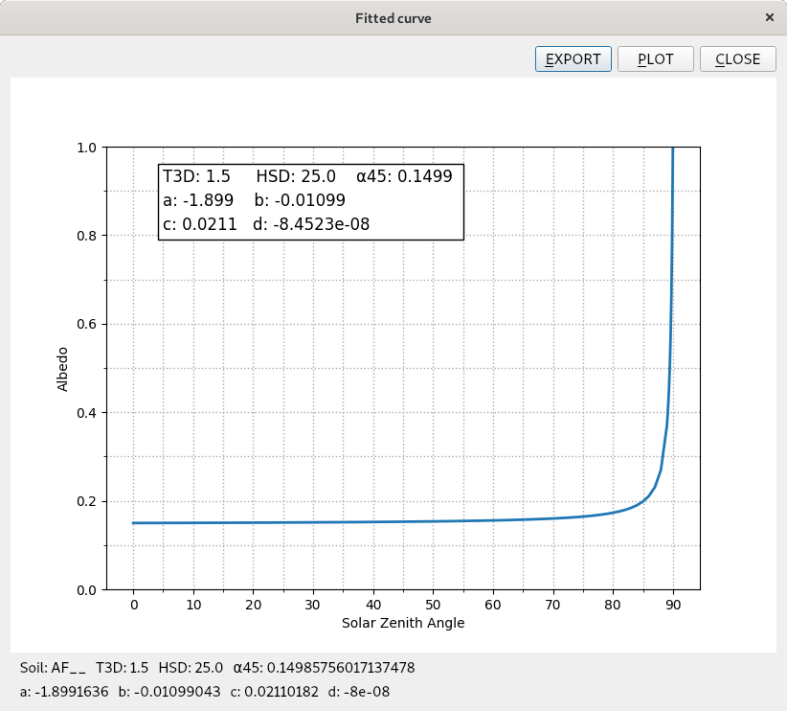Figure 2: Albedo curve dialog

Export button:
Export all the parameters necessary to visualize the albedo in external software and save as an excel file. Curve sheet contains soil angle and albedo values. Paramterer sheet contains soil parameters: a45, T3D, HSD and curve paramters: a, b, c, d.

Plot button:
allow saving the plot as graphic (pdf, png or svg) file. Location and name are set by save file dialog. Parameters a,b,c and d are parameters of curve formula.
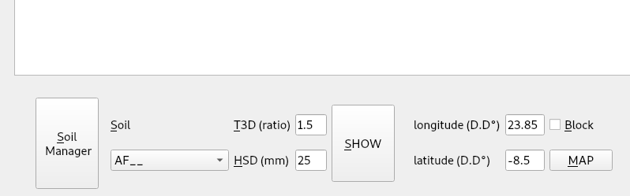Figure 3: Soil and location section of the toolbar

Coordinate section:
Coordinate sections allow setting geographic coordinates (place on Earth) where changes of the albedo are calculated. Each soil sample, if has geolocation push its location to the coordinates section. Such coordinates can be changed directly by entering values manually into the appropriate fields or by pointing location on the map.

Map button:
map button calls the Earth map where the location of all main arable lands in marked by colors. If one wants to select a custom location on the map, simply point coordinates using the cursor and clicking on the map. The Map allows selecting coordinates with an accuracy of 0.5 decimal degree.

Block check box:
When checked, the coordinates set in the coordinate section cannot be altered, when changing soil parameters in the soil section. This feature is especially useful to test how different soils will behave in the given location.

Date selection section
Date selection allows one to select date or range of dates for which the albedo variability will be calculated.
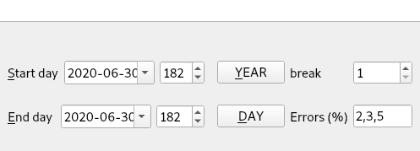Figure 4: Date selection section of the toolbar

Start day, end day:
Both start and end day can be selected as the exact date using calendar pop up or direct entering of the date. The second method is <day of year>. It allows the user to choose the day as a number between 1 and 366. Each date can be selected in any form, and calendar widget and day of year field are synchronized. First and last day creates a time series of days for which albedo will be calculated.

Year button:
Changes the start and end day to the first and last days of the year, respectively. It allows the user to calculate the day changes of albedo for each day of the year.

Day button:
set the end day to the start day. It allows to calculate changes of the albedo for the given one day of the year.

break:
Allow increasing the interval between subsequent days in the time series. Useful primarily for very long time series (like a year) when small changes in the following days are unimportant. Number in the field describes interval between days; default one means every day in time series, 2 means every second day 3 means every third day, etc.

Errors
Errors in % (values between 0 and 100) to calculate and mark ranges where albedo deviates from its mean value between -error and +error

Results section
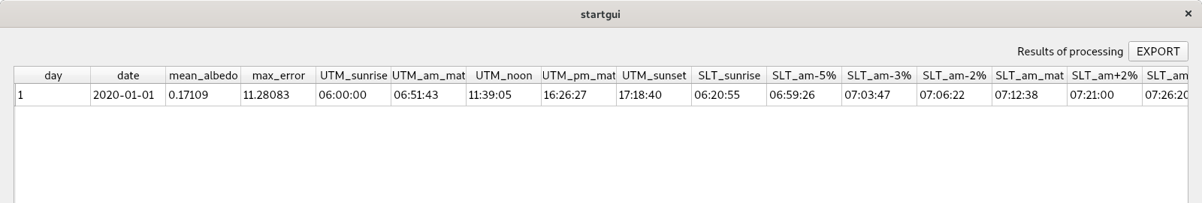Figure 5: One day results
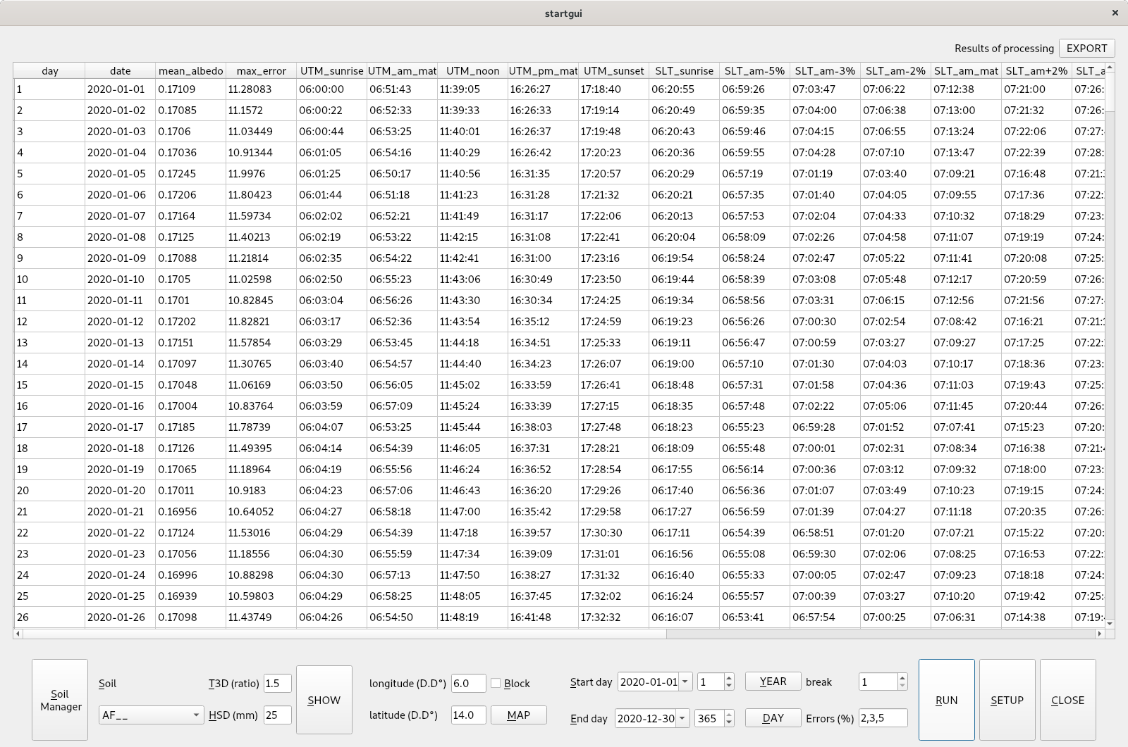Figure 6: Full year results
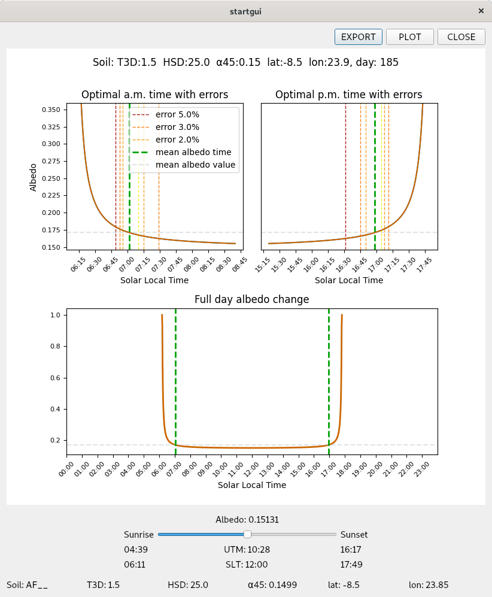Figure 7: Albedo curve for one day

Soil Manager
Soil manager is a sub-module designated to manage soil spectra. It is divided into two sections (tabs): one prepared to add, remove, print, and modify each soil spectra, second to group individual spectra into collections, and to massive import and export of data. The first section is called spectrum manager, second collection manager. Soil list is a part shared by the spectra and collection manager. It works differently, depending on the section.

Section spectra manager:
This section is designed to manage individual spectra.

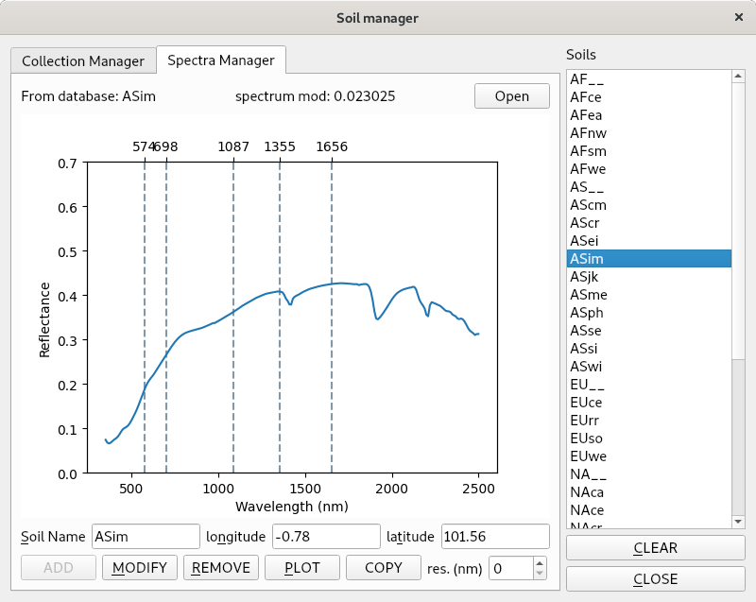Figure 8: Soil manager - spectra manager with active spectrum

Soil list:
It allows the user to select and activate individual soil. To select soil user must click deselected soil name. Only one soil can be actively selected, so clicking on the different names will deselect current soil. Selected soil is marked blue. To deselect all soils user must click the clear button.

Open Button:
Opens file containing individual spectra. It must be an Excel or csv (comma separated values) file formatted in a way described in the input data section. The file then is parsed, and after that spectrum is shown as a plot. If the spectrum is not yet added to the database, source info in the left-right corner is “From file”. If soil spectrum has extended format, i.e. it also contains the soil sample's name and coordinates, these parameters are automatically added to appropriate fields in the soil manager window. Both name and geolocation can be changed during the import. If the user accepts input data can add spectrum to soil database.

Name field:
Allow to choose or change the name of the soil spectrum.

Latitude, Longitude:
Allow to choose or change the geolocation of the soil spectrum. It can be remained empty (not recommended).

Add Button:
Adds spectrum to soil database. Active only when new soil is added.

Modify Button
Modify selected soil already added to the database. Only the name and location can be changed. Spectrum cannot. If the user wants to change the spectrum, one must delete it and then re-import.

Delete Button:
Allow removing the selected spectrum from the database. This operation is undone; however, any removed spectrum must be re-added using Open and Add buttons.

Clear Button:
Clear selection or remove imported soil before adding it to the database.

Plot Button:
Allow saving spectrum chart as png, svg or pdf file. The default is pdf.

Copy Button:
Copy structure of the selected spectrum file to the clipboard. Content of the clipboard can be pasted to any file, including text files and spreadsheets.

Resolution field:
The resolution field is connected with the copy button and allow to select the resolution of the copied spectrum. 0 means that the resolution of the spectrum will remain unchanged (as is in the database), while values between 1 and more mean that spectrum will be exported with a given interval.

Section collection manager:
This section is designed to work with a group of soils in one step. The group must contain at least one soil. In the collection manager, the soil list allows selecting more than one soil to create a group called a collection. Selection – a group of selected soils is independent of the collection. Soils can be temporarily added removed from the collection before any future actions.

Soil list:
To select soil in the soil list, one must click any deselected soil name. To deselect user must click one of the selected soil. Selected soil is marked blue. To clear selection user must click the clear button. It clears all selections in the entire section.

New Button (collections):
Allow creating a new collection from selected soils. At least one soil must be selected.

Modify Button (collections):
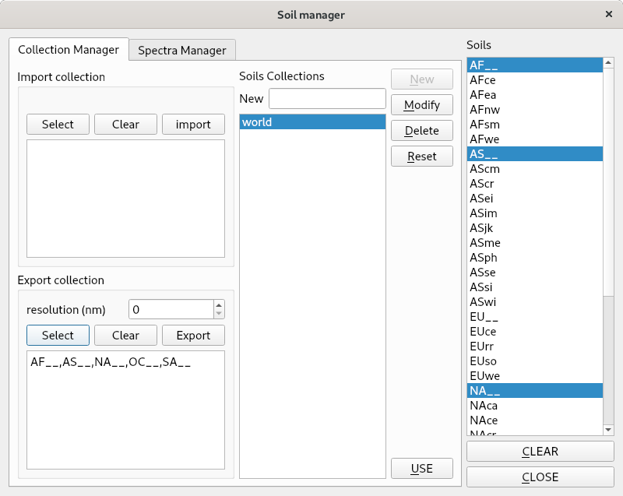Figure 9: Soil manager - collection manager with active collection
Allow modifying the existing collection. To modify collection user must to select a collection from collections list, next by selecting or deselecting preferred soils, and next to click modify button.

Delete Button (collections):
Allow removing the collection. It only removes collection as a container. The content of the collection (soils) remains untouched.

Reset Button (collections):
Limit selection to the active collection. Useful when the user temporarily added or removed soils from the collection.

Clear Button (collections):
Clear all selections in the entire section, including soil list, collection list, import, and export section.
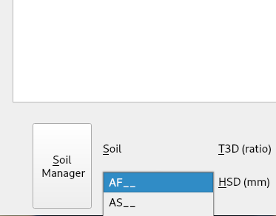Figure 10: Limited collection of soils

Use Button (collections):
Use only active selection in the rest of the software.

Close Button:
Close soil manager.

Select (import):
Selects external file to import of soils spectra. Soils spectrum must be formatted in a way described in the input data section. This step does not yet import data. If soil names found it the import file are also found in the soil database, those columns are excluded from import. It allows re-using existing external file already containing spectra when single spectra were added to that file. A list of imported soils is listed in the text box below.

Clear (import):
Clear selection, nothing will be imported.

Import (import):
Process importing of selected spectra. After importing soils are added to the soil list and selected. The user can then create a new collection from imported soils or add them individually to existing collections or left them unassigned. After importing, newly added soils may be added outside the current list view. The user must check if any soils are added by inspecting the entire soil list.

Select (export):
Use an active selection to export soils to the external file. The file will be formatted in a way described in the input data section, so the file can be used to re-import data. A list of exported soils is listed in the text box below.

Clear (export):
Clear selection, nothing will be exported.

Export (export):
Process exporting of selected spectra. The message will appear after success.

Resolution field:
The resolution field is connected with the Export button and allows the user to select the copied spectrum resolution. 0 means that the resolution of the spectrum will remain unchanged (as is in the database), while values between 1 and more mean that spectrum will be exported with a given interval.

Import Data format:

Individual spectrum:
Spectrum data before importing must be formatted in a specific way. Two file types are accepted: comma-separated values (csv) and Excel files (both xls and xlsx). To import individual soil file must contain at least spectrum: left column contains wavelengths, right column reflectance. Optionally import can contain symbol (soil name) and latitude and longitude of soil spectrum. Wavelengths can have any resolution in nanometers, but must start from 350 nm and ends on 2500 nm. Latitude and longitude must be in Decimal Degrees (D.D)

Table 1: Formatting of individual file. Optional elements are marked blue
Symbol | SoilName
lat | -30.01
lon | 23.12
350 | 0.13
360 | 0.19
...
2500 | 0.43

Group spectrum:
To import an entire group of spectrum the file must contain both spectrum and name and geolocation (latitude and longitude). This is necessary because during the import, user cannot manage names and geolocations for individual spectra.
Table 2: Formatting of group file.
Symbol | Soil1 | Soil2 | Soil3
lat | -30.01 | -30.01 | -30.01
lon | 23.12 | 23.12 | 23.12
350 | 0.13 | 0.13 | 0.13
360 | 0.19 | 0.19 | 0.19
...
2500 | 0.43 | 0.43 | 0.43

Setup
Setup dialog allow one to select imput and output directories for application.
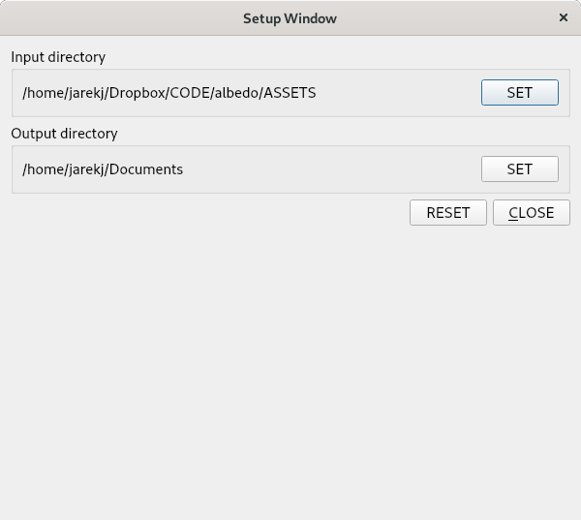Figure 11: Setup dialog

