

ANalysis Report

Assignment on Order data set



February 7, 2022

Data science lab pvt.ltd.

Pune

# Methodology

Our overall purpose in this analysis report is to analyze data and discover insights. There are 8 variables and 66 records in the "Order" data set that have no missing values.

Data set consists 10 customer’s information related to order products history. The "Number of Delivery days" variable is calculated using the Excel command "INT," which is the difference between the order delivery date and the order date. Tableau Public and Python (Jupyter notebook) were used to do exploratory data analysis (EDA).

# Analysis

The following links will take you to a graphical representation and a cross table:

Dashboard 1:[Click here](https://public.tableau.com/app/profile/sachin.jare/viz/OrderDataSet_Int/Dashboard1?publish=yes)

Dashboard 2: [click here](https://public.tableau.com/app/profile/sachin.jare/viz/Order_Dashboard_16442295725950/Dashboard1?publish=yes)

Python Work: [Click here](https://colab.research.google.com/drive/1DleX-TtXiIzJi4GozYyWyfthIhqQUoyH)

*Note: For a better visual experience, access the link on a laptop or computer.*

**Data types of each variable and missing values:**

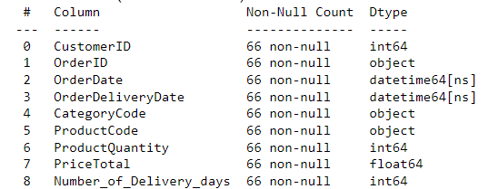

There are 66 records in all, none of which have a missing value (null value) for each column.

**Summary Statistics:**

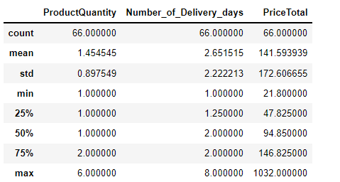

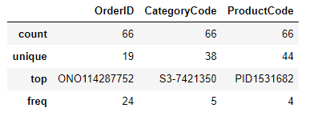

## **In the provided data set, the following insights are found:**

**1.** The loyal customers think highly of your brand, products, or services, which increases the chance that they will repeatedly buy from you.

Customer ID:202595 and 264981 are loyal customers in our database.

**Customer ID:202595** purchased items in four different months.

**Customer ID:264981** purchased items in two different months.

Above two customers out of ten have placed orders in different months, while the remaining eight have only placed in a month.

To attract customers, it would be advisable to provide an offer or provide a discount to that eight customers.

**2.** The overall amount of money spent by each consumer is shown in the table below.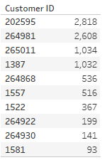 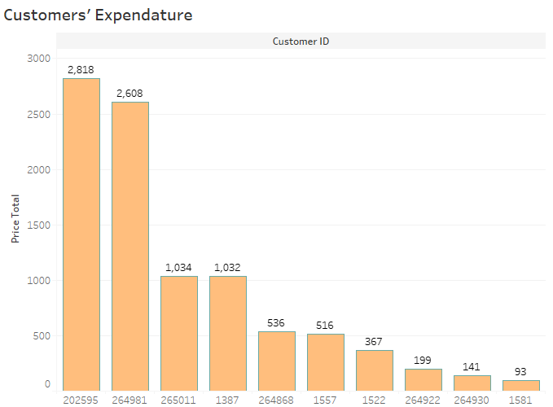

Customer ID: 202595 spent the most money, while customer ID: 1581 spent the least money.

**3.** There were 38 different category codes under which customers had placed their orders.

The majority of orders come from the following categorization codes: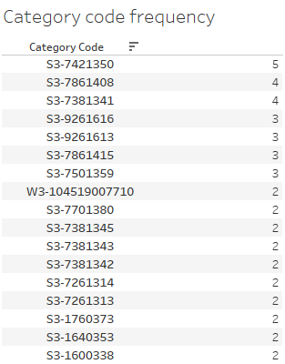

**4.** There were 44 different products which customers had placed their orders.

The following are the most frequently ordered products:

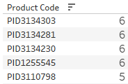

**5. Revenue on a quarterly and monthly basis:**

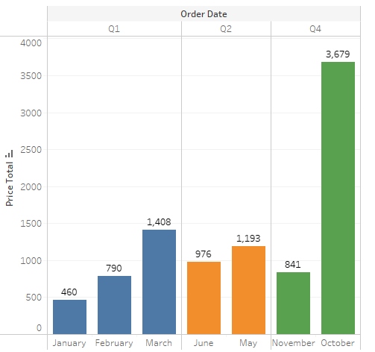

The above graph shows that there were no orders in the months of April, July, August, September, and October. As a result, quarter 3 will be absent of any orders.

**In each quarter, total revenue from customers:**

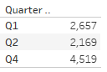

**6. Delivery time:**

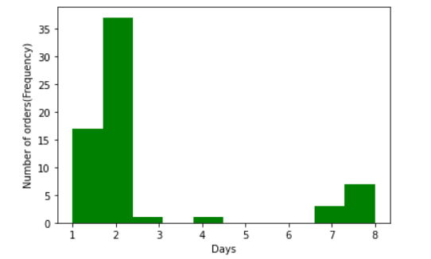

**Cumulative percentage table:**

|  |  |  |  |
| --- | --- | --- | --- |
| **Days** | **Frequency** | **Cumulative**  **Frequency** | **Cumulative Percentage** |
| 1 | 17 | 17 | 25.76% |
| 2 | 37 | 54 | 81.82% |
| 3 | 1 | 55 | 83.34% |
| 4 | 1 | 56 | 84.85% |
| 5 | 0 | 56 | 84.85% |
| 6 | 0 | 56 | 84.85% |
| 7 | 3 | 59 | 89.4% |
| 8 | 7 | 66 | 100% |

* It has happened seven times in the past for a product to take eight days to arrive.
* There is an 82 percent chance that the product will be delivered in two days.

**In past, the following items took an additional eight days to arrive.**

