Control of Mobile Robotics | CDA 4621 | Lab 3

Vision-based Navigation & Obstacle Avoidance

Julie Gibson | Jennifer Patterson

# List of Code

· ThreadedWebcam.py

o Used to implement a threaded webcam.

· UnthreadedWebcam.py

o Used to implement an unthreaded webcam.

· Calibration.py

o Used to run a calibration

· bugAlgorithm.py

o This program implements “bug 0” algorithm to find a specified goal.

· faceGoal.py

o This program rotates the robot around its center until it faces one of the specified goals.

· Kinematics.py

o This program contains kinematic functions

· Movement.py

o This program contains functions for motions such as orientation function and PID functions.

· motionToGoal.py

o This program rotates robot unit it faces a desired goal then performs motion to goal and stops motion once robot is 5 inches from the goal.

· encoder_lib.py

o This file includes functions of controlling the robot’s hardware including servos and encoders.

· triangulation.py

o This program is used to determine the robot location relative to 3 goals based on trilateration methods using a mapping of blob sizes to relative distance.

# Plots

### Internal Obstacles:

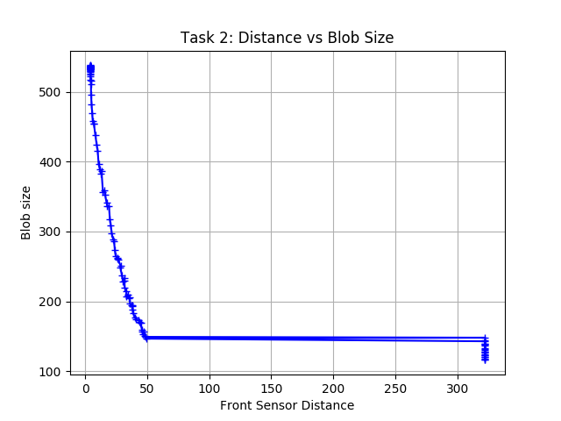

### 

### 

### 

### External Obstacles:

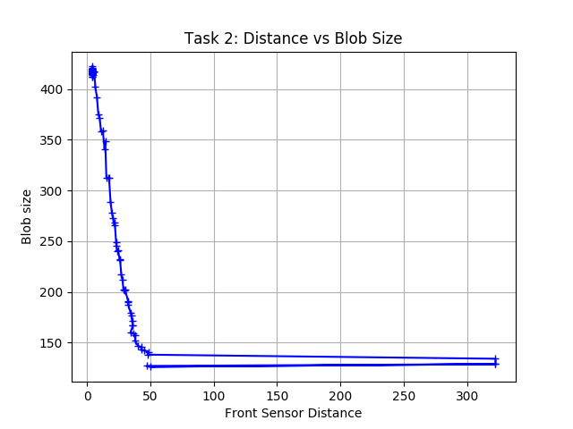

## Description

To create the plots depicted above the opencv blob detector was implemented on a masked image. Once the blob was recognized by the camera, a PID function was used to center the closest blob detected in the frame. Once the blob is centered within an allowable degree of error, the program implements a forward PID function moving towards the goal. The PID equations include:

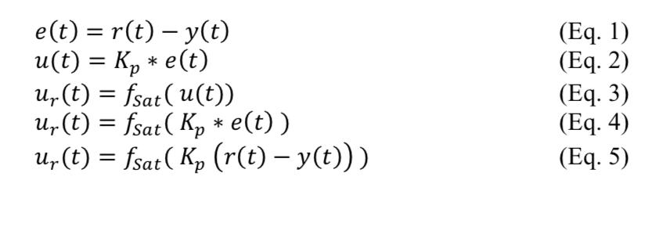

# Video Analysis

To analyze the video frame and recognize and extract a single goal position for both figures, the color of each goal was determined in the HSV color space. Then the opencv library function inRange() was used to mask the frame returned from the camera. The inRange() function takes in the minimum and maximum HSV values that approximately identify a goal. Once the goal is detected and the robot is directly facing a specific goal, the blob size is used to determine the distance of the robot from the goal. This is accomplished through a mapping of blob sizes to distance. A calibration file with blob size to relative distance was created for this purpose. With the relative distance from the goal determined by the size of the blob in the frame, trilateration methods were used to determine the x, y position of the robot. The following equations were used:

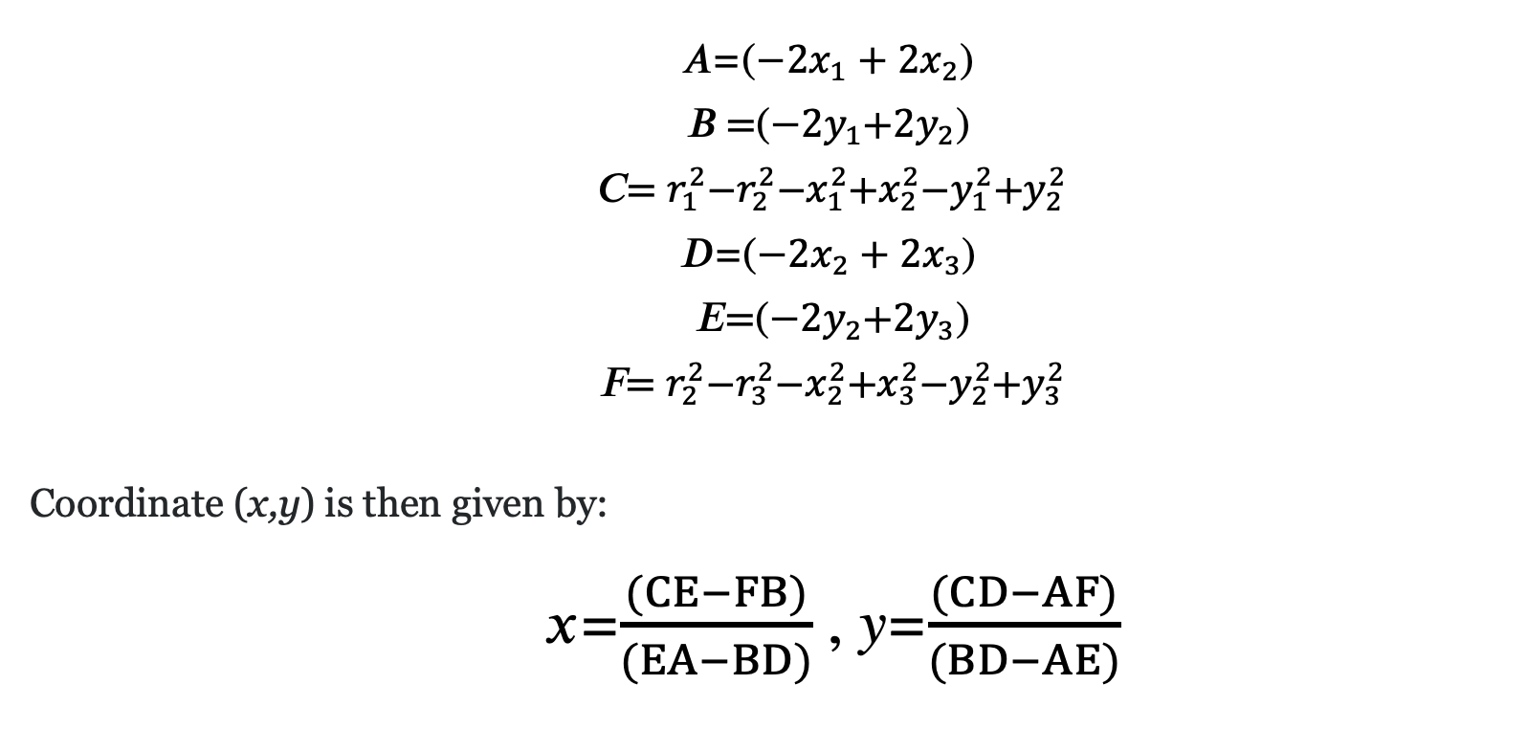

# Link

<https://youtu.be/BsVU4jgYr9o>

# Conclusions

During the implementation of methods in this lab, our team was able to attain a deeper understanding of computer vision techniques and their application in autonomous robotics. One of the largest hurdles that we encountered was the ability to recreate the set up for conducting this lab. Specifically, we learned that if side walls were too high, the detection of blobs became more difficult to detect when the robot was in close proximity of a goal. This led us to have a deeper understanding of how the size of the blob was important for accomplishing the tasks in this lab. Our second attempt at the maze construction allowed us to find blobs and ascertain distances more effectively. Another issue we encountered was finding the correct lighting conditions in which the goals could be identified. We still had some issues with light during the motion to go presentation. Also, we noticed that the robot has sensor limitations that impacted the trilateration execution of this lab. For example, the maximum sensor reading that we found empirically was approximately 46 inches. This meant that if the target was outside of the range, the sensor would return > 300 inches. We attempted to increase range by modifying the VL53L0X_LONG_RANGE_MODE to VL53L0X_LONG_RANGE_MODE, but this only increased the range to approximately 55 inches. As a temporary solution we used a hard limit if > 300 was returned by the distance sensor.