VISSIM-MOVES Integration
This guide covers the basic steps to integrate output from VISSIM and MOVES.

Configuration of VISSIM (or Translation of Microsimulation Output)

Expected Microsimulation Output File
In order to use the integration program, VISSIM must be configured to give proper output. Any microsimulation platform can be used by the program, but output must be structured in the following manner:
* LINES WITH A * Are Ignored, comments.
* This style of file is outputted by VISSIM. The next lines start with a
* header that identifies the columns, and then the values themselves.
* $VEHICLE: marks the file as a vehicle record, and the remaining are labels.
$VEHICLE:SIMSEC;NO;LANE\LINK\NO;LANE\INDEX;ACCELERATION;SPEED;POS;POSLAT;VEHTYPE\CATEGORY
200.20;63;6;1;-0.04;18.88;632.51;0.50;Car
200.20;65;6;1;-0.22;16.63;553.90;0.50;Car
200.20;67;6;1;-0.22;16.83;532.60;0.50;Car
Listing 1 – Sample Microsimulation Text Output File (Required Information highlighted in Red)
The program requires simulation timestamp (exactly one record per second), vehicle number, lane number, vehicle type, vehicle speed (m/s) and acceleration (m/s²). All data must be semi-colon delimited. These values can come in any order in the file, but must have the following header names: SIMSEC; NO; LANE\LINK\NO; LANE; VEHTYPE\CATEGORY; SPEED; ACCELERATION.

VISSIM Configuration
Output in this format can be configured in VISSIM. To enable this navigate to “Evaluation > Configuration” as shown in the picture below.
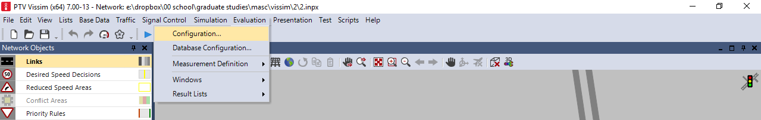
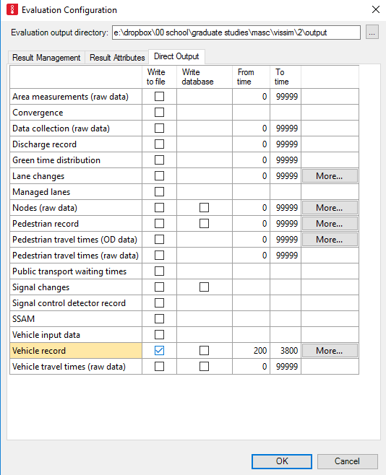
After selecting configuration, the “Evaluation Configuration” dialog box will appear. Navigate to the “direct ouput” tab and check the box next “write to file”. The columns “From time” and “To time” control the length of the record file. These should be set to capture a duration of time that spans 1 hour (MOVES can only model 1 hour increments). If you use default simulation options, this will correspond to a “To time” of 3600 and “From time” of 0. Refer to the figure above. Select and take note of the output directory (highlighted with the blue box) as the record file will be saved here. After finishing the previous step, click on the button labelled “More…” to configure additional options.
NOTE: If “From time” is not 0, it will need to be entered into the VISSIM-MOVES integrator (see line 54)
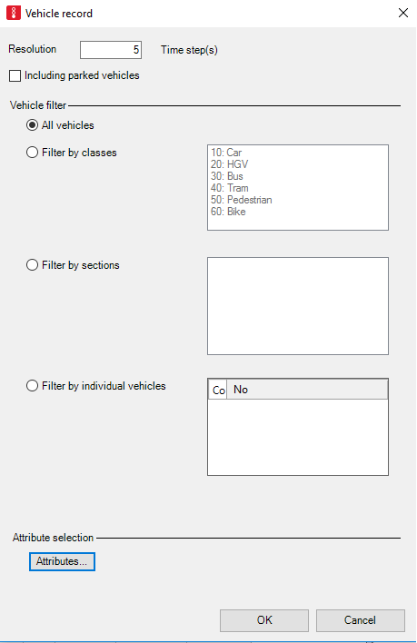
The “Vehicle Record” dialog appears, as shown above. The resolution paremeter controls the frequency of data collection. MOVES only analyses per-second data. This parameter must be changed based on the simulation resolution employed. By default, each simulation step in VISSIM is 0.2s. To achieve a data resolution of 1s, this value would then be 5. If you have used a different simulation step, this parameter must be changed accordingly.
When you are done, select the “Attributes” button to configure the records that will be included.
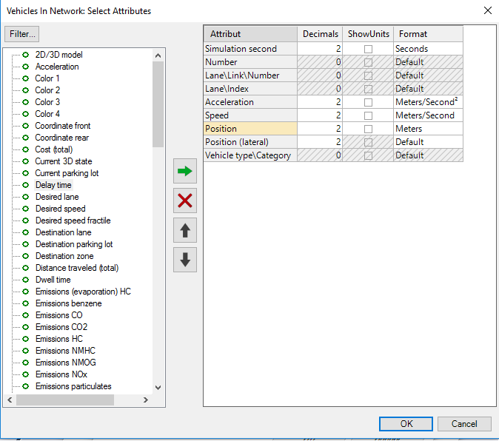
The “Select Attributes” dialog should appear (shown above). You must configure the vehicle record to include the attributes discussed on lines 16-19 of this document. To add an attribute, find it in the list on the left (blue box in above figure) and press the green arrow button to add it to the panel on the right. The entry text should match what is shown above. The required items are highlighted with a green box in the above figure. Ensure that the format for Simulation second is in seconds, acceleration is in Meters/Second² and speed is in Meters/second. (See line 120 for discussion on vehicle types)
When you are done, press okay on every dialog box to close them and return to VISSIM. You may now run the simulation and generate the output.

Configuration of the VISSIM-MOVES Integrator
Run the VISSIM-MOVES integrator. When it is run, the following dialog appears.
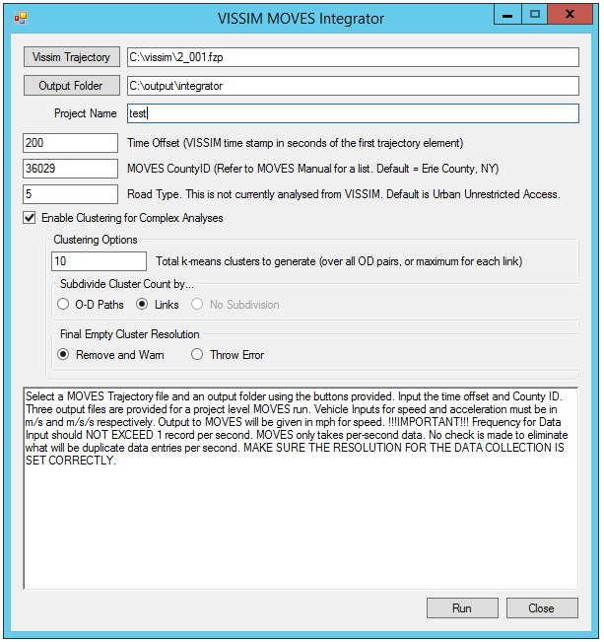
The first three text boxes are used to load the VISSIM output file, configure where output from the integrator should be put, and add a name that will be used as a prefix in all output files. To load a VISSIM input file, click the “Vissim Trajectory” button and navigate to the location you configured in VISSIM (see line 30). This file should have an extension “.fzp”.

Set the “Time Offset” to the record collection starting time configured in VISSIM (See line 33). This value is required as adjustment of the timestamps is necessary for importing into MOVES.
The MOVES CountyID should be set to correspond to the county you choose to model in MOVES (see line 113). This is required and MOVES will not import the data if this value is not set to the same county used in MOVES for the analysis.
The Road type is not analyzed from VISSIM. The “Road Type” field allows specification of the number of the type of road to be assigned to every vehicle. The default is 5, which corresponds to an Urban Unrestricted Access road in MOVES.

The integrator always provides files to simulate each vehicle individually on in MOVES. The final options can be used to configure an additional clustering analysis that can be used on complex networks. Vehicle trajectories are analyzed on a per-link or per-Origin/Destination (this is contolled by the “Subdivide cluster Count by…” option) and are grouped together based on similarities in their paths. The default is to create 10 path groups for each Link. Optimal selection of k will depend on the network condition and computational power available for analysis. The k-means algorithm allows the possibility of 0 size clusters to be generated. The algorithm employs a number of tactics to avoid this, but cases may arise where it is not possible to divide the volume into the requested number of clusters (e.g. if cluster count is greater than volume). The program can be configured to halt and throw an error (not recommended) or remove the cluster and display a warning to the screen.
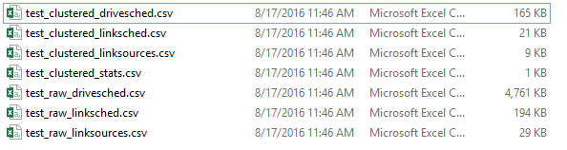
Final Output from the integrator comes in the form of 7 files. If the clustered analysis is not performed, the *_clustered_* files will have size 0, but will still be present. Three files for use in the subsequent MOVES analysis are generated. They are shown below.
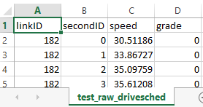
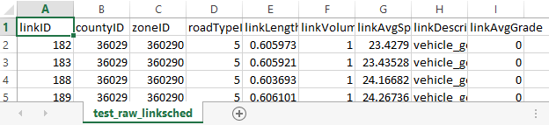
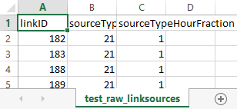
The drivesched (drive schedule) file provides a second-by-second trace of the vehicles in a format that can be understood by MOVES. Grade is included by not analyzed from VISSIM. Speed here is in mph.
The linksched (table of links) file summarizes the links that will be analyzed in MOVES. In the _raw_ file these links will all have a volume of 1 (each vehicle is modelled as individually). In the _clustered_ file, these links will have the volume of the cluster that the trajectory represents.
The linksources (table of vehicle types) contains the fraction of vehicle types that will be modelled as determined from the VISSIM output. At present only gasoline powered trucks and cars are translated from the VISSIM output, additional vehicles can be added. In the _raw_ file, the “sourceTypehourFraction” value will always be “1” and there will only be a single entry for each linkID. In the _clustered_ files, the sourceTypeHourFraction will vary from 0 to 1 based on the proportion of each vehicle type, and there will be multiple entries for each.

Configuration of MOVES
This section briefly discusses important elements of the MOVES configuration process as they relate to this integration. For more in-depth instructions please refer to the user manual.
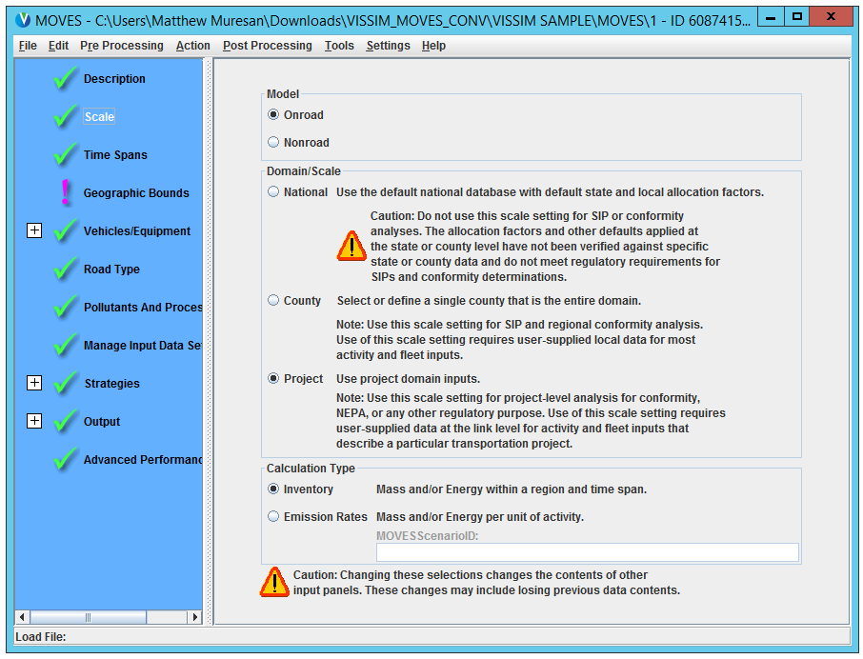
Configuration of MOVES through the GUI is controlled by configuring each of the options listed on the left panel. These options start out with large X’s beside them, and switch to green checkmarks when complete.
The integration framework is based on a project-level analysis, so this option must be selected in MOVES.
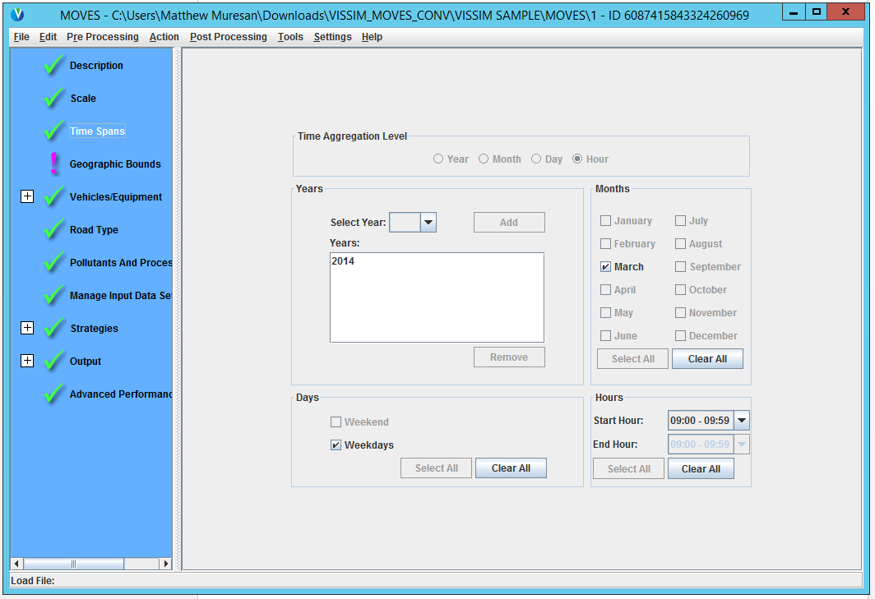
In a project analysis you can only make an analysis for a single hour. To analyze multiple hours, you will need to do multiple analyses.

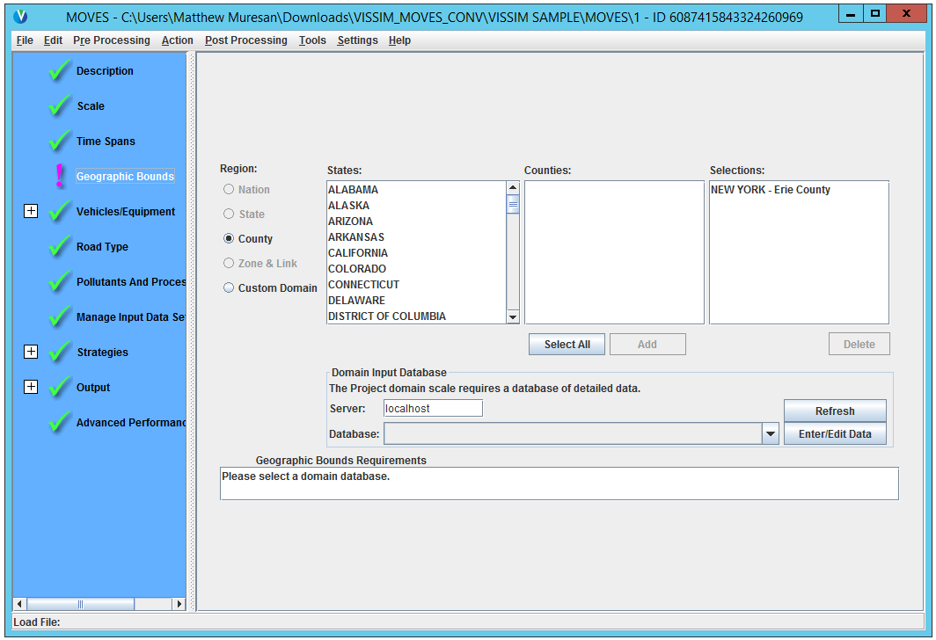
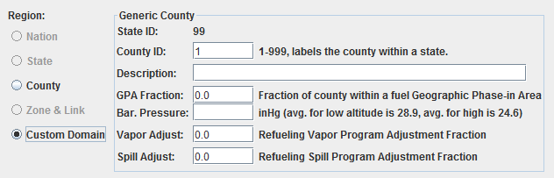
As discussed on line 63, in the VISSIM-MOVES integrator a county code was manually entered. If you select an existing county from the MOVES database, you must lookup its corresponding county code and enter it into the integrator. Add that county to the analysis by finding its state and name using the listboxes (highlighted with red boxes in the above figure). If you use a custom county (see blue boxed figure) the county code you enter into the VISSIM-MOVES integrator is 99XXX where XXX corresponds to the county ID you define (e.g. a county ID of 1 would be 99001).
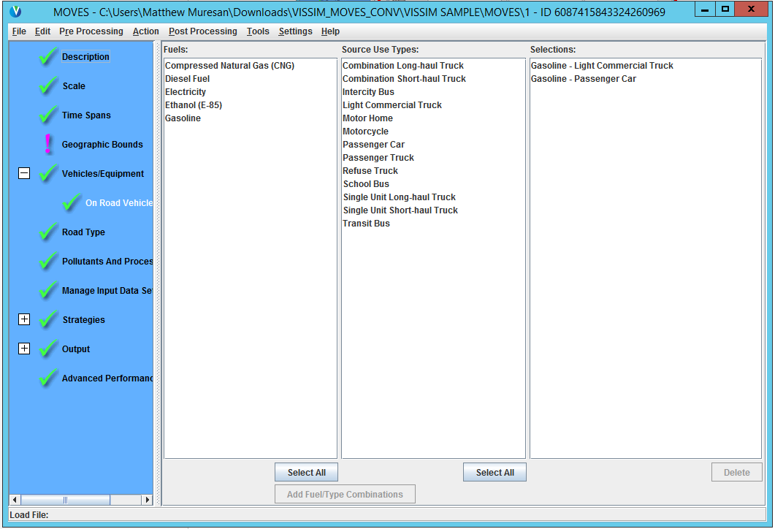
At present the integrator only analyzes two types of vehicles from VISSIM. Vehicle types “Car” and “HGV” are mapped to “Gasoline – Passenger Car” and “Gasoline – Light Commercial Truck” by default. Configuration for vehicle types through the GUI is a planned feature of the Integration Application and will be added soon.
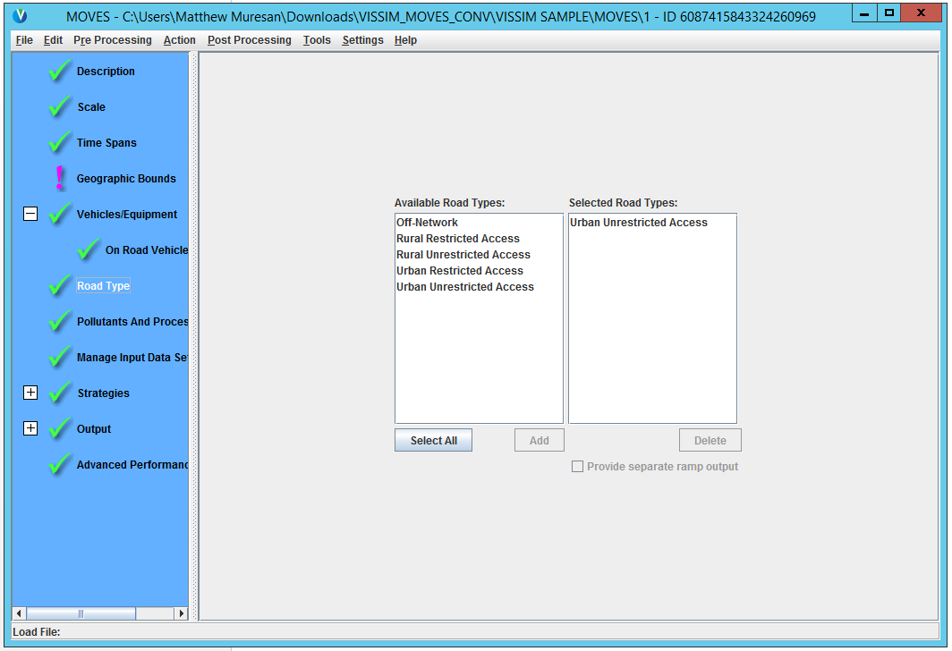
Only one road type should be included in the analysis. This is controlled through an option in the VISSIM-MOVES Integrator, and here you should select the corresponding road type and add it. The default option is “Urban Unrestricted Access”, which are Urban Roads that do not use interchanges to limit vehicles from entering.
When you have finished adding all other required information, you will be ready to use the “Project Data Manager”. Select it from the “Pre Processing” dropdown menu. This option can only be selected when all other options are configured correctly (check marks beside all MOVES menu options). If it is greyed out, you may have an error in your configuration, or your database may be improperly setup.
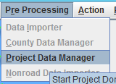
When you select this, the Project Data Manager will appear.
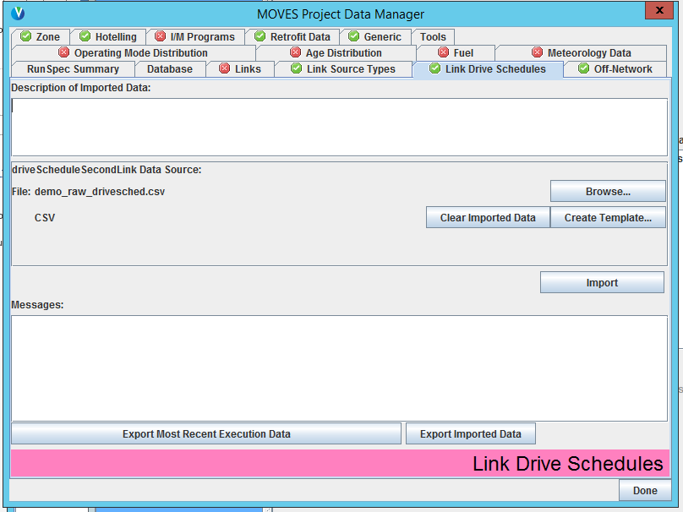
The project data manager contains a number of tabs used to import needed data. Data from the integrator should be imported using the “Links” “Link Source Types” and “Link Drive Schedules” tab. Use the brows button to navigate to the correct file and press import on each of these tabs. If successful, the label next to the tab should change from a red x to a green check. If there are errors, they will be displayed in the “Messages” section. The following should also be configured and should not have a red “x” next to them.
- Links, Link Source Types, Link Drive Schedules (using the files from the integrator)
- Meterology Data (weather), Fuel (can be configured to use default data from MOVES if using an existing county by clicking “export default data”)
- Age Distribution (provide a statistical distribution showing how old vehicles are)
All other options can be configured if needed. Do not configure the “Operating Mode Distribution” section.
When you are done, run the file to obtain estimates.

