- Dataset Overview:
The dataset used for this project is the Viral social media Trends & Engagement Analysis from Kaggle, which contains 5,000 social media posts to explore the underlying patterns that drive virality. The analysis focuses on how platform, content type, hashtags, region, and user engagement metrics interact to influence trend formation across platforms.
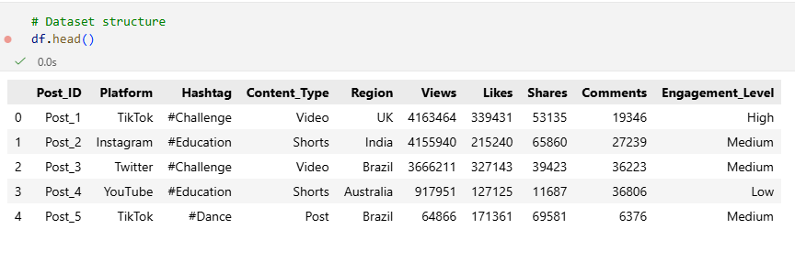
Dataset Loading: The dataset was loaded using Python. Checked the first 5 rows and column names to understand the structure and content.

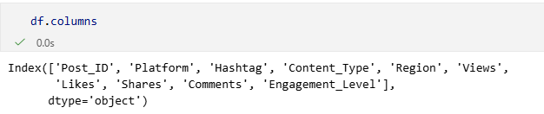
Dataset Description: It contains the following columns:

Column | Description
Post_ID | Unique identifier of each post
Platform | Social media platform (TikTok, Instagram, YouTube, Twitter)
Hashtag | Main hashtag used in the post
Content_Type | Type of content (Video, Shorts, Post, Live Stream, Reel)
Region | Country or region of the post
Views | Number of views received
Likes | Number of likes received
Shares | Number of shares received
Comments | Number of comments received
Engagement_Level | Target variable (Low / Medium / High) indicating virality or engagement level
Data Types: It contains two different types of data;
- Categorical: Post_ID, Platform, Hashtag, Content_Type, Region, Engagement_Level
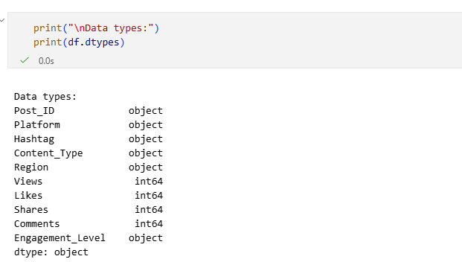
- Numerical: Views, Likes, Shares, Comments

- Exploratory Data Analysis:
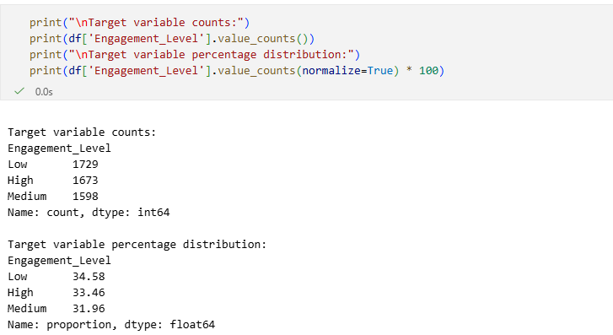
Target Variable Distribution: The target variable is distributed into three classes.

The Target Variable Distribution table is given below;
Engagement Level | Count | Percentage
Low | 1,729 | 34.6%
Medium | 1,598 | 32.0%
High | 1,673 | 33.4%
Total | 5,000 | 100%

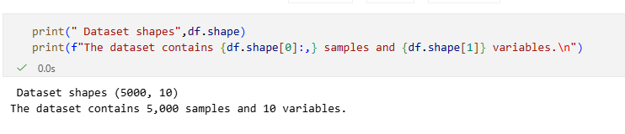
Check dataset Dimensions: The dataset has a shape of (5000, 10), meaning it contains 5,000 samples (rows) and 10 variables (columns). Each row represents a single observation, while the columns capture different attributes relevant to the analysis.
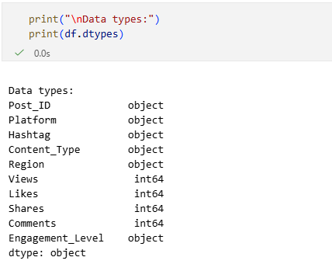
Data types of all columns: The dataset contains a mix of categorical and numerical variables. The dataset consists of five categorical variables (Post_ID, Platform, Hashtag, Content_Type, Region, Engagement_Level) and four numerical variables (Views, Likes, Shares, Comments).

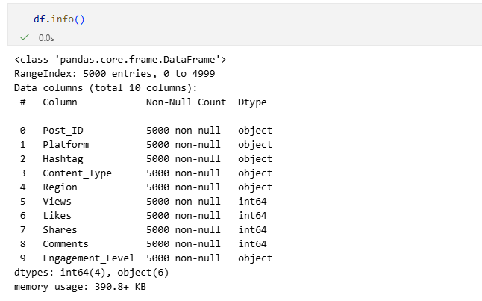
Data information: The dataset has 5,000 entries and 10 columns. All columns have 5,000 non-null values, so there are no missing values. Four columns are numeric (Views, Likes, Shares, Comments) and six are categorical/object type (Post_ID, Platform, Hashtag, Content_Type, Region, Engagement_Level).

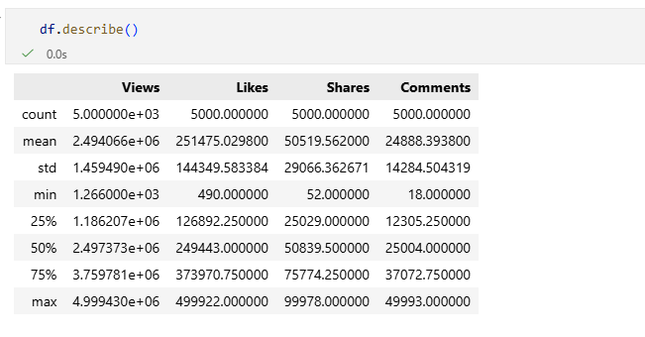
DATA SUMMARY: The screenshot below summarizes the main descriptive statistics for the numeric engagement metrics in the dataset: Views, Likes, Shares, and Comments. These statistics provide insights into the distribution, central tendency, and variability of post engagement.
Observations
- Views: Posts range from 1,266 to 4,999,430 views, with a mean of around 2.49 million, indicating a wide spread in popularity.
- Likes: The mean number of likes is ~251,000, with some posts reaching nearly 500,000 likes, suggesting that a few posts went viral.
- Shares: Shares vary from 52 to nearly 100,000, showing some posts are shared much more than others.
- Comments: The median (~25,004) is close to the mean (~24,888), suggesting a relatively symmetric distribution of comments, but the maximum shows some posts received unusually high interaction.
- Overall: The high standard deviations indicate significant variation in engagement metrics across posts.

Data Wrangling / Cleansing
- Data Wrangling /cleansing
Handling Missing Values: The dataset was checked for missing values in all columns. The results show that there are no missing values in any of the columns. Count of missing values per column:
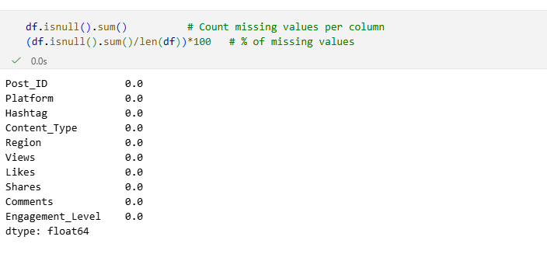
Plotting Missing Values:

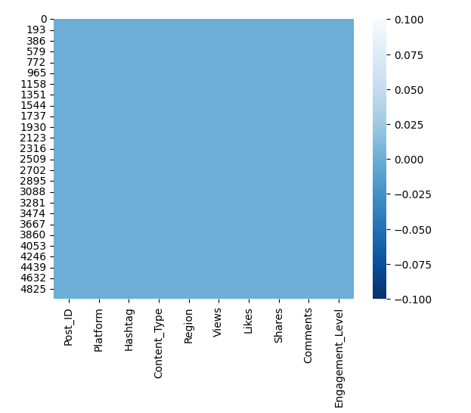

This indicates that the dataset is complete and does not require any imputation or handling of missing data before analysis.
Remove Duplicates: The dataset was examined for duplicate entries. The analysis found that there are no duplicate rows in the dataset.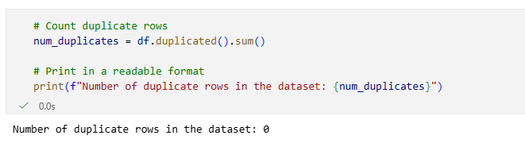
Fix Inconsistent Categories:
Categorical columns may contain inconsistencies such as:
- Different capitalization: e.g., TikTok vs tiktok
- Leading or trailing spaces: e.g., " YouTube" vs "YouTube"
- Minor variations or typos: e.g., Shorts vs short
If these inconsistencies are not corrected, the analysis would treat them as separate categories, leading to Incorrect counts and percentages, Misleading patterns in visualizations, and Erroneous correlations in analysis. So, all categorical values were standardized by:
- Removing leading/trailing spaces
- Capitalizing or title-casing platform, content, and region names
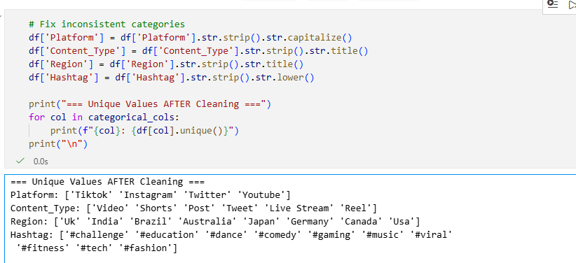
- Converting hashtags to lowercase
The categorical variables were standardized to ensure consistency and accuracy in analysis. Leading and trailing spaces were removed using str.strip(), capitalization was standardized using str.capitalize() or str.title(), and hashtags were converted to lowercase with str.lower() since they are typically written in lowercase.
After cleaning, the unique values for the categorical columns are as follows:
- Platform: Tiktok, Instagram, Twitter, Youtube
- Content_Type: Video, Shorts, Post, Tweet, Live Stream, Reel
- Region: Uk, India, Brazil, Australia, Japan, Germany, Canada, USA
- Hashtag: #challenge, #education, #dance, #comedy, #gaming, #music, #viral, #fitness, #tech, #fashion
This cleaning ensures that categories are consistent across the dataset, preventing errors in counts, groupings, and visualizations during exploratory data analysis.
Remove Columns: Post_ID is removed because it’s just a unique identifier and doesn’t carry predictive information and don’t help the model.
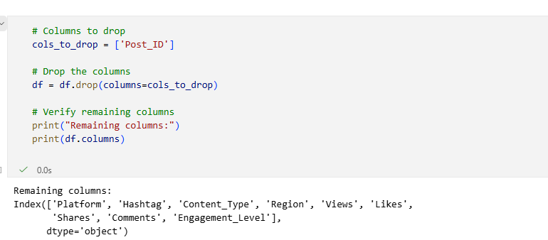
Feature Engineering: Derived Engagement Metrics
To better understand post engagement and virality, new features were derived from the raw interaction metrics (Likes, Shares, Comments, Views):
Total_Engagement
- Definition: Sum of all interactions per post.
- Purpose: Captures overall engagement intensity in a single metric
$$​Likes + Shares + Comments$$

Engagement_Rate
- Definition: Total engagement normalized by post views:
- Purpose: Allows fair comparison of posts with different reach, highlighting which posts generate higher engagement relative to their audience size.
$$Engagement_{Rate}=​{Likes + Shares + Comments​}/{Views}$$
Virality_Score
- Definition: Weighted measure of virality:
- Purpose: Emphasizes posts that are shared more frequently, as shares indicate content that spreads more widely and drives virality.
$$Virality_Score=​{2×Shares+Likes+Comments​}/{Views}$$
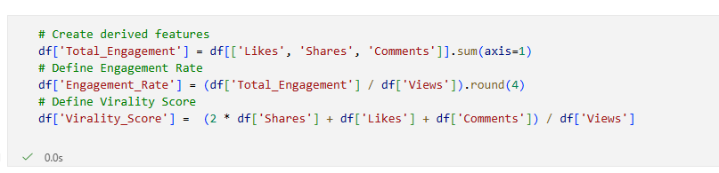
These derived metrics standardize interactions relative to post visibility. They are useful for both exploratory data analysis (e.g., identifying highly engaging posts) and predictive modeling (as features to predict Engagement_Level).
Engagement and Virality by Content Type: To understand which types of content drive the most engagement and virality, the dataset was analyzed by grouping posts based on Content_Type and calculating the average Engagement_Rate and Virality_Score for each category. Short-form, entertaining content is more likely to both engage audiences and spread virally. Feature engineering metrics like Engagement_Rate and Virality_Score help identify high-performing content types beyond simple likes or views.
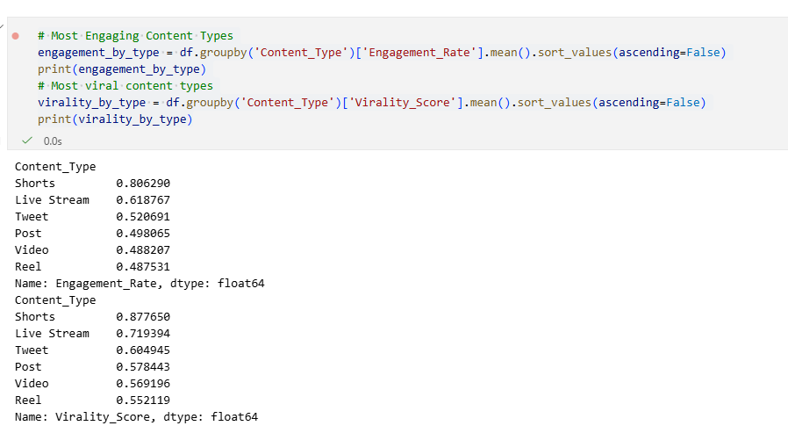
Platform-Level Insights
- Engagement Rate: Instagram (0.66) > TikTok (0.64) > YouTube (0.51) > Twitter (0.47)
- Virality Score: Instagram (0.77) > TikTok (0.71) > YouTube (0.58) > Twitter (0.53)
Instagram and TikTok posts have the highest engagement and virality, while YouTube and Twitter perform lower.
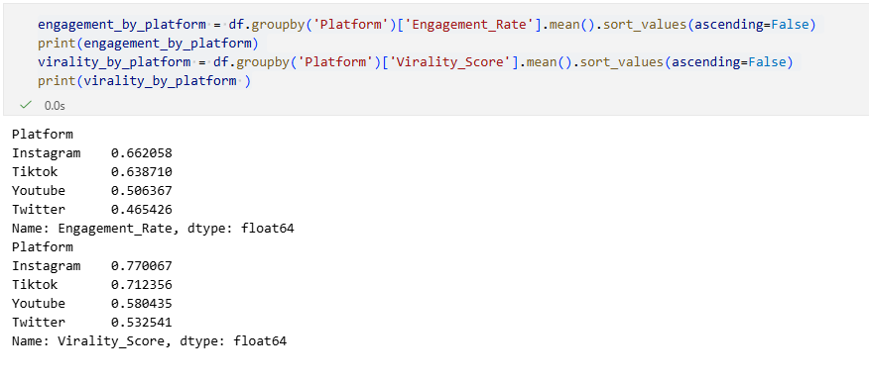
Posting Frequency by Content Type
The distribution of posts across content types is fairly even:
- Live Stream: 855
- Post: 853
- Reel: 841
- Tweet: 836
- Video: 828
- Shorts: 787
All content types are well-represented, providing a balanced dataset for engagement and virality analysis.
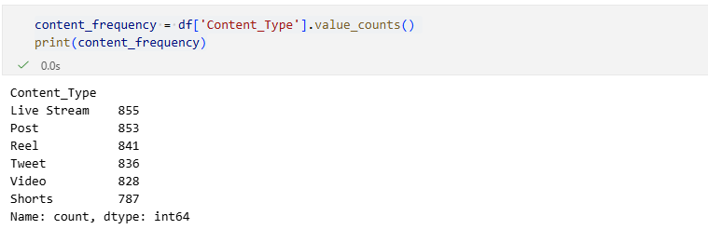
Summary Statistics for Numeric Features:
Feature | Mean | Median | Std | Min | Max | Skewness | Kurtosis
Views | 2,494,066 | 2,497,373 | 1,459,490 | 1,266 | 4,999,430 | 0.00 | -1.22
Likes | 251,475 | 249,443 | 144,350 | 490 | 499,922 | -0.01 | -1.19
Shares | 50,520 | 50,840 | 29,066 | 52 | 99,978 | -0.02 | -1.22
Comments | 24,888 | 25,004 | 14,285 | 18 | 49,993 | -0.00 | -1.19
Total_Engagement | 326,883 | 327,744 | 148,090 | 12,418 | 635,139 | -0.02 | -1.07
Engagement_Rate | 0.57 | 0.13 | 4.86 | 0.0 | 281.74 | 42.42 | 2290.44
Virality_Score | 0.65 | 0.15 | 5.16 | 0.0 | 283.10 | 37.97 | 1883.87
The table below shows key statistics for numeric columns, including raw engagement metrics and derived ratios:

- Raw engagement metrics (Views, Likes, Shares, Comments) have a high mean and variability, reflecting posts of very different popularity.
- Derived ratios (Engagement_Rate, Virality_Score) are highly skewed with extreme outliers, indicating a few posts go viral.
- Median values of raw metrics are close to the mean, suggesting relatively symmetric distributions, while ratio metrics highlight highly engaging content.
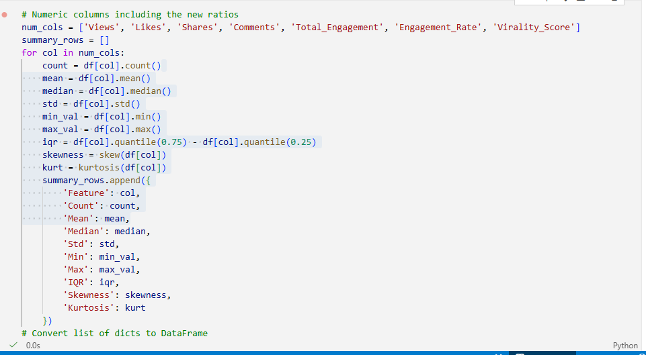
Feature Engineering: Like-to-View Ratio
A new feature, Like_View_Ratio, was created to measure the percentage of viewers who liked a post:
- Purpose: Identify genuinely engaging posts and benchmark strong engagement.
- Outlier Detection: Posts with Like_View_Ratio > 30% are considered extreme outliers.
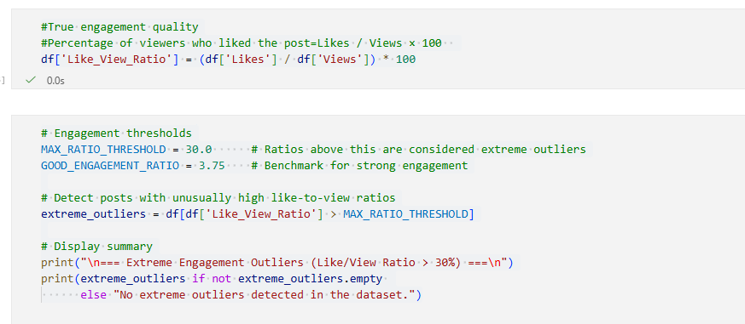
- Observation: Most posts fall within typical engagement levels, with few or no extreme outliers.

High Engagement Posts and Calculated Engagement Levels
The dataset was filtered to examine posts labeled as High Engagement and sorted by Views, Likes, Shares, and Comments to identify the top-performing content.
To standardize engagement measurement, a new column, Engagement_Level_Calculated
Classification Thresholds:
- High: Engagement Rate ≥ 10%
- Medium: 5% ≤ Engagement Rate < 10%
- Low: Engagement Rate < 5%
Purpose:
- Highlights posts that are genuinely engaging relative to their views.
- Allows comparison with the original engagement labels to validate patterns in virality.
High engagement posts consistently have higher interactions relative to views. Sorting by engagement metrics helps identify content characteristics that drive virality.
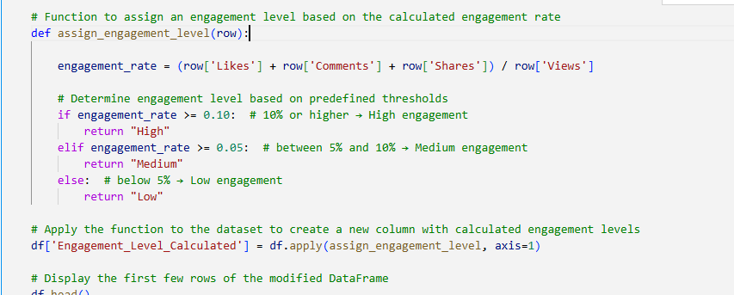
A comprehensive engagement metric, Engagement_Level_Calculated, was created to classify posts as High, Medium, or Low engagement based on the overall interaction rate (Likes + Shares + Comments relative to Views). This aligns with the target variable and supports further analysis and machine learning modeling.
Additionally, a Like_View_Ratio feature was calculated to measure the percentage of viewers who liked a post. It was primarily used to identify posts with unusually high like-to-view ratios, highlighting extreme engagement cases, but is not the main metric for analysis.
Engagement Level Correlation Analysis:
To assess the consistency between the original engagement labels (Engagement_Level) and the calculated metric (Engagement_Level_Calculated), a Pearson correlation was computed. Correlation coefficient 0.019 and P-value: 0.17786.
The very low correlation suggests that the calculated engagement levels do not closely align with the original labels. This indicates that Engagement_Level_Calculated captures a different aspect of engagement, emphasizing overall interaction rate (Likes + Shares + Comments relative to Views), rather than matching the original categorical labels. Despite the low correlation, it remains a useful metric for exploratory analysis and machine learning, as it standardizes engagement across all posts.
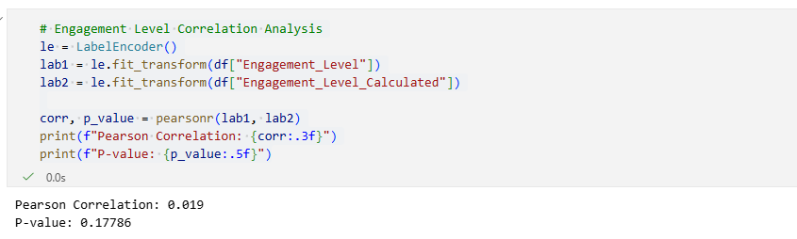
Data Filtering and Engagement Level Mapping
To focus on realistic engagement patterns and remove extreme or inconsistent data points, the dataset was filtered to ensure Likes, Shares, and Comments do not exceed Views and Like-to-View ratio does not exceed 30%.
After filtering, the Engagement_Level_Calculated was mapped to numeric values for modeling purposes:
- Low → 0
- Medium → 1
- High → 2
This step ensures the dataset is clean, consistent, and ready for machine learning analysis.
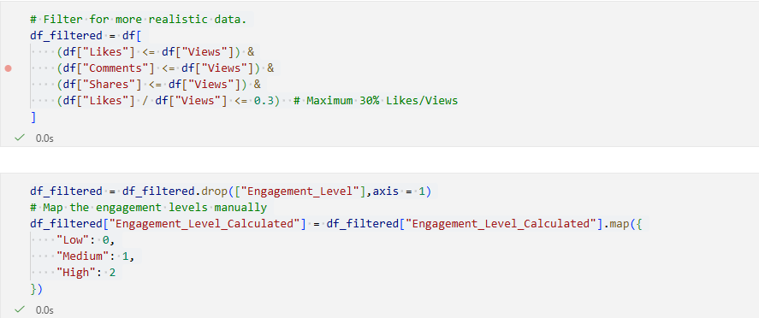
Final Dataset columns and Data types:
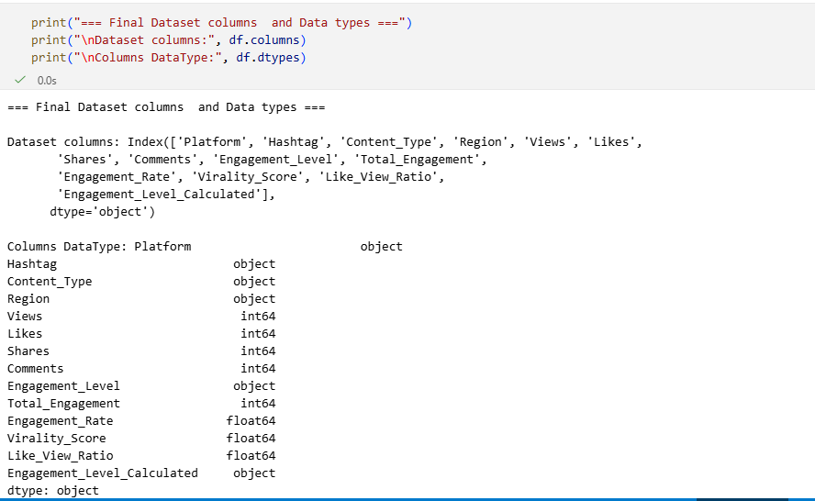
After performing data cleaning, filtering, and feature engineering, the dataset is now ready for visualization and machine learning modeling.

Build multiple charts using Python
Engagement_Level distribution count plot:
The target variable Engagement_Level shows how posts are categorized based on engagement. The counts for each class are as follows:
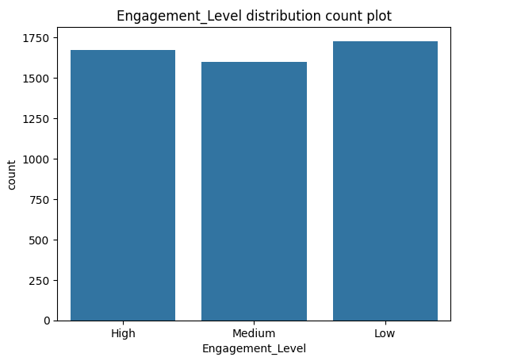

Univariate Analysis (Numerical Features):
For univariate analysis these features are used;
Raw numeric features: Views, Likes, Shares, Comments
Derived features: Engagement_Rate,Total_Engagement,Virality_Score
Here are Histogram + KDE Plots and Box plots of above mention features;

Histogram + KDE Plot of Views | Box plot of Views
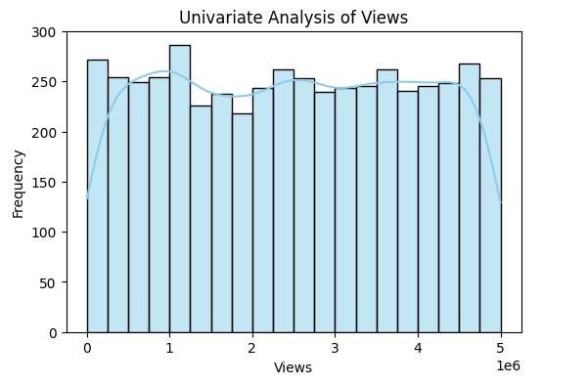 | 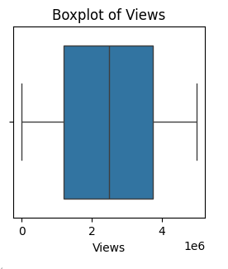
Histogram + KDE Plot of Likes | Box plot of Likes
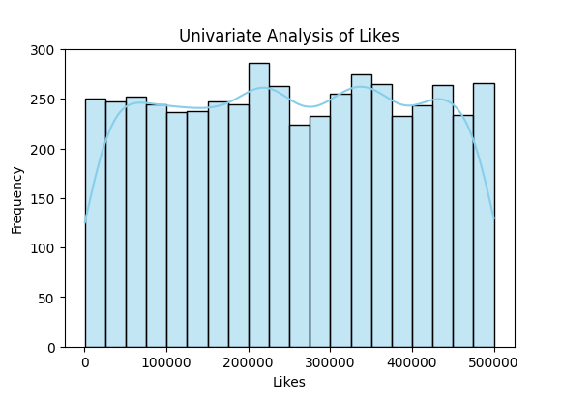 | 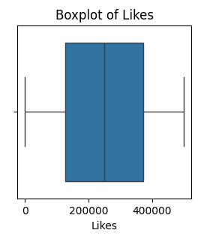
Histogram + KDE Plot of Share | Box plot of Share
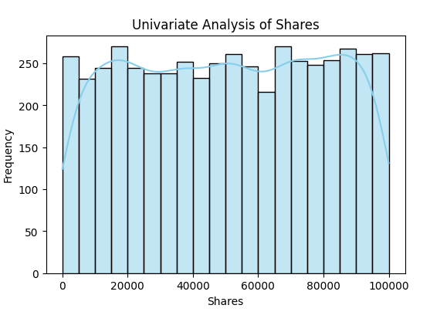 | 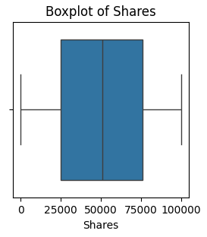
Histogram + KDE Plot of Comments | Box plot of Comments
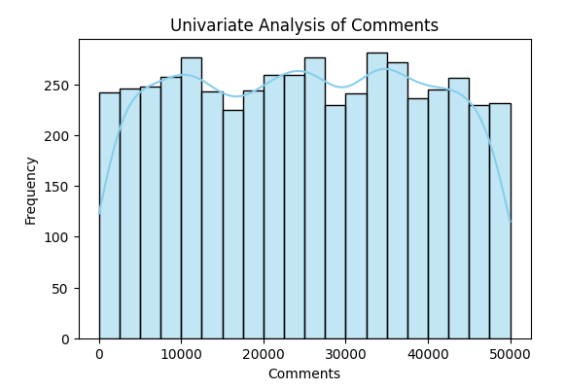 | 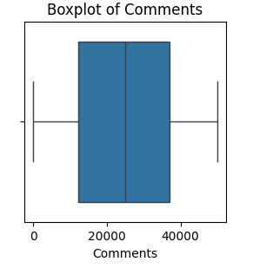
Histogram + KDE Plot of Engagement_Rate | Box plot of Engagement_Rate
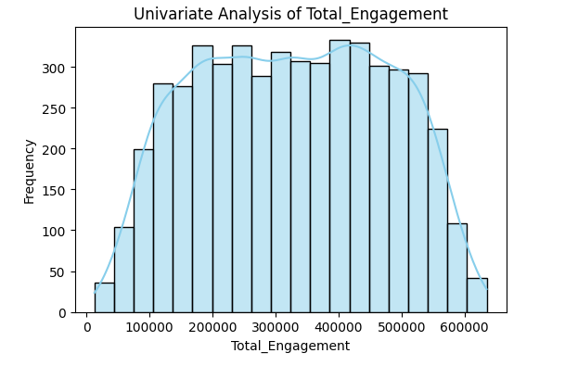 | 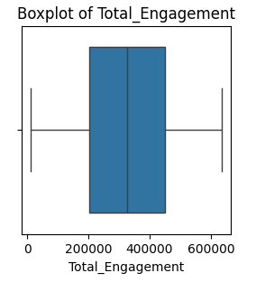
Histogram + KDE Plot of Engagement,Virality | Box plot of Engagement,Virality
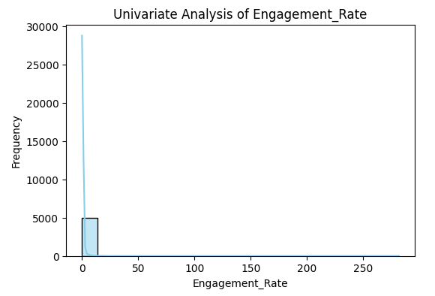 | 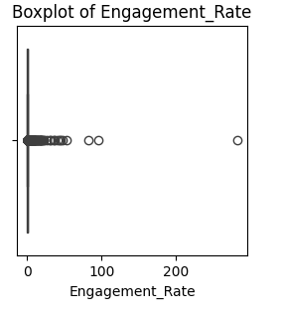
Histogram + KDE Plot of Virality_Score | Box plot of Virality_Score
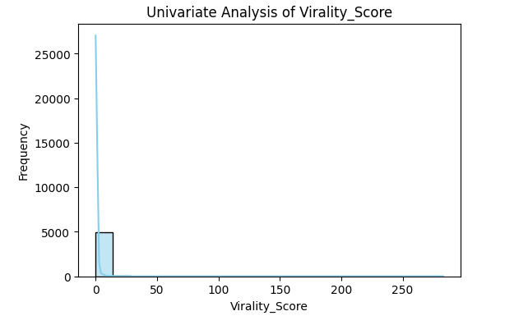 | 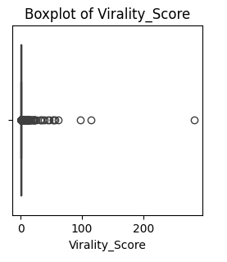
All numeric features both raw and derived exhibit right-skewed distributions with notable extreme outliers. Engagement patterns indicate that the majority of content receives moderate interactions, while a small fraction of posts drives exceptionally high engagement and virality. The derived features, such as Engagement Rate and Virality Score, are particularly informative, as they help identify high-quality and highly shareable content, providing normalized insights beyond raw interaction counts. From an analysis and modeling perspective, the skewed distributions suggest that log transformations may be beneficial, while the outliers often represent important viral posts and should not be removed indiscriminately.

