Physics of Solid Earth Spring

Second Mid Term exam

Question 1:

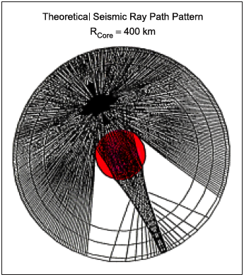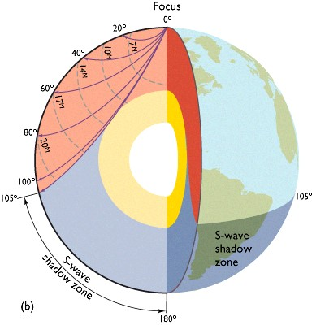

Nakamura, 1983

The 2 figures show the S waves travel path for the Earth and the Moon. In reality, for the Moon the seismic velocity field is well known only up to 500 km (Moon Radius 1730km) and the graph shows the theoretical ray path for s waves. The real size of the Moon core is only approximately known from gravity study.

1. Why the left figure cannot be the Earth?

1. How do we know that the inner core of the earth is solid if S waves do not travel through liquid?
2. Based on the previous answer how would you expect to be the magnetic field of the Moon?

Question 2

In the last lab you have analyzed the model of McKenzie for basin formation assuming pure shear and isostasy. Here you need to apply the same model for mountain formation as in the following figure.

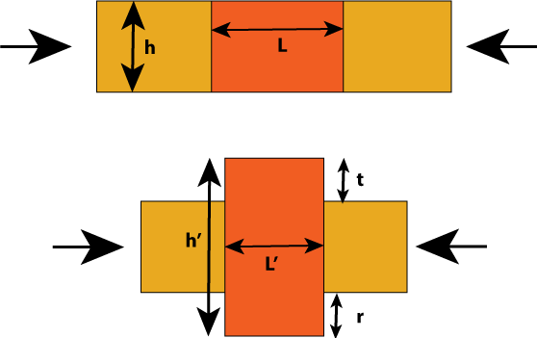

A crust of density rho_c and thickness h (15 km) is located above an inviscid (no viscosity) mantle of density rho_m. Lateral forces compress the block of dimension L=100 km of a factor C (C=L/L’ C=2 means that L’=L/2, C=3 L’=L/3, etc…).

1. Assuming that during the compression the volume (area) of the block of crust does not change, plot the thickness of the crust as function of C (for 1<=C<4). What is the meaning of C smaller than 1 and bigger than 0?

2. Using the Airy’s isostasy assumption of fix pressure at the compensation depth D write the expression of the topography as function of C (>1).

Question 3

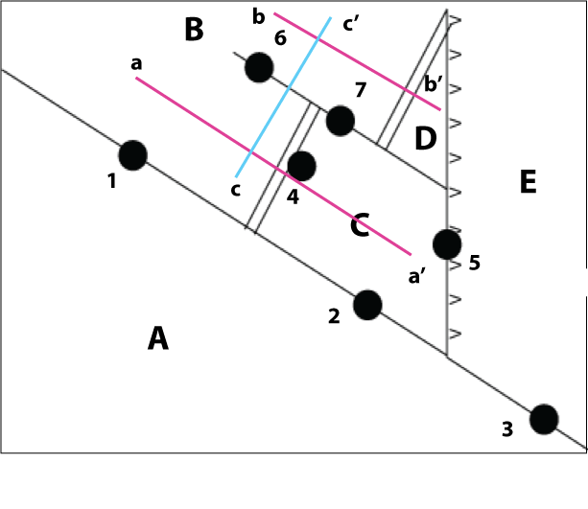

Is an earthquake possible at each black dot? Why?

On the previous figure plot the focal mechanisms associated with each black dot in the figure where if would expect to have earthquakes. Assume that that the borders between AE and AC are right-lateral and AB is left-lateral.

Given the above configuration, for a fixed A, which velocity magnitude do you expect to be higher, aVc or aVe? why?

Sketch the bathymetry profile along the line cc’

Sketch on the same graph two profiles of the bathymetry, lithospheric thickness and heat flow for plates B,C, and D along the two profiles aa’ and bb’.

Question 4

1. Describe 3 different methods of heat conduction making an everyday-life example for each of them.
2. Make an example related to solid earth for 2 of the heat transport methods.
3. One extreme of a 0.5m glass rod (thermal diffusivity=2.5 10-7 m2/s) is put in contact with a furnace. Assuming that heat is transported only by conduction along the rod (1d conduction), use dimensional analysis to estimate how long it would take before the change of temperature on the furnace side will be felt at the other end of the rod.