Lab # : 1; Lab Name :Creating Amazon EC2 Server using UCB AMI ; Subject Name : Information Storage and Retrieval; Week #: 1; Lab Duration : 20 to 30 mins

# Intro

In this introductory lab we will familiarize ourselves with the environment that we will use for the upcoming labs and exercises in this course. Today, we will learn about the following:

* Amazon EC2 Environment and your Account
* What an AMI Is
* How to Find an AMI and Launch a Server
* How to Choose a Server
* How to Check for Already Installed Software on a Server

Let’s go!

### Step-1. Amazon EC2 Environment and your account

By now, you should have received an email about your Amazon EC2 Account information. Please find the amount of credit you got as well, so that you can use it during the labs and exercises of this course. Note that Amazon EC2 credits are used whenever your server is up and running. You can always keep an eye on the balance of your account in the Amazon EC2 Console.

For getting familiar with Amazon EC2, you should refer to the following links.

a. <http://en.wikipedia.org/wiki/Amazon_Elastic_Compute_Cloud>

b. <http://en.wikipedia.org/wiki/Amazon_Web_Services>

To login to your account, go to the following link, <http://aws.amazon.com>. Once you have reached to the following screen, click on “My Account” to login with the credential provided. 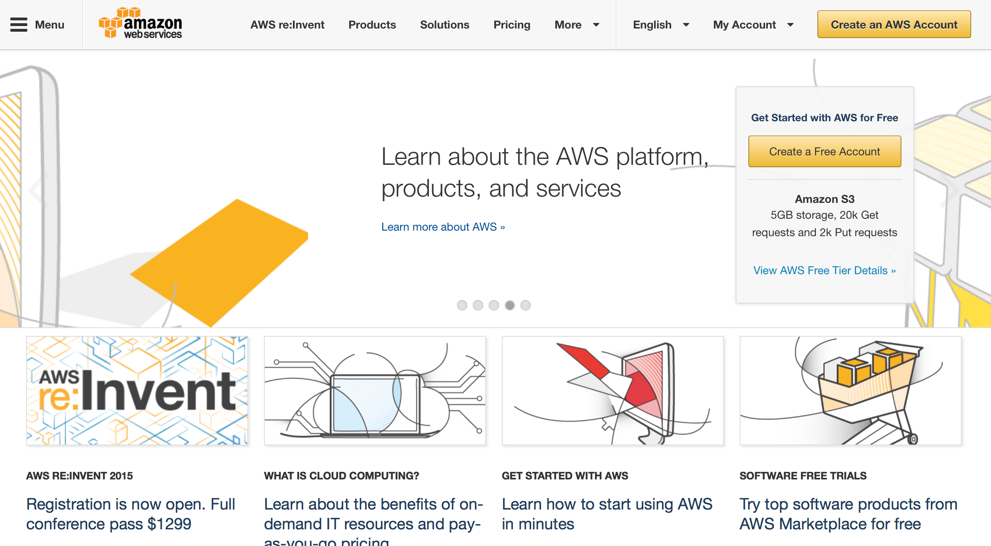

Verify your account balance. If you have any questions or concerns, please contact the UCB admin.

Amazon provides various types of VMs/Servers according to your particular needs. You can get familiar with types of servers that Amazon EC2 provides in the following link,

[http://aws.amazon.com/ec2/instance-types/.](http://aws.amazon.com/ec2/instance-types/)

Here are a few examples of Amazon EC2 M3 Servers.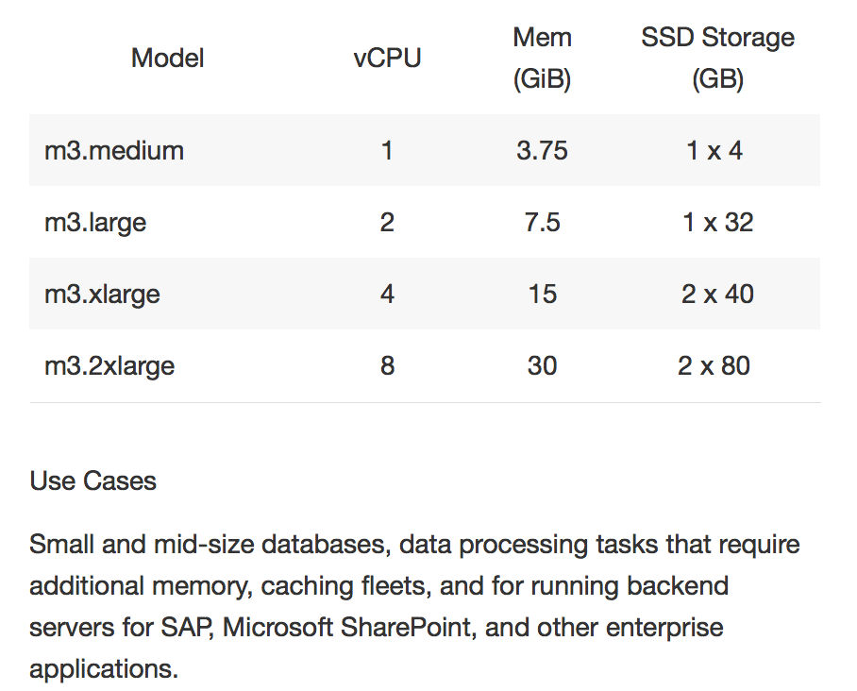

### Step-2.What an AMI Is

An Amazon Machine Image (AMI) is a static state of a server which doesn’t use CPU or I/O. You can launch the servers you want using an AMI. In EC2, the launched servers would be mainly VMs in the cloud.

The following link goes into great detail about AMIs:

<http://docs.aws.amazon.com/AWSEC2/latest/UserGuide/AMIs.html>

Once an AMI is created, it needs to be registered. If you want others to access your AMI, you must grant permission to that user or make the AMI public. A public AMI is accessible for anyone to use and launch a server based on that AMI.

### Step-3. How to Find an AMI and Launch a Server

You can use the following steps to find an AMI:

1. Open Amazon EC2 Console using the following link, <http://aws.amazon.com/ec2/>
2. Click on the “My Account” drop down menu
3. Click on AWS Management Console.
4. Log in with your credential.

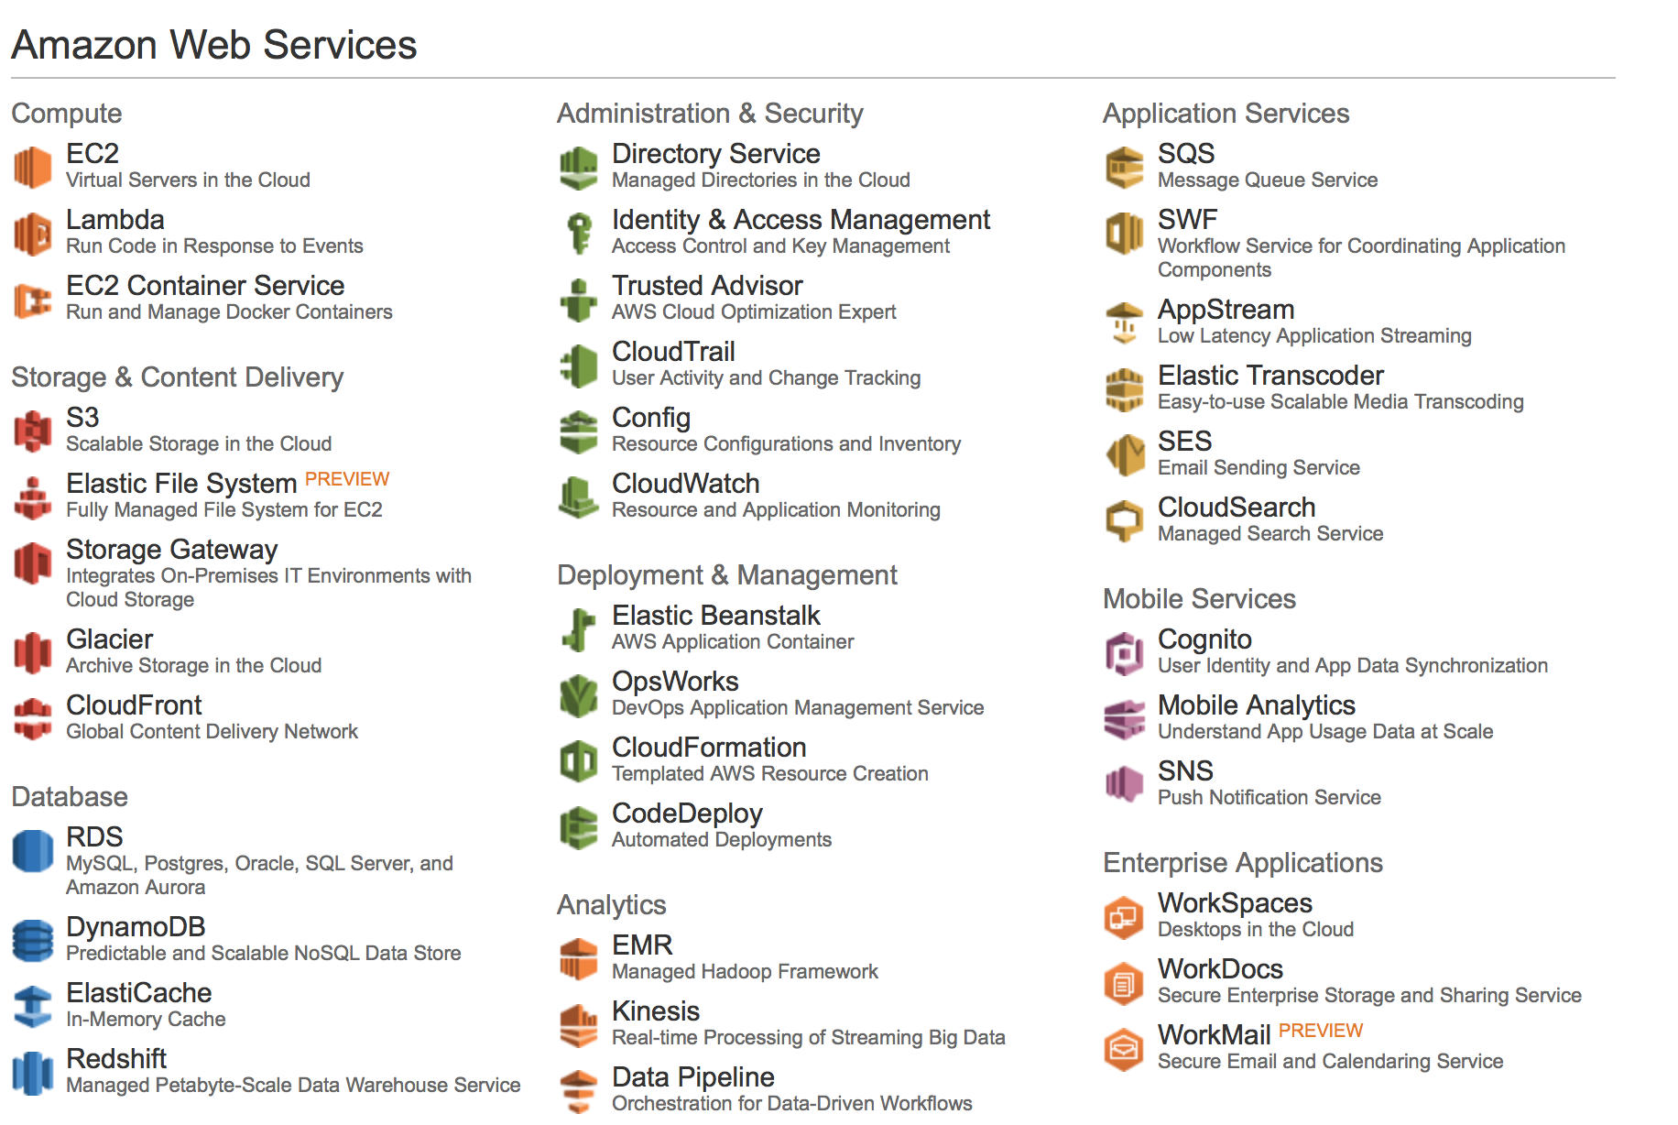

This is a great link for launching an Instance as well : <http://docs.aws.amazon.com/AWSEC2/latest/UserGuide/launching-instance.html>

Once you have logged on, click on “Instance” in order to launch your instance. In this course, you will be using the AMI provided by UCB. Search for UCB AMI in the following screen.

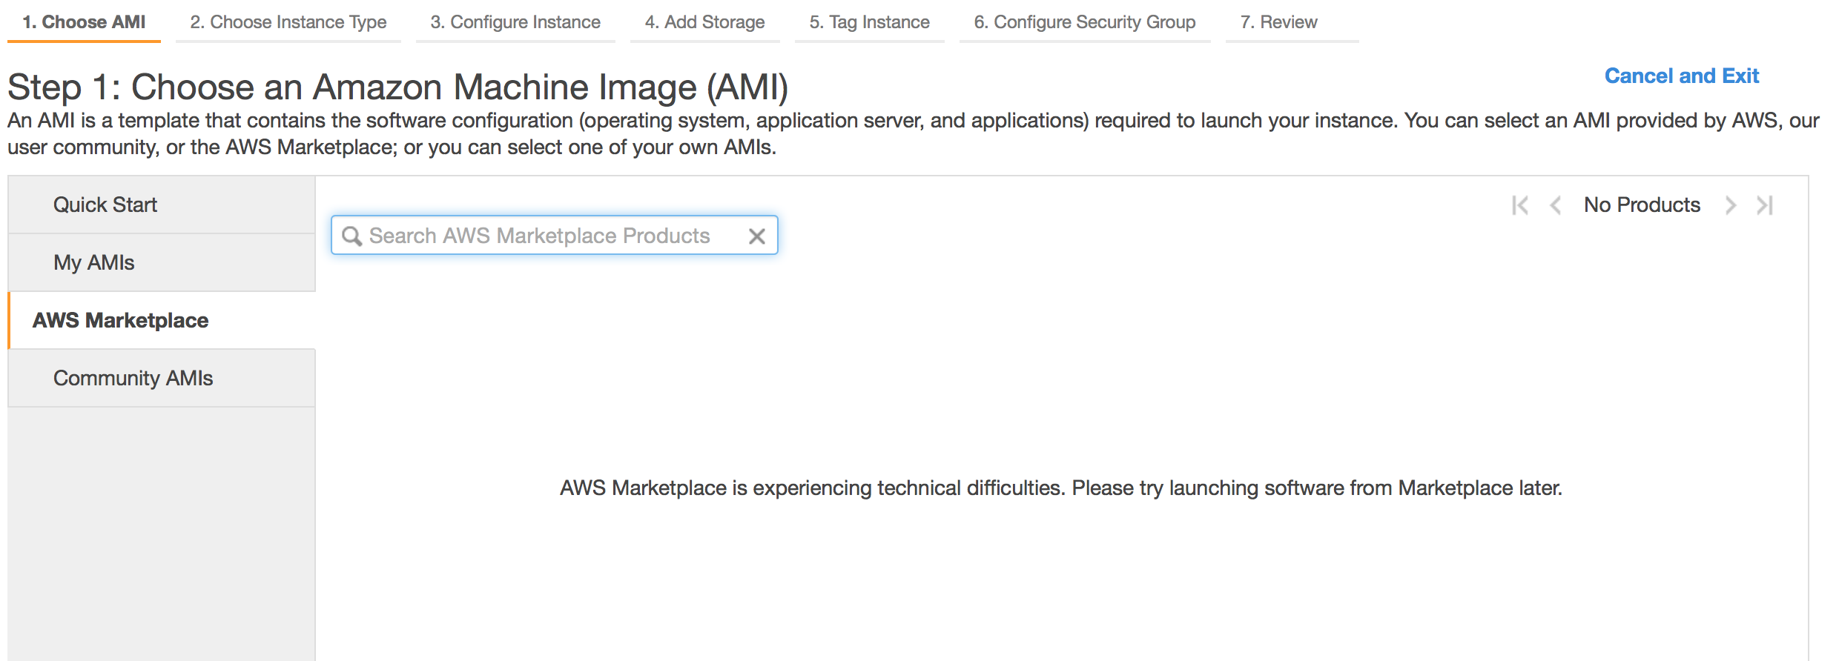

Next, you will have to chose the Instance Type. Here, you can choose a m3.medium. Please check the configuration for this.

Once you have started creating the server using the UCB AMI, you can check the progress of it in the same console.

The UCB AMI that you will be using for this subject is : **UCB W205 Base** - ami-98848cf0.

### Step-4. How to Chose a Type of Server

There are various types of servers available in the Amazon EC2 environment. However, you will need to choose one in which you can run Hadoop and several softwares that are necessary for all the labs and exercises.

Please refer to the link above for the types of servers available.

[http://aws.amazon.com/ec2/instance-types/ .](http://aws.amazon.com/ec2/instance-types/)

**Step-5. How to Check for Already Installed Software on a Server**

Once you have created your server/instance using the UCB AMI, you should find the following software with the respective versions.

* Python 2.7.3
* HDFS
* Postgres
* Hive
* Apache Spark
* Apache Sqoop
* Cloudera Express 5.4.1
* Apache Storm

You can check if these are installed and the location of the software by using unix commands such as “which”.

**Questions:**

Q1 : What is an AMI?

Q2 : When would you consider a cloud infrastructure?

Q3 : What are the types of servers readily available on EC2?

Q4. What is S3 and EBS?