MIDS W205

|  |  |  |  |
| --- | --- | --- | --- |
| **Lab #** | 6 | **Lab Title** | Apache Storm Introduction |
| **Related Module(s)** | 6 | **Goal** | Get you started on Storm |
| **Last Updated** | 2/15/16 | **Expected duration** | 90–120 minutes |

# Introduction

A Storm application is designed as a "topology" represented as a direct acyclic graph (DAG) with *spouts* and *bolts* acting as graph vertices. Edges on the graph are named streams, and they direct data from one node to another. Together, the topology acts as a data-transformation pipeline. At a superficial level the general topology structure is similar to a MapReduce job, with the main difference being that data are processed in real time as opposed to in individual batches. Additionally, Storm topologies run indefinitely until killed, whereas a MapReduce job must eventually end.

Storm can be used with many different languages. To avoid introducing a new language we will be using Python for our implementations of spouts and bolts. To get an example running quickly, we will use streamparse. Although the installation of streamparse is somewhat cumbersome, we believe it will simplify repeated usage of Storm and Python.

If you run sparse quickstart, streamparse will quick-start a local Storm and Python project using the streamparse framework. The following basic example will implement a simple word count against a stream of words. Going into that directory and executing sparse run will create a local Apache Storm cluster and execute your topology of Python code against the local cluster.

**Note: You are going to configure the UCB AMI and learn how to install streamparse. We therefore suggest that you do not use your saved instance image with the attached volume from the previous labs. Instead, we suggest you create a new image from UCB AMI specifically for this lab. Installing streamparse may cause changes such as broken links or unnecessary package upgrades. These changes can impact other software packages used in other labs.**

## Here are the steps we will cover in this lab:

* Watch a video tutorial that helps configure the Storm installation on the UCB AMI.
* Install streamparse and its prerequisites so that we can run Storm example quickly.
* Review of the definition and implementation of a simple word-count application that uses Storm.
* Run the sample word-count Storm application.
* Create and explore a new application simulating a tweet-analysis application.

# Instructions, Resources, and Prerequisites

In the following table you will find references to resources related to programs and components used and mention in subsequent sections.

|  |  |
| --- | --- |
| **Resource** | **What** |
| http://storm.apache.org/documentation.html | Apache Storm documentation |
| http://streamparse.readthedocs.org/en/latest/quickstart.html | Introduction to streamparse topology definitions |
| https://streamparse.readthedocs.org/en/latest/api.html | Streamparse documentation |
| http://www.pixelmonkey.org/2014/05/04/streamparse | Short description of streamparse |
| [https://drive.google.com/file/d/0B6706xGNaPPycWpIVU9YWUtKelU/view?usp=sharing](https://drive.google.com/file/d/0B6706xGNaPPycWpIVU9YWUtKelU/view?usp=sharing" \t "_blank) | Instruction video referred to in this lab |
| https://pip.pypa.io/en/stable/ | pip documentation |
| http://docs.python-guide.org/en/latest/dev/virtualenvs/ | Description of virtualenv |
| <https://raw.githubusercontent.com/technomancy/leiningen/stable/bin/lein.bat> | lein for windows |

# Step 1: Environment and Tool Setup

The following video tutorial will walk you through setting up your Apache Storm streamparse environment. It will also show you how to run a word-count Storm application.

[https://drive.google.com/file/d/0B6706xGNaPPycWpIVU9YWUtKelU/view?usp=sharing](https://drive.google.com/file/d/0B6706xGNaPPycWpIVU9YWUtKelU/view?usp=sharing" \t "_blank)

It can be hard to catch all the commands from the video. To make the installation easier to follow, we provide a summary of the commands below.

Check the version of the Storm installed on your system.

$storm version

/usr/bin/storm: line 2: /usr/hdp/2.2.4.2-2/etc/default/hadoop: No such file or directory

0.9.3.2.2.4.2-2

Check the version of Python installed on your system. For purpose of this lab you will need Python version 2.7.x.

$python --version

Python 2.6.6

Install the required version of Python.

$sudo yum install python27-devel –y

You can see that the Python in your execution path ($PATH) is still 2.6.X by checking the version again.

$python --version

Python 2.6.6

Rename the current version to reflect its correct version.

$mv /usr/bin/python /usr/bin/python266

Create a symbolic link from the file in the path to the version you want to execute.

$ln -s /usr/bin/python2.7 /usr/bin/python

Check that the link indeed refers to the intended version of Python.

$/usr/bin/python --version

Python 2.7.3

Check that the shell picks up the version of Python you intended.

$python --version

Python 2.7.3

Install ez\_setup.

$sudo curl -o ez\_setup.py <https://bootstrap.pypa.io/ez_setup.py>

$sudo python ez\_setup.py

Use ez\_install to install pip, which is a package manager for Python software.

$sudo /usr/bin/easy\_install-2.7 pip

Then use pip to install virtualenv. virtualenv is a tool to create and manage dependencies for distinct Python environments. Streamparse uses virtualenv to manage all dependencies for individual Python Storm projects.

$sudo pip install virtualenv

Streamparse requires the build tool lein to resolve dependencies, so now you will install lein.

*Note: In the video the installer fails to save to /usr/bin, so we have to move the lein file there. If the command succeeds you will not need to use the mv lein /usr/bin command.*

$wget --directory-prefix=/usr/bin/ <https://raw.githubusercontent.com/technomancy/leiningen/stable/bin/lein>

If you check the permissions on the lein file, you will see it is not executable. This means the shell and operating system will not allow you to run it as a command.

$ls -l /usr/bin/lein

-rw-r--r-- 1 root root 12713 Oct 25 17:01 /usr/bin/lein

Use the following chmod command to turn on the executable permission for all users.

$ chmod a+x /usr/bin/lein

Check that it looks like what you expected.

$ls -l /usr/bin/lein

-rwxr-xr-x 1 root root 12713 Oct 25 17:01 /usr/bin/lein

The first time you run lein, it will install itself.

$sudo /usr/bin/lein

$lein version

WARNING: You're currently running as root; probably by accident.

Press control-C to abort or Enter to continue as root.

Set LEIN\_ROOT to disable this warning.

Leiningen 2.5.3 on Java 1.7.0\_79 Java HotSpot(TM) 64-Bit Server

Install streamparse.

$pip install streamparse

Now you have streamparse installed. It will greatly simplify the creation of Python Storm projects and help you get a simple example up and running quickly. The following command creates an installation of the wordcount example.

$sparse quickstart wordcount

After watching the video and understanding the structure of topology definitions and the actual spout and bolt, run the word-count example use the following commands:

$cd wordcount

$sparse run

# Step 2: Implementation of a Tweet Word-Count Topology

In this step, your task is to use the following topology to create *one spout* and *two bolts* that parse the tweets and *one* *bolt* that counts the number of a given word in a tweet stream.

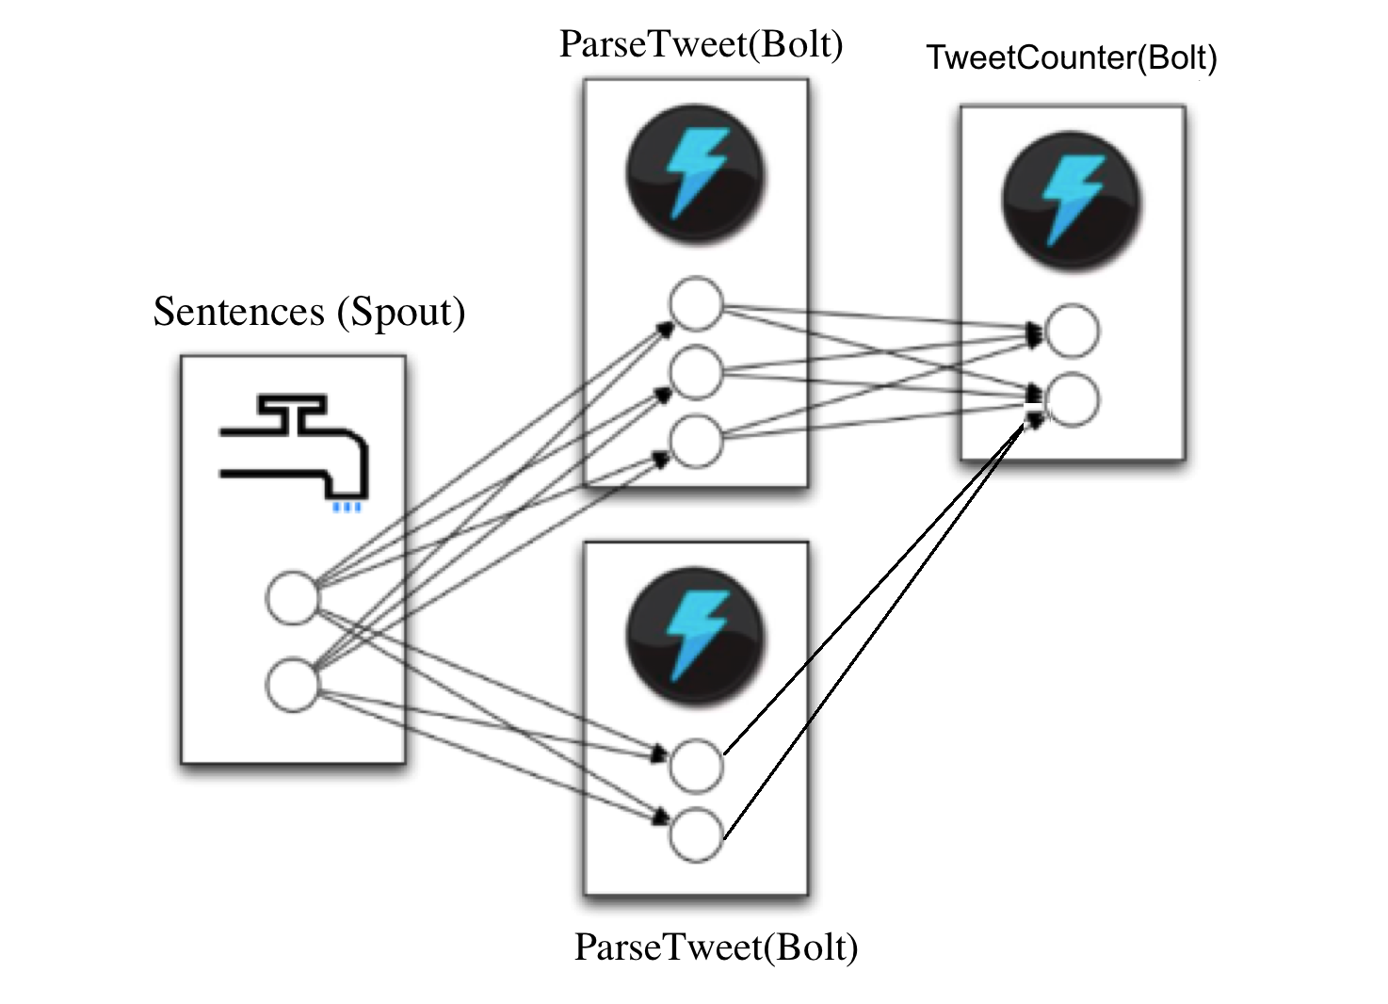

Figure 1: Task Topology

Create a project by running the following command:

$sparse quickstart tweetcount

This command provides a basic wordcount topology example, as seen in Step 1. You can modify this topology according to Figure 1 by modifying the file wordcount.clj in tweetcount/topologies/.

When constructing your topology it is important to remember that the topology is a function definition. This function must return an array with two dictionaries and take one argument called options. The first dictionary holds a named mapping of all the spouts that exist in the topology; the second holds a named mapping of all the bolts. Observe that the array is defined with square brackets [], and each dictionary is defined as a list with curly brackets {}. The options argument contains a mapping of topology settings.

You need to make sure that the topology and code are consistent with respect to the names for emitted tuples, dependencies, and so on. Be careful because starting a topology can take a long time. If you have multiple bolts, the structure is similar to the following code. Observe that when referring to the spout or bolt, the first component is the filename <filename> and the second the class name <classname>. The following snippet is only an outline and not a fully functional example:

(:use [streamparse.specs])

(:gen-class))

(defn tweetcount [options]

[

;; spout configuration

{"X-spout" (python-spout-spec

options

"spouts.<filename>.<classname>"

[<emitted name>]

) }

;; bolt configuration 1

{"Y-bolt"

…

;; bolt configuration 2

"Z-bolt"

…

}

]

)

## Code Base

The code snippets that you can use for your spout and bolts follow. Remove all the words.py from your spouts directory and wordcount.py from your bolts folder in tweetcount/src/.

**Spout Name**: Sentences(Spout)

Create a file called sentences.py using the following sample code. This is the spout code that will continuously generate tweet-like data.

from \_\_future\_\_ import absolute\_import,print\_function, unicode\_literals

import itertools

from streamparse.spout import Spout

class Sentences(Spout):

def initialize(self, stormconf, context):

self.sentences = [

"She advised him to take a long holiday, so he

immediately quit work and took a trip around the world",

"I was very glad to get a present from her",

"He will be here in half an hour",

"She saw him eating a sandwich",

]

self.sentences = itertools.cycle(self.sentences)

def next\_tuple(self):

sentence = next(self.sentences)

self.emit([sentence])

def ack(self, tup\_id):

pass # if a tuple is processed properly, do nothing

def fail(self, tup\_id):

pass # if a tuple fails to process, do nothing

This Storm spout has the following methods:

* initialize: Initializes the storm spout and generates the data.
* next\_tuple: Passes the events to bolts one by one.
* ack: Acknowledges the event delivery success.
* fail: If event fails to deliver to bolts, this method will be called.

Now you can put sentences.py into the /src/spouts/ directory.

**Bolt 1 Name**: ParseTweet(Bolt)

This bolt will capture the input coming from the Sentences spout, filter out specific formats, and pass it to the next bolt of the topology, called tweetcount. Create a file called parse.py using the following sample code:

from \_\_future\_\_ import absolute\_import, print\_function,unicode\_literals

import re

from streamparse.bolt import Bolt

def ascii\_string(s):

return all(ord(c) < 128 for c in s)

class ParseTweet(Bolt):

def process(self, tup):

tweet = tup.values[0] # extract the tweet

# Split the tweet into words

words = tweet.split()

valid\_words = []

for word in words:

if word.startswith("#"): continue

# Filter the user mentions

if word.startswith("@"): continue

# Filter out retweet tags

if word.startswith("RT"): continue

# Filter out the urls

if word.startswith("http"): continue

# Strip leading and lagging punctuations

aword = word.strip("\"?><,'.:;)")

# now check if the word contains only ascii

if len(aword) > 0 and ascii\_string(word):

valid\_words.append([aword])

if not valid\_words: return

# Emit all the words

self.emit\_many(valid\_words)

# tuple acknowledgment is handled automatically.

ParseTweet(bolt) will filter out input data that represents URLs, user mentions, hash tags, and so on and will emit each word to the tweet-count bolt.

ParseTweet bolt methods:

* process: Actual programming logic is applied in this method.
* Tuple acknowledgment is handled automatically.

**Bolt 2 Name**: TweetCounter(Bolt)

This bolt will capture the input coming from the ParseTweet bolt, update the count of a given input word, and print the result into a log with the format self.log('%s: %d' % (word, self.counts[word])). Create a file named tweetcounter.py using the following sample code:

from \_\_future\_\_ import absolute\_import, print\_function,

unicode\_literals

from collections import Counter

from streamparse.bolt import Bolt

class TweetCounter(Bolt):

def initialize(self, conf, ctx):

self.counts = Counter()

def process(self, tup):

word = tup.values[0]

# Increment the local count

self.counts[word] += 1

self.emit([word, self.counts[word]])

# Log the count - just to see the topology running

self.log('%s: %d' % (word, self.counts[word]))

TweetCounter bolt methods:

* initialize: Initializes the bolt method with required variable initialization.
* process: Actual programming logic is applied in this method.
* Tuple acknowledgment is handled automatically.

Now you can put both parse.py and tweetcounter.py into your bolts/ directory.

## Run the Storm Application

The final step is to run your application. You need to go inside tweetcount folder and run:

$cd tweetcount

$sparse run

# Submission

Submit a PDF that includes your topology file based on Figure 1 (wordcount.clj) and a screenshot of your running application that shows the stream of tweet counts on screen.