**UC Berkeley**

**Masters of Information and Data Science**

**W205 – Storing and Retrieving Data**

**Lab 9 – Working with Graphs**

**Solution – July 2017**

**Kevin R. Crook**

#1

What is the shortest path between 'DR. STRANGE/STEPHEN' and 'DR. DOOM/VICTOR VON'?

Please provide: the query, the Text side tab results of running the query, and the answer.

**Query:**

MATCH p=(strange:Hero {name: 'DR. STRANGE/STEPHEN'})-[:APPEARED*0..2]-(doom:Hero {name: 'DR. DOOM/VICTOR VON'})  
RETURN p, length(p)  
ORDER BY length(p)   
LIMIT 1

**Text side tab result:**

╒══════════════════════════════════════════════════════════════════════╤═══════════╕

│"p" │"length(p)"│

╞══════════════════════════════════════════════════════════════════════╪═══════════╡

│[{"name":"DR. STRANGE/STEPHEN","degree":777},{"w":8},{"name":"DR. DOOM│1 │

│/VICTOR VON","degree":441}] │ │

└──────────────────────────────────────────────────────────────────────┴───────────┘

**Answer:**

1

#2

List the 5 shortest paths between 'DR. STRANGE/STEPHEN' and 'DR. DOOM/VICTOR VON'.

Please provide: the query and the Text side tab results of running the query.  
Only provide 5 even if there are ties (hint: use the LIMIT 5 clause in the query).

**Query:**

MATCH p=(strange:Hero {name: 'DR. STRANGE/STEPHEN'})-[:APPEARED*0..2]-(doom:Hero {name: 'DR. DOOM/VICTOR VON'})  
RETURN p, length(p)  
ORDER BY length(p)   
LIMIT 5

**Text side tab result:**

**(Note: there are numerous paths of length 2. Our examples in the lab don’t place a further sort order, so they may have different length 2 paths which should be ok.)**

╒══════════════════════════════════════════════════════════════════════╤═══════════╕

│"p" │"length(p)"│

╞══════════════════════════════════════════════════════════════════════╪═══════════╡

│[{"name":"DR. STRANGE/STEPHEN","degree":777},{"w":8},{"name":"DR. DOOM│1 │

│/VICTOR VON","degree":441}] │ │

├──────────────────────────────────────────────────────────────────────┼───────────┤

│[{"name":"DR. STRANGE/STEPHEN","degree":777},{"w":12},{"name":"DR. DOO│1 │

│M/VICTOR VON","degree":441}] │ │

├──────────────────────────────────────────────────────────────────────┼───────────┤

│[{"name":"DR. STRANGE/STEPHEN","degree":777},{"w":3},{"name":"CAPTAIN │2 │

│BRITAIN/BRIA","degree":327},{"name":"CAPTAIN BRITAIN/BRIA","degree":32│ │

│7},{"w":2},{"name":"DR. DOOM/VICTOR VON","degree":441}] │ │

├──────────────────────────────────────────────────────────────────────┼───────────┤

│[{"name":"DR. STRANGE/STEPHEN","degree":777},{"w":3},{"name":"CAPTAIN │2 │

│BRITAIN/BRIA","degree":327},{"name":"CAPTAIN BRITAIN/BRIA","degree":32│ │

│7},{"w":1},{"name":"DR. DOOM/VICTOR VON","degree":441}] │ │

├──────────────────────────────────────────────────────────────────────┼───────────┤

│[{"name":"DR. STRANGE/STEPHEN","degree":777},{"w":1},{"name":"REDWING"│2 │

│,"degree":175},{"name":"REDWING","degree":175},{"w":1},{"name":"DR. DO│ │

│OM/VICTOR VON","degree":441}] │ │

└──────────────────────────────────────────────────────────────────────┴───────────┘

#3

List 5 Friends of Friends of 'COLOSSUS II/PETER RA' with the most connections.

Please provide: the query and the Text side tab results of running the query.  
Only provide 5 even if there are ties (hint: use the LIMIT 5 clause in the query)

**Query:**

MATCH (colossus:Hero { name: 'COLOSSUS II/PETER RA' })-[:APPEARED*2]-(friend_of_friend)

WHERE NOT (colossus)-[:APPEARED]-(friend_of_friend)

AND friend_of_friend.name <> 'COLOSSUS II/PETER RA'

RETURN friend_of_friend.name, COUNT(*)

ORDER BY COUNT(*) DESC , friend_of_friend.name

LIMIT 5

**Text side tab result:**

╒═══════════════════════╤══════════╕

│"friend_of_friend.name"│"COUNT(*)"│

╞═══════════════════════╪══════════╡

│"WONG" │453 │

├───────────────────────┼──────────┤

│"MOONSTONE II/KARLA S" │370 │

├───────────────────────┼──────────┤

│"CARTER, PEGGY" │367 │

├───────────────────────┼──────────┤

│"POWER MAN/ERIK JOSTE" │350 │

├───────────────────────┼──────────┤

│"KINGPIN/WILSON FISK" │342 │

└───────────────────────┴──────────┘

#4

Visualize 10 Friends of friends for 'IRON MAN/TONY STARK'.

Please provide: the query and an image of the graph visualization. Only provide 10 even if there are ties (hint: use the LIMIT 10 clause in the query)

**Query:**

MATCH (tony:Hero { name: 'IRON MAN/TONY STARK' })-[:APPEARED*2]-(friend_of_friend)

WHERE NOT (tony)-[:APPEARED]-(friend_of_friend)

AND friend_of_friend.name <> 'IRON MAN/TONY STARK'

RETURN friend_of_friend

LIMIT 10

**Image of the graph visualization:**

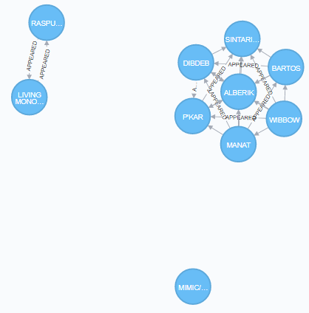

#5

Visually discover how the Avengers grew over time from 5 to 10 members, who was added to the team, and verify connectivity.

We will assume the avengers started out with 'IRON MAN/TONY STARK' and 'THOR/DR. DONALD BLAK'. We will start out with a modification of the "Finding Teammates" query above. In the RETURN clause, we will add tony and donald so they show up in the results. We will first limit our results to 5 members, so we will use LIMIT 3. We will re-run the query up to and including 10 members (LIMIT 8). The query below should be your first query:

MATCH (tony:Hero {name:'IRON MAN/TONY STARK'}) -[e:APPEARED]-> (other) <-[f:APPEARED]- (donald:Hero {name:'THOR/DR. DONALD BLAK'})

RETURN tony, donald, other

ORDER BY e.w DESC, f.w DESC

LIMIT 3

Run this query with the LIMIT of 3 to return 5 members.

Edit and re-run this same query with a LIMIT 4 (6 members), LIMIT 5 (7 members), LIMIT 6 (8 members), LIMIT 7 (9 members), LIMIT 8 (10 members).

Please provide for each run of the query (6 total runs): The query, a list of member for this run, a statement as to whether or not the graph is fully connected, and the an image of the graph visualization

(next page)

**Query:**

MATCH (tony:Hero {name:'IRON MAN/TONY STARK'}) -[e:APPEARED]-> (other) <-[f:APPEARED]- (donald:Hero {name:'THOR/DR. DONALD BLAK'})

RETURN tony, donald, other

ORDER BY e.w DESC, f.w DESC

LIMIT 3

**Members:**

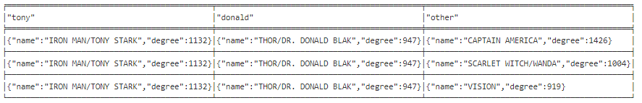

**Fully Connected: Yes**

**Graph:**

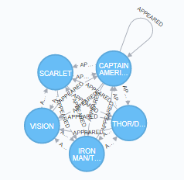

**Query:**

MATCH (tony:Hero {name:'IRON MAN/TONY STARK'}) -[e:APPEARED]-> (other) <-[f:APPEARED]- (donald:Hero {name:'THOR/DR. DONALD BLAK'})

RETURN tony, donald, other

ORDER BY e.w DESC, f.w DESC

LIMIT 4

**Members:**

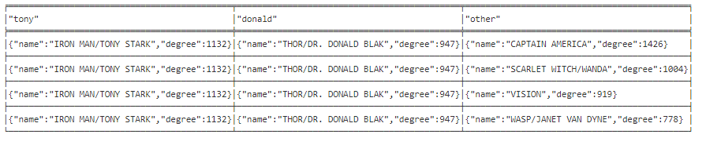

**Fully Connected: Yes**

**Graph:**

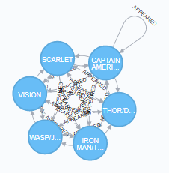

**Query:**

MATCH (tony:Hero {name:'IRON MAN/TONY STARK'}) -[e:APPEARED]-> (other) <-[f:APPEARED]- (donald:Hero {name:'THOR/DR. DONALD BLAK'})

RETURN tony, donald, other

ORDER BY e.w DESC, f.w DESC

LIMIT 5

**Members:**

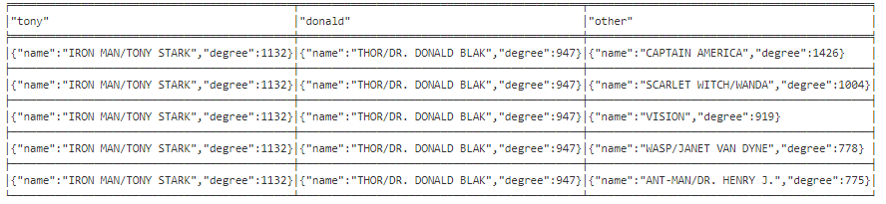

**Fully Connected: Yes**

**Graph:**

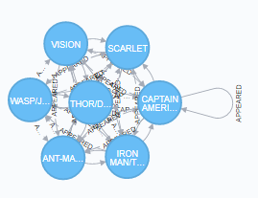

**Query:**

MATCH (tony:Hero {name:'IRON MAN/TONY STARK'}) -[e:APPEARED]-> (other) <-[f:APPEARED]- (donald:Hero {name:'THOR/DR. DONALD BLAK'})

RETURN tony, donald, other

ORDER BY e.w DESC, f.w DESC

LIMIT 6

**Members:**

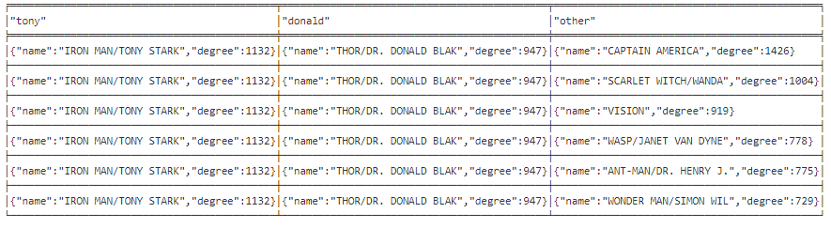

**Fully Connected: Yes**

**Graph:**

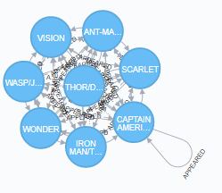

**Query:**

MATCH (tony:Hero {name:'IRON MAN/TONY STARK'}) -[e:APPEARED]-> (other) <-[f:APPEARED]- (donald:Hero {name:'THOR/DR. DONALD BLAK'})

RETURN tony, donald, other

ORDER BY e.w DESC, f.w DESC

LIMIT 7

**Members:**

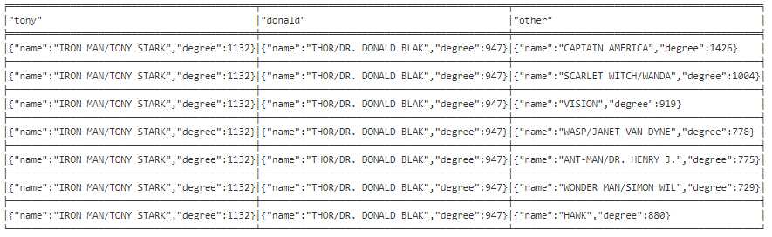

**Fully Connected: Yes**

**Graph:**

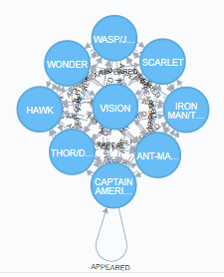

**Query:**

MATCH (tony:Hero {name:'IRON MAN/TONY STARK'}) -[e:APPEARED]-> (other) <-[f:APPEARED]- (donald:Hero {name:'THOR/DR. DONALD BLAK'})

RETURN tony, donald, other

ORDER BY e.w DESC, f.w DESC

LIMIT 8

**Members:**

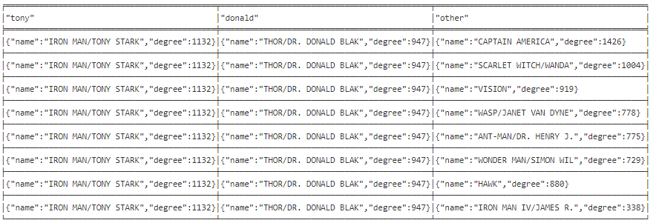

**Fully Connected: Yes**

**Graph:**

