Density Based Dynamic Traffic Control System

ABSTRACT: The project is aimed at designing a density based dynamic traffic signal system where the timing of signal will change automatically on sensing the traffic density at any junction. Traffic congestion especially at road intersections has become an issue for which road traffic users contend with daily. But conventional traffic light system is based on fixed time concept allotted to each side of the junction which cannot be varied as per varying traffic density. At some times, priority of traffic light needs to be changed based on more number of vehicles waiting in same road. Moreover, traffic polices are appointed to control the flow of traffic manually where automatic control system is not available. To optimize this problem, we have made a framework for an intelligent traffic control system. Sometimes higher traffic density at one side of the junction demands longer green time as compared to standard allotted time We, therefore propose here a mechanism in which the time period of green, yellow and red light is assigned on the basis of the density of the traffic present at that time. This is achieved by using PIR (proximity Infrared sensors). Once the density is calculated, the glowing time of each light is assigned by the help of the microcontroller (Arduino). The sensors which are present on sides of the road will detect the presence of the vehicles and sends the information to the microcontroller where it will decide how long a flank will be open or when to change over the signal lights. In subsequent sections, we have elaborated the procedure of this framework.

INTRODUCTION: In our daily life we have to face severe problems regarding traffic jam or congestion. In addition to this problem, traffic accident has also increased at an alarming rate recent years. Due to the massive growth in urbanization and traffic congestion, automatic based traffic light controller is needed to reduce the traffic delay and travel time especially in developing countries. Traffic congestion is now considered to be one of the biggest problems in the urban environments. Traffic problems will be also much more widely increasing as an expected result of the growing number of transportation means and current low-quality infrastructure of the roads. We have worked on the basis of real time car counting and controlling.

CIRCUIT COMPONENTS:
- Arduino Uno
- Digital IR sensor
- Circuit board
- Jumper wire
- Battery
- 7805

OPERATIONAL MODEL: The model works on the principle of changing delay of Traffic signals based on the number of cars passing through the roads. There are four sensors placed at four sides of a four ways road which counts the number of cars passing by the area covered by the sensors. Here we are using IR sensors replacing system to design an intelligent traffic control system. IR sensor contains IR transmitter IR receiver (photodiode) in itself. These IR transmitter and IR receiver will be mounted on same sides of the road at a particular distance. As the vehicle passes through these IR sensors, the IR sensor will detect the vehicle & will send the information to the microcontroller. The microcontroller will count the number of vehicles, and decide the glowing time to LED according to the density of vehicles. The traffic lights are initially running at a fixed delay of 5 seconds, which in turn produces a delay of 20 seconds in the entire process. This entire embedded system is placed at that junction. Microcontroller is interfaced with LEDs and IR sensors. The total no of IR sensor required are 4 and LED are 12.Therefore these are connected to any two ports of microcontroller.

Working principle of the sensor used: The sensor utilizes photo resistance and the value of the resistance varies with the amount of reflected IR, thus voltage across that resistance varies too. The decision is given whether the voltage is above or below the threshold one

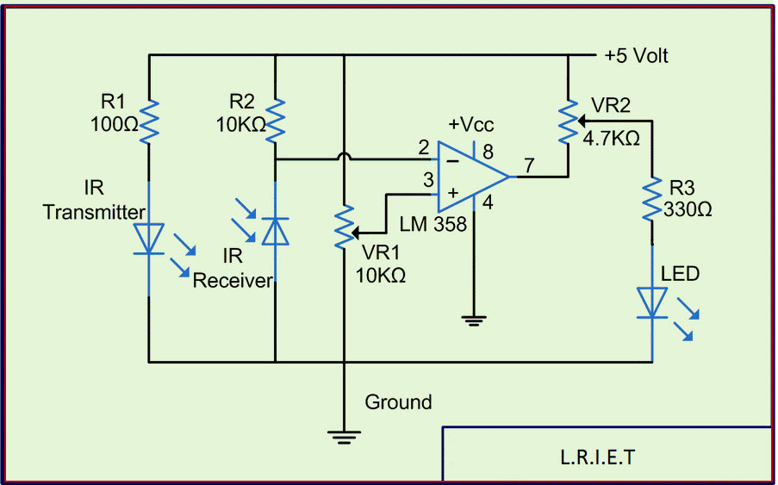

Microcontroller circuit diagram
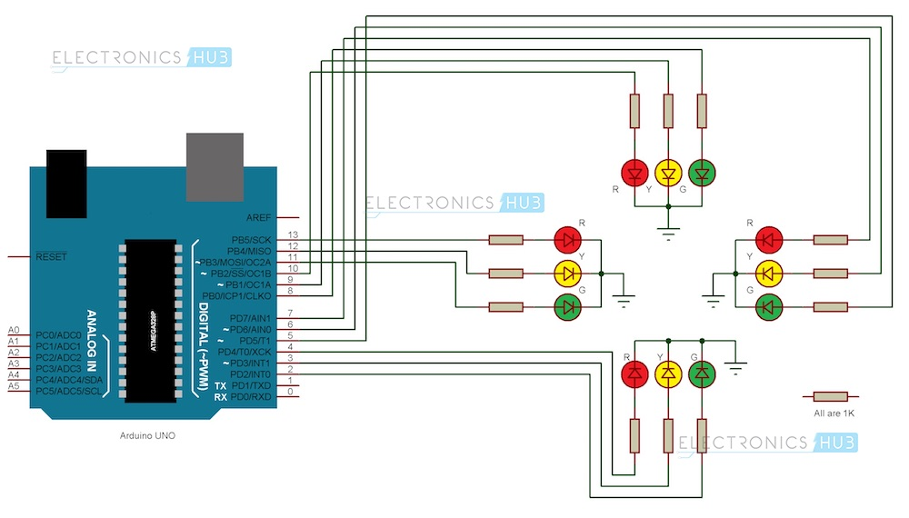

Glowing sequence of LEDs: Sequence of glowing is decided according to the density of vehicles in each road 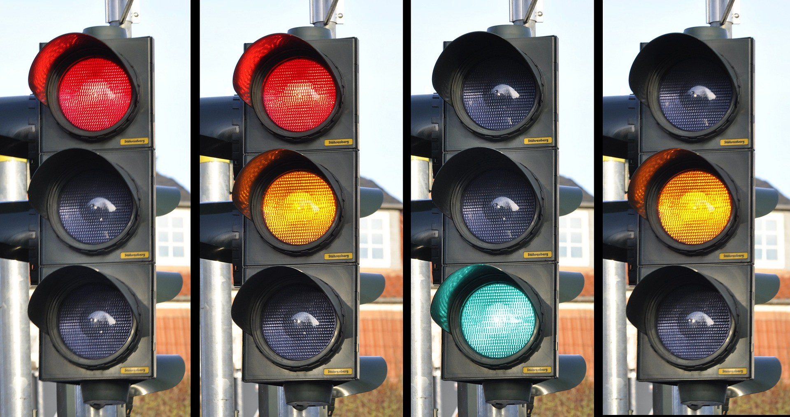

CODE

int R1=A0; //road 1
int Y1=A1;
int G1=A2;
int R2=A3; // road 2
int Y2=A4;
int G2=A5;
int R3=2; // road 3
int Y3=3;
int G3=4;
int R4=5; // road 4
int Y4=6;
int G4=7;
int gap=0;
int sensor1=8; // sensor 1
int sensorState1=1;
int lastsensorState1=1;
int CarCounter1=0;
int sensorState2=1;
int sensor2=9; // sensor 2
int lastsensorState2=1;
int CarCounter2=0;
int sensorState3=1;
int sensor3=10; // sensor 3
int lastsensorState3=1;
int CarCounter3=0;
int sensor4=11; // sensor 4
int sensorState4=1;
int lastsensorState4=1;
int CarCounter4=0;
unsigned long previousMillis = 0000;
long interval =5000;
int target=0;
int Yel=0;

void setup() {
// put your setup code here, to run once:
pinMode(G1, OUTPUT);
pinMode(G2, OUTPUT);
pinMode(G3, OUTPUT);
pinMode(G4, OUTPUT);
pinMode(R1, OUTPUT);
pinMode(R2, OUTPUT);
pinMode(R3, OUTPUT);
pinMode(R4, OUTPUT);
pinMode(Y1, OUTPUT);
pinMode(Y2, OUTPUT);
pinMode(Y3, OUTPUT);
pinMode(Y4, OUTPUT);
pinMode(sensor1, INPUT);
pinMode(sensor2, INPUT);
pinMode(sensor3, INPUT);
pinMode(sensor4, INPUT);
digitalWrite(G1, HIGH);
digitalWrite(Y2, HIGH);
digitalWrite(R3, HIGH);
digitalWrite(R4, HIGH);
digitalWrite(Y4, HIGH);
Serial.begin(9600); // for serial monitor
}

void loop() // Part that is executed again and again
{
//Counting mechanism for sensor1
sensorState1 = digitalRead(sensor1);
if (sensorState1 != lastsensorState1)
{ if (sensorState1 == LOW)
{ ++CarCounter1;
} }
lastsensorState1 = sensorState1;
//Counting mechanism for sensor2
sensorState2 = digitalRead(sensor2);
if (sensorState2 != lastsensorState2)
{
if (sensorState2 == LOW)
++CarCounter2;
}
lastsensorState2 = sensorState2;
//Counting mechanism for sensor3
sensorState3 = digitalRead(sensor3);
if (sensorState3 != lastsensorState3)
{
if (sensorState3 == LOW)
++CarCounter3;
}
lastsensorState3 = sensorState3;
//Counting mechanism for sensor4
sensorState4 = digitalRead(sensor4);
if (sensorState4 != lastsensorState4)
{
if (sensorState4 == LOW)
++CarCounter4;
}
lastsensorState4 = sensorState4;
delay(10);
unsigned long currentMillis = millis();
//Serial.print("time:");
//Serial.println(currentMillis-previousMillis);
if ((currentMillis-previousMillis)>=interval)
{
//Serial.print("time:");
//Serial.println(previousMillis);
previousMillis=currentMillis;
Serial.print ("number of car passed in 1: ");
Serial.println(CarCounter1);
Serial.print ("number of car passed in 2: ");
Serial.println(CarCounter2);
Serial.print ("number of car passed in 3: ");
Serial.println(CarCounter3);
Serial.print ("number of car passed in 4: ");
Serial.println(CarCounter4);

if((CarCounter1==CarCounter2)&& (CarCounter2==CarCounter3) && (CarCounter3==CarCounter4))
{
if(digitalRead(G1)==HIGH)
{
digitalWrite (G1, LOW);
digitalWrite (R1, LOW);
digitalWrite (Y1, HIGH);
digitalWrite (G2, HIGH);
digitalWrite (Y2,LOW);
digitalWrite (R2,LOW);
digitalWrite (G3, LOW);
digitalWrite (R3, HIGH);
digitalWrite (Y3, HIGH);
digitalWrite (G4,LOW);
digitalWrite (R4,HIGH);
digitalWrite (Y4,LOW);
//Serial.print ("number of car passed in 2: ");
//Serial.println(CarCounter2);
//interval= 5000;
CarCounter2=0;
//delay(1000);
}
else if(digitalRead(G2)==HIGH)
{
digitalWrite (G2, LOW);
digitalWrite (R2, LOW);
digitalWrite (Y2, HIGH);
digitalWrite (G3, HIGH);
digitalWrite (Y3,LOW);
digitalWrite (R3,LOW);
digitalWrite (G4, LOW);
digitalWrite (R4, HIGH);
digitalWrite (Y4, HIGH);
digitalWrite (G1,LOW);
digitalWrite (R1,HIGH);
digitalWrite (Y1,LOW);
//Serial.print ("number of car passed in 3: ");
//Serial.println(CarCounter3);
//interval= 5000;
CarCounter3=0;
//delay(1000);

}
else if(digitalRead(G3)==HIGH)
{
digitalWrite (G3, LOW);
digitalWrite (R3, LOW);
digitalWrite (Y3, HIGH);
digitalWrite (G4, HIGH);
digitalWrite (Y4,LOW);
digitalWrite (R4,LOW);
digitalWrite (G1, LOW);
digitalWrite (R1, HIGH);
digitalWrite (Y1, HIGH);
digitalWrite (G2,LOW);
digitalWrite (R2,HIGH);
digitalWrite (Y2,LOW);
//Serial.print ("number of car passed in 4: ");
//Serial.println(CarCounter4);
//interval= 5000;
//delay(1000);
CarCounter4=0;
}
else if(digitalRead(G4)==HIGH)
{
digitalWrite (G4, LOW);
digitalWrite (R4, LOW);
digitalWrite (Y4, HIGH);
digitalWrite (G1, HIGH);
digitalWrite (Y1,LOW);
digitalWrite (R1,LOW);
digitalWrite (G2, LOW);
digitalWrite (R2, HIGH);
digitalWrite (Y2, HIGH);
digitalWrite (G3,LOW);
digitalWrite (R3,HIGH);
digitalWrite (Y3,LOW);
//Serial.print ("number of car passed in 1: ");
//Serial.println(CarCounter1);
//interval= 1000*CarCounter1+1000;
//delay(interval);
CarCounter1=0;
} }
else if((CarCounter1>=CarCounter2) && (CarCounter1>=CarCounter3) && (CarCounter1>=CarCounter4)){
digitalWrite(G1,HIGH);
digitalWrite(R1,LOW);
digitalWrite(Y1,LOW);
digitalWrite(G2,LOW);
digitalWrite(G3,LOW);
digitalWrite(G4,LOW);
if ((CarCounter2>=CarCounter3)&&(CarCounter2>=CarCounter4)){
digitalWrite(R2,HIGH);
digitalWrite(Y2,HIGH);
if (CarCounter3>=CarCounter4){
digitalWrite(R3,HIGH);
digitalWrite(Y3,LOW);
digitalWrite(R4,LOW);
digitalWrite(Y4,HIGH);
}
else {
digitalWrite(R4,HIGH);
digitalWrite(Y4,LOW);
digitalWrite(R3,LOW);
digitalWrite(Y3,HIGH);
}

}
else if ((CarCounter3>=CarCounter4)&&(CarCounter3>CarCounter2)){
digitalWrite(R3,HIGH);
digitalWrite(Y3,HIGH);
if (CarCounter2>=CarCounter4){
digitalWrite(R2,HIGH);
digitalWrite(Y2,LOW);
digitalWrite(R4,LOW);
digitalWrite(Y4,HIGH);
}
else {
digitalWrite(R4,HIGH);
digitalWrite(Y4,LOW);
digitalWrite(R2,LOW);
digitalWrite(Y2,HIGH);
}

}
else if ((CarCounter4>CarCounter2)&&(CarCounter4>CarCounter3)){
digitalWrite(R4,HIGH);
digitalWrite(Y4,HIGH);
if (CarCounter2>=CarCounter3){
digitalWrite(R2,HIGH);
digitalWrite(Y2,LOW);
digitalWrite(R3,LOW);
digitalWrite(Y3,HIGH);
}
else {
digitalWrite(R3,HIGH);
digitalWrite(Y3,LOW);
digitalWrite(R2,LOW);
digitalWrite(Y2,HIGH);
}

}
gap= 1000*CarCounter1+1000;
delay(gap);
CarCounter1=0;
}

else if((CarCounter2>=CarCounter3) && (CarCounter2>=CarCounter4) && (CarCounter2>CarCounter1)){
digitalWrite(G2,HIGH);
digitalWrite(R2,LOW);
digitalWrite(Y2,LOW);
digitalWrite(G1,LOW);
digitalWrite(G3,LOW);
digitalWrite(G4,LOW);
if ((CarCounter1>=CarCounter3)&&(CarCounter1>=CarCounter4)){
digitalWrite(R1,HIGH);
digitalWrite(Y1,HIGH);
if (CarCounter3>=CarCounter4){
digitalWrite(R3,HIGH);
digitalWrite(Y3,LOW);
digitalWrite(R4,LOW);
digitalWrite(Y4,HIGH);
}
else {
digitalWrite(R4,HIGH);
digitalWrite(Y4,LOW);
digitalWrite(R3,LOW);
digitalWrite(Y3,HIGH);
}

}
else if ((CarCounter3>=CarCounter4)&&(CarCounter3>CarCounter1)){
digitalWrite(R3,HIGH);
digitalWrite(Y3,HIGH);
if (CarCounter1>=CarCounter4){
digitalWrite(R1,HIGH);
digitalWrite(Y1,LOW);
digitalWrite(R4,LOW);
digitalWrite(Y4,HIGH);
}
else {
digitalWrite(R4,HIGH);
digitalWrite(Y4,LOW);
digitalWrite(R1,LOW);
digitalWrite(Y1,HIGH);
}

}
else if ((CarCounter4>CarCounter1)&&(CarCounter4>CarCounter3)){
digitalWrite(R4,HIGH);
digitalWrite(Y4,HIGH);
if (CarCounter1>=CarCounter3){
digitalWrite(R1,HIGH);
digitalWrite(Y1,LOW);
digitalWrite(R3,LOW);
digitalWrite(Y3,HIGH);
}
else {
digitalWrite(R3,HIGH);
digitalWrite(Y3,LOW);
digitalWrite(R1,LOW);
digitalWrite(Y1,HIGH);
}

}
gap= 1000*CarCounter2+1000;
delay(gap);
CarCounter2=0;
}

else if((CarCounter3>=CarCounter4) && (CarCounter3>CarCounter2) && (CarCounter3>CarCounter1)){
digitalWrite(G3,HIGH);
digitalWrite(R3,LOW);
digitalWrite(Y3,LOW);
digitalWrite(G2,LOW);
digitalWrite(G1,LOW);
digitalWrite(G4,LOW);
if ((CarCounter1>=CarCounter2)&&(CarCounter1>=CarCounter4)){
digitalWrite(R1,HIGH);
digitalWrite(Y1,HIGH);
if (CarCounter2>=CarCounter4){
digitalWrite(R2,HIGH);
digitalWrite(Y2,LOW);
digitalWrite(R4,LOW);
digitalWrite(Y4,HIGH);
}
else {
digitalWrite(R4,HIGH);
digitalWrite(Y4,LOW);
digitalWrite(R2,LOW);
digitalWrite(Y2,HIGH);
}

}
else if ((CarCounter2>=CarCounter4)&&(CarCounter2>CarCounter1)){
digitalWrite(R2,HIGH);
digitalWrite(Y2,HIGH);
if (CarCounter1>=CarCounter4){
digitalWrite(R1,HIGH);
digitalWrite(Y1,LOW);
digitalWrite(R4,LOW);
digitalWrite(Y4,HIGH);
}
else {
digitalWrite(R4,HIGH);
digitalWrite(Y4,LOW);
digitalWrite(R1,LOW);
digitalWrite(Y1,HIGH);
}

}
else if ((CarCounter4>CarCounter2)&&(CarCounter4>CarCounter1)){
digitalWrite(R4,HIGH);
digitalWrite(Y4,HIGH);
if (CarCounter1>=CarCounter2){
digitalWrite(R1,HIGH);
digitalWrite(Y1,LOW);
digitalWrite(R2,LOW);
digitalWrite(Y2,HIGH);
}
else {
digitalWrite(R2,HIGH);
digitalWrite(Y2,LOW);
digitalWrite(R1,LOW);
digitalWrite(Y1,HIGH);
}

}
gap= 1000*CarCounter3+1000;
delay(gap);
CarCounter3=0;
}
else if((CarCounter4>CarCounter1) && (CarCounter4>CarCounter2) && (CarCounter4>CarCounter3)){
digitalWrite(G4,HIGH);
digitalWrite(R4,LOW);
digitalWrite(Y4,LOW);
digitalWrite(G2,LOW);
digitalWrite(G3,LOW);
digitalWrite(G1,LOW);
if ((CarCounter1>=CarCounter2)&&(CarCounter1>=CarCounter3)){
digitalWrite(R1,HIGH);
digitalWrite(Y1,HIGH);
if (CarCounter2>=CarCounter3){
digitalWrite(R2,HIGH);
digitalWrite(Y2,LOW);
digitalWrite(R3,LOW);
digitalWrite(Y3,HIGH);
}
else {
digitalWrite(R3,HIGH);
digitalWrite(Y3,LOW);
digitalWrite(R2,LOW);
digitalWrite(Y2,HIGH);
}

}
else if ((CarCounter2>=CarCounter3)&&(CarCounter2>CarCounter1)){
digitalWrite(R2,HIGH);
digitalWrite(Y2,HIGH);
if (CarCounter1>=CarCounter3){
digitalWrite(R1,HIGH);
digitalWrite(Y1,LOW);
digitalWrite(R3,LOW);
digitalWrite(Y3,HIGH);
}

else {
digitalWrite(R3,HIGH);
digitalWrite(Y3,LOW);
digitalWrite(R1,LOW);
digitalWrite(Y1,HIGH);
}
}

APPLICATIONS: In modern city life, the problem of traffic congestion and accident has come to an explosion now specially in Dhaka city. So it is high time we took initiatives to solve this severe problem or to make it to a tolerable limit. A properly coded Automatic Traffic Control System will serve the purpose. It will serve other purpose too. At present. traffic control is achieved by the use of a system of hand signs by traffic police personnel which is both wastage of time and man power. Automatic Traffic System also solves the problem.
LIMITATIONS: There is a limitation regarding the car counter process. Once the whole loop is finished, we get the number of cars in each road side and based on the output different LED will glow in different sides. At the time of glowing, no car is counted in although there may be new car gathering on any road. Car counter function will not consider that cars gathering during the operation of LEDs. After specified period of glowing every car counter will be reset and start counting the car from beginning.

CONCLUSION: There is exigent need of efficient traffic management system in our country, as Bangladesh meets several road accidents every year. To reduce this congestion and unwanted time delay in traffic an advanced system is designed here in this project. Although we have to upgrade the project with field application of this technology, the maddening chaos of traffic can be effectively channelized by distributing the time slots based on the merit of the vehicle load in certain lanes of multi junction crossing. We have successfully implemented the prototype at laboratory scale with remarkable outcome. The next step forward is to implement this schema is real life scenario for first hand results, before implementing it on the largest scale. We believe that this may bring a revolutionary change in traffic management system on its application in actual field environment.

REFERENCES: 1)https://github.com/darshthakkar/Density-based-Traffic-Control-System-using-Arduino-UNO-/blob/master/TL2.ino?fbclid=IwAR0cKkY0YTfXIMt8Ftb1ebogQ8rr2wJ9q65c6VmAzfh5PxfFBrZ3D7j-GEU
2) https://en.wikipedia.org/wiki/Traffic_light_control_and_coordination
3) https://electronicshobbyists.com/density-based-traffic-light-controller-using-arduino/?fbclid=IwAR11VJCENOgAry2aNYAtN1vQqJ6p3Ae93otujCvTNjuspLwCwEmyX75Z0tk

