Mob_10

Run 1

* gr0gr1
  + Gr0 shrinks the most
  + Gr1 grows the most, followed by gr2
  + Gr3 stays close to the same size
  + Gr0 shrinkage seems mostly correlated with gr1 growth, though gr2 growth also contributes.
  + Initially, gr3 > gr0 > gr2 > gr1, rapidly switches to gr3 > gr0 > gr1 > gr2 and stays like this for most of the simulation, then at about 3/4ths the total simulation time, switches to gr3 > gr1 > gr0 > gr2
* gr0gr2
  + Gr2 shrinks the most
  + Gr0 grows the most
  + Grains 1 and 3 stay roughly the same size
  + The growth/shrinkage of gr0/gr2 occurs rapidly at the beginning, but quickly stagnates (~75 ‘seconds’, or 15000 steps (dt = 0.005)), and seems highly correlated between the two.
  + Gr3 > gr0 > gr2 > gr1 at the beginning, quickly changes to gr0 > gr3 > gr1 > gr2 and stays like this for most of the simulation, but towards the end grains 0 and 3 switch places again (appears from the area plot that gr3 grows at expense of gr0 at this point)
* gr0gr3
  + Gr0 shrinks the most
  + Gr2 grows the most
  + Grains 1 and 3 stay roughly the same size
  + Growth of gr2 seems to be at the expense of gr0, though gr3 starts to grow slightly during the latter part of the simulation.
  + Gr3 > gr0 > gr2 > gr1 throughout the simulation
* gr1gr2
  + Gr2 grows the most
  + Gr0 shrinks the most
  + Grains 1 and 3 stay roughly the same size
  + Growth of 2 appears to be at the expense of gr0
  + Gr3 > gr0 > gr2 > gr1 throughout
* gr1gr3
  + Gr2 and gr3 appear to grow roughly the same
  + Gr0 and gr1 appear to shrink roughly the same
  + Gr2/gr0 growth/shrinkage appears correlated, and gr3/gr1 growth/shrinkage appears correlated (independently)
  + Gr3 > gr0 > gr2 > gr1 throughout (if simulation continued for longer, gr0 and gr2 would probably switch places)
* gr2gr3
  + Gr2 grows the most
  + Gr3 shrinks the most, followed by gr0
  + Gr2/gr3 growth/shrinkage seems fairly correlated (gr3+gr0 shrinkage appears to match gr2 growth better)
  + Gr1 stays roughly the same size
  + Initially, gr3 > gr0 > gr2 > gr1, rapidly switches to gr0 > gr3 > gr3 > gr1 and stays there for the remainder of the simulation (last quarter of simulation shows gr3 growing, potentially at the expense of gr0, and eventually reaching roughly the same area: gr0 ≈ gr3 > gr2 > gr1)
* Across all simulations, gr0 grows the most for high mobility at the gr0gr2 boundary, and shrinks the most with high mobility at the gr0gr1 boundary. All other high mobility boundaries see gr0 shrink, but significantly less than in the gr0gr1 case.
* Across all simulations, gr1 grows the most for high mobility at the gr0gr1 boundary, and shrinks the most at the gr1gr3 boundary. All other boundaries see a roughly stable grain size.
* Across all simulations, gr2 grows the most with high mobility at the gr2gr3 boundary, and shrinks the most at the gr0gr2 boundary. All other high mobility boundaries see gr2 grow, but significantly less than in the gr2gr3 case.
* Across all simulations, gr3 grows the most with high mobility at the gr1gr3 boundary, and shrinks the most for the gr2gr3 boundary. All other high mobility boundaries see a roughly stable grain size.
* Across all simulations, the growth/shrinkage of gr2/gr0 seems the most highly correlated (see all_mob_10_anisotropy_effect.png)

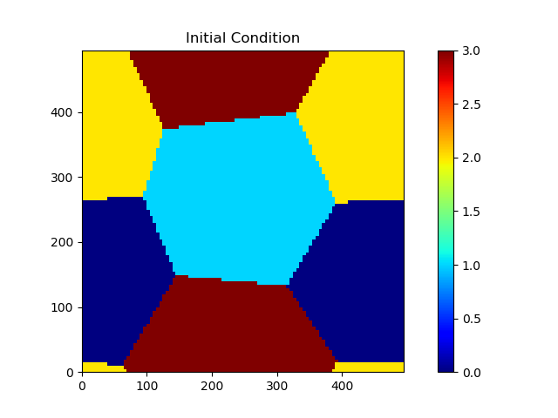

Run 2

* gr0gr1
  + Overall the grain sizes seem relatively stable: gr1 grows slightly
  + Gr0 and gr2 appear to shrink/grow at each other’s expense (almost mirror images)
  + Gr1 > gr3 ≈ gr2 > gr0 initially, gr2 and gr3 switch places several times during the simulation, and final result is gr1 > gr3 > gr2 > gr0
* gr0gr2
  + largest size fluctuations over all simulations observed – could be due to algorithmic artifacts (no correlated significant structural changes in grain sizes over the course of the simulation)
  + relatively stable grain sizes: gr0 grows slightly, gr2 shrinks slightly
  + gr1 and gr3 appear relatively stable
  + gr1 > gr3 > gr2 > gr0 initially, gr3 and gr2 switch places several times due to large fluctuations in gr2, which eventually incorporates gr0. The final quarter of the simulation is more stable (no large size fluctuations), and has the trend gr1 > gr3 > gr0 > gr2.
* gr0gr3
  + gr0 grows the most, gr3 shrinks the most (not very highly correlated though?)
  + gr1 and gr2 are relatively stable in size
  + gr1 > gr3 ≈ gr2 > gr0 initially, quickly changes to gr1 > gr2 > gr0 > gr3, and then again rapidly changes to gr1 > gr0 > gr2 > gr3
* gr1gr2
  + relatively stable grains throughout the simulation – gr2 shrinks the most, gr1 experiences some growth
  + Towards the end of the simulation run, grains 0 and 3 experience some grow (appears to be at the expense of grains 1 and 2)
  + Gr1 > gr3 ≈ gr2 > gr0, quickly changes to gr1 > gr3 > gr0 > gr2 and stays like this for the remainder of the simulation
* gr1gr3
  + gr3 experiences a large amount of growth
  + gr1 experiences a large amount of shrinkage
  + Grains 0 and 2 appear relatively stable, with some shrinkage/growth respectively towards the end of the simulation (appears highly correlated – almost mirror images of each other)
  + Gr1 > gr3 ≈ gr2 > gr0, quickly changes to gr3 > gr1 > gr2 > gr0, then gr1 continues to shrink, becoming smaller than gr2, then switching places with gr0 several times before the end of the simulation where the trend is gr3 > gr2 > gr0 > gr1
* gr2gr3
  + gr2 grows the most
  + gr3 shrinks the most (not very highly correlated)
  + gr0 experiences some shrinkage
  + gr1 stays roughly the same size
  + Gr1 > gr3 ≈ gr2 > gr0, then quickly changes to gr1 > gr2 > gr0 > gr3 for the remainder of the simulation
* Across all simulations, gr0 grows the most with the gr0gr3 boundary having high mobility, and stays relatively stable for all other simulations. Significant grain size fluctuations for anisotropy at the gr0gr2 boundary. For the gr0gr1 high mobility boundary, final size is the smallest between the simulations, but does go back and forth with gr0gr2
* Across all simulations, gr1 grows the most with gr0gr1 high mobility boundary. Gr1 shrinks the most with the gr1gr3 high mobility boundary. All other simulations see a relatively stable grain size.
* Across all simulations gr2 grows the most with gr2gr3 high mobility boundary. Gr2 shrinks the most with gr1gr2 boundary. All other simulations see a relatively stable grain size. For gr0gr2, some significant fluctuations occur throughout the simulation.
* Across all simulations gr3 grows the most with the gr1gr3 high mobility boundary. Gr3 shrinks the most with gr0gr3. Most of the other simulations see a relatively stable grain size, though gr2gr3 sees some shrinkage.

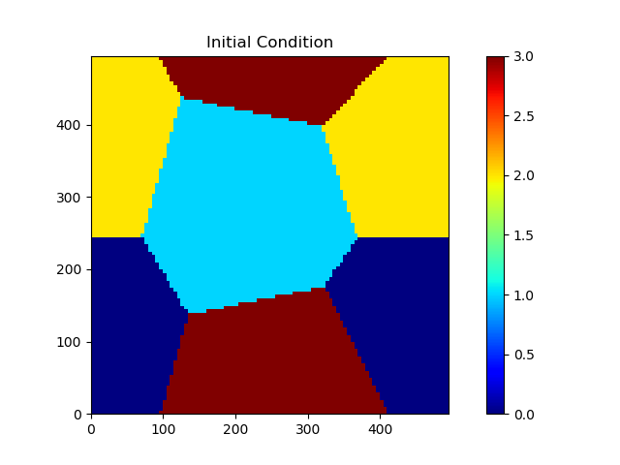

Run 3

* gr0gr1
  + Gr1 grows the most, gr0 shrinks the most (fairly well correlated)
  + Grains 2 and 3 stay roughly the same size throughout the simulation
  + gr0 > gr2 > gr1 > gr3 initially, then gr0 > gr1 > gr2 > gr3, then gr1 > gr0 > gr2 > gr3. From ~halfway through the simulation, gr1 > gr0 ≈ gr2 > gr3, and stays there to the end.
* gr0gr2
  + gr0 grows the most, gr2 shrinks the most (highly correlated – near mirror images of each other)
  + Grains 1 and 3 stay almost exactly the same size throughout (with respect to themselves, and to each other, i.e. gr1 ≈ gr3 for the duration of the simulation)
  + gr0 > gr2 > gr1 > gr3 initially, then gr0 > gr1 ≈ gr3 > gr2 after approximately a quarter of the way through the simulation
* gr0gr3
  + Gr0 shrinks, gr3 grows the most (significantly correlated, but some growth in gr3 appears to occur due to shrinkage in gr1)
  + Gr2 stays relatively stable, as does gr1
  + gr0 > gr2 > gr1 > gr3 initially, then a triple point occurs where gr0 ≈ gr2 ≈ gr3 > gr1 about a quarter of the way through the simulation, then gr3 > gr2 > gr0 > gr1
* gr1gr2
  + gr2 grows, gr2 shrinks, fairly correlated
  + grains 0 and 3 stay roughly the same size
  + gr0 > gr2 > gr1 > gr3 initially, then quickly changes to gr0 > gr2 > gr3 > gr1
* gr1gr3
  + All grain sizes are fairly stable
  + Growth/shrinkage for grains 1 and 3 seems highly correlated (mirror images of each other)
  + gr0 > gr2 > gr1 > gr3 initially, then gr0 > gr2 > gr3 > gr1 within the first 50000 time steps
  + Grain size is relatively stable throughout the simulation, overall microstructural evolution appears to occur due to shear of the top half with respect to the bottom half, with some slight grain deformation in grains 0 and 2
* gr2gr3
  + gr2 grows, gr3 shrinks
  + appears to be more correlation between grains 1 and 3
  + gr0 > gr2 > gr1 > gr3 throughout
* Across all simulations, gr0 grows the most with gr0gr2 high mobility boundary, shrinks the most with gr0gr3 boundary, and stays the same with all other high mobility boundaries except gr0gr1, which experiences some significant shrinkage
* Across all simulations, gr1 grows the most with gr0gr1 high mobility boundary, shrinks the most with gr1gr2 boundary, and stays the same with all other high mobility boundaries
* Across all simulations, gr2 grows the most with gr1gr2 high mobility boundary, shrinks the most with gr0gr2 boundary, and stays the same with the other boundaries except gr2gr3, which experiences some growth, but not as significant as gr1gr2
* Across all simulations, gr3 grows the most with gr0gr3 high mobility boundary, shrinks the most with the gr2gr3 boundary, and stays almost exactly the same size for all other simulations
* Grains 1 and 3 exhibited very similar growth behaviors, being almost near copies of each other, while grains 0 and 2 are almost mirror images of each other

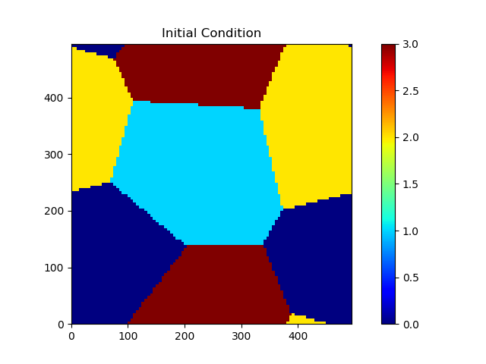

Run 4

* gr0gr1
  + Relatively stable grain sizes, no significant growth
  + Gr1 > gr2 > gr0 > gr3 throughout the simulation
  + Grains 0 and 1 have more jagged growth profiles
* gr0gr2
  + gr0 grows, gr2 shrinks (highly correlated)
  + grains 1 and 3 stay roughly the same size
  + Gr1 > gr2 > gr0 > gr3 initially, then gr2 and gr0 rapidly switch places (roughly equal initial sizes), and then about halfway through the simulation through the end the trend is gr0 > gr1 > gr2 > gr3
* gr0gr3
  + gr3 grows, gr0 shrinks somewhat correlated
  + grains 1 and 2 stay roughly the same size
  + Gr1 > gr2 > gr0 > gr3 initially, gr1 > gr2 > gr3 > gr0 after a quarter of the way through the simulation to the end
* gr1gr2
  + gr2 grows, gr1 shrinks, somewhat correlated
  + grains 0 and 3 stay roughly the same size
  + Gr1 > gr2 > gr0 > gr3 initially, gr2 > gr1 > gr0 > gr3 after about a quarter of the way through the simulation to the end
* gr1gr3
  + gr1 grows, gr3 shrinks, highly correlated
  + grains 0 and 2 stay roughly the same size
  + Gr1 > gr2 > gr0 > gr3 throughout
* gr2gr3
  + gr3 grows, gr2 shrinks initially, switches about 3/4ths of the way through
  + grains 0 and 1 stay roughly the same size, some slightly shrinkage, growth respectively
  + Gr1 > gr2 > gr0 > gr3 initially, then gr0 and gr2 switch places for the majority of the simulation, then switch back near the end of the simulation
* Across all simulations, gr0 grows the most with gr0gr2 high mobility boundary, shrinks the most with gr0gr3 boundary, and stays roughly the same for all other high mobility boundaries.
* Across all simulations, gr1 grows the most with gr1gr3 high mobility boundary, shrinks the most with gr1gr2 boundary, and stays roughly the same for all other high mobility boundaries
* Across all simulations, gr2 grows the most with gr1gr2 high mobility boundary, shrinks the most with gr0gr2 boundary, and stays roughly the same for all other high mobility boundaries
* Across all simulations, gr3 grows the most with gr0gr3 high mobility boundary, shrinks the most with gr1gr3 boundary, and stays roughly the same for all other high mobility boundaries.
* The profiles for all four grains across all simulations are very similar, just differing primarily in which boundary leads to the greatest changes.

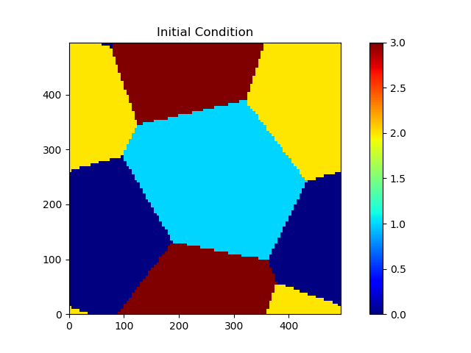

Run 5

* gr0gr1
  + gr1 grows, gr0 shrinks
  + grains 2 and 3 stay roughly the same size
  + gr0 > gr1 > gr3 > gr2 initially, gr0 and gr1 switch near the end
* gr0gr2
  + gr0 grows, gr2 shrinks
  + grains 1 and 3 stay nearly the same size
  + gr0 > gr1 > gr3 > gr2 throughout (grains 1 and 3 are almost exactly the same size throughout)
* gr0gr3
  + gr3 grows, gr0 shrinks
  + grains 1 and 2 stay roughly the same size
  + gr0 > gr1 > gr3 > gr2 initially, gr3 quickly switches with gr1
* gr1gr2
  + gr2 grows, gr1 shrinks
  + grains 0 and 3 stay nearly the same size
  + gr0 > gr1 > gr3 > gr2 initially, quick change to gr0 > gr3 > gr1 > gr2 for about a quarter of the simulation, then changes to gr0 > gr3 > gr2 > gr1 for the remainder.
* gr1gr3
  + Grain sizes appear relatively stable – gr2 appears to grow the most, while gr0 shrinks the most (which isn’t very much)
  + Grains 1 and 3 do not appear to grow
  + gr0 > gr1 > gr3 > gr2 throughout
  + Looking at the snapshots of the structure, the structure changes rapidly from the initial condition, with the gr1-gr2-gr3 triple junction rapidly migrating down to flatten the gr1-gr3 boundary
* gr2gr3
  + gr2 grows, gr3 shrinks
  + grains 0 and 1 appear to be relatively stable
  + gr0 > gr1 > gr3 > gr2 initially, then switches to gr0 > gr1 > gr2 > gr3 after about a quarter of the simulation has elapsed.
* Across all simulations, gr0 grows the most with gr0gr2 high mobility boundary, shrinks the most with gr0gr1, shrinks a little with gr0gr3, and stays roughly the same for the other boundaries
* Across all simulations, gr1 grows the most with gr0gr1 high mobility boundary, shrinks the most with gr1gr2, and stays roughly the same size for all other high mobility boundaries
* Across all simulations gr2 grows the most with gr2gr3 high mobility boundary, shrinks the most with gr0gr2, has some significant growth with gr1gr2, and stays roughly the same size for all other high mobility boundaries
* Across all simulations gr3 grows the most with gr0gr3 high mobility boundary, shrinks the most with gr2gr3, and stays roughly the same for all other boundaries

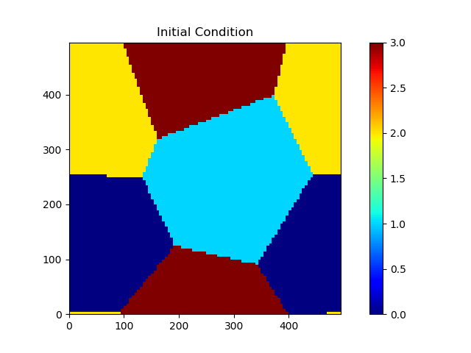

Centroids_1 (1 large/small angle, two identical angles)

* gr0gr1
  + gr0 initially shrinks, then grows (slightly)
  + gr3 initially grows, then shrinks (slightly)
  + grains 1 and 2 grow/shrink respectively (slightly)
  + gr0 > gr1 > gr2 > gr3 throughout
* gr0gr2
  + gr0 > gr1 > gr2 > gr3 throughout
  + grains 0 and 1 grow (slightly)
  + grains 2 and 3 shrink (slightly)
* gr0gr3
  + gr0 > gr1 > gr2 > gr3 throughout
  + gr0 grows initially, then stagnates
  + gr3 shrinks initially, then stagnates (equilibrium reached)
* gr1gr2
  + gr0 > gr1 > gr2 > gr3 throughout
  + gr0 and gr1 grow slightly
  + gr2 and gr3 shrink slightly
* gr1gr3
  + gr0 > gr1 > gr2 > gr3 throughout
  + mostly stagnated grain area – gr1 grows slightly, grains 2 and 3 shrink slightly
* gr2gr3
  + gr0 > gr1 > gr2 > gr3 throughout
  + grains 0 and 1 grow slightly
  + grains 2 and 3 shrink slightly
* Across all simulations, the grain growth occurred within the first 10000ish time steps – equilibrium was reached after this point.
* Because equilibrium was reached quickly (and because there was enough of a difference between the initial sizes) the order of grain sizes did not change for all simulations
* Gr0 experienced the most growth from the gr0gr3 high mobility boundary; gr1 experienced the most growth from the gr2gr3 boundary (odd…); gr2 experienced the most growth with the gr0gr3 boundary (odd…); gr3 experienced the most growth with the gr0gr1 boundary (odd…)
* Gr0 experienced the most shrinkage from the gr0gr1 boundary; gr1 experienced the most shrinkage from the gr0gr3 boundary (odd…); gr2 experienced the most shrinkage from the gr2gr3 boundary; gr3 experienced the most shrinkage from the gr0gr3 boundary
* Gr1’s size changed the least across all simulations

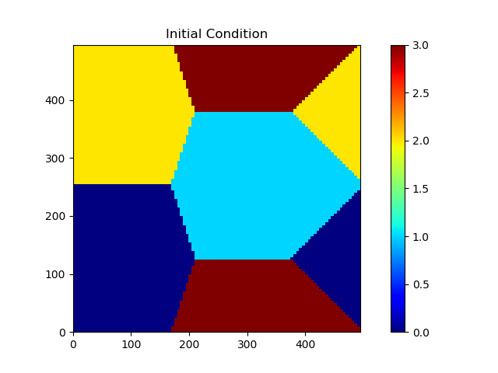

Centroids 2 (1 large/small angle, and two different angles)

* gr0gr1
  + gr0 shrinks, gr1 grows (well correlated)
  + grains 2 and 3 stay roughly the same
  + gr0 > gr3 > gr1 > gr2 throughout
* gr0gr2
  + gr0 shrinks, gr2 grows (well correlated)
  + grains 1 and 3 stay roughly the same
  + gr0 > gr3 > gr1 > gr2 throughout
* gr0gr3
  + gr0 grows, gr3 shrinks (well correlated)
  + grains 1 and 2 stay roughly the same
  + gr0 > gr3 > gr1 > gr2 throughout
* gr1gr2
  + gr1 grows, gr2 shrinks (well correlated)
  + grains 0 and 3 stay roughly the same
  + gr0 > gr3 > gr1 > gr2 throughout
* gr1gr3
  + gr3 grows, gr1 shrinks (well correlated)
  + grains 0 and 2 stay roughly the same
  + gr0 > gr3 > gr1 > gr2 initially, switches to gr3 > gr0 > gr1 > gr2
* gr2gr3
  + gr3 appears to shrink, gr1 appears to grow slightly
  + overall, relatively little size changes
  + gr0 > gr3 > gr1 > gr2 throughout
* Overall: gr0 grows most with gr0gr3 and shrinks most with gr0gr2; gr1 grows most with gr1gr2 and shrinks most with gr1gr3; gr2 grows most with gr0gr2 and shrinks most with r1gr2; gr3 grows most with gr1gr3 and shrinks most with gr0gr3.
* For the most part, the other simulations (not mentioned in the previous bullet) show roughly the same areas over time with the following exception
  + gr0gr1 shows some grain shrinkage for gr0, and growth for gr1

