Jaron Ellingson
Homework #1

Position and Velocity State and Estimate:
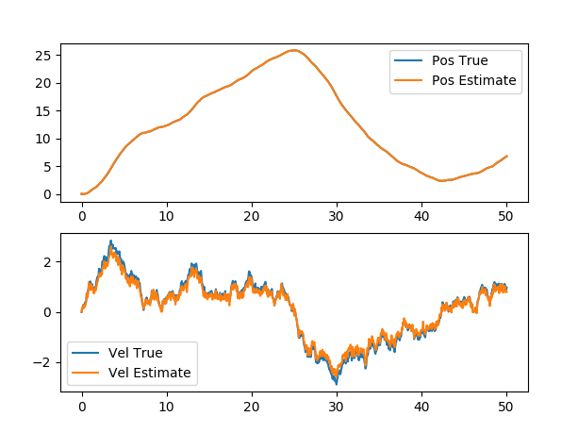

Estimation Error and Covariance:
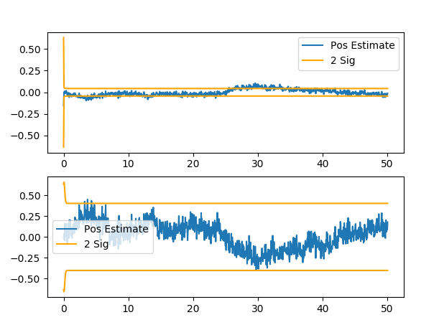

Kalman Gains:

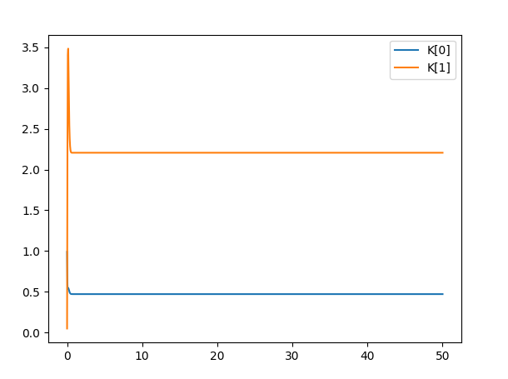

Questions:
1) The estimator seems to estimate the truth of both position and velocity.
2) The covariance does change in between the prediction and measurement update. The plot shown here only shows the covariance after the both steps, which stays the same.
3) The gains seems to settle pretty easy to values. As I increase the measurement noise, the gains decrease and vice-versa.

