1)
Linear Non-Linear
mu = 0.1
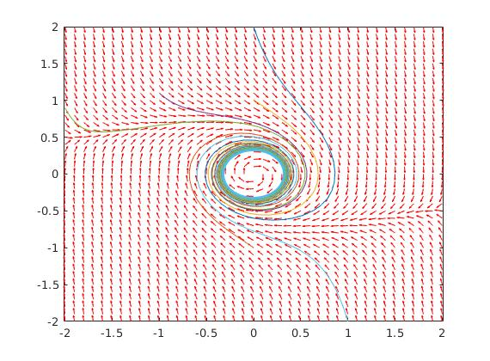
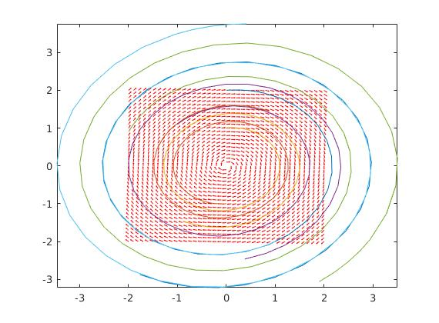
mu = 2.1
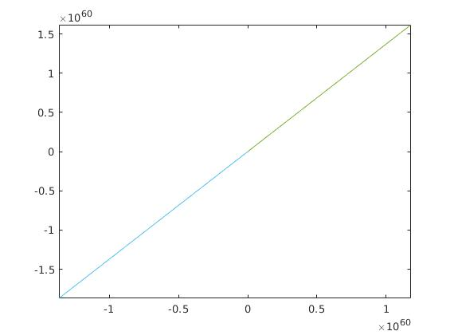
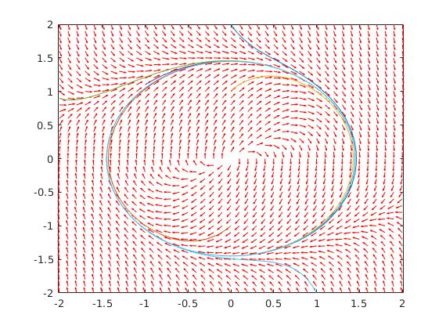

mu = -0.1
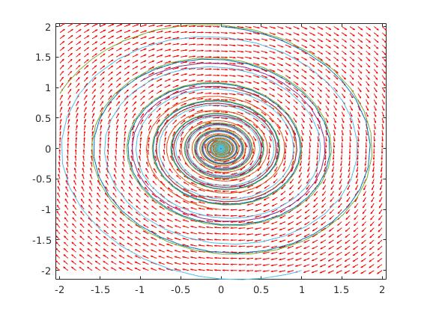

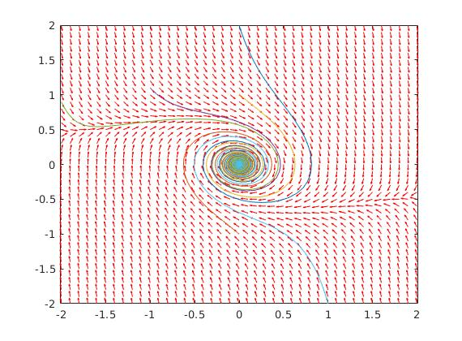

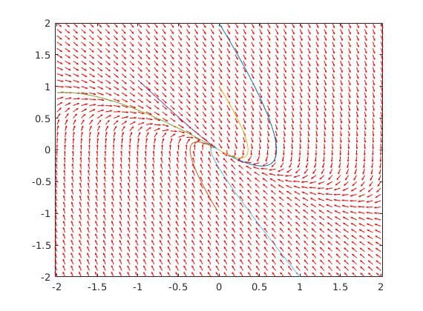
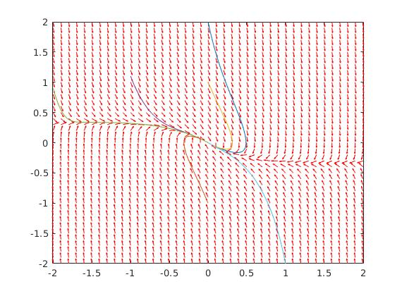
mu = -2.1

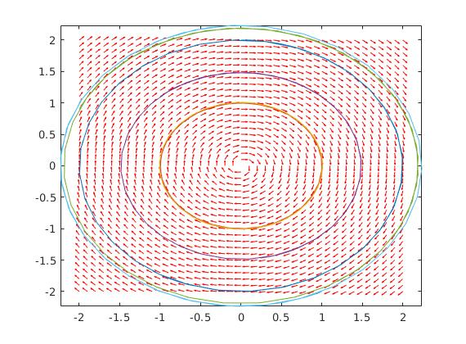
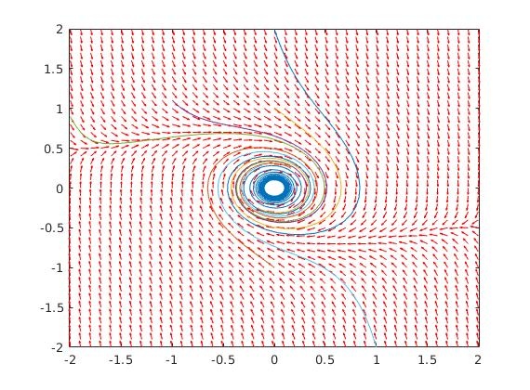
mu = 0

The differences between the linear system and the nonlinear system can be seen on the above plots with different values of mu for the linear and nonlinear systems. For the most part the linear system approximates the nonlinear system closely. Where the linear system breaks down is where mu > 0 and mu = 0. When mu > 0 the nonlinear system is very unstable but the nonlinear system appears to find a center to oscillate around. This therefore means that the linear system is accurate up to that specific center. When mu = 0, you cannot approximate the nonlinear system with the linear system. But if we to anyway we would see that the linear system shows a center while the nonlinear shows a stable focus.

6)
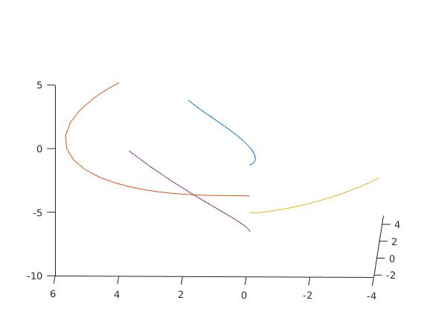
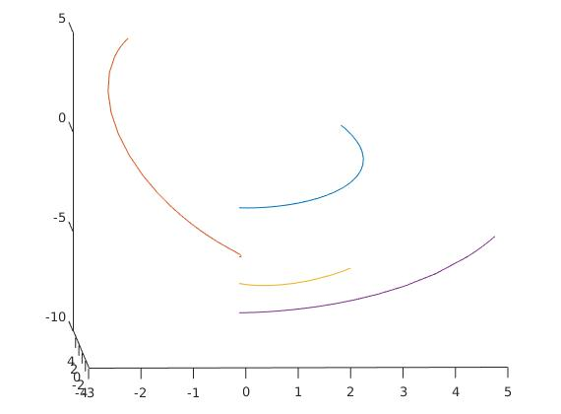
These plots show some sample trajectories converging to x1 = 0 and x2 = 0 but to different values of x3. This is consistent with results form a quadratic Lyapunov function.

