Jaron Ellingson
Robotic Vision
Homwork #2: Camera Calibration

1)
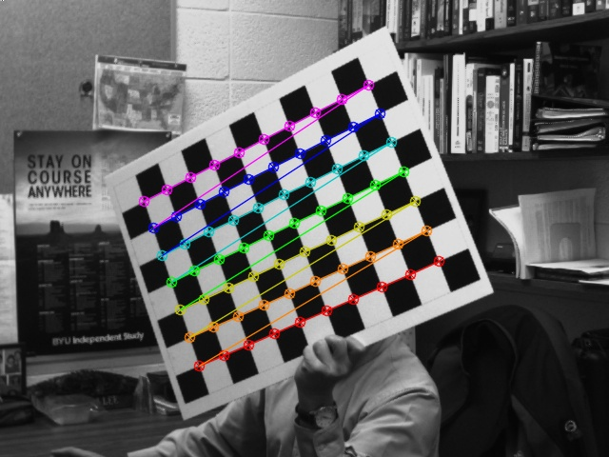
2)
Intrinsic =
[1147.75831140695, 0, 330.2783509145018;
0, 1146.051544898603, 222.3585009984769;
0, 0, 1]

Distortion =
[-0.2615355821474672, 0.1925267405961408, -0.001487764164593302, -0.001375431422797464, -0.7687061870630719]

The actual focal length is 8.5 mm

3)
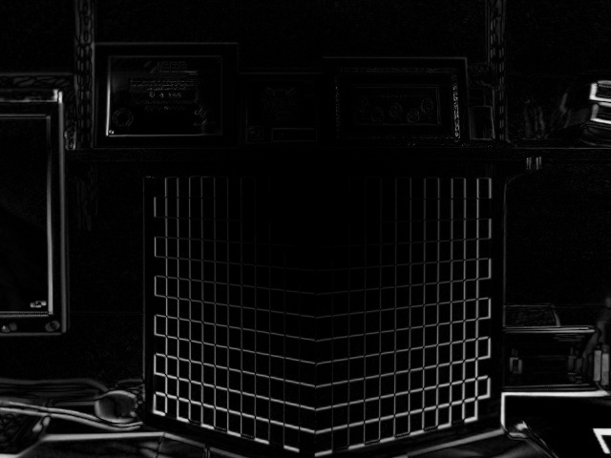
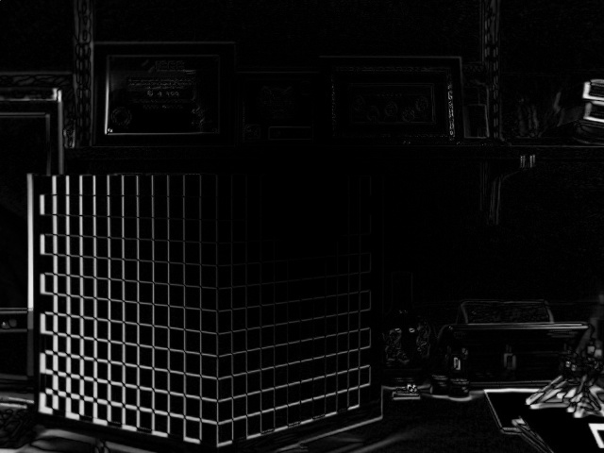
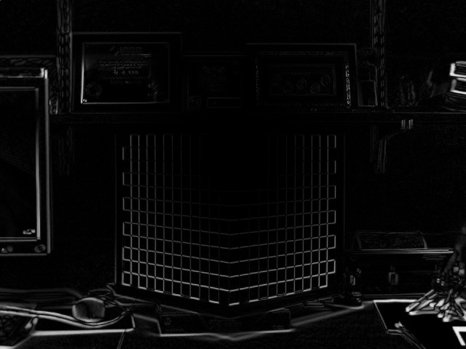
4)

Rotation =
[0.7346888530639297, -0.6782765966931499, 0.01315855470654559;
-0.003374350822207162, -0.02304971426192529, -0.9997286253923972;
0.678395830573962, 0.7344450755848264, -0.01922311132628066]

Translation =
[-0.07955474903864794;
10.48040648111225;
46.79404636169787]

5)
Intrinsic =
[646.2781437417966, 0, 318.4729123672404;
0, 640.0254592370362, 294.567777941952;
0, 0, 1]

Distortion =
[0.1742658233823047, -0.05082874562162452, 0.02743401083504981, 0.002222634503966477, -0.4147522752271028]

6)
Absolute Diff:
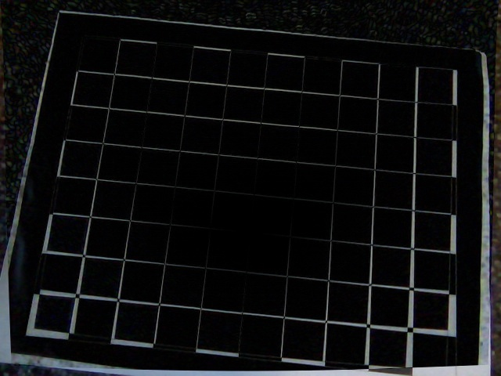
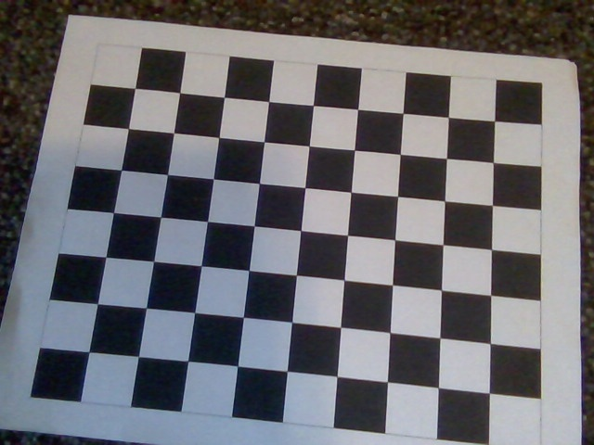

Original:

