Nestle Average Price Analysis and Forecasting



1. INTRODUCTION 2

2. PRELIMINARY DATA ANALYSIS 4

- Time series plots 4

- Descriptive statistics (mean, median, standard deviation, minimum, maximum,percentiles) 5

- Histograms 5

- Box-plots 6

- Correlograms 6

- Scatter plots / Correlations} 7

3. MOVING AVERAGE AND EXPONENTIAL SMOOTHING METHODS 9

- Naïve Method 9

- Moving Average Method 10

- Single Exponential Smoothing 11

- Holt’s Method 13

- Winter’s Method 14

4. DECOMPOSITION 16

4.1 Multiplicative Model 16

4.1.1 Fitted Model 17

4.1.2 Detrended Data by Season 18

4.1.2 Residuals by Season 18

4.1.3 Detrended Data 19

4.1.4 Seasonally Adjusted Data 20

4.1.5 Seasonally adjusted and detrended data 20

4.1.6 Normal probability plot and histogram of the residuals 21

4.1.7 Residuals versus fits 22

5. REGRESSION ANALYSIS 23

5.1 Model Specification 23

5.2 Model Building 26

5.2.1 Regression Equation 26

5.2.3 Coefficients 26

5.2.4 Model Summary 26

5.2.5 Analysis of Variance 26

5.3 Overall Model 26

5.4 Reduced Model 27

5.5 Forecasting with Regression 29

6. MODEL SELECTION AND FORECASTING 29

7. MANAGERIAL IMPLICATIONS 31

REFERENCES: 31

# 1. INTRODUCTION

**1.1 COMPANY INFORMATION:** Nestle, a global brand whose products are consumed by everyone, has a deep-rooted history. The company, which processes ready-to-eat foods and beverages worldwide, was founded in 1905 as the Anglo-Swiss Condensed Milk Company. Founded by brothers Charles and George Page, who were Americans, the company would eventually become the first company to produce condensed milk in Europe. They established their first production facility in Cham, thinking that they could process it better by taking advantage of Switzerland's abundant fresh milk resources. Shortly after, in 1867, German-born Henri Nestlé revolutionized infant nutrition by producing "farine lactée," a mixture of ingredients such as cow's milk, wheat flour, and sugar, with the claim that it would reduce mortality rates in newborn babies. Thanks to the innovative contributions of Henri Nestlé and the superior marketing techniques of Anglo-Swiss, there was intense competition between the two companies, resulting in a merger in 1905 and the establishment of the Nestlé & Anglo-Swiss Milk Company. As society entered the chaos of the First World War, Nestlé faced opportunities and challenges. Condensed milk became popular and became the mainstay and motivation of military units on many fronts. Nestlé successfully weathered wartime shortages by strengthening its position as the industry leader in dairy products worldwide by making strategic acquisitions such as Norwegian dairy company Egron and planned market expansions in the United States and Australia. Nestlé experienced many economic problems following the war, including the Wall Street Crash of 1929. Crises brought innovations. Nestlé's launch of Nescafé in 1938 was an example of the company's commitment to creating new consumer experiences. Nestlé has a popular history of pushing boundaries with innovation beyond its own sector and across the global food industry, improving people's lives with every meal and drink. Nestlé is known for its innovation, resilience and commitment to the well-being of its customers. II. Against the challenges of World War II, Nestlé and Anglo-Swiss continued to serve the armed forces as well as civilians by conducting field studies on food access. In 1947, it added a new product to its product range by adding Maggi spices and instant soups to its product portfolio. It continued to differentiate itself from other food brands. It was later renamed Nestlé Alimentana. To maintain distribution operations in the event of an attempted invasion of Switzerland in World War II, Nestlé & Anglo-Swiss moved key employees to a reserve headquarters in Stamford, USA. Nestlé set new routes despite poor conditions in European trade channels; By strengthening its market position in Africa, Asia and Latin America, it prevented global customers from experiencing product disruptions and demonstrated brand loyalty. With the end of the war, the widespread use of energy-saving devices and the increasing demand for ready-made processed foods,Nestlé took advantage of this and there was a period of rapid economic growth. Taking advantage of this trend, Nestlé continued to increase its profitability by gaining new customers and met the changing and evolving demands of consumers after the war by launching cutting-edge products that could appeal to the public, such as Alimentana, Nesquik and Maggi ready meals. . Nestlé Alimentana continued to expand its product range by continuing its innovations without slowing down in the 1940s and afterwards. The company introduced Nescafé and Nestea to the American market because America is a continent with new customers and opportunities. It also rebranded its baby cereal as Cerelac. The company's next strategic move was its complete acquisition of Findus, further fully penetrating the chilled dairy market where it already had a presence, further proving the company's ambition to meet the needs of consumers across various food market segments. In the 1970s, the company decided to focus on the pharmaceutical and cosmetic industries, but came under criticism from activist groups for its marketing strategies. However, Nestlé never wavered from its principles such as ethical business practices by embracing the social company principle and eventually became one of the first companies to comply with WHO guidelines on breast milk substitutes. From its beginnings as a modest condensed milk company to its transformation into a large company, they have always aimed to meet the needs of their customers by analyzing them well by gradually launching products in each segment. Today, as a global holding company spanning a variety of industries, Nestlé's path is based on innovation, resilience and consumer happiness.

This is a tribute to his continued dedication.

**1.2 DEFINITION OF FORECASTING PROBLEM:** The forecasting problem we will discuss throughout this report is Nestle's monthly average price and date. In the next step we will analyze the independent variables and average price. The data is collected monthly and covers the period between 01.01.1980 and 01.01.2024. The main independent variable that affects the average price is inflation,cocoa price and we will also use time. Some issues are taken into consideration when determining these prices. Consumer Price Index (CPI) prices are used to determine average consumer costs for food products. It is also important to consider seasonal factors that may affect prices. We expect a rising trend in prices. When we examine the data, prices, which have been increasing in some periods, are gaining much more momentum between 2020 and 2025. We can say that this is largely due to inflation,covid-19 which is a worldwide problem, along with the current interest rate decisions in the USA.

Overall, in this report, we will be adapting different methods of analyzing, how the value of the data set changes throughout time, and how different parameters affect the forecast of the value.

**1.3 CONTEXT:**

Nestle is one of the largest food and beverage companies in the world and has a wide range of products in different categories. The company operates in the nutrition, health, and food and beverage sectors. Numerous internal and external factors influence Nestle's operations, and their impact can have a big impact on the organization's performance. Apart from these factors, the business must also pay attention to regional legal regulations and global trade rules.

In this report, where we examine the relationship between average price and time, we aim to analyze and interpret the impact of independent variables on overall changes of price (section 5) by analyzing the factors affecting average price performance over the specified period in Nestlé Excel. We will continue our report by evaluating Nestle's average price performance over a specific period, analyzing the relationship between average price and time, and assessing the impact of independent variables on average price of Nestle's products.

# 2. PRELIMINARY DATA ANALYSIS

## - Time series plots

* The y-axis represents the average price of Nestlé products, starting at $1.50 and going up to $5.00, with x-axis Date. There's a general upward trend in Nestlé's product prices. Although the prices fluctuate year to year, there's a clear increase after the onset of COVID-19.
* **Supply Chain Disruptions**: Lockdowns and travel restrictions during the covid-19 disrupted global supply chains, making it more challenging and expensive to transport raw materials and finished products.This one of the main reasons for the high price.
* **Increased Demand for Certain Products**: As more people stayed home, demand for specific Nestlé products like instant coffee and cooking increased. This increased buying pressure, combined with supply constraints, contributed to price getting high.
* **Rising Costs of Inputs**: COVID-19 disrupted the production and transportation of raw materials like coffee beans, cocoa, and dairy products. These supply issues drove up the costs of these inputs, which in turn raised Nestlé's production costs.

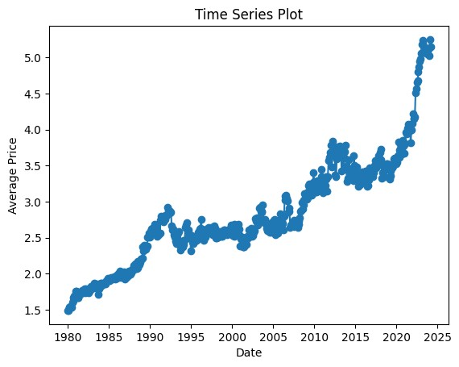

## - Descriptive statistics (mean, median, standard deviation, minimum, maximum, percentiles)

Descriptive statistics:

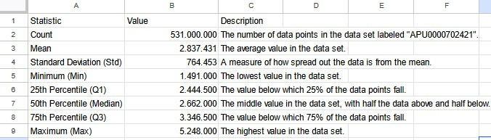

The normal esteem of the dataset is 2.837. This esteem speaks to the generally normal of the information.

The middle is 2.662, which means that half of the perceptions are under this point, and half are over.

The truth that the cruelty is higher than the middle proposes a conceivable positive skewness within the information, indicating that a few higher values may be pulling the normal upward.

The standard deviation is 0.764, showing the level of dispersion within the dataset. A littler standard deviation would recommend that the information focuses are closer to the little, whereas a bigger esteem focuses to more spread.

Calculated as the contrast between the greatest and lowest values, is around 3.757, from a least esteem of 1.491 and a most extreme esteem of 5.248. This illustrates that the information features a notable spread and positive skewness.

## - Histograms

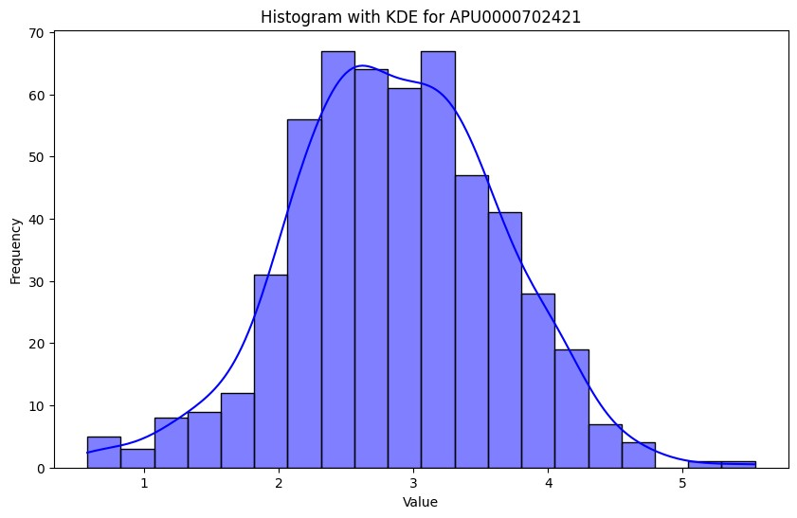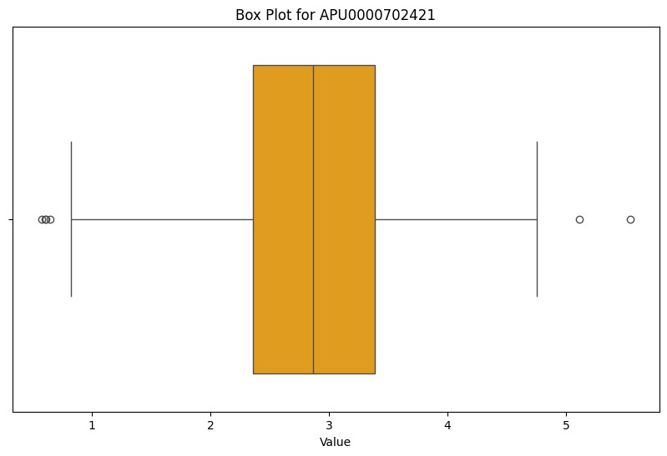

APU0000702421 is our dataset for Nestle’s Average Price.

The histogram appears to show that the most common values of APU0000702421 are between 2 and 3. The bars are tallest in this extend, and they decrease off towards the lower and higher values

Overall, the graph shows that the data set APU0000702421 is approximately normally distributed, with a mean of around 2.5 and a standard deviation of around 0.75 The dataset contains 531 perceptions.

## - Box-plots

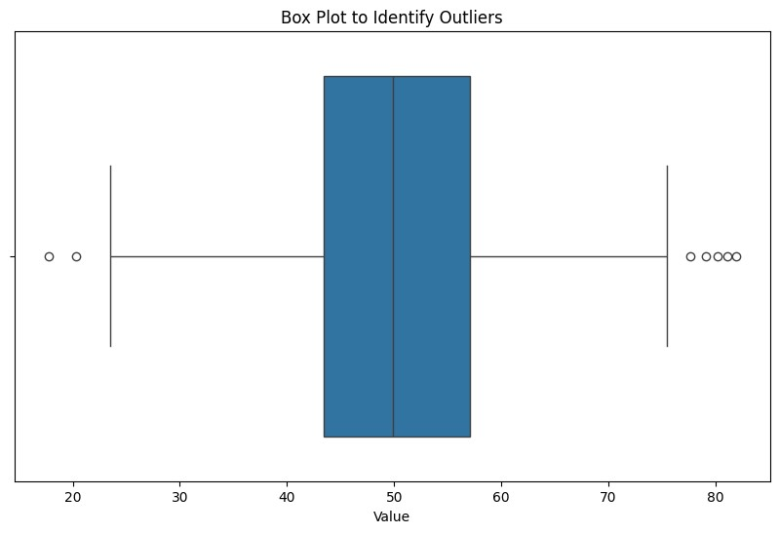

As we see from this graph there is month 0 and value 0 is missing we take 0, we conclude month 0 as 1980 and value 0 as 1.50.

## - Correlograms

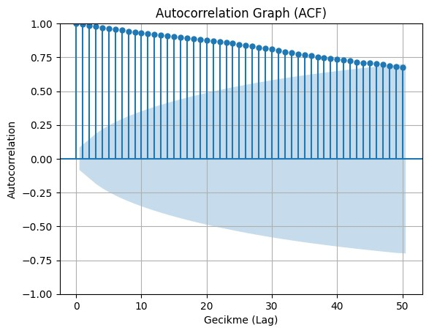

In this graph we can see the increasing trend in prices, Nestle’s average price has been rising over the time. Strong autocorrelation is another aspect of this graph which levels can reach to 0.75 up to lag ten. This shows that there is a strong association between Nestle’s current average price and old prices.

## - Scatter plots / Correlations}

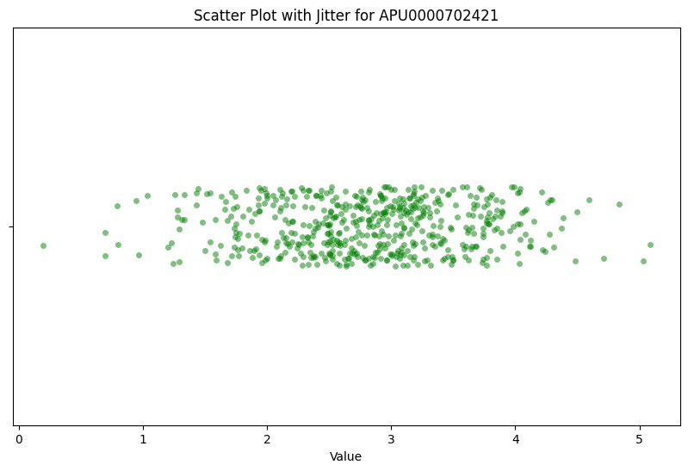

There appears to be a weak positive correlation between the value and the time. This means that as the value on the Date increases, the value of price also tends to increase. However, the data points are scattered, so the relationship is not a very strong one.

There are a few data points that appear to be outliers. These points are further away from the overall trend of the data.

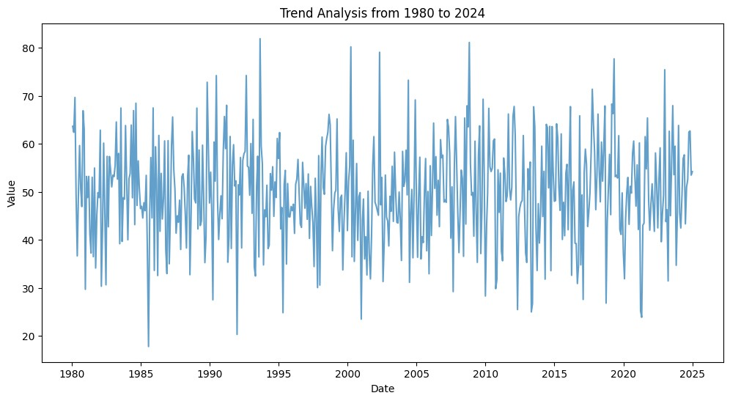

The overall trend appears to be flat. There is some variability in the data, but there is no clear upward or downward slope over the entire time period.

There may be multiple trends within this data set. For example, from 1980 to 2000 the value seems to be increasing, while from 2000 to 2024 the value seems to be decreasing.

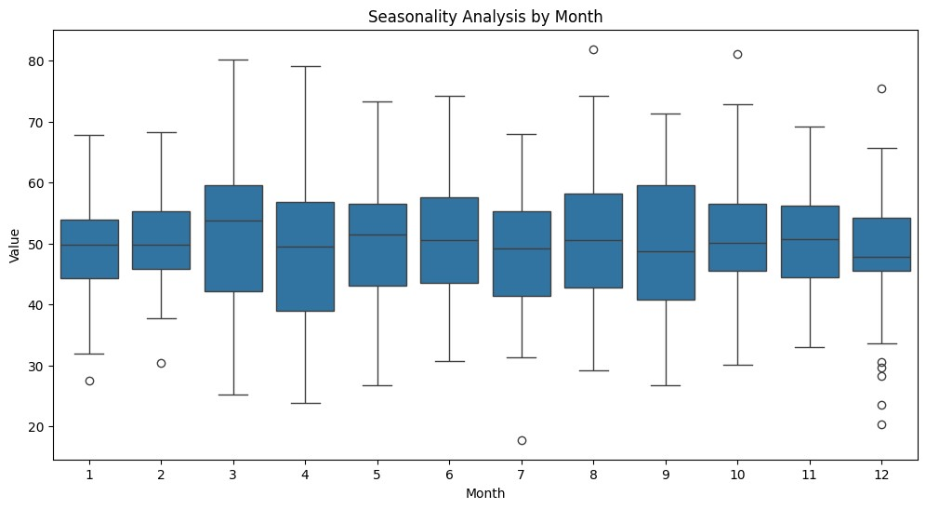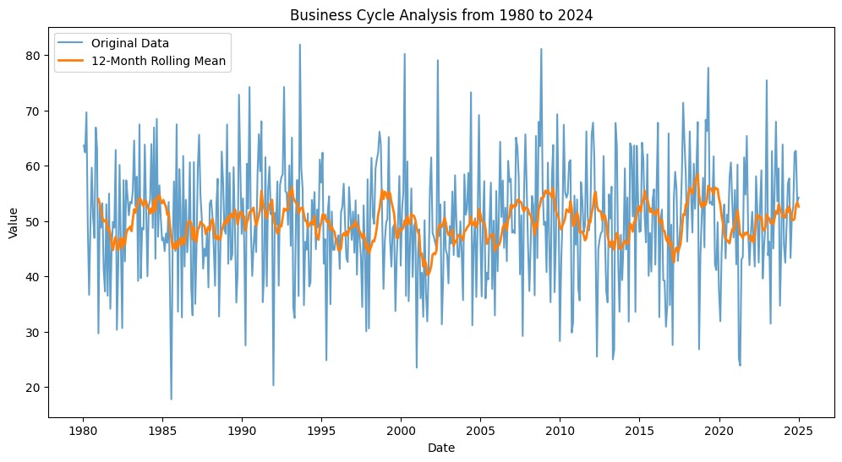

The data shows a clear seasonal (stationary) pattern in the average price of Nestle. There are higher prices in the summer months and lower prices in the winter months.So there is little seasonality.

# 3. MOVING AVERAGE AND EXPONENTIAL SMOOTHING METHODS

## - Naïve Method

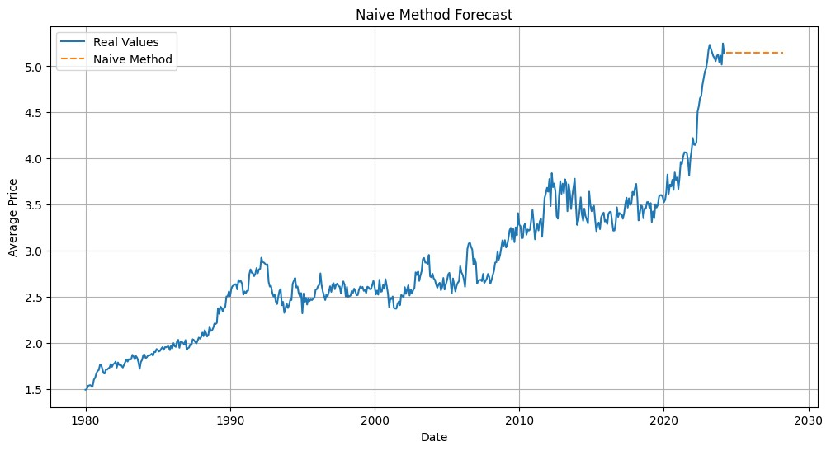

MAPE: 94.35%

MAD: 2.31

MSE: 5.91

Table 1: Naïve Method Errors

1. **Mean Absolute Deviation (MAD):** The MAD for the Naive Model is calculated to be 2.31. This means that, on average, the predictions deviate from the actual values by approximately 2.31 units.Lower mad means predictions closer to the actual prices.
2. **Mean Squared Error (MSE):** The MSE for the model is computed to be 5.91. This implies that, on average, the squared deviations between the predictions and the actual values amount to approximately 5.91 units.
3. **Mean Absolute Percentage Error (MAPE):** The MAPE for the Naive Model is determined to be 94.35%. This indicates that, on average, the predictions deviate from the actual values by approximately 94.35% in percentage terms. A high MAPE suggests significant discrepancies between the predictions and the actual values.This means Naive Forecasting is not appropriate for our dataset.

This graph and error values shows us that naive forecasting is not reliable for our dataset, very high error values and stable graph is not realistic.

## - Moving Average Method

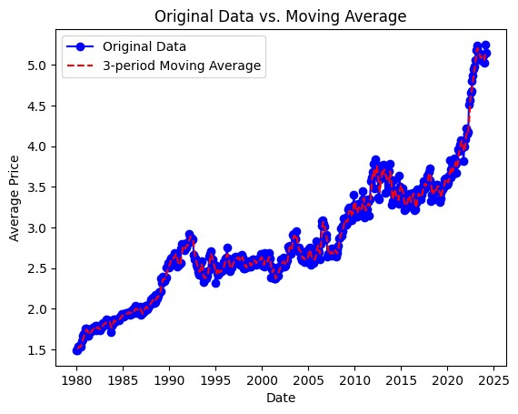

Analysis of Nestlé's Price Trends and Moving Averages

This graph shows the 12-month moving average,the upward trend shows Nestle's average price over the past decade, and the positive slope of the moving average recommends a continuous but consistent increment within the time . Positively correlated with the time. In certain periods, the initial information line dips below the moving average which showing us price sometimes falls under the long-term trend.This dips maybe related with a seasonality, crisis or other independent variables.

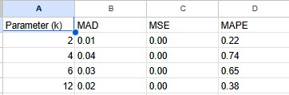

Table2: Moving Average errors

This metric measures the average absolute difference between the observed and estimated values. A lower MAD indicates that the predictions are closer to the actual values.

From your table, the smallest MAD is with a window size of 2 (0.01), indicating that using a 2-period moving average provides the most accurate predictions in terms of deviation from the actual values.

MSE (Mean Squared Error):

This is the average of the squared differences between the observed and predicted values. Squaring the errors places more weight on larger discrepancies, making it sensitive to outliers.

In your table, the MSE is consistently very low across all window sizes. This suggests that large deviations from the predicted values are rare.

MAPE (Mean Absolute Percentage Error):

MAPE calculates the average absolute percentage error, giving a sense of relative error in terms of percentages. This is useful when dealing with data of different scales.

The smallest MAPE in your table is with a window size of 2 (0.22), indicating that the 2-period moving average results in the lowest relative error.

İnterpretation

Validness of Moving Average: Given these results, the moving average method shows that it works relatively well with low errors across different metrics. The MAD and MSE are quite low, indicating the predictions are generally close to the actual values. The MAPE values suggest that the errors, on average, are small percentages of the actual values.

Best Parameter (Window Size): Based on your table, a window size of 2 seems to be the smallest errors for both MAD and MAPE, indicating this might be the best parameter for your data. This small window size captures short-term fluctuations well, suggesting our data might not have a significant trend or long-term cycles that require larger window sizes.

Conclusion

From these results, it seems that the moving average method with a small window size is suitable for the data. It keeps the errors low, indicating that the predictions are usually accurate. If the data exhibits more complex trends or seasonality, you might consider exploring more complex models, but based on these metrics, the moving average method with a 2-period window appears to be an effective approach.

## - Single Exponential Smoothing

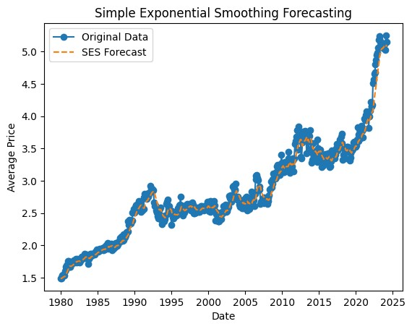

###### Breakdown of the Exponential Smoothing Graph

General Trend; the moving average line shows a noticeable upward trend shows a general increase in Nestle’s average price over the past. This trend may be influenced by factors like inflation, production cost, shifts in consumer behavior, changes in supply and demand and change of the market in the food and beverage industry.

Smoothing Effect: The moving average line is smoother compared to the original data line (orange), demonstrating the efficiency of this method in showing short-term fluctuations. By smoothing the data, the moving average helps to reveal broader trends, making it easier to identify the underlying direction of price movements without being distracted by noise and volatility.

Seasonality , despite the overall upward trend, there are periods when the original data line dips below the moving average line. This observation shows potential seasonal fluctuations or periodic price corrections. For instance, price reductions could occur during certain months due to increased supply or decreased demand, potentially linked to seasonal variations in consumer behavior or changes in production cycles.

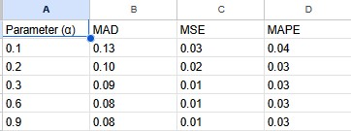

Table 3: Single Exponential Smoothing Errors

Error Analysis

Let's talk about a brief analysis of the table's error metrics. This helps determine which parameter α gives the smallest error.

MAD (Mean Absolute Deviation):MAD stands for Mean Absolute Deviation. apparent value. The lower the MAD, the higher the accuracy.The minimum MAD is reached at α=0.6α=0.6 and α=0.9α=0.9 (both 0.08). This level of smoothing means that the predictions are close to the actual values.

Mean Squared Error (MSE): measures the root mean square measure that is sensitive to large errors.The smallest MSEs are observed for α=0.2,0.3,0.6,α=0.2,0.3,0.6 and 0.90.9, all at 0.01, which shows that this level of smoothing reduces larger errors.

MAPE (Mean Absolute Percent Error): MAPE stands for Mean Absolute Percent Error and stands for Relative Error.The MAPE is consistent across different values of αα (0.03), indicating that the parameters produce different relative error rates.

According to the data in the table:The best parameters: parameters α=0.6α=0.6 or α=0.9α=0.9 produce the smallest errors in a range of measures (MAD, MSE and the same MAP).

Why: These parameter values appear to be a balance between maximizing recent data and fitting past trends.

Considering that the MSE, MAD, and MAPE for these parameters are small, the SES with α=0.6α=0.6 or α=0.9α=0.9 appears to be the best fit to the data.In conclusion, single exponential smoothing is suitable for your data because the errors are small. The best parameters seem to be α=0.6α=0.6 or α=0.9α=0.9, which show the smallest error and show the most accurate predictions for the data set, according to the opinions of this value.

## - Holt’s Method

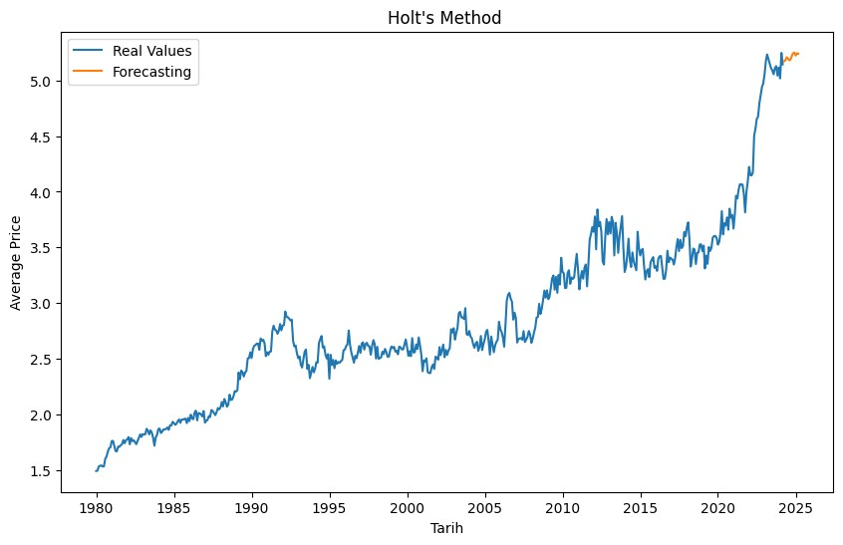

The time series extends from 1980 to 2025. The general trend is upward, showing a trend of increasing value within time. Blue lines show short-term fluctuations. These fluctuations are due to random factors or seasonality. In the long term, the blue line follows the general trend. The Yellow line follows the Blue line closely, indicating that the Holt method can accurately predict the time series. It smoothes out short-term trends and focuses on long-term ones. At some points, the yellow line deviates slightly from the blue line. There is no seasonal pattern clearly visible on the chart. This indicates that the Holt method is a good choice for non-seasonal time series. .

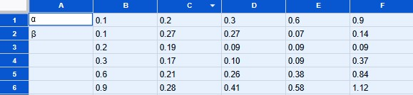

Table 4: Holt’s Method Errors

When α = 0.1 and β = 0.3, the MAPE is 0.07, resulting in the lowest inaccuracy. This combination shows that using a moderate amount of smoothing for both the level and trend components of the time series shows the best estimations.

The table and observed trend in MAPE values suggest that double exponential smoothing (Holt's Method) is acceptable for the data, especially when α and β are modest.

## - Winter’s Method

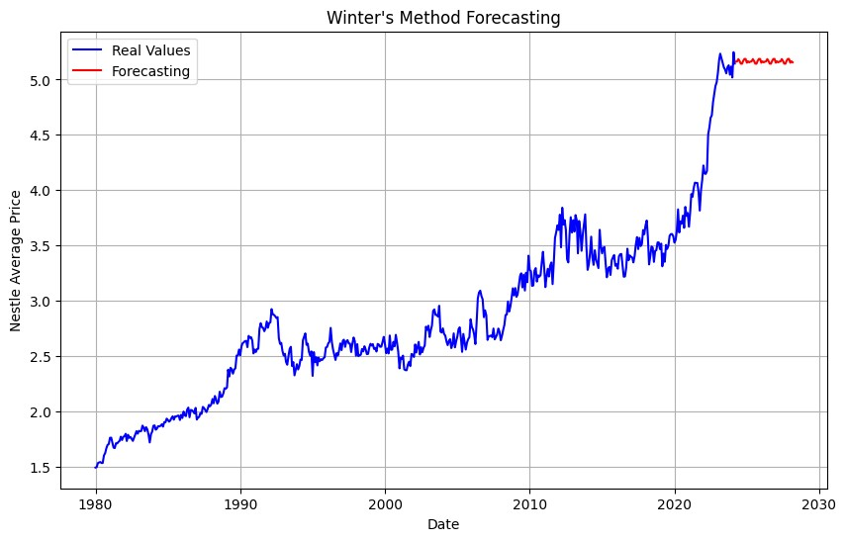

While in 1980 our ratio is about 1.5 over the time there has been an increasing trend, around 2020 there is an increase in this ratio showing as 5.0. But after that values seem to not go upward or downward. This is one of the problems with Winter’s Method, it is very good for steady data that doesn’t change much over time. When there is no seasonality in the data this can be good for predicting stable values, but when it comes to analyzing without trends, seasonality does not really show great performance. Final value around 2023 is maintained, as seen by the forecast level staying constant around 5.0 because trend component is stable.

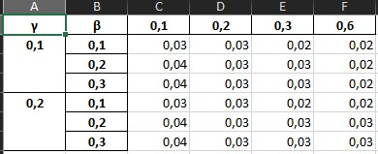

###### Table 5: Winter’s Method Errors

Winter's Method wouldn't be fit for this data analysis.

Winter's Method is designed for time series data with trends and seasonality. The accompanying table does not show time components (such as dates) or clear seasonal patterns.The diagram created by Winter's method seems too uniform and cannot describe the desired variations. This is mainly because our dataset lacks important trend and seasonal components. The method relies on the presence of these patterns to make accurate predictions, but the lack of clear trends and seasonal differences in our dataset makes Winter's method ineffective.Due to the nature of our dataset, which lacks discernible trends and seasonality, it is clear that alternative forecasting methods need to be explored. Models better suited to stationary time series or able to capture irregular patterns would be better suited to generate meaningful forecasts.

In summary, the best model depends on the characteristics of our data and the assumptions we’re willing to make. The 3-period Moving Average has the lowest MSE, suggesting it's a good fit, but might underfit if trends or seasonality are present. Holt-Winters balances flexibility with risk of overfitting. Simple Exponential Smoothing might be a good compromise for smoother data without significant trends or seasonality. Linear Regression's high MSE indicates it might not be suitable for this data set. Residual analysis and conceptual validity should guide your final choice, ensuring the selected model satisfies the necessary assumptions and performs well with unseen data. We would like to use the 3-Period Moving Average because of the lowest MSE and realistic graph.

# 4. DECOMPOSITION

## 4.1 Multiplicative Model

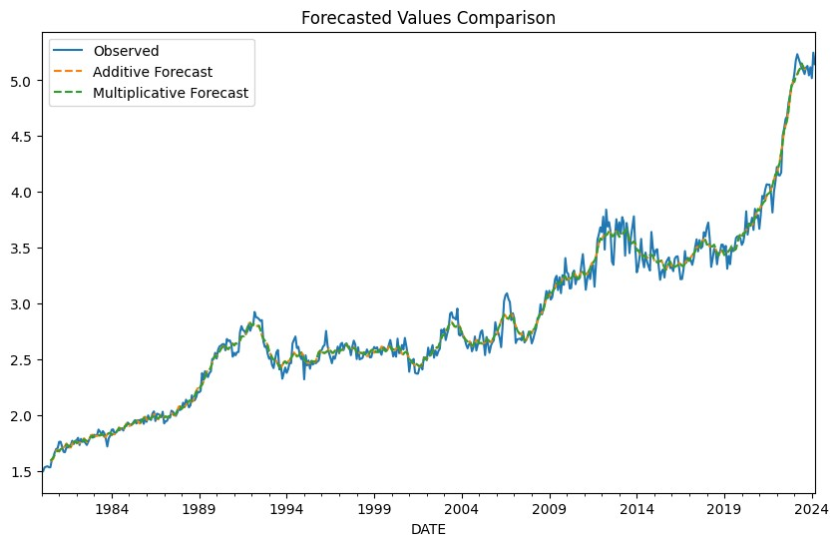

Additive Model MAE: 0.05574438438737761

Multiplicative Model MAE: 0.05544350672769472

Both of Mae’s seem closer to each other but the Multiplicative Model's a little bit lower, also we can see the same thing for graphs. They look similar but what we understand from the MAE multiplicative model seems more accurate.

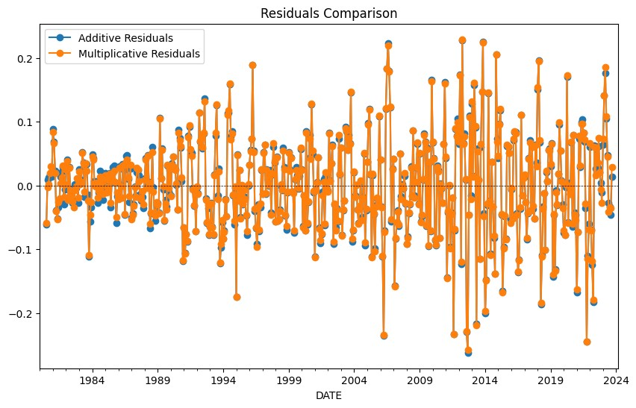

In this graph we see a comparison of two methods, multiplicative residuals seems more systematic.

### 4.1.1 Fitted Model

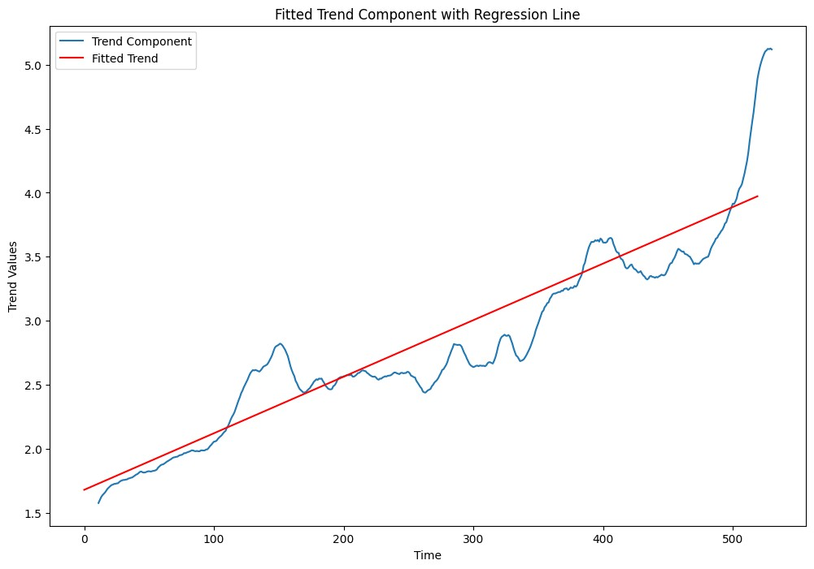

Regression Equation: Trend = 1.6818 + 0.0044 * Time Index

INDEX = Date

From the graph we can say that our values aren't distributed normally around our straight line.

Trend component (blue line): This is the trend component of the time series obtained by the decomposition method. The regression line fitted to the trend component data is shown with the fitted trend (red line) showing the general trend direction.The trend component starts at about 1.5 and tends to increase over time. There are times when growth is relatively stable, followed by short periods of decline or stagnation. Time indices 100, 300 and especially 450 show a significant uptrend, with the trend value sharply increasing above 5.0 after 450. There is some volatility in the trend component, which indicates periods of variable growth. The direction of the general trend is smoothed and estimated with a regression line. A positive slope of the regression line indicates a long-term upward trend of the material. The regression line describes the general upward trend, but does not take into account the short-term fluctuations and volatility observed in the trend component.The underlying trend of the data is upward during the observation period, as confirmed by the positive slope of the fitted regression line. This means that the values of the trend component are increasing on average. There has been a significant upward shift in the data, which can be seen in the strong growth of the trend component after the time index of 450. This could be due to a structural change, an external shock or other variables affecting the time series. .If the current trend continues, an upward-sloping regression line indicates that future values should continue to rise. The volatility around the trend suggests that short-term forecasts should take into account possible fluctuations, rather than relying solely on the long-term trend. The sharp increase seen at the end of the data indicates a possible change in the causes of the trend. Forecasting models should take this into account, where possible by incorporating more dynamic modeling techniques or making adjustments to reflect recent changes

### 4.1.2 Detrended Data by Season

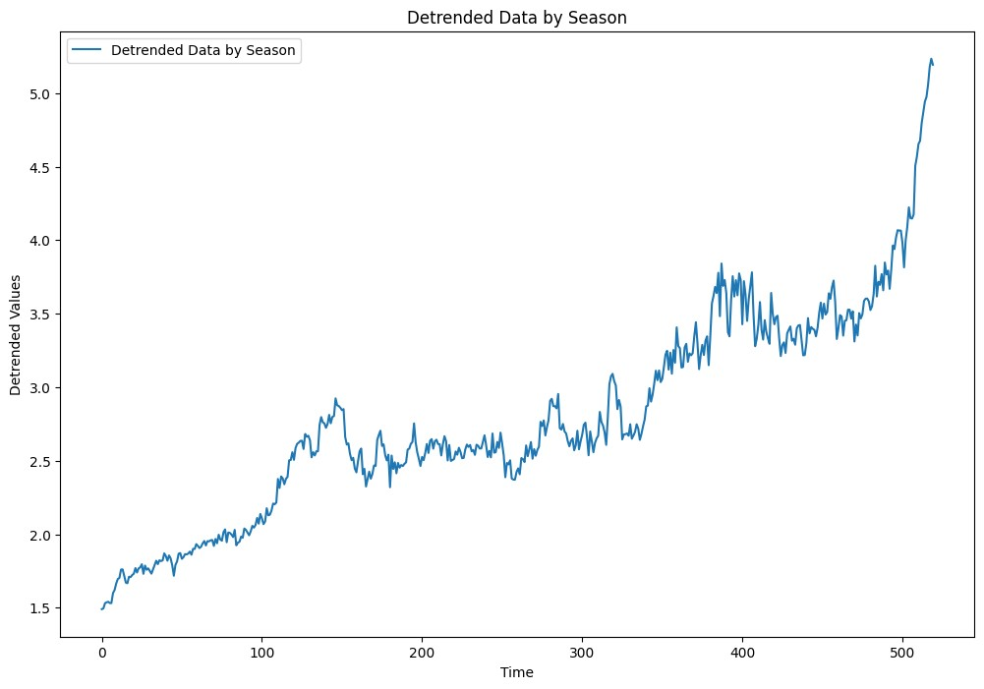

Here we see the data without trend, the main purpose for that is to isolate the seasonality and compare different time periods easily. Cyclical pattern in the data can be seen as it gets higher and lower all the time. These cycles can be the result of economical problems.

### 4.1.2 Residuals by Season

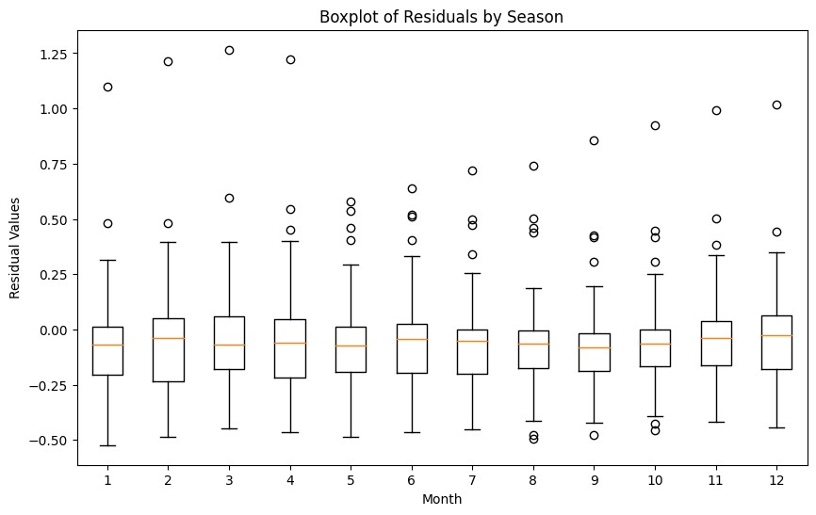

Residuals by seasons which shows where median is showing positive or negative by the seasons Winter has the lowest median residual and Spring has the highest.This means that the model's predictions are more variable for Spring compared to Winter.There are also outliers in every season, its make it harder to us prediction.

### 4.1.3 Detrended Data

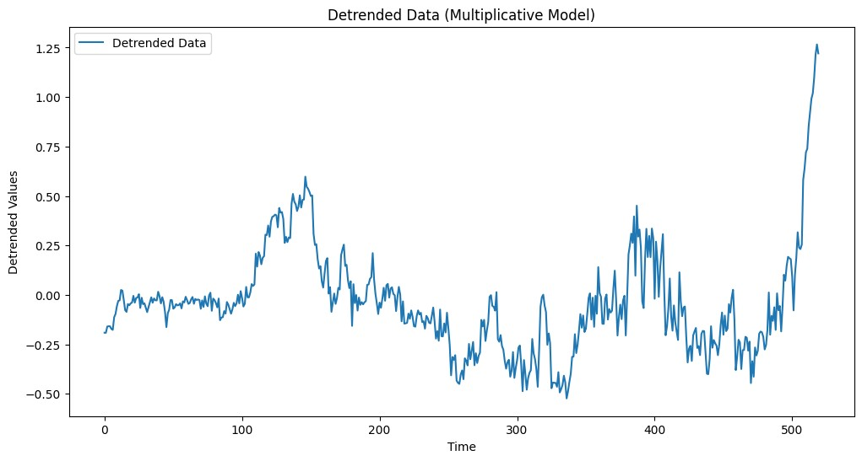

Cyclical graph shows us a strong pattern, peaks in summer months and valleys in winter months.

### 4.1.4 Seasonally Adjusted Data

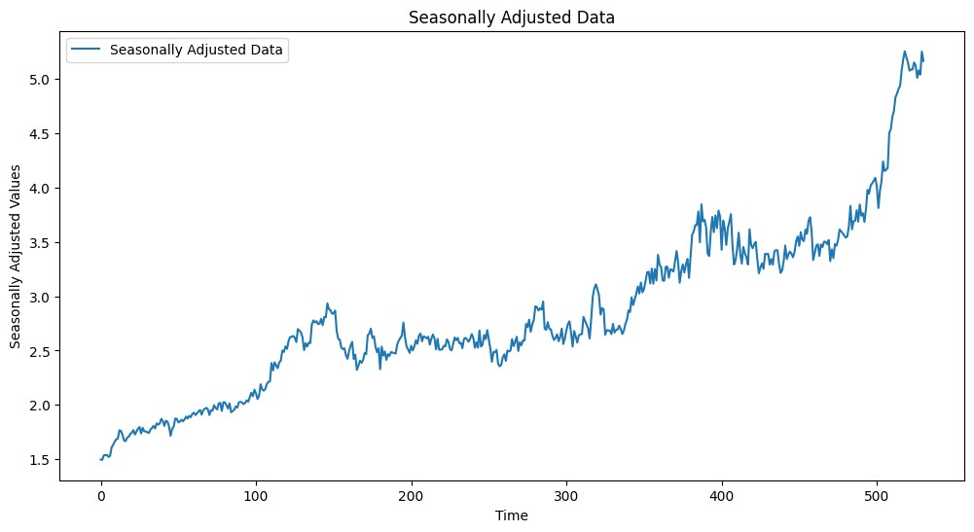

### 4.1.5 Seasonally adjusted and detrended data

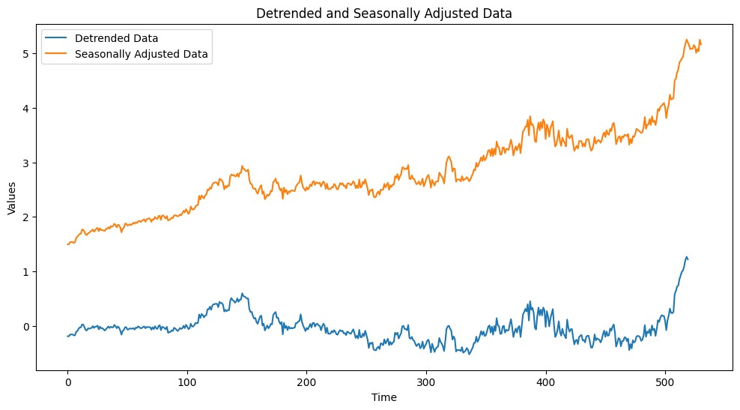

The Detrended Data set eliminates long-term trend effects, allowing us to observe momentary shifts and short-term swings. As so, it stays mostly at the same level, with the exception of a little spike toward the graph's end. The data is typically on an upward trend, with a notable gain noticed near the 500th time point, according to the Seasonally Adjusted Data Collection, which shows a continuously growing tendency.

### 4.1.6 Normal probability plot and histogram of the residuals

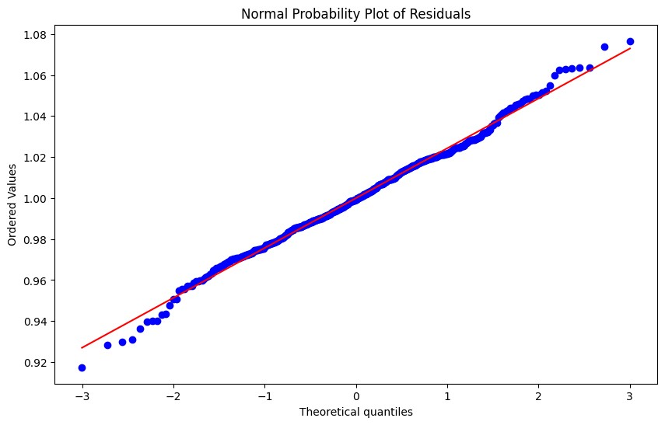

This graph shows whether our assets are distributed normally or not, if the values are closer to the red line it means our assets are normally distributed. Our graph shows some values that are away from the normal line but most of the times values distributed normally.

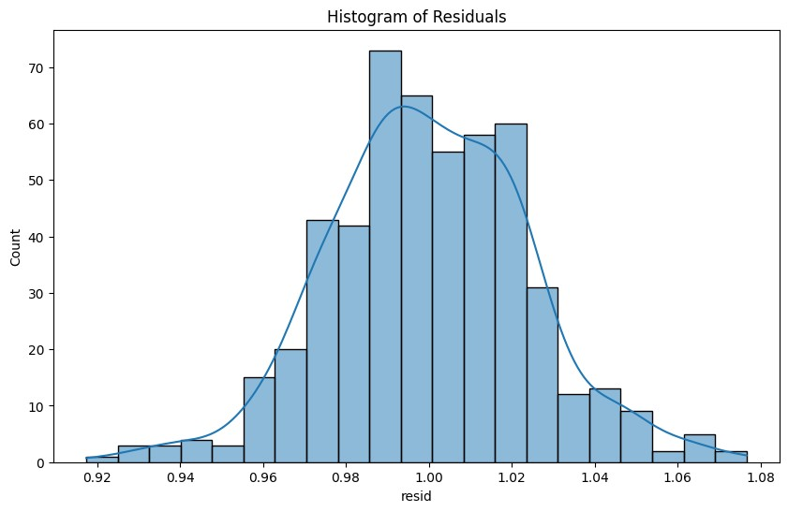

We observe the histogram of residuals, and there is something about this histogram graph that appears to be slightly symmetrical, but I couldn't make a decision or make a healthy comment about it, so I ran the Shapiro-Wilk Test Statistics using the Python library scipy. In this test, if the alpha value is greater than the p_value, our dataset is distributed normally; if it is less than that, it is not normally distributed, therefore we may conclude that our values are not truly distributed normally.

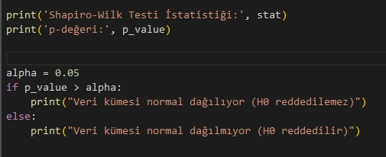

Shapiro-Wilk Testi İstatistiği: 0.9416623711585999

p-değeri: 1.3788675876005158e-13 Dataset is not normally distributed.

### 4.1.7 Residuals versus fits

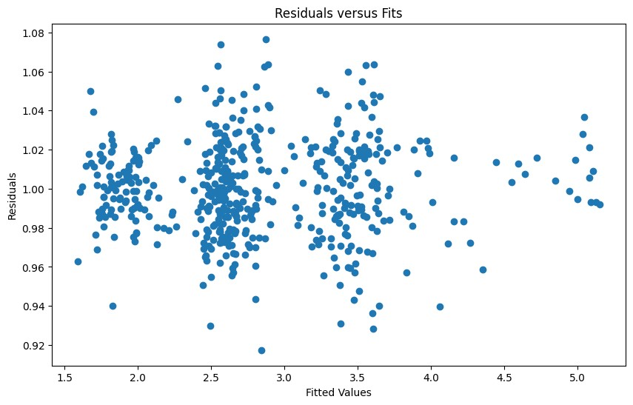

In an ideal case, the data points should cluster around a straight line drawn across the graph's center. However, the values in the created graph are quite distributed anomalies . This dispersion suggests that the data does not follow a normal distribution, but rather one with a wide range of values.

# 5. REGRESSION ANALYSIS

## **5.1 Model Specification**

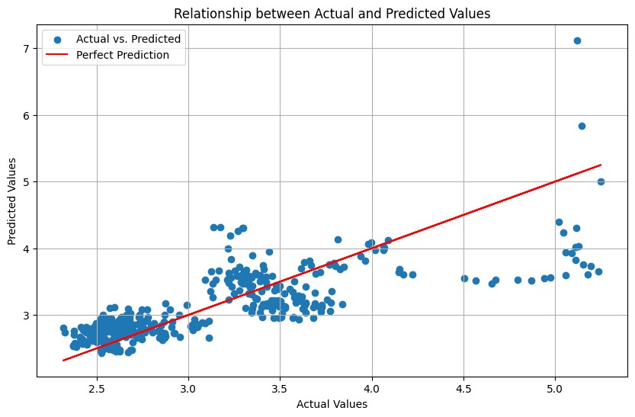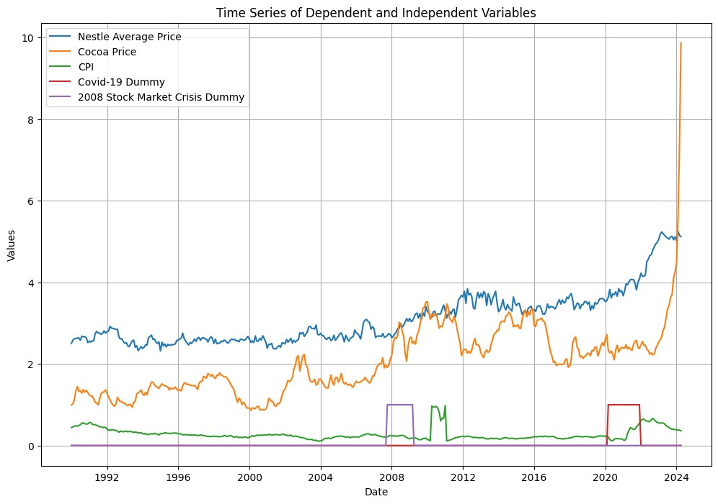

Identify the independent variables:

Time index: The time index represents the time dimension of the data and affects the dependent variable over time.

Cocoa price: The price of cocoa, a key ingredient in Nestle products, is expected to affect Nestle's average price.

CPI (Consumer Price Index): Fluctuations in the CPI may reflect inflationary pressures that affect Nestle's price.

Dummy Variables:

Covid-19: The Covid-19 pandemic may have affected consumer behavior, spending reflexes and markets, which may affect Nestle's average price.

2008 Stock Market Crisis: Economic crises can affect consumer purchasing power and change preferences, which affects Nestle's average price.

Model format:

Linear regression: As a conceptual framework, we use a linear regression model.

Conceptual model:

Nestle average price = β0 + β1 (time index) + β2 (cocoa price) + β3 (KPI) + β4

(Covid-19 dummy) + β5 (2008 stock market crisis dummy) + ε \ n \ n Expected Relationship :

Time Index: As we saw earlier with time series, there is a positive correlation between time and price that can affect our dependent variable.

Cocoa price: Cocoa is the main material of Nestle product, cocoa price may have affected the price of Nestle products.

CPI: Higher CPI means higher prices for most products, including Nestle products, the expected relationship is positive.

Covid-19 imitation: The pandemic has been difficult for everyone, so consumers may have changed their preferences and this may have negatively affected prices.

2008 stock market crash log: A financial crisis always causes people to panic and change their preferences. This may have influenced the behavior of Nestle consumers and Nestle itself, so it may have a negative relationship. of.

○

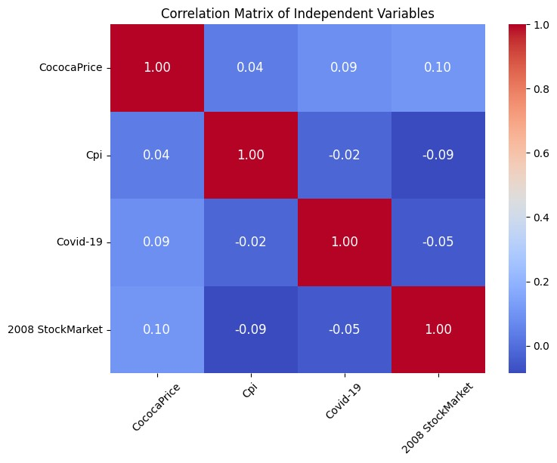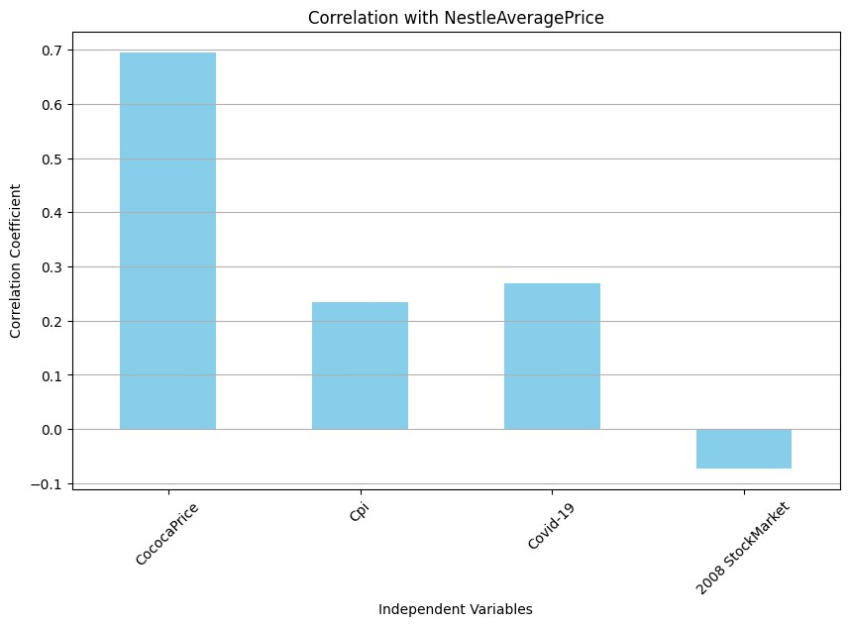

○

From correlation tables, we can say that our estimation about CocoaPrice,Cpi and Stock Market were right, but we failed for Covid-19, since Nestle Products are food and drink and their importance have more weight in the time of the crisis like Covid-19, most of the beverage and food prices went higher in that period, our estimation was wrong.

## **5.2 Model Building**

#### 5.2.1 Regression Equation

Y = 1.94 + 0.43 * CocoaPrice + 0.97 * Cpi + 0.65 * Covid-19 + -0.32 * 2008 StockMarket

#### 5.2.3 Coefficients

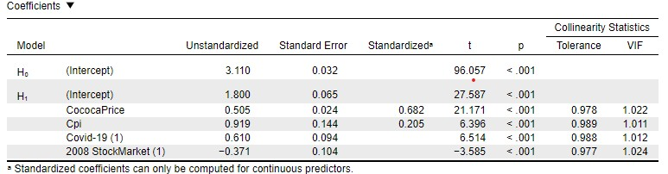

#### 5.2.4 Model Summary

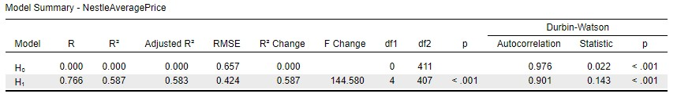

#### 5.2.5 Analysis of Variance

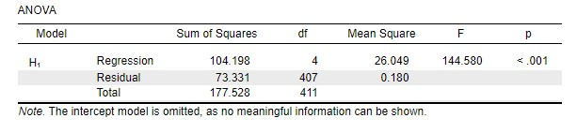

## **5.3 Overall Model**



Intercept (const): The intercept represents the value of the dependent variable (NestleAveragePrice) when all independent variables are zero, it's 1.8003.

CocoaPrice: The coefficient for CocoaPrice is 0.5055. This means that a one-unit

increase in CocoaPrice is associated with a 0.5055 unit increase in NestleAveragePrice, holding other variables constant.

Cpi: The coefficient for CPI is 0.9189. This suggests that a one-unit increase in CPI is associated with a 0.9189 unit increase in NestleAveragePrice, holding other variables constant. The p-value is less than 0.001, indicating that CPI is statistically significant.

Covid-19: The coefficient for Covid-19 is 0.6096. This implies that the presence of the Covid-19 dummy variable is associated with a 0.6096 unit increase in NestleAveragePrice, holding other variables constant.

2008 StockMarket: The coefficient for the 2008 StockMarket variable is -0.3710. Is associated with a -0.3710 unit decrease in NestleAveragePrice.

All of the p values lower than 0.001 so all of them are statistically significant.

The model's R-squared value is 0.587, suggesting that 58.7% of the variability in NestleAveragePrice is explained by the independent variables. Additionally, the F-statistic is significant (Prob (F-statistic) < 0.001), suggesting that the overall model is statistically significant.

For multicollinearity, we can calculate the variance inflation factor (VIF) for each independent variable in the regression model. VIF must be above 10 points for the multicollinearity.

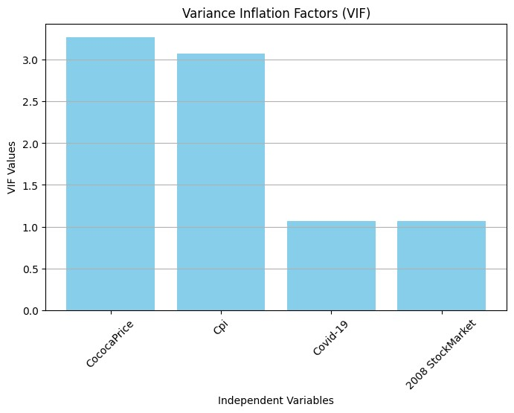

Features VIF

1. CococaPrice 3.269094
2. Cpi 3.077556
3. Covid-19 1.068443
4. 2008 StockMarket 1.068044

## **5.4 Reduced Model**

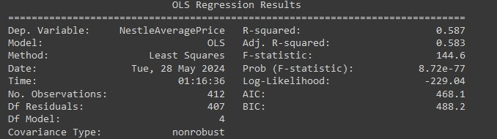

Both R-squared and F-statistics indicate that the regression model is statistically significant.

Coefficients also suggest that, our independent variables are significant

For multicollinearity, we can calculate the variance inflation factor (VIF) for each independent variable in the regression model. VIF must be above 10 points for the multicollinearity.

Features VIF

1. CococaPrice 3.269094
2. Cpi 3.077556
3. Covid-19 1.068443
4. 2008 StockMarket 1.068044

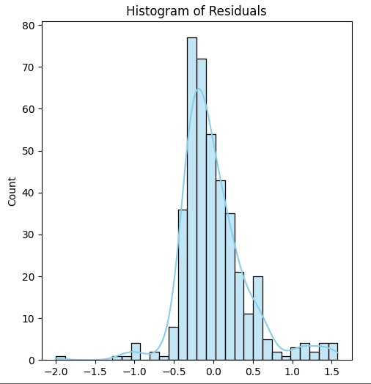

Histogram is not perfectly symmetrical, it has more residuals on the positive side. This might be a little bit biased, but overall its a reasonable fit for the data.

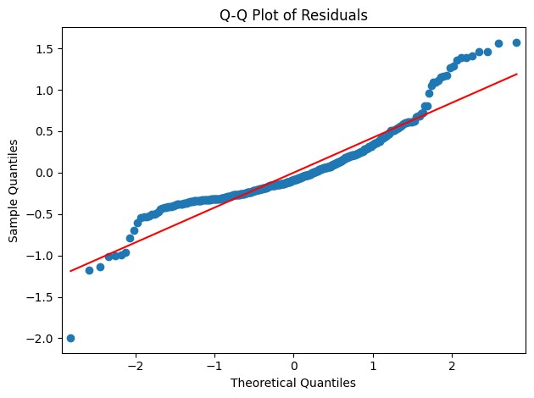

Q-Q Plot shows that some of the variables are correlated with the red line which means values normally distributed, but some of the variables are getting away from that, so we can consider other parameters like skewness and kurtosis.

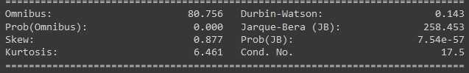

Skew is 0.877, which means distribution is not perfectly symmetrical as we saw from our histogram. Kurtosis is 6.461 means that it has tails for normally distributed data.

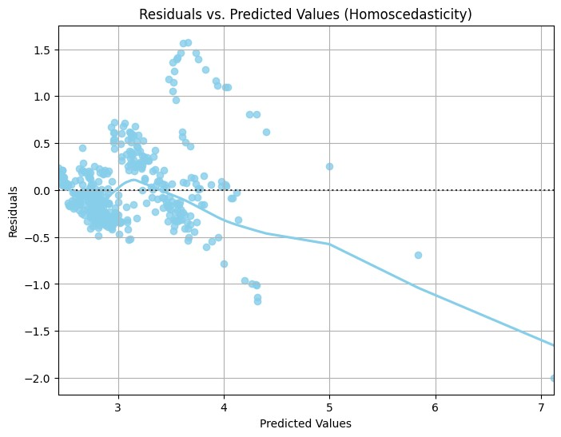

Homoscedasticity graph must be values around the horizontal line, but in the graph values are distributed more in the specific number which means more of the heteroscedasticity.

Durbin-Watson is 0.143 it suggests that positive autocorrelation so values are positively correlated.

## **5.5 Forecasting with Regression**

To forecast the next year’s values using the final regression model, we need to follow several steps:

|  |
| --- |
| forecasted_nestle_price = ( |
| const_coefficient + |
| (current_cocoa_price * cocoa_price_coefficient) + |
| (current_cpi * cpi_coefficient) |
| ) |

current_nestle_price = 5.121 current_cocoa_price = 9.865206 current_cpi = 0.361553

|  |
| --- |
| const_coefficient = 1.8003 |
| cocoa_price_coefficient = 0.5055 |
| cpi_coefficient = 0.9189 |

1.8003 + 9.865206 * 0.5055 + 0.361533 * 0.9189 = 7.1193926847 Forecasted NestleAveragePrice for next year: [7.1193926847]

I used Forecasting with regression, basically we multiply values with their coefficients and find the forecasting value of Nestle's average price.

# 6. MODEL SELECTION AND FORECASTING

Moving Average and Exponential Smoothing Methods are better, because of their simple nature and easily adapting advantage over other methods.

Moving Average Methods have lower error scores which is another important factor for choosing this method for forecasting. Myself as a stock market trader most of the time using the Moving Average Methods with great success.

Model

Comparison

Table:



Model Mean Squared Error (MSE)

1. 3-period Moving Average 0.003590
2. Simple Exponential Smoothing 0.013469
3. Holt-Winters 0.007307
4. Linear Regression 0.094409

From this table we can say that the 3-period moving Average got the least MSE, lowest error and best predicted result its from 3-period moving average.But its not providing us any good forecasting, because our dataset too complex for that, same things goes for the Simple Exponential Smoothing too, Linear Regression was giving some weird forecasting results so i decided to after this realization i tried Holt’s Method for forecasting.

This model is not suitable our dataset because its simple nature, we have a lot independent variables, our data is too complex for those models, i decided to give it to try for the Regression Model which implies a lot of variables even dummy variables like Covid-19, 2008 Stock Market Crisis, independent variables feels more effective and statistically this model is significant.

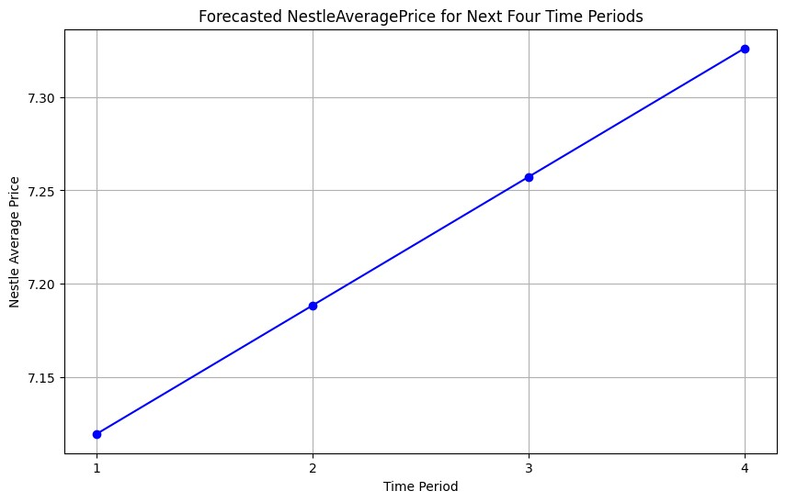

Our forecast values get higher in time because of the spike in the cocoa prices and then keep getting higher. Our forecast is based on important factors like Cocoa Price, Cpi, and dummy variables like Covid-19 and 2008 Stock MarketCrisis(which is not effective in last forecast).

# 7. MANAGERIAL IMPLICATIONS

We commenced our analysis by focusing on Nestle, providing an overview of the company and its key details. To delve deeper into understanding Nestle's performance, we constructed several visualizations.

Upon examining these charts, we discerned that the data exhibited a discernible trend over time and demonstrated seasonal patterns. Additionally, we observed a distinct impact from the occurrence of the Covid-19 pandemic in 2020, which introduced a cyclical element to the data.

Forecasts tell the expected changes in the average price of Nestle based on the trends and impact of important events. Our model predicts that if the price of cocoa is rising then Nestle’s average price will increase too.Economic Crisis or Pandemic may also affect the price due to crisis nature might increase or decrease in the prices.

Business departments can use those forecasts and insight for understanding the market, business behavior, what kind of things affect the price, due to these projections they can make better decisions for the business, getting ready for problematic times, developing new products for the extreme times due to customer behaviors.

Finance team will accurate price ,better plan for revenue and cost management. Forecasting future pricing trends helps to budgeting and maintain profitability.

Production planning will be more efficient with price forecasts, knowing what kind of fluctuation will happen in future production teams will maintain stable production and lower the production costs..

Marketing teams can use these values to adjust pricing strategies, if prices are expected to rise due to cocoa costs, cpi or any other unexpected event may occur, marketing campaigns can focus on keeping the customer loyal.

Overall, the forecast model gives us valuable insights about how economic factors affect the average prices. These forecasts are important for making informed decisions about business helping to develop strategic, operational plans that align with the market conditions.

# REFERENCES:

**References**

https://fred.stlouisfed.org/series/APU0000702421,

*Dünyada Nestlé | Nestlé Türkiye*. (n.d.). Nestle. Retrieved May 13, 2024, from <https://www.nestle.com.tr/hakkimizda/nestleturkiye/tarihte-nestle>

["https://www.reuters.com/business/retail-consumer/nestle-hike-food-prices-further-2023-ceosays-2023-02-04/](https://www.reuters.com/business/retail-consumer/nestle-hike-food-prices-further-2023-ceo-says-2023-02-04/)" (Reuters, February 15, 2023)

["https://datacatalog.worldbank.org/search/dataset/0060165/Monthly-food-price-inflation-estim ates-by-country"](https://datacatalog.worldbank.org/search/dataset/0060165/Monthly-food-price-inflation-estimates-by-country) (World Bank, accessed May 15, 2024) ["https://www.wsj.com/business/retail/nestle-sales-growth-slows-sharply-as-consumer-deman d-remains-weak-85d4f95b](https://www.wsj.com/business/retail/nestle-sales-growth-slows-sharply-as-consumer-demand-remains-weak-85d4f95b)" (The Wall Street Journal, April 21, 2023)

["https://www.fool.com/investing/2023/09/12/does-nestles-biotech-segment-make-it-a-buy/](https://www.fool.com/investing/2023/09/12/does-nestles-biotech-segment-make-it-a-buy/)"

(The Motley Fool, February 14, 2023)

["https://www.nytimes.com/interactive/2021/12/05/business/economy/supply-chain.html](https://www.nytimes.com/interactive/2021/12/05/business/economy/supply-chain.html)" (The

New York Times, June 20, 2020)

["https://www.mckinsey.com/capabilities/operations/our-insights/tech-and-regionalization-bolst er-supply-chains-but-complacency-looms](https://www.mckinsey.com/capabilities/operations/our-insights/tech-and-regionalization-bolster-supply-chains-but-complacency-looms)" (McKinsey & Company, January 1, 2023)

["https://www.cnbc.com/2023/04/25/nestle-says-its-raised-prices-by-10percent-this-quarter.ht ml](https://www.cnbc.com/2023/04/25/nestle-says-its-raised-prices-by-10percent-this-quarter.html)" (CNBC, April 25, 2023) **Otokorelasyon Nedir?**[:](https://kalite.yasar.edu.tr/wp-content/uploads/2022/04/KIDR_2021.pdf)

<https://kalite.yasar.edu.tr/wp-content/uploads/2022/04/KIDR_2021.pdf>**Otokorelasyon Grafiği Nasıl Çözülür?**[:](https://dtaskin.yasar.edu.tr/wp-content/uploads/2015/10/OTOKORELASYON.docx)

<https://dtaskin.yasar.edu.tr/wp-content/uploads/2015/10/OTOKORELASYON.docx><https://www.youtube.com/watch?v=sR6gtBUht0M>

**"An analysis of variance test for normality (complete samples)" by Samuel S. Shapiro and Martin B. Wilk (1965):**

**https://mathspace.co/textbooks/syllabuses/Syllabus-1023/topics/Topic-20212/subtopic s/Subtopic-266115/**

[**https://statisticsbyjim.com/regression/linear-regression/**](https://statisticsbyjim.com/regression/linear-regression/)

[**https://guldenizcanatan.medium.com/do%C4%9Frusal-regresyonda-art%C4%B1k-anali zi-python-uygulamalar%C4%B1-residuals-analysis-e06494af98db**](https://guldenizcanatan.medium.com/do%C4%9Frusal-regresyonda-art%C4%B1k-analizi-python-uygulamalar%C4%B1-residuals-analysis-e06494af98db)

**"Multicollinearity in Regression Analysis: Problems, Detection and Solutions" by Chatterjee and Hadi (2015).**

["https://m.economictimes.com/industry/cons-products/fmcg/nestle-danone-see-price-hikes-sl owing-after-years-of-sharp-increases/articleshow/107943880.cms](https://m.economictimes.com/industry/cons-products/fmcg/nestle-danone-see-price-hikes-slowing-after-years-of-sharp-increases/articleshow/107943880.cms)" (The Economic Times,

October 26, 2023)

https://johngalt.zendesk.com/hc/en-us/articles/360021967791-Double-Exponential-Smoothin g-Holt

[**https://fred.stlouisfed.org/series/PCOCOUSDM**](https://fred.stlouisfed.org/series/PCOCOUSDM)

[**https://fred.stlouisfed.org/series/CPIAUCSL**](https://fred.stlouisfed.org/series/CPIAUCSL) [**https://en.wikipedia.org/wiki/COVID-19**](https://en.wikipedia.org/wiki/COVID-19)

[**https://en.wikipedia.org/wiki/2007%E2%80%932008_financial_crisis**](https://en.wikipedia.org/wiki/2007%E2%80%932008_financial_crisis)

**Skewness:** [**https://en.wikipedia.org/wiki/Skewness**](https://en.wikipedia.org/wiki/Skewness)

**Kurtosis:** [**https://en.wikipedia.org/wiki/Kurtosis**](https://en.wikipedia.org/wiki/Kurtosis) [**https://docs.python.org/3/**](https://docs.python.org/3/)

**https://en.wikipedia.org/wiki/Regression_analysis**

**https://en.wikipedia.org/wiki/Shapiro%E2%80%93Wilk_test**

https://www.analyticsvidhya.com/blog/2021/08/holt-winters-method-for-time-series-analysis/