1)
Instance created.
The instructions missed a crucial step – to add another security group that would allow connecting to the instance.
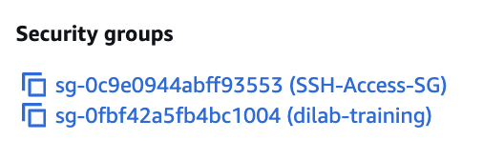
Following steps accessed the server and PostgreSQL
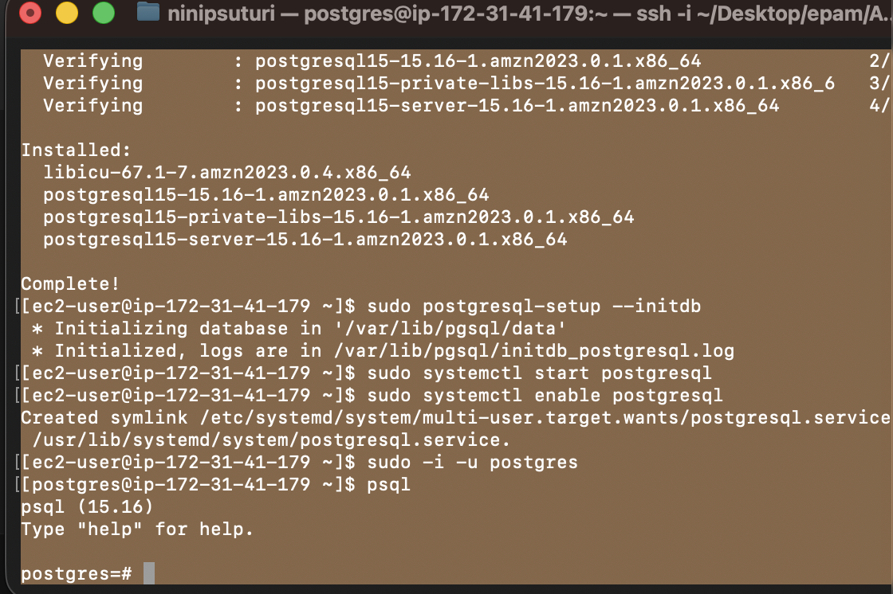
Table and view added.
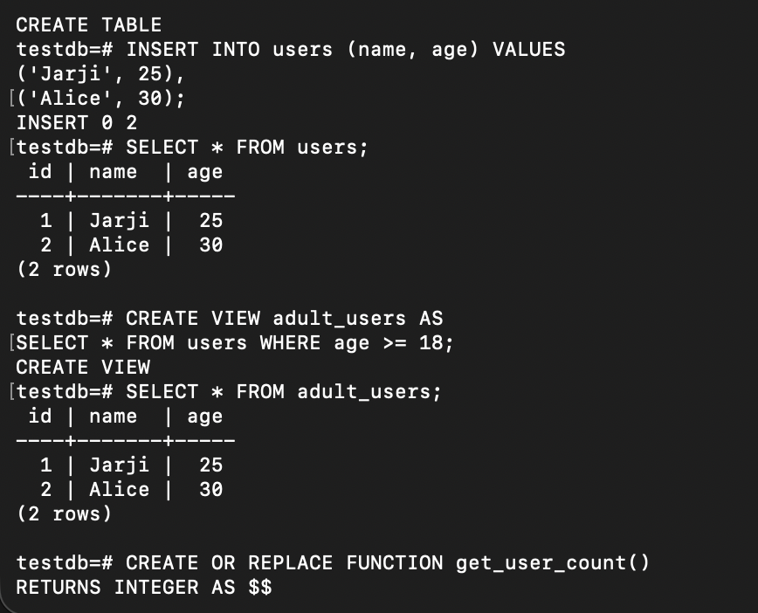

2)
Connecting to bucket, mine is there among the others.
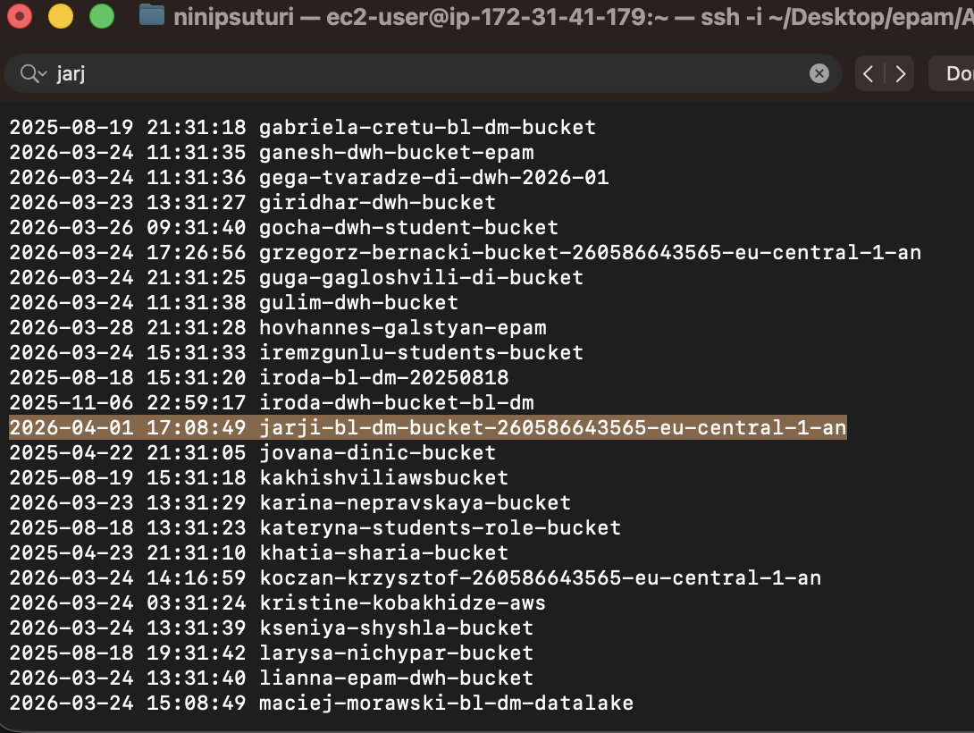

Specific file selected.
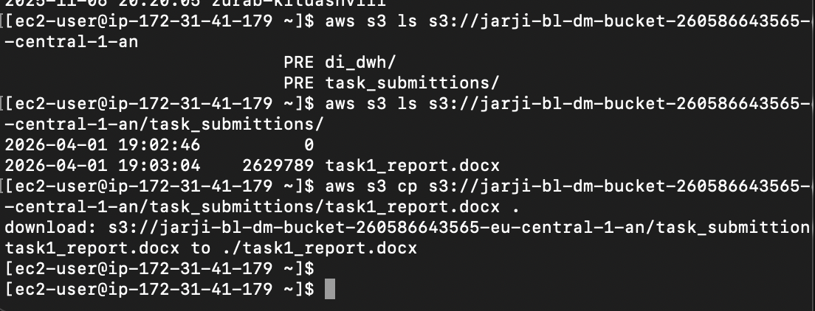

3)
Snapshot created.
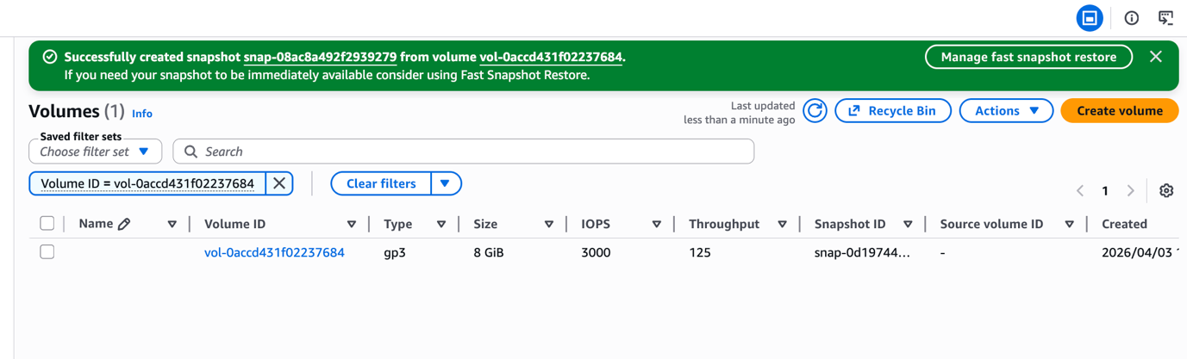
AMI created.
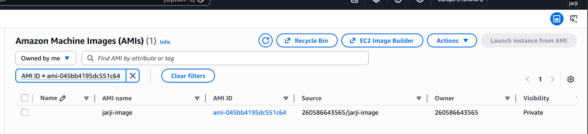

4)
Launching new instance using AMI, same settings as before.
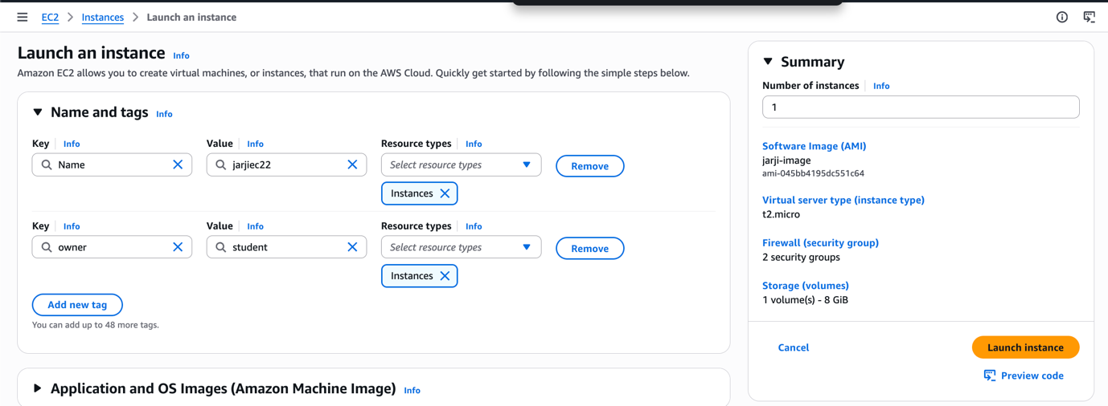
Machine cloned.
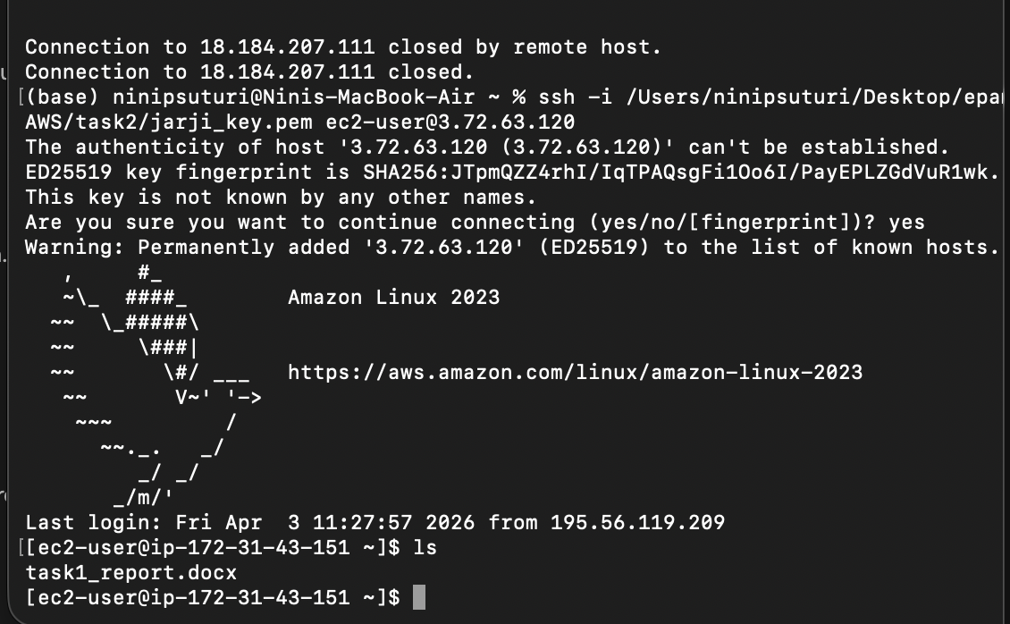

5)
HTML file created, browser to EC2 flow established
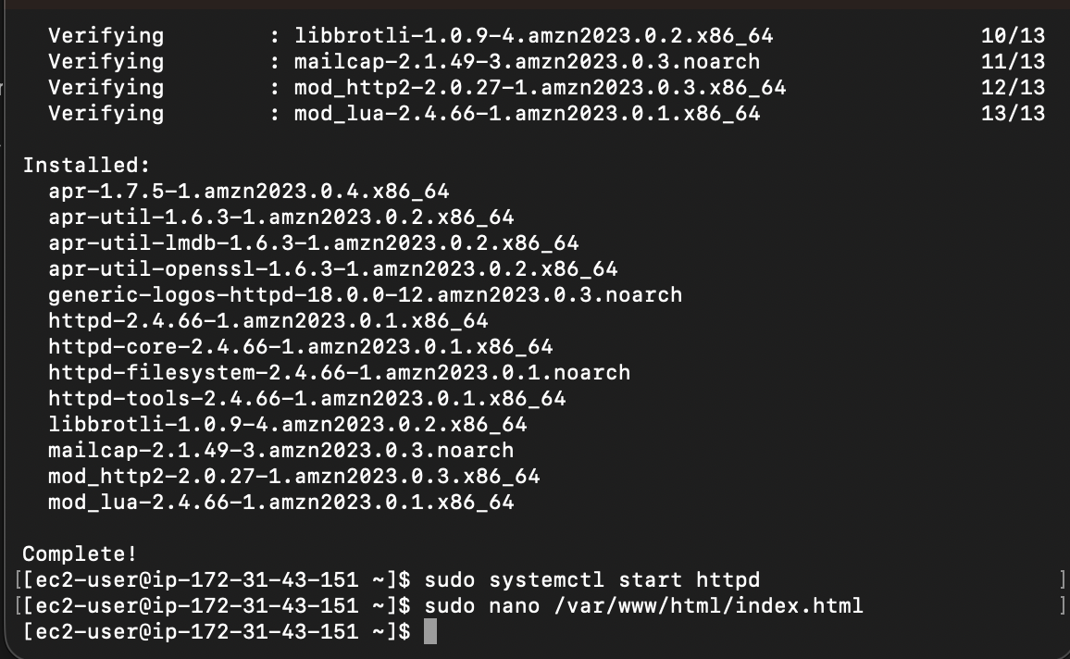
Turned into website.
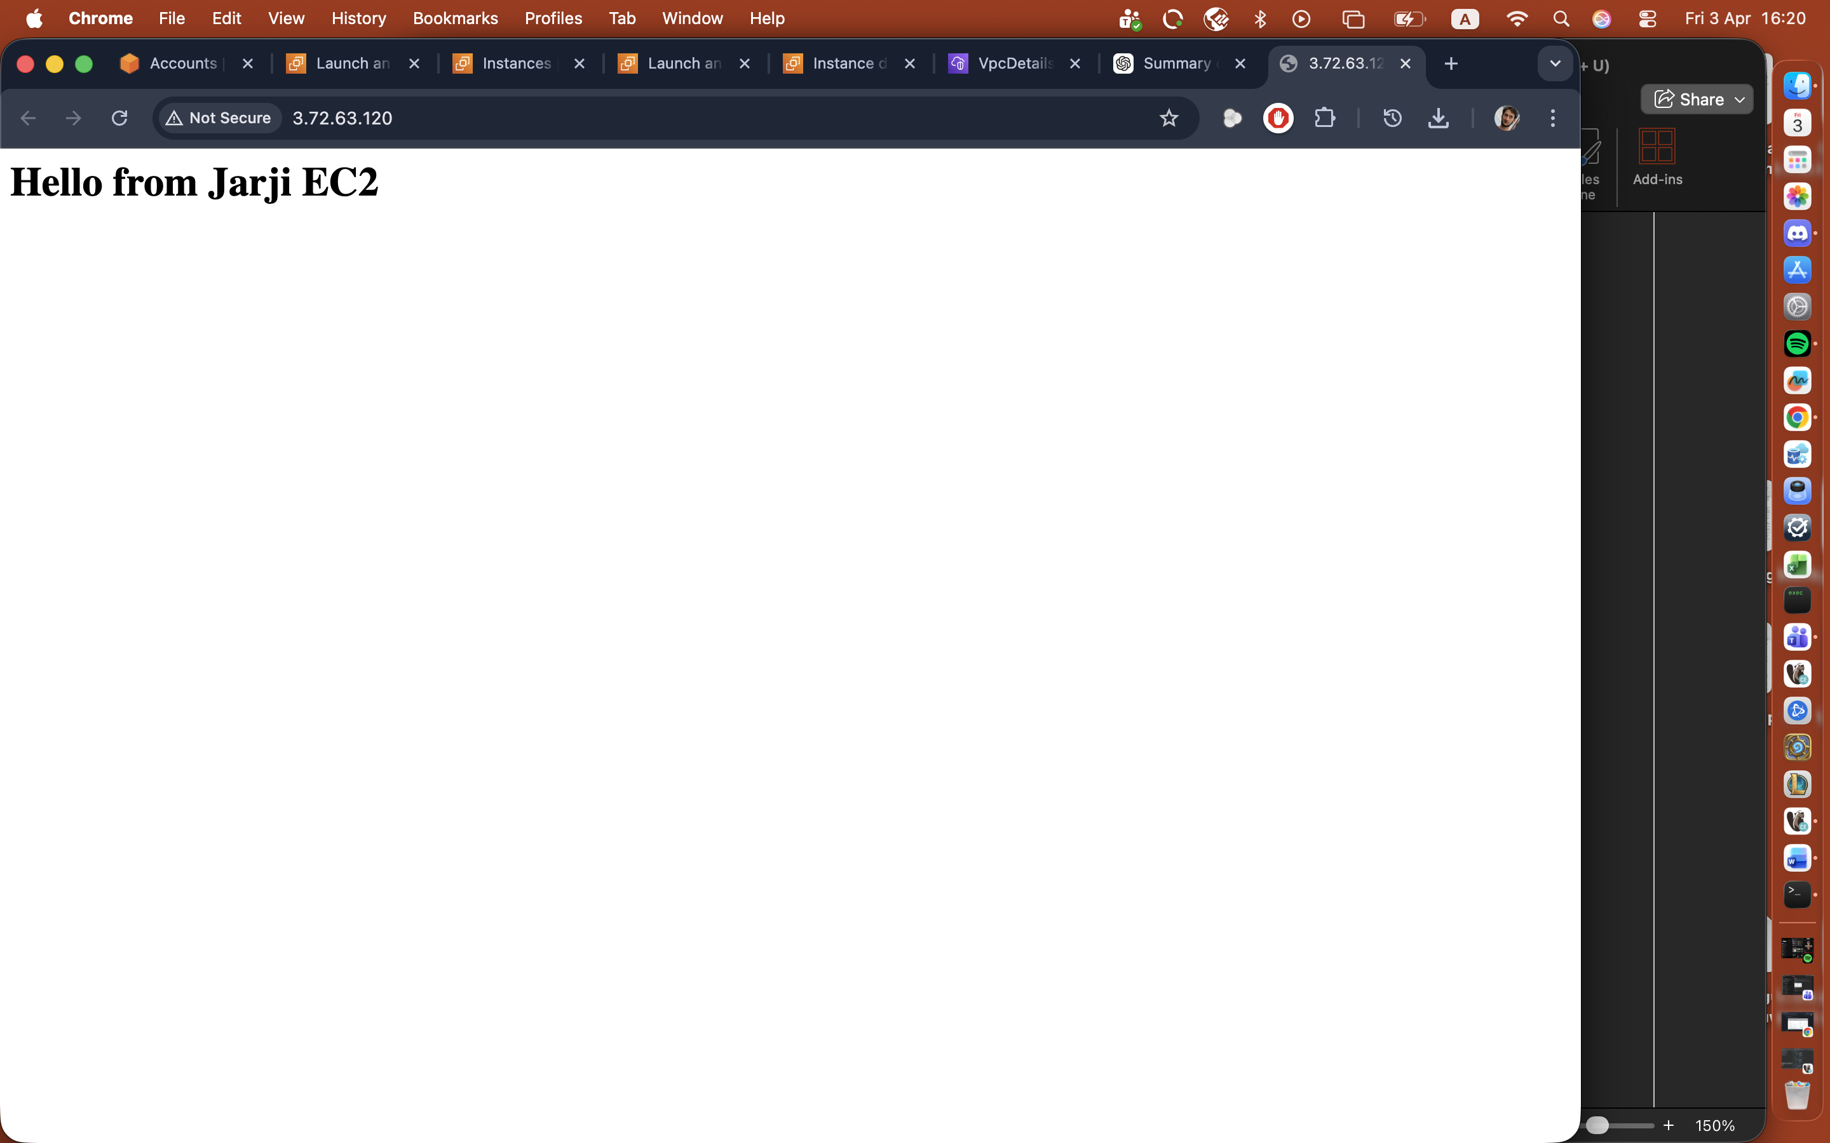

6)
Topic created, subscription created and confirmed.

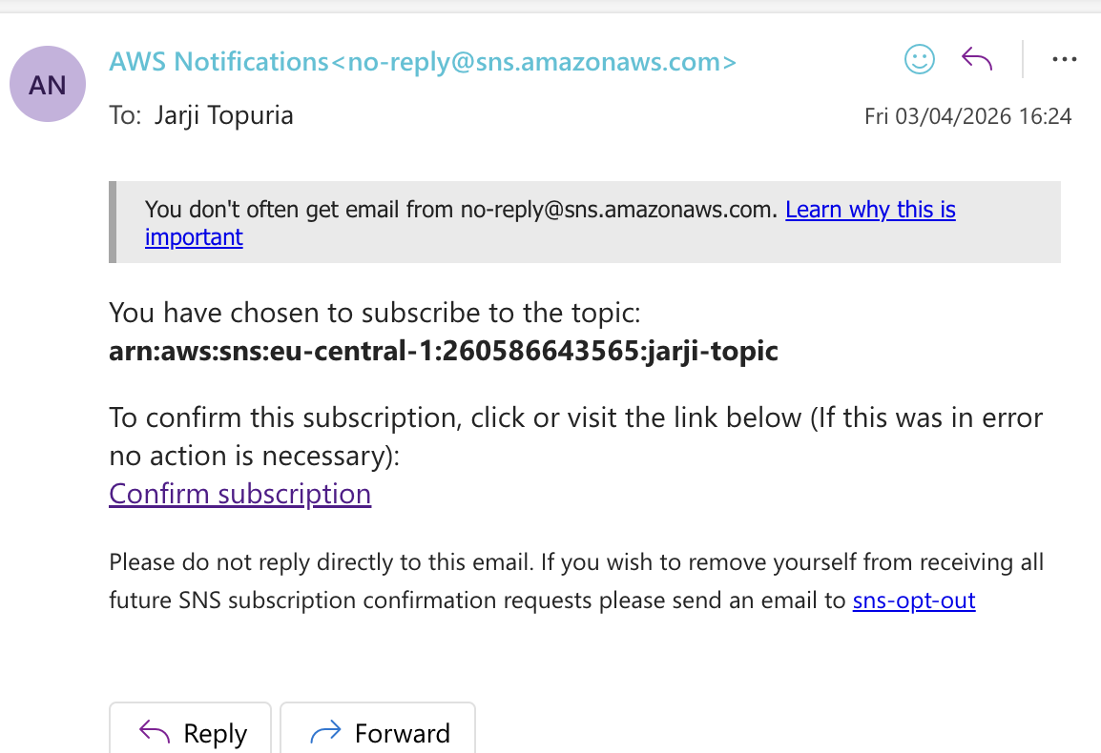
Setting up the alarm using my instance.
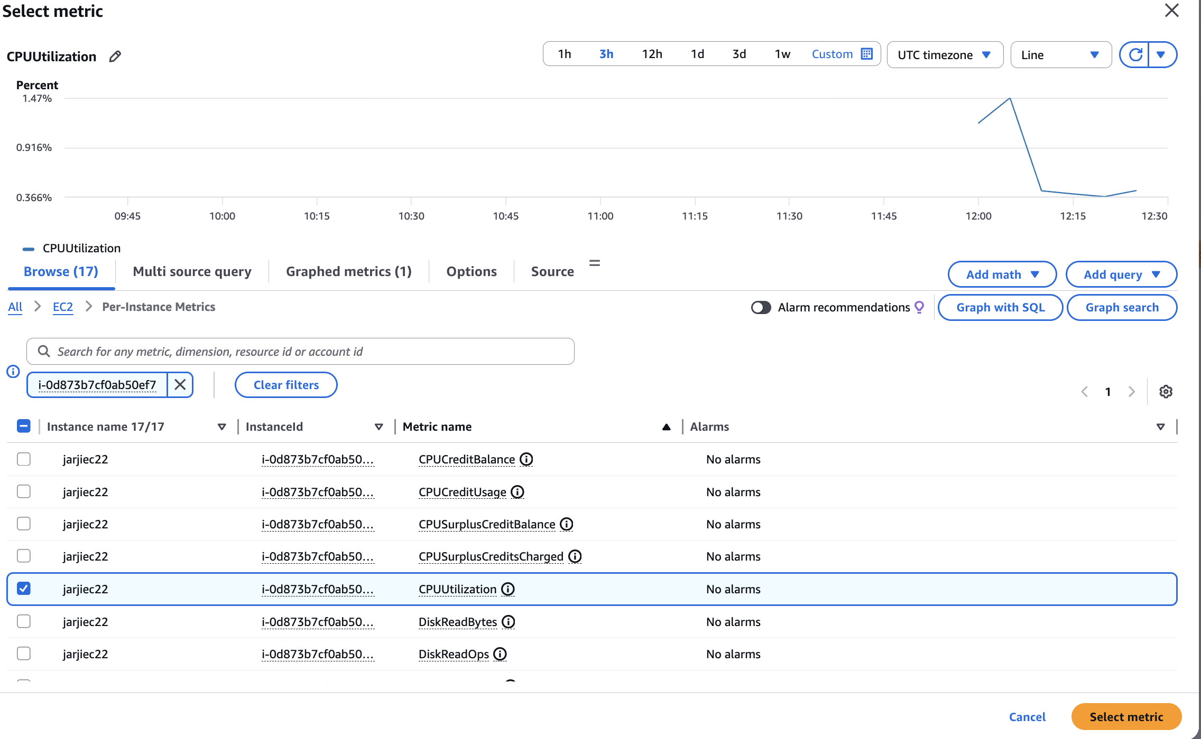
Metrics set up.
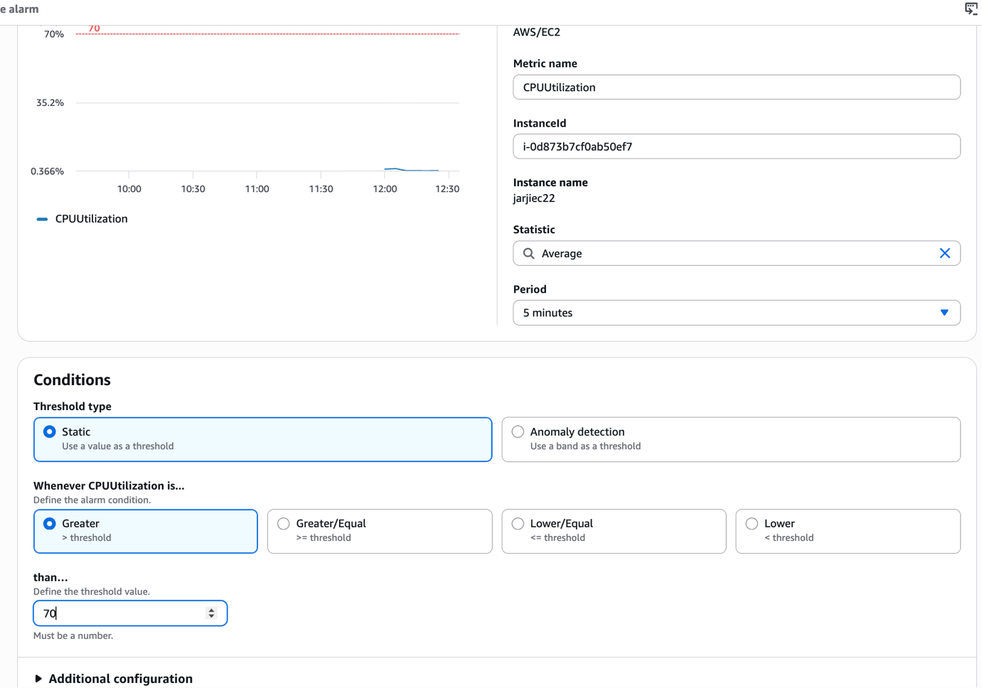
Alarm created.
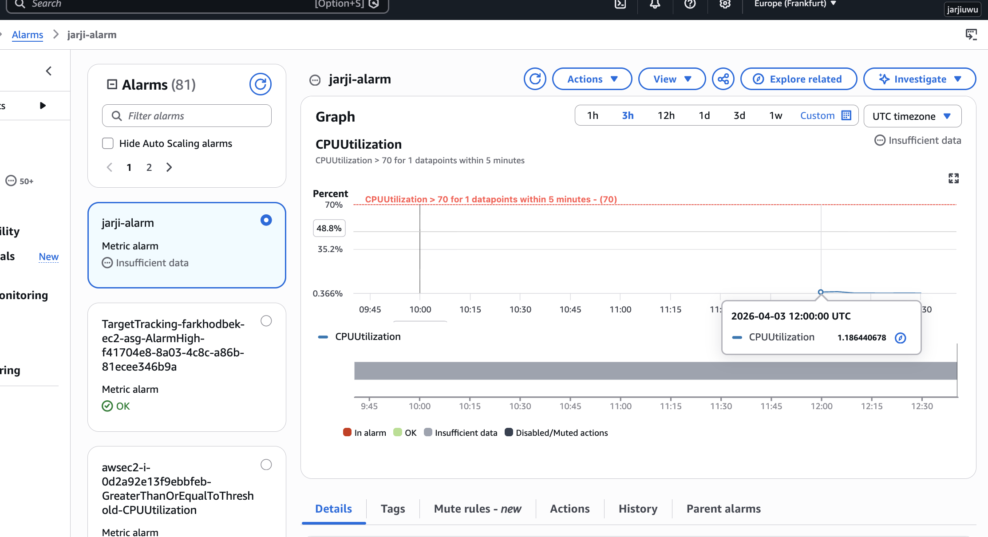

7)
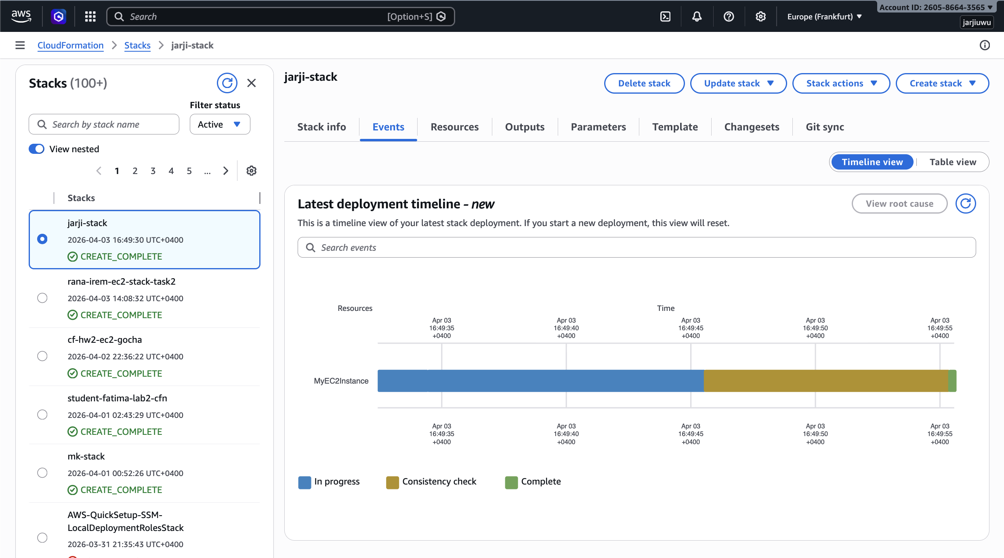
Stack created using template:
AWSTemplateFormatVersion: '2010-09-09'
Resources:
MyEC2Instance:
Type: AWS::EC2::Instance
Properties:
InstanceType: t2.micro
ImageId: ami-0e872aee57663ae2d
KeyName: jarji_key
SecurityGroupIds:
- sg-0fbf42a5fb4bc1004
- sg-0c9e0944abff93553
Tags:
- Key: owner
Value: student
- Key: Name
Value: jarji-cf-instance

