Connected to Redshift cluster via EC2.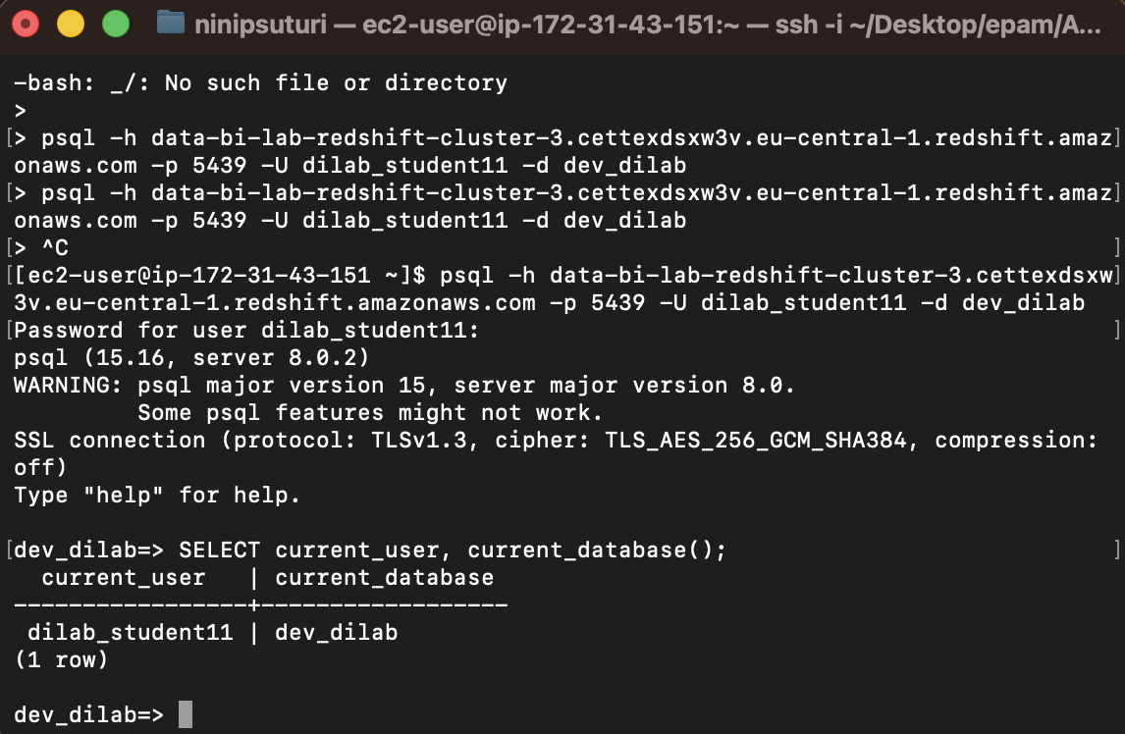
Loaded source tables from S3 using COPY command, namely product store and payment tables.
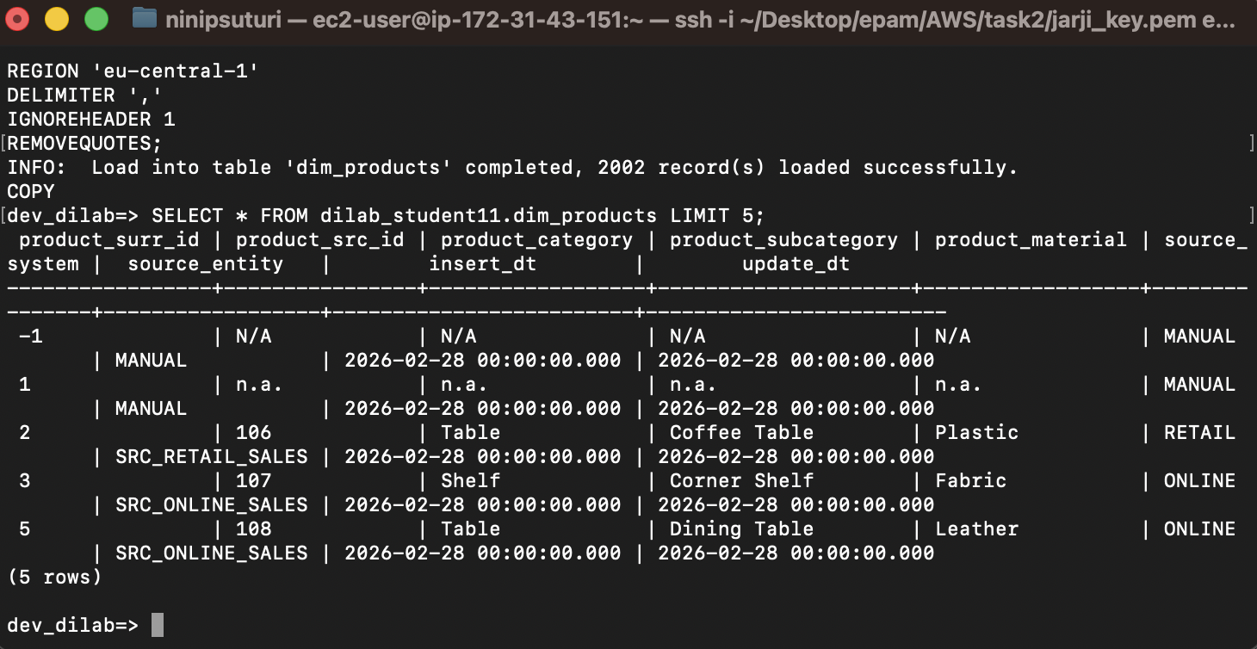
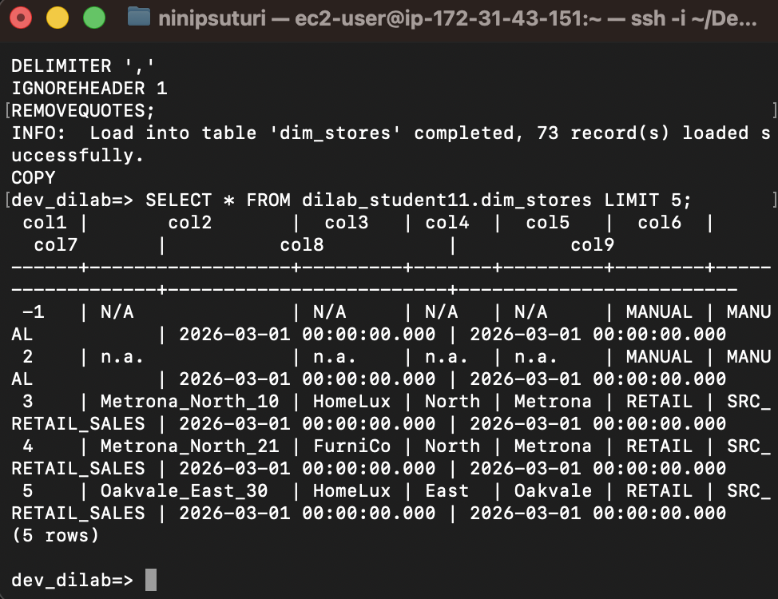
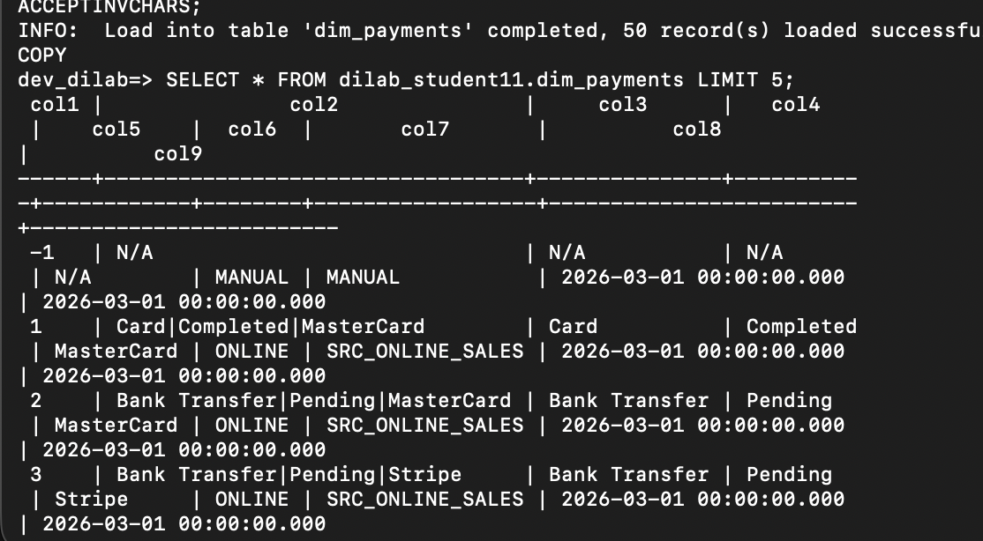

Checked column encoding for dim_products table.
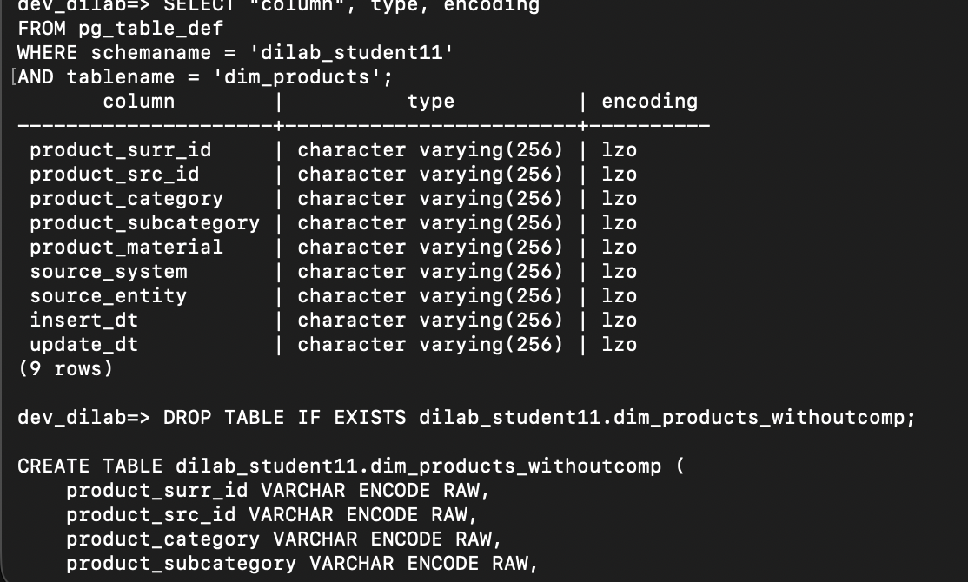

Created uncompressed table and analyzed compression.
A copy of the dim_products table without compression was created and populated with data. The ANALYZE COMPRESSION command was used to evaluate optimal encoding, but no improvements over existing compression were suggested.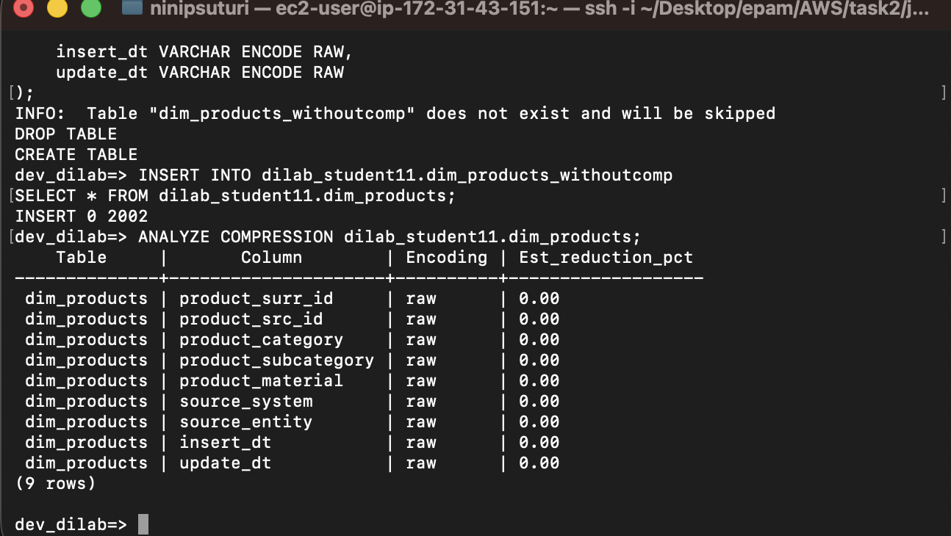

Created and executed stored procedure for report generation.
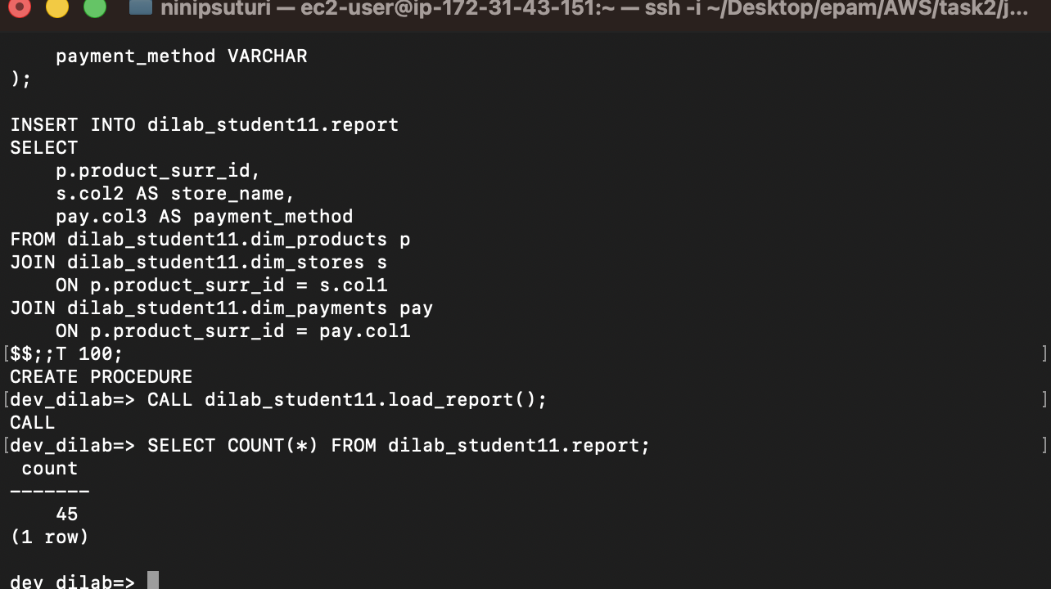

Query execution plan after optimization.
The execution plan of the optimized query is analyzed using EXPLAIN. The plan shows hash joins and sequential scans, indicating how Redshift processes joins between tables. The use of DISTSTYLE KEY helps reduce data movement across nodes, improving join efficiency.
