Auction House


Contents
1 Business Description 3
1.1 Business background 3
1.2 Problems. Current Situation 3
1.3 The benefits of implementing a database. Project Vision 3
2 Model description 3
2.1 Definitions & Acronyms 3
2.2 Logical Scheme 3
2.3 Objects 3

Business Description

Business background
Auction House sells antiques and artwork at auctions. The owners of items put up for auction by the company are the legal sellers.

Problems. Current Situation
After several successful years in business, company expanded and is facing challenges that come with scale. One of those challenges is to accurately keep track of information about items, buyers, sellers, auctions, employees and etc. for legal and business intelligence purposes.

the Benefits of implementing a database. Project Vision
Implementing a database allow managers and executives easier and quicker access to specific or general data. DBMS will also strengthen data integrity and consistency. Having a DBMS in place will be useful for cooperating with regulators, or conducting an internal analysis.

Model description

Definitions & Acronyms
Key sign – primary key
Lines between tables – relationships. 3-way branch at the end of the line means one to many relationship.
On the left of each table there are column names, on the right there are data types.
If there is a question mark at the end of data type, it means the value can be null.
If there is a flag at the start of data type, it means there is a default value.
If more than one column has a key sign, together they make a composite key.

Logical Scheme
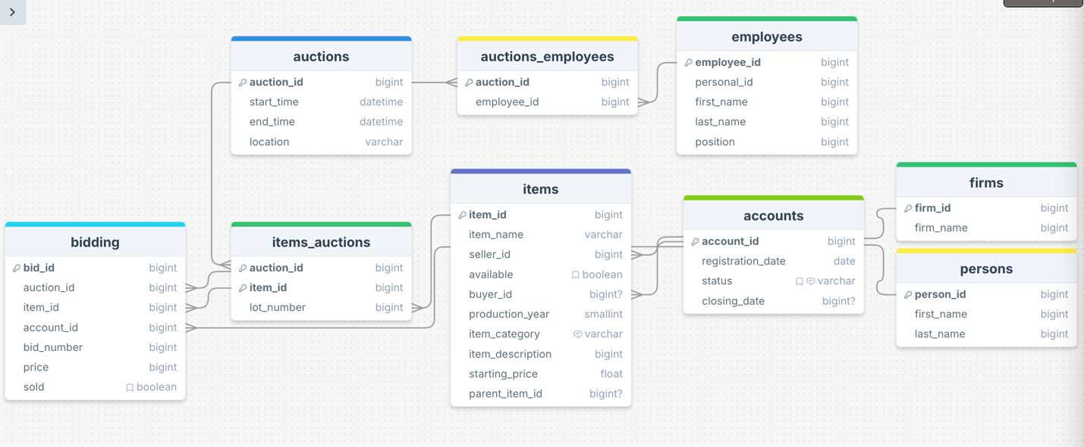

Objects

Table Description
<description>

Table Name | Field name | Field Description | Data Type
Firms | Firm_id | PK | int
 | firm_name |  | varchar

Table Name | Field name | Field Description | Data Type
Perrsons | Person_id | PK | Int
 | First_name |  | Varchar
 | Last_name |  | varchar

Table Name | Field name | Field Description | Data Type
Accounts | Accounts_Id | FK | Int
 | Registration_date |  | Datetime
 | Status | Default = Active | Varchar
 | Closing_date | Only for accounts that have status closed | datetime

Table Name | Field name | Field Description | Data Type
Items | Item_id | PK | int
 | Item_name |  | Varchar
 | Seller_id | FK | Int
 | Available |  | Boolean
 | Buyer_id | FK | Int
 | Production_year |  | Smallint
 | Item_category |  | Varchar
 | Item_description |  | Varchar
 | Starting_price |  | Float
 | Parent_item_id | Nullable, for items that come with other items | bigint

Table Name | Field name | Field Description | Data Type
Bidding | Bid_id | PK | Int
 | Auction_id | FK | int
 | Item_id | FK | Int
 | Account_id | FK | Int
 | Bid_number | Order of bid on that specific item during that auction | Int
 | Price |  | Float
 | Sold |  | Boolean

Accounts_id consists of one to one relationships with firm_id and person_id.
Accounts_id has one to many relationship with seller_id and buyer_id in items.
Example with data
Bidding takes FKs from various tables – it’s the table where most of information is logged

