Section 1
The size difference is caused by comparing different datasets. The car_prices dataset is significantly larger than the bank dataset, which explains why the parquet file is bigger. However, when the same dataset is stored in parquet and CSV formats, parquet is typically smaller due to compression and columnar storage.
Section 2
bank dataset
Contains customer information from a bank marketing campaign.
Typical fields: age, job, marital status, balance, loan info, contact results.
Used for:
- Predicting if a client will subscribe to a product (e.g., term deposit)
- Customer segmentation
- Marketing optimization
car_prices dataset
Contains used car sales data.
Typical fields: make, model, year, condition, mileage, selling price, seller type.
Used for:
- Price prediction
- Market trend analysis
- Inventory valuation

Section 3
Bank
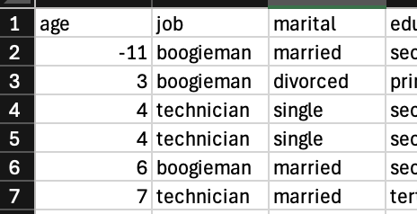
Several data quality issues were identified in the bank dataset:
- Invalid age values
Some records contain unrealistic age values (e.g., extremely high or very low). These are likely data entry errors and should be validated or removed.
- Missing or undefined values
Certain attributes, such as job, education, or contact, contain values like “unknown” or are left blank. This reduces the reliability of analysis and may affect model performance.
- Inconsistent categorical values
Some categories appear in slightly different formats (e.g., “admin.” vs “admin”), which can lead to incorrect grouping and aggregation.
- Outliers in financial data
The balance attribute contains extreme values, including unusually large positive or negative amounts. These may represent errors or exceptional cases that require verification.
Cars
The following anomalies were observed in the car prices dataset:
- Missing values in key fields
Important attributes such as make, model, or selling_price contain missing values, which limits their usability for analysis and modeling.
- Unrealistic price values
Some records show prices that are either too low or excessively high compared to typical market values. These entries may be incorrect and should be reviewed.
- Invalid production years
Certain entries include years that are not realistic (e.g., future dates or implausibly old vehicles), indicating potential data quality issues.
- Mileage inconsistencies
The odometer field includes negative values or unusually high mileage, which are not physically plausible and suggest data errors.
- Duplicate records
Some entries appear to be duplicated, which can distort analysis results and should be addressed through deduplication.

