Furniture sales – retail and ecommerce


Contents
1 Business Description 3
1.1 Business background 3
1.2 Problems because of poor data management 3
1.3 Benefits from implementing a Data Warehouse 3
1.4 DATASETS DESCRIPTION 3
1.5 GRAIN / DIM / FACT 4
2 Business Layer 3NF 4
3 Business Layer Dimensional Model 4
4 Logical Scheme 4
5 Data Flow 4
6 Fact Table Partitioning Strategy 4

Business Description

Business background
Furniture is an essential part of everyday life, as it is necessary for living, working, and resting spaces. There are many furniture stores that offer a wide variety of products, including items for different purposes, styles, budgets, and living conditions. Because of this wide availability, the furniture retail market is highly competitive. To be successful in this field, businesses must carefully analyze the factors that influence customers’ purchasing decisions. One effective way to do this is by collecting furniture sales data and analyzing it using appropriate analytical tools to better understand customer behavior and market trends.

Problems because of poor data management
Poor data management doesn’t let to do successful business because of insufficient information about what should you do next. If you don’t use instruments which can give you information for analysis and which can help you to come up with a business strategy you won’t be competitive in this or that field.

Benefits from implementing a Data Warehouse
Using of data warehouse can help you with the problems described above. Implementing a data warehouse can answer you the following questions:
- Which brands have the highest prices?
- Which ones have the widest distribution of prices?
- Is there a typical price distribution (e.g., normal) across brands or within specific brands?
Further processing data would also let you:
- Correlate specific product features with changes in price.
- If there are any differences between various types of furniture.
- And many other.

DATASETS DESCRIPTION
The analytical model is based on two fact datasets: retail sales and online (e-commerce) sales. Both datasets share common dimensions such as products and suppliers, enabling cross-channel analysis.
Dataset 1 - This dataset represents sales transactions that occur in physical retail stores.
Product Information:
- Product ID – unique identifier of the product
- Product Category – main furniture category (chair, table, sofa, bed, desk, etc.)
- Product Subcategory – detailed classification (office chair, dining table, etc.)
- Product Material – primary material (wood, metal, fabric, leather, plastic)
- Product Cost – cost of the product including manufacturing and logistics
Supplier Information:
- Supplier ID – unique supplier identifier
- Supplier Country – country of origin
- Supplier Size – small, medium, or large supplier

Store Information:
- Store ID – unique store identifier
- Store City – city where the store is located
- Store District – district within the city
- Store Brand – retail brand
Employee Information:
- Supplier ID – unique supplier identifier
- Supplier Country – country of origin
- Supplier Size – small, medium, or large supplier
Customer Information:
- Customer ID – unique customer identifier
- Customer Gender – male or female
- Customer Age – age of the customer
- Customer Segment – VIP, regular, or new

Dataset 2 - This dataset represents furniture sales made through the online channel.
Product Information:
- Product ID – unique identifier of the product
- Product Category – main furniture category (chair, table, sofa, bed, desk, etc.)
- Product Subcategory – detailed classification (office chair, dining table, etc.)
- Product Material – primary material (wood, metal, fabric, leather, plastic)
- Product Cost – cost of the product including manufacturing and logistics
Supplier Information:
- Supplier ID – unique supplier identifier
- Supplier Country – country of origin
- Supplier Size – small, medium, or large supplier
Online Sales Information:
- Online Transaction ID – unique identifier
- Order Date – date when the order was placed
- Landing Page – categories, product page, or main page
- Retail Price – listed online price
- Discount – discount percentage (applied only to a subset of orders)
- Sales Price – final transaction price
Customer Information:
- Registered Customer Flag – indicates whether the customer is registered
- Customer ID – populated only for registered customers
- Customer Registration Date – registration date for registered users
- Delivery Address – delivery location
- Delivered In (Days) – delivery time in days
Payment Information:
- Payment ID – unique identifier for each payment transaction.
- Payment Method – method used to complete the transaction (credit card, debit card, bank transfer, digital wallet, or cash on delivery).
- Payment Status – current status of the payment (completed, pending, or failed).

Together, these datasets provide an overview of furniture sales across retail and e-commerce channels, enabling analysis of sales performance, pricing strategies, customer behavior, and differences between online and in-store purchasing patterns.
While the two datasets share the major attributes, the retail dataset has a hierarchical breakdown of the location of the sale – city > district > store. The online dataset contains information about the landing page and promotional brand. Most of the products are shared among the two datasets. There are products unique to each source as well.

GRAIN / DIM / FACT
Business Process
We are modeling two related business processes within a single data warehouse:
- Online furniture sales through the website with delivery and online payment
- Retail furniture sales through physical stores with in-store employees
Both processes track individual product sales transactions.
Grain
The grain is one product per transaction across all channels.
Channel-specific details (store, employee, delivery, payment) are recorded through their respective dimensions and may be null depending on the sales channel.Dimensions
Dimensions
Product: details of the furniture sold.
Supplier: information about the supplier of the product.
Customer: demographic and registration information about the buyer.
Store: retail store location and brand (applicable for retail transactions).
Employee: sales employee information (applicable for retail transactions).
Delivery: delivery address (applicable for online transactions).
Payment: payment method, provider, and status (applicable for online transactions).

Facts
price_retail: original price of the product
price_discount: discount percentage applied (0.00–1.00)
price_sale: final sale price after discount
product_cost: cost of the product to the business
i_delivered_in: delivery time in days (online only, null for retail)
delivery_address: delivery location for online sales (null for retail)
date: transaction date
FACT_SALES
Contains transactional measures for all furniture sales, both online and retail. Each row represents one product sold in a single transaction. Shared measures include price_retail, price_discount, price_sale, and product_cost. Online-specific measures include i_delivered_in and delivery_address. Transaction date is included for all sales.
Column name | Description | Data Type
transaction_id | Unique identifier for each sale | BIGINT
date | Date when the transaction occurred | DATE
price_retail | Original price of the product | NUMERIC(10,2)
price_discount | Discount percentage applied (0.00–1.00) | NUMERIC(3,2)
price_sale | Final sale price after discount | NUMERIC(10,2)
product_cost | Cost of the product to the business | NUMERIC(10,2)
delivery_address | Delivery location for online sales | VARCHAR(100)
i_delivered_in | Delivery time in days (online only) | INTEGER

Example Data:
transaction_id | date | price_retail | price_discount | price_sale | product_cost | delivery_address | i_delivered_in
1 | 2023-05-15 | 450.00 | 0.10 | 405.00 | 270.00 | Tbilisi | 3
2 | 2023-05-16 | 1200.00 | 0.00 | 1200.00 | 720.00 | N/A | N/A
3 | 2023-05-17 | 850.00 | 0.15 | 722.50 | 510.00 | Batumi | 5

DIM_PRODUCT
Description: Product dimension containing furniture product details including category, subcategory, and material.
Column name | Description | Data Type
product_id | Unique identifier for each product | BIGINT
product_category | Main category of furniture (Chair, Table, Sofa, Bed, Desk, Cabinet, Shelf, Stool) | VARCHAR(50)
product_subcategory | Specific type within category | VARCHAR(100)
product_material | Primary material used (Wood, Plastic, Metal, Leather, Fabric) | VARCHAR(50)
Example Data:
product_id | product_category | product_subcategory | product_material
234 | Chair | Office Chair | Leather
789 | Table | Dining Table | Wood
456 | Sofa | Sectional | Fabric

DIM_SUPPLIER
Description: Supplier dimension containing information about product suppliers.
Column name | Description | Data Type
supplier_id | Unique identifier for each supplier | BIGINT
supplier_country | Country where supplier is located | VARCHAR(100)
supplier_size | Size classification of supplier (Small, Medium, Big) | VARCHAR(20)
Example Data:
supplier_id | supplier_country | supplier_size
1 | Georgia | Small
5 | China | Big
3 | Italy | Medium

DIM_CUSTOMER
Description: Customer dimension containing demographic and registration information.
Column name | Description | Data Type
customer_id | Unique identifier for each customer | BIGINT
customer_gender | Customer's gender (Male, Female) | VARCHAR(10)
customer_age | Customer's age in years | INTEGER
customer_segment | Customer segment (VIP, Regular, New) | VARCHAR(20)
registered_customer | Flag indicating if the customer is registered (online only) | BOOLEAN
customer_registration_date | Date the customer registered (online only) | DATE
Example Data:
customer_id | customer_gender | customer_age | customer_segment | registered_customer | customer_registration_date
15678 | Female | 34 | Regular | TRUE | 2021-02-15
23456 | Male | 52 | VIP | TRUE | 2020-11-22
89012 | Female | 28 | New | FALSE | N/A

DIM_STORE
Description: Store dimension containing retail store location and brand information.
Column name | Description | Data Type
store_id | Unique identifier for each store | BIGINT
store_city | City where store is located | VARCHAR(100)
store_district | District/area within the city | VARCHAR(100)
store_brand | Brand name of the store | VARCHAR(50)
Example Data:
store_id | store_city | store_district | store_brand
12 | Metrona | North | FurniCo
8 | Riverton | Central | HomeLux
25 | Oakvale | East | Decora

DIM_EMPLOYEE
Description: Employee dimension containing retail sales employee information.
Column name | Description | Data Type
seller_employee_id | Unique identifier for each employee | BIGINT
seller_employee_role | Employee's role (Manager, Consultant, Trainee) | VARCHAR(50)
seller_employee_years | Years of experience at the company | INTEGER
Example Data:
seller_employee_id | seller_employee_role | seller_employee_years
45 | Consultant | 5
22 | Manager | 12
78 | Trainee | 1

DIM_DELIVERY
Description: Delivery dimension containing online delivery address.
Column name | Description | Data Type
delivery_address | Address where the product is delivered | VARCHAR(100)

Example Data:
delivery_address
Tbilisi
Batumi
Kutaisi

DIM_PAYMENT
Description: Payment dimension containing online payment details.
Column name | Description | Data Type
payment_method | Payment method used (Card, PayPal, Bank Transfer, COD) | VARCHAR(50)
payment_status | Status of the payment (Completed, Pending, Refunded) | VARCHAR(50)
payment_provider | Payment provider (Visa, MasterCard, Stripe, PayPal) | VARCHAR(50)
Example Data:
payment_method | payment_status | payment_provider
Card | Completed | Visa
PayPal | Pending | PayPal
Bank Transfer | Refunded | MasterCard

Business Layer 3N
The initial datasets represented online and retail furniture sales as separate transactional sources with overlapping entities such as products, suppliers, customers, stores, employees, payments, and deliveries. Both datasets were first reviewed to identify common business entities and attributes in order to create a unified data model.
The grain of the data was defined as one product sold per transaction across all sales channels. This ensured consistent level of detail for both online and retail sales and allowed measures such as price and cost to be stored at the transactional level.
Next, shared entities from both datasets were consolidated into single tables in order to avoid duplication. For example, product, supplier, customer, and employee data were merged into unified entities rather than being stored separately for each sales channel.
The model was then normalized to Third Normal Form (3NF). All non-key attributes were made fully dependent on their primary keys, and transitive dependencies were removed. As part of this process, geographical data was separated into individual city and district entities, with stores referencing districts to ensure proper normalization.
Surrogate keys were introduced for all entities to ensure uniqueness and improve performance, while natural keys from source systems were retained for traceability. Source triplet attributes were added to support data lineage and integration from multiple datasets.
The customer entity was implemented as an SCD Type 2 table (CE_CUSTOMERS_SCD) to track historical changes over time using START_DT, END_DT, and IS_ACTIVE fields. All attributes were assigned specific data type lengths for consistency and storage optimization. NOT NULL constraints were applied to mandatory fields such as primary keys, source triplet attributes, and INSERT_DT to enforce data integrity throughout the model.
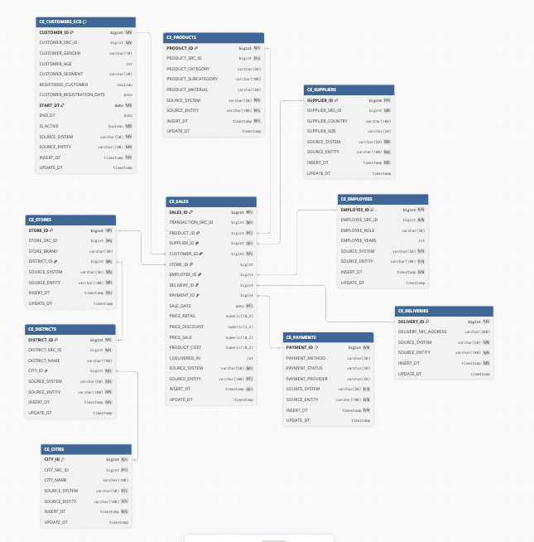

Business Layer Dimensional Model
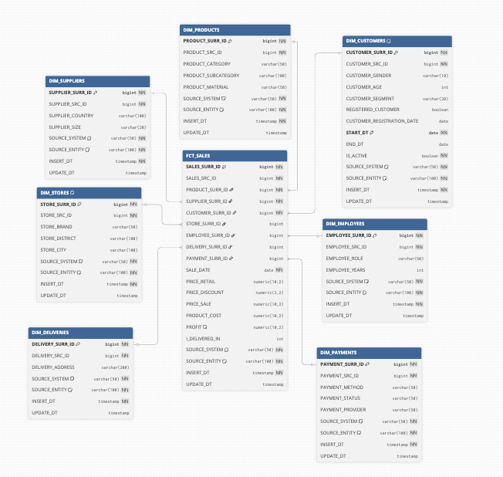

The fact table FCT_SALES contains the following metrics:
Base Metrics:
Metric | Description | Data Type
PRICE_RETAIL | Original retail price of the product | NUMERIC(10,2)
PRICE_DISCOUNT | Discount percentage applied | NUMERIC(3,2)
PRICE_SALE | Final sale price after discount | NUMERIC(10,2)
PRODUCT_COST | Cost of the product to the business | NUMERIC(10,2)
I_DELIVERED_IN | Delivery time in days | INTEGER
Calculated Metrics:
Metric | Formula | Description | Data Type
PROFIT | PRICE_SALE - PRODUCT_COST | Net profit per transaction | NUMERIC(10,2)

Logical Scheme
The DWH consists of four layers: Data Sources → Staging → 3NF (BL_3NF) → Dimensional Model (BL_DM).
Data is loaded from retail and online CSV files into staging tables.
It is then cleansed and normalized into 3NF tables (including SCD2 for customers).
Finally, the data is transformed into a star schema with dimensions and a fact table for analytics.

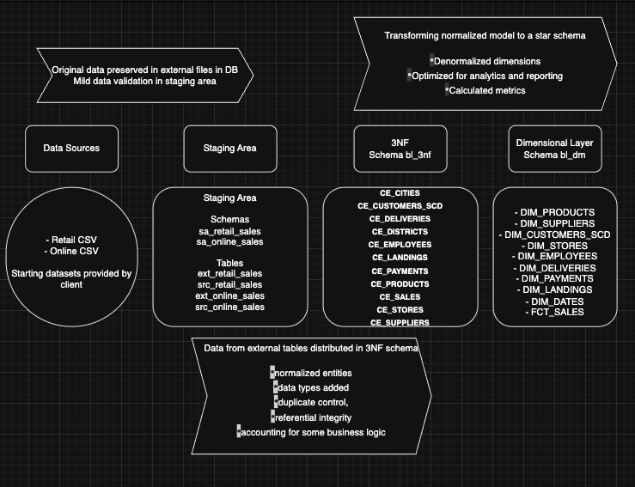

Data Flow
Source files → Staging tables → 3NF layer (cleaning, deduplication, SCD2) → Dimensional layer (denormalization, surrogate keys, fact loading).
The fact table stores measurable metrics such as sales, cost, profit, and delivery duration.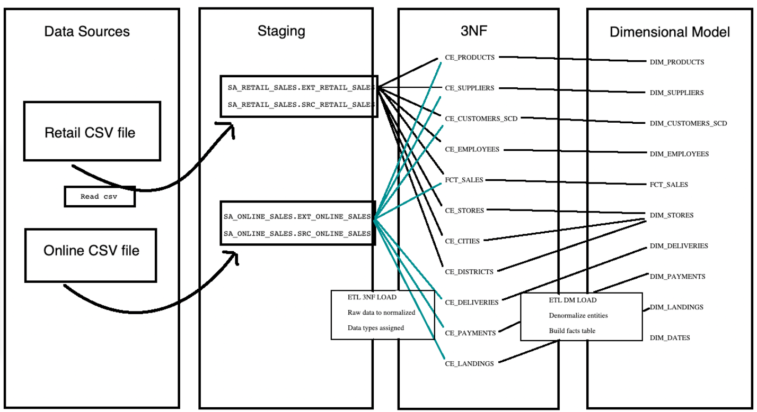

Fact Table Partitioning Strategy

