Contents
1 Business Description 3
1.1 Business background 3
1.2 Problems. Current Situation 3
1.3 The benefits of implementing a database. Project Vision 3
2 Model description 3
2.1 Definitions & Acronyms 3
2.2 Logical Scheme 3
2.3 Approach To Modeling 3

Business Description

Business background
Fuel Station Network buys, stores, distributes among its stations and sells various fuels. The company serves passing vehicles and corporate clients.

Problems. Current Situation
Company’s previous methods of tracking and manipulating information about their sales, purchases, operations, logistics, etc. were error-prone and slow. As company expands and scales it’s necessary to implement a solid digital database.

the Benefits of implementing a database. Project Vision
For an extremally scrutinized business such as fuel station network, it is imperative to have an effective and efficient system of tracking their operations for both external and internal purposes – legal obligations, safety, business maintaining and expansion interests. A robust, well-implemented database is one of the important keys to the goals above.

Model description

Definitions & Acronyms
PK – Primary Key, FK -Foreign Key
Lines between tables – relationships. 3-way branch at the end of the line means one to many relationship.
On the left of each table there are column names, on the right there are data types.
If more than one column has a key sign, together they make a composite key.

Logical Scheme
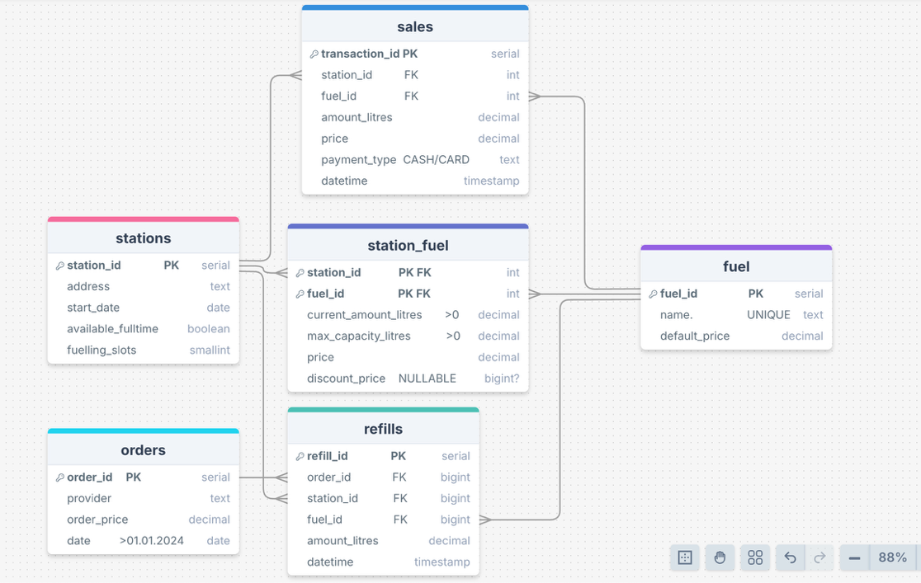

Approach To Modeling
The model tracks some of the core interests of the business – purchases, sales, locations, types of product.
Tables station and fuel describe the location and the types of products being sold at them.
Table station_fuel is there to capture the many to many relationship between fuels and stations – one station may contain multiple fuels and one type of fuel may be distributed in many stations. There is no guarantee that one type of product necessarily has the same price across all stations, so whenever we want to know how much certain fuel costs at a certain location, station_fuel table should be used.

Sales table contains information about the sales of the fuels at the stations – uses foreign keys from the corresponding tables. Price for the customers should be calculated with trigger/function that will fetch the current information from station_fuel table. If the company implements any discounts for specific groups, or for marketing purposes, it will conditionally override the usual price.
Tables orders and refills cover procurement of the fuels. Our model serves the idea where after an order is placed, company receives certain amounts and types of fuels in its stations and the price of the order is calculated afterwards. There is one to many relationship between orders and refills table – during one order more than one refill may occur in one or more stations.

