1) Establish connection to AWS account:
VPN installed and activated.
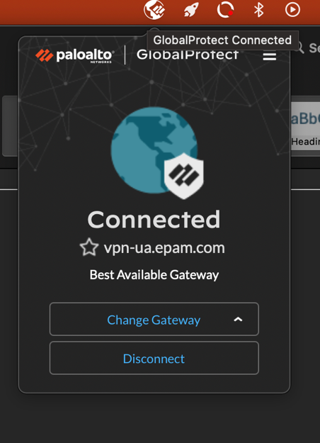
Using Frankfurt connection.
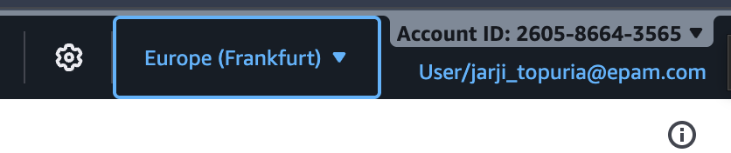

Switched to student.
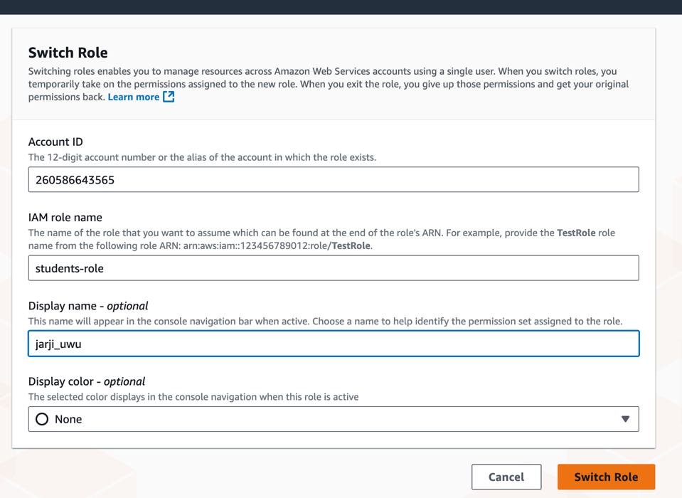

AWS CLI installed.
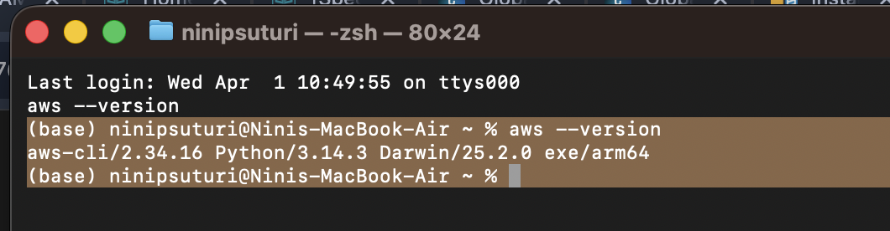

Info added to config file.
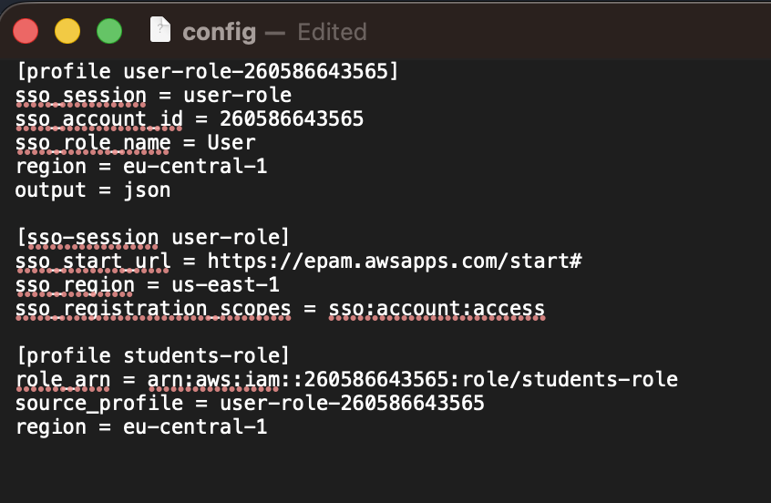

Student-role assumed.
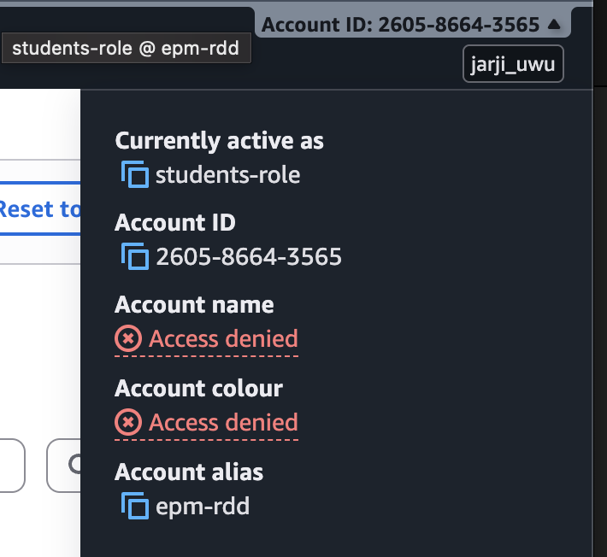
Getting correct information.
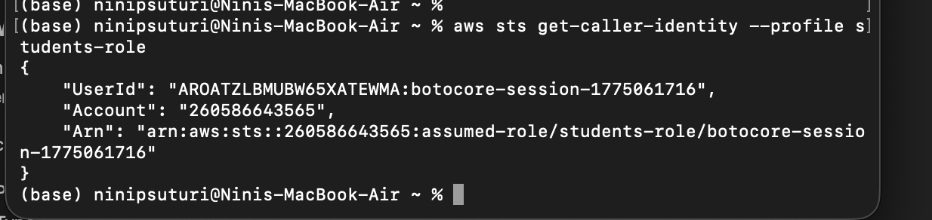

2) Working with AWS services:
Bucket created, file uploaded with API:
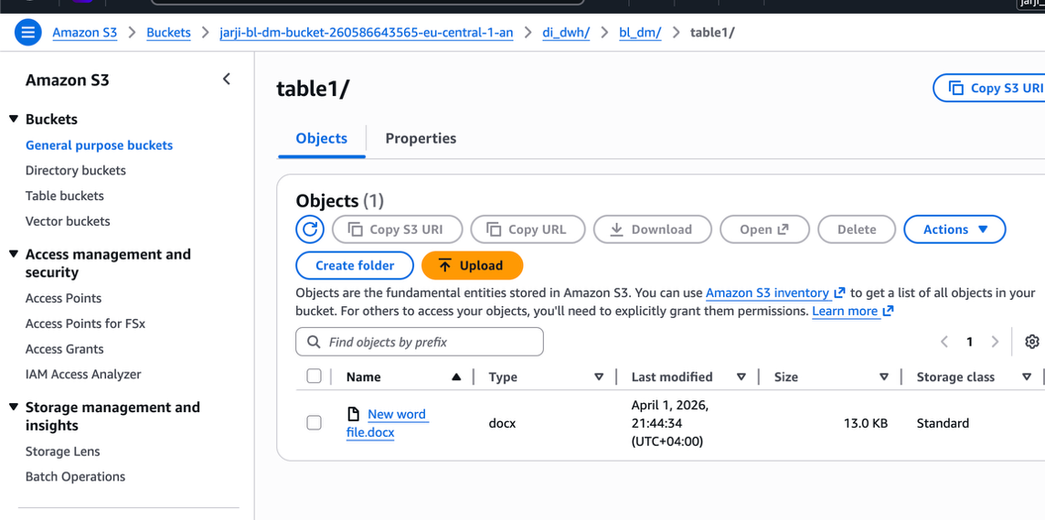

Files from the previous project uploaded.
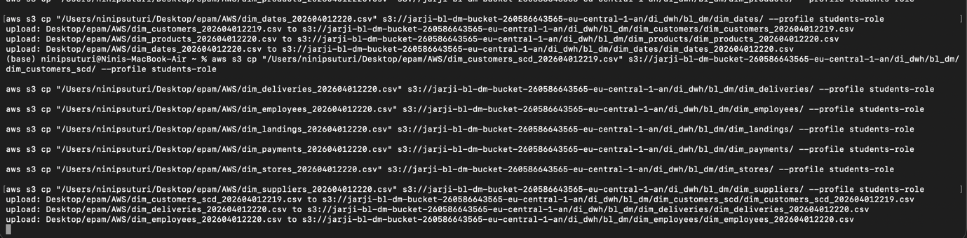

Crawlers used.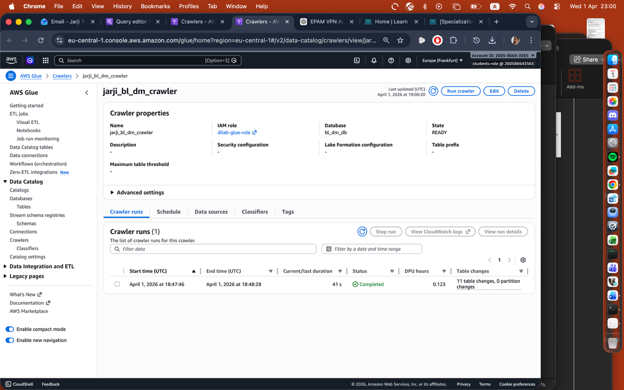

Table added queries can be used. Problem is it’s added in a shared space with other people who have same table names.
