Report Home Directories with No Files Modified in Last 90 Days

*System Requirements & User Guide*

# SYSTEM REQUIREMENTS

## User Permissions

* The logged on user must have the following permissions:
  + Local Administrator privileges
  + Full Control permissions (folder and all subfolders) on all Home Directory paths
* Before running the script, the Powershell execution policy must be set to unrestricted. To set the execution policy as required, open a Powershell prompt via “Run as Administration” and execute the following command:

*Set-ExecutionPolicy Unrestricted*

## Software Requirements

* Windows 7 (or newer)
* Microsoft .NET Framework (3.5.1 or 4.5)
* Windows PowerShell – Windows Management Framework 4.0 (Recommended)

# USER GUIDE

## Folder Contents

* ReportOldHomeDirs.ps1

*PowerShell script for reporting home directories that do not have files modified in last 90 days*

* ReportOldHomeDirs.bat

*Launcher used to run the script*

* README.pdf

*This document*

* ExampleReport.html

*Example of the report output*

## Functions Performed by this Script

* Creates and HTML report on all Home Directories with the “zzz_” prefix that do/do not have modified files within the last 90 days.

## Running the Script

1. Right-click on *ReportOldHomeDirs.bat* and then click on *Run as administrator*.

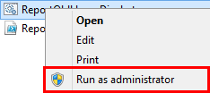

1. If prompted, click on *Yes* at the UAC Prompt.
2. In the *Browse For Folder* window, browse to the root directory that contains the users home directories and then click OK.

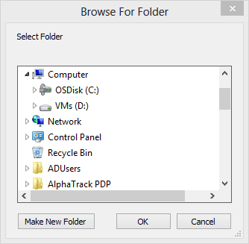

1. The Powershell command prompt window remains open when the script has completed executing. Review the output in the command prompt window for errors (red text in console) and then click on the *X* to close the window.

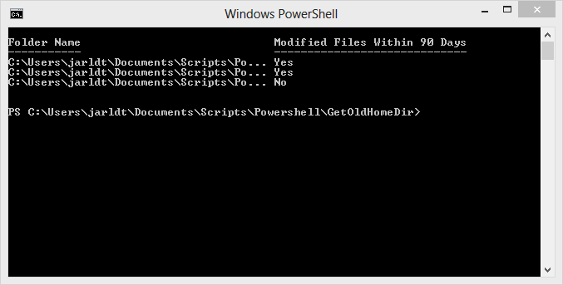

1. If no errors occurred, open Windows Explorer and browse to the directory where you extracted the script
2. In the script directory, you will find an HTML report named like the following:  
     
   *Report-HomeDir_Not_Modified_In_90_Days__<Time Stamp Here>.html*