GetBrokenDrivers

System Requirements & User Guide

# SYSTEM REQUIREMENTS

## User Permissions

* The logged on user must have the following permissions:
* Full Administrator permissions in ConfigMgr
* Permissions to access the UNC paths for all drivers imported into ConfigMgr

## Software Requirements

* Windows 7 (or newer)
* Microsoft .NET Framework (3.5.1 or 4.5)
* Windows PowerShell
  + Windows Management Framework 4.0 (Recommended)
* System Center 2012 Configuration Manager Admin Console

# USER GUIDE

## Folder Contents

* GetBrokenDrivers(x64).bat  
  PowerShell script launcher for 64-BIT systems
* GetBrokenDrivers(x86).bat  
  PowerShell script launcher for 32-BIT systems
* GetBrokenDrivers.ps1  
  The PowerShell script to generate a .csv file of all drivers with a broken content source path
* README.pdf  
  This document

## Functions Performed by this Script

* Generates a .csv (comma delimited) file for all drivers in ConfigMgr with a broken content source path

## Running the Script

1. Edit the GetBrokenDrivers(x64).bat or GetBrokenDrivers(x86).bat and change the value after –SiteCode to the site code of your ConfigMgr environment.  
   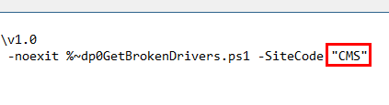
2. Double-click on either GetBrokenDrivers(x64).bat or GetBrokenDrivers(x86).bat depending on the architecture of your installed Operating System.
3. The Powershell command prompt window remains open when the script has completed executing. Once the script has completed, you will see the following line in the CMD prompt:   
   “The script has finished executing.”
4. The CSV file is created in the same directory as the script. The file is named like the following:  
     
   GetBrokenDrivers_<year><month><day><hour><minute>.csv  
     
   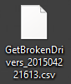
5. Review the output in the command prompt window for errors and then click on the X to close the window.  
   