Deliverable 2 – Group 97

**Implementation**: We’ve done the implementation ourselves, with inspiration coming from the pdf handout. We’ve chosen to use the given Map_Obj() file in the handout as visualizer.

**How to run the code:** In order to run the code, all you have to do is run the python file named «main.py». This will run all the five tasks sequentially. A map will show up for each of the tasks where you can see the goal path plotted in yellow. Some of the solutions take a bit of time to compute.

**Visualizations:** You can see the maps with the plotted goal below:

**Task 1:**

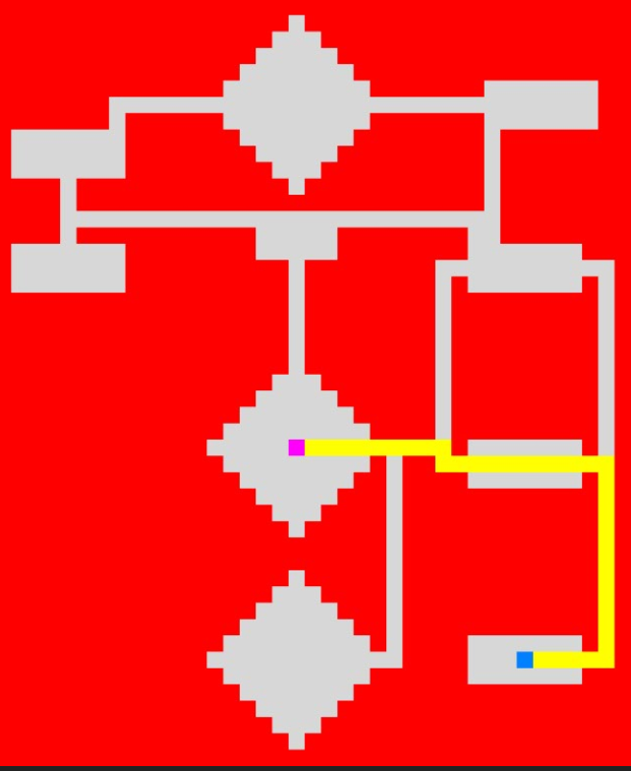

**Task 2:**

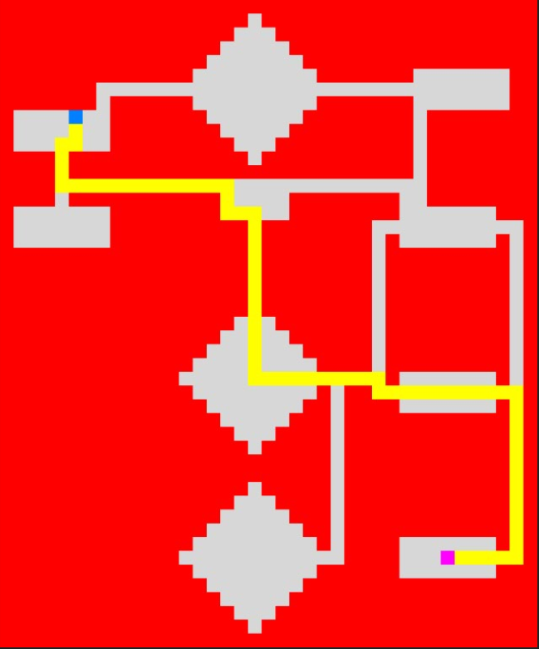

**Task 3:**

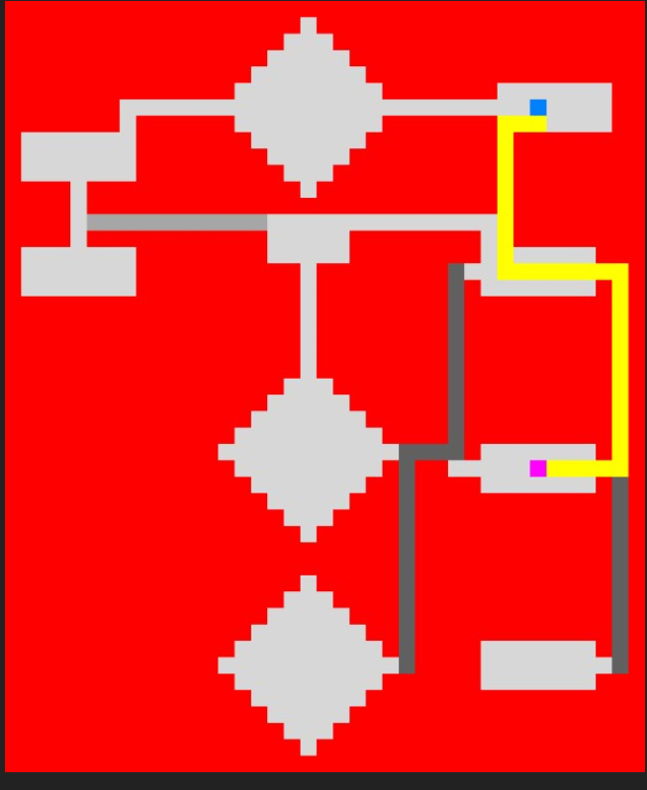

**Task 4:**

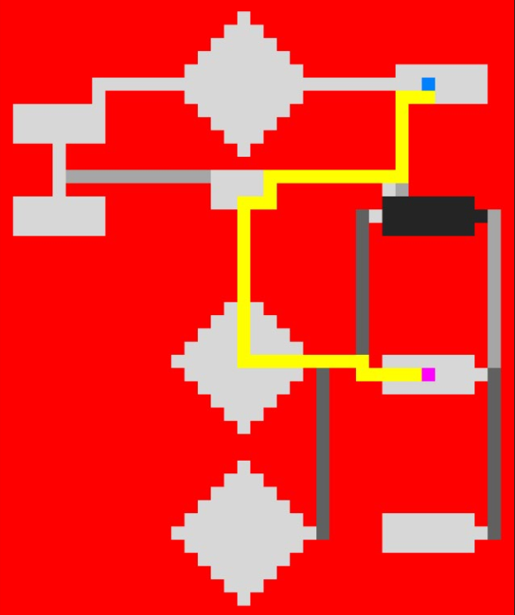

**Task 5:**

