Design:
- Open the template tool (First QR code on reverse)
- Choose a template and font.
- Use the “Customize” tab to customize to your liking.
- Preview the design to show the SVG that will be used for cutting.
- Share Design to save it as an SVG.
- Upload the SVG to the file server for cutting:

Prepare for cutting:
- Move over to Lightburn PC
- Open Firefox and go to
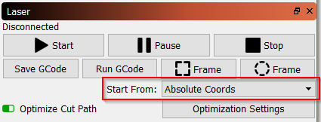
- http://vinyl.lan/
- Find your design in the uploads and download it to: Documents/Lightburn Projects/
- Open Lightburn from the Desktop
- File→Import, open your design from the imports folder
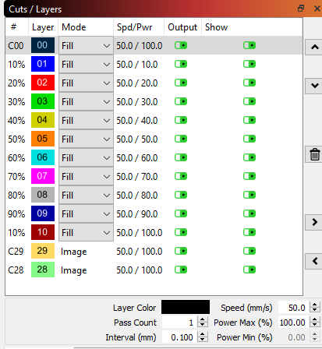
- Select all and align your design to X,Y at (60mm,60mm) to line it up with the jig using the icons on the toolbar.
- Select Absolute Coordinates:

- Set the “Mode” and the “Speed/Power” for each of the colors
  - Images: Image mode, speed 250mm/s power 20%
  - Text (maroon): Fill or Line mode, speed 250mm/s power 20%
  - Lines (blue): Line mode, speed 250mm/s power 20%
  - Set the outermost line to turn off “Output”
- Confirm that “Cut Selected Graphics” is not turned on.
- Click “Send” button and give it a name (8 characters max)

Perform the cut:
- Move over to laser cutter
- Place cutting board in jig, aligning it either “Portrait” or “Landscape” depending on your template.
- Use the “File” button and arrow keys on the laser cutter to select your file
- Press “Enter” to open up your file
- Press “Frame” button to draw the outline of your design and confirm it’s in the right place
- Confirm with your instructor that machine is ready to go (ventilation, chiller, power, air pump).
- Close door and press green “Start” button.
- Wait for machine to beep, do not leave unattended.

Other References
Other references that may be useful for making your own designs
Spark Cutting Board Templates  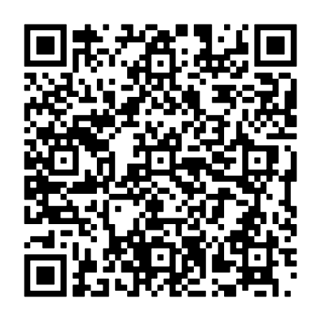 | Location to upload files for cutting  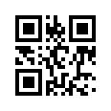 | More Spark Studio Laser Resources  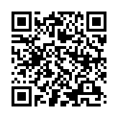
Inkscape Tutorials  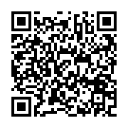 | Lightburn Tutorials  