Outline of procedures to align the gantry, optics, and bed

Table of Contents
Introduction 1
Alignment Procedure Outline 1
1. Gantry Skew 1
2. Gantry Mirror Interference 2
3. Bed Leveling 2
4. Tube Adjustment 5
5. Mirror 1 Adjustment 5
6. Mirror 2 Alignment 6
7. Mirror #1 fine-tuning 7
8. Mirror #3 alignment 8
9. Gantry Square 8
Lens Maintenance 10
Monthly Inspection 10
1. Inspect and clean optical elements 11
2. Bed level tests 11
3. Laser beam alignment tests 11
4. Gantry Square Test 11

Introduction
The performance of these laser cutters is highly dependent on how well the machine is aligned and calibrated. The alignment of the machine is something of an art and requires patience and understanding of the fundamentals of optics. Fortunately, if inspected regularly, the full procedure is rarely needed. This document contains an outline of the main alignment procedures and also a monthly maintenance guide. Once aligned, the machine should be maintained by following the monthly inspection process to verify that the machine is still adequately aligned and perform minor adjustments as needed. This is intended to ensure that the full alignment process is needed only rarely and that most of the time, only minor adjustments are needed to keep the machine in working order.

Alignment Procedure Outline

1. Gantry Skew

In this stage, we aim to align the gantry so that the left and right rails are parallel. Using a bubble-level, check that each of the rails is angled from front-to-back by the same amount. If necessary, the entire machine can be trammed so that they are both level as closely as possible. Note that precise alignment is not necessary, but try to get the left and right rails within about 1 degree of the same angle front-to-back. The height of the front anchor point of each of the rails can be adjusted by loosening the screws holding the Y axis rails to the chassis and moving them higher or lower. Continue iterating on this until they are as close to parallel as you can make them. [Ref 1].

This is not too crucial for the optics because mirror #2 rides along the rails. Any “skew” in the yz plane will be washed out because the mirror moves with the rail. Nonetheless, make an effort to ensure that the rails are as level as possible in reference to one another.

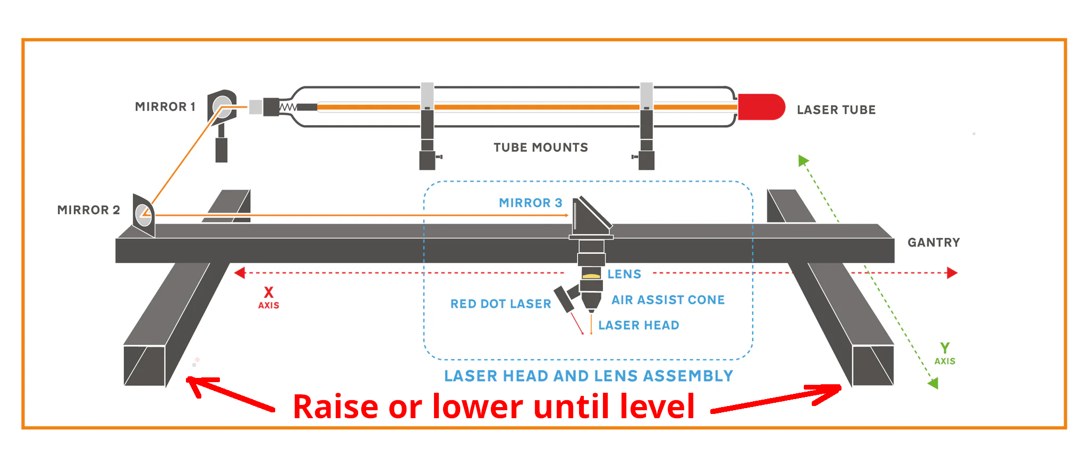
Measuring gantry skew. In order to check the gantry for skew, use a piece of fine thread stretched taught on the two diagonals of the gantry rails. If the gantry is square in the YZ plane, the two threads will intersect at the center. If one is higher or lower, then the rails are not perfectly parallel. Raise or lower the gantry until the two threads are just barely touching. You can secure the thread at each end with magnets or tape so they remain tight while making adjustments. Make sure to remove the thread after adjustment.

2. Gantry Mirror Interference
It sometimes happens that mirror #2 mounted on the gantry is accidentally bumped by the drag chain, cables, or other impediments. It only takes a microscopic deflection to move the mirror and thus beam spot at the far end of the machine. Take care to ensure that the cables, drag chain, and other moving parts do not bump or interfere with the free motion of the mirror mounted on the gantry.

3. Bed Leveling

In this stage, we aim to ensure that the XY plane of the bed is parallel to the XY plane of the gantry. The easiest way to do this is to place a large rigid, square object on the bed. Ideally, this object should be a) flat b) rigid, and c) cover the entire bed.

Next, jog the laser head to each of the 4 corners and use a small flat object to move the laser head so that the lowest of the 4 corners just touches the object. Our aim from here will be to adjust the z-axis lead screws so that all 4 corners match. To adjust one of the lead screws, use a hex wrench to loosen the set screw for the sprocket for that lead screw and manually adjust the lead screw until it just touches the object or the dial indicator reads the correct height. Re-tighten the set screw for the sprocket to lock the position in place. Continue this process until all 4 corners read the same height in reference to the tip of the laser tube.

For extra precision, a dial indicator can be mounted on the laser lens tube. Once done, the laser head can carefully be moved around the bed to measure how much deviation there is across the bed. A good alignment should yield something on the order of 10 thousandths of an inch (0.254mm)

This image depicts using a dial-indicator mounted on the laser lens aperture to measure relative height of the bed against the plane of the gantry. Note that the indicator SHOULD NOT BE MOUNTED UNTIL THE CONTROLLER HAS BEEN TURNED ON AND HOMED. You don’t want the indicator to be dragged by the controller over the bed during homing as this can damage the indicator and possibly crash the head.
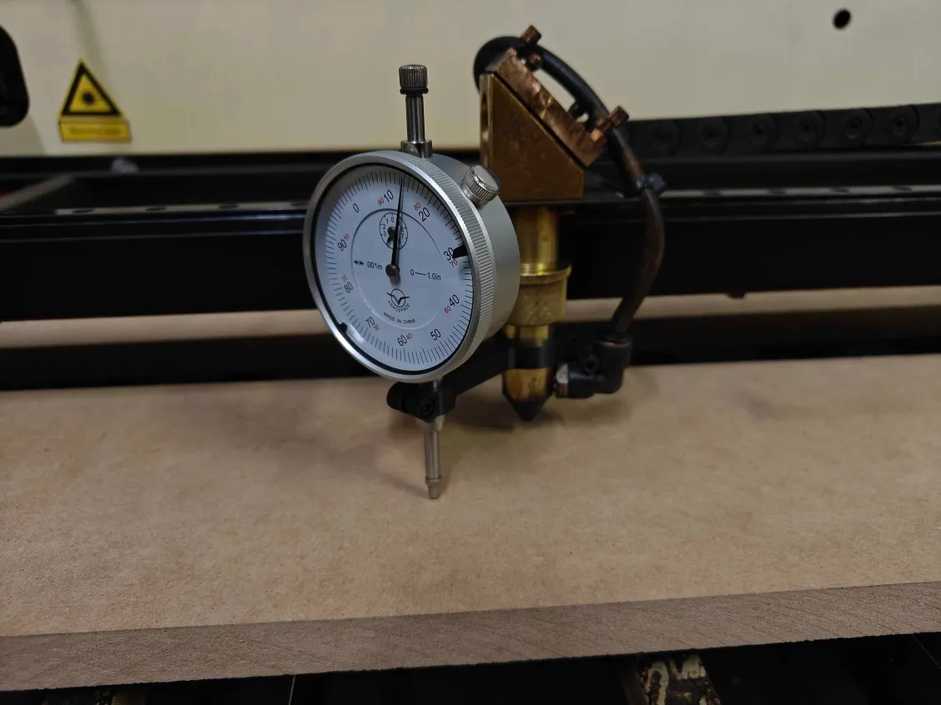
Once the indicator can measure the height in different locations, the bed can be adjusted carefully to raise or lower the corners until the bed and gantry are in the same plane.
[Ref 2]
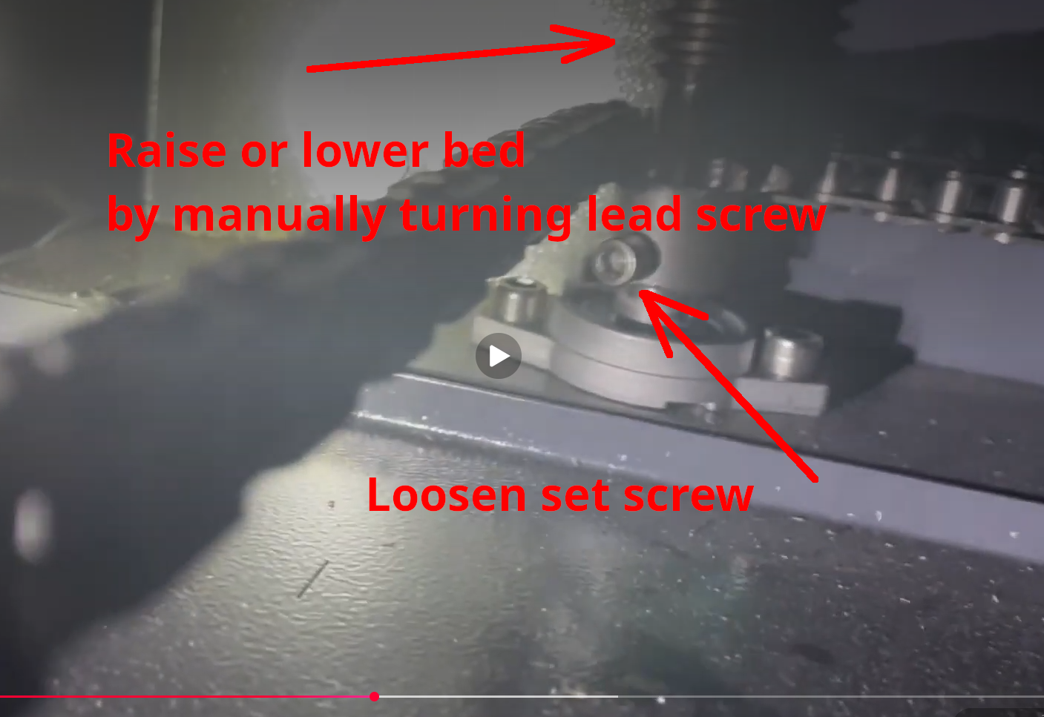

4. Tube Adjustment

In this stage, we aim to ensure that the laser beam arrives at mirror #1 in the center of the aperture. In order to do this, it may be necessary to shim the laser tube or make fine adjustments to the tube location until the beam arrives at the center as parallel as possible. Note that it is difficult to ensure that the tube is exactly perpendicular to the aperture because there is only a very small gap between the end of the laser tube and the aperture, but align it as closely as possible with the naked eye. Alignments of the mirrors will make up for small deviations from the correct angle.

5. Mirror 1 Adjustment

In this stage, we aim to ensure that the laser beam arrives at mirror #2 at the center of the aperture.

Place a piece of blue painter’s tape over one of the “Mirror 2 Target”, mark the grid and aperture location with a pen using the accompanying templates. These markings will assist in objectively knowing the position of the test pulse in reference to the aperture and a 10x10mm grid.

Then, place the target in the input aperture of mirror #2. Close the lid and power on the laser. Fire a test pulse at 10% power with the laser head in the upper-left corner of the bed (closest to the laser head). Repeat this process in the lower-left corner. If the pulses arrive in different locations, carefully adjust the set-screws on mirorr #1 for the up/down and left/right to move the beam in the desired direction. Note that when adjusting the mirror, the one in the “lower” corner will move a larger distance than the one in the “upper” corner. Repeat this adjustment until both pulses arrive in the approximate center of the aperture and as close to one another as possible.

Note that after aligning mirror #2, it may be necessary to further adjust mirror #1, but this should be the approximate starting location for further alignment.

6. Mirror 2 Alignment

In this stage, we aim to ensure that the laser beam arrives at mirror #3 (the mirror on the laser head) in the exact center of the aperture consistently all the way across the bed.

Place a piece of blue painter’s tape across one a “Mirror 3 Target” and mark the grid and aperture location with a pen using the accompanying templates. These markings will assist in objectively knowing the position of the test pulse in reference to the aperture and a 10x10mm grid.

Then place the target in the input aperture of mirror #3. Jog the laser head to the upper-left corner of the bed. Fire a test pulse at 10% power. Repeat this for each of the 4 corners. It is sometimes helpful to save these pulses by sticking them to a copy of the “Laser Alignment Worksheet”. This will give the location of the pulses on each of the 4 corners of the bed.

Adjusting the set-screws on mirror #2 will move each of those pulses up and down or left and right. Note that there will be more movement of the beam on the right side than the left, but the motion of them should be approximately the same. For example, if the upper-right and lower-right test spots are both 4mm high, you would want to adjust mirror #2 downward. Doing this would move both the upper-right and lower-right spots downward by the same amount. It is usually not the case that they will move in different directions or by different amounts.

Also note that the right side spots will move more than the left-side spots. This is because the left-side spots are a very small distance from mirror #2 than the right-side spots.

Begin the adjustment by carefully adjusting the “left/right” screw until all 4 spots are as close to the center as possible and cluster around it. For example, if they’re not quite aligned, you goal would be to put one spot slightly to the left and the other slightly to the right. Once the left/right is approximately on center, proceed to the “up/down” adjustment.

Again, for the “up/down” adjustment of mirror #2, you should aim to get all 4 spots as close to the center as possible. If they’re not quite aligned, you should aim to get them evenly distributed above/below so that “on average” they’re in the same location.

If the 4 test spots are within about 1-2mm of center, that is usually sufficient. If so, skip to step 8. If not, it may be required to re-adjust mirror #1 (Step 6) and then come back to mirror #2 (Step 5).

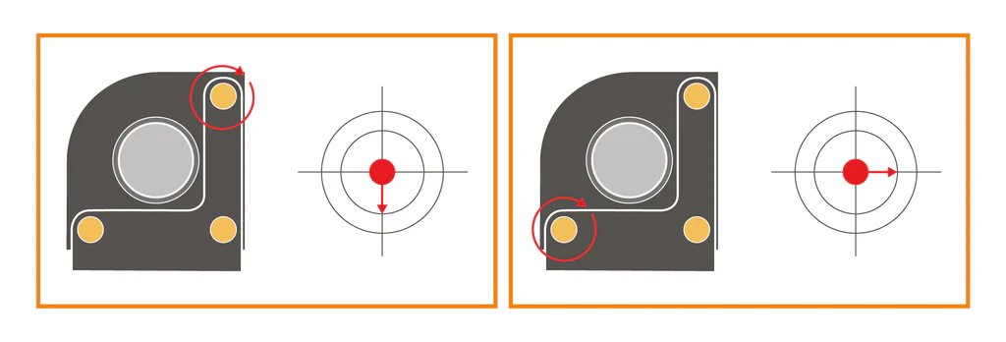
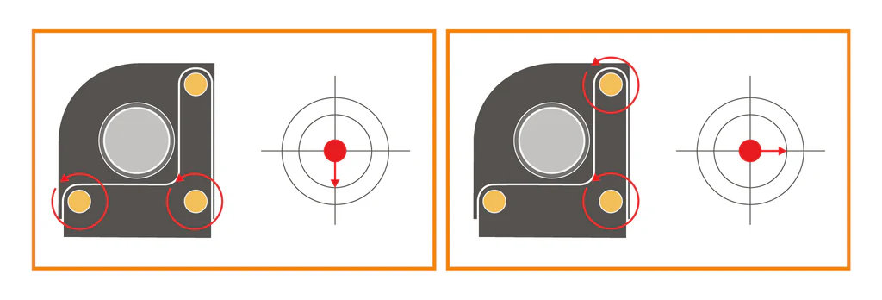
[Ref 1]

7. Mirror #1 fine-tuning
Because adjustment of mirror #2 will move the spots on the right side (furthest from the mirror) by approximately the same amount, mirror #2 usually cannot compensate for the fact that the right-side spots are not consistent from front to back of the machine. This is because the beam length traveled and mirror angle are the same for these locations. In order to adjust the location of the spots relative to one another, it will be necessary to very slightly adjust mirror #1. This is because the length of the path from the upper-right to mirror #1 is shorter than the length of the path from the lower-right to mirror #1.

The goal of this alignment is to VERY SLIGHTLY alter the direction of the beam until the spots in the upper-right and lower-right hit at the same location EVEN IF THEY ARE NOT IN THE CENTER. Centering these spots will be done by returning to step 5. where both can be moved at the same time using mirror #2. This alignment only aims to make sure that the amount they of off by is the same.

Return to step 5 to re-center the spots. Note that after this fine-tuning adjustment, the spots from the original mirror #1 alignment may no longer arrive at the exact center of the aperture. This is ok as long as the spots arrive at the center of mirror #3 consistently across the bed.

8. Mirror #3 alignment
The goal of this stage is to ensure that the beam arrives at the center of the lens. There is no alignment target for this, so adjustment will have to be done without a specific target.

Remove the lens from the laser head and place a piece of blue painter’s tape on the bottom. Score or mark the painter’s tape so that the aperture can be judged. Fire a test pulse to mark the painter’s tape. Carefully adjust the set-screws on mirror #3 and repeat this process until the spot arrives as close as possible to the center of the output aperture (where the lens will be).

Once this is done, place a piece of tape on the bed and fire a test-pulse. Move the bed to its lowest position and fire another test-pulse. Continue adjusting mirror #3 until the two pulses (highest Z to lowest Z) arrive are at the same location. This process ensures that the beam is aligned so that it is perfectly perpendicular to the work surface.

9. Gantry Square
The goal of this step is to make sure that the gantry is truly square. This must be done after step 7 because it relies on having a consistent beam all across the bed in order to mark a square.

Perform a test etch on a piece of material as large as possible. The test etch should be done at low power (~15%) and high speed (~200mm/s). The test pattern should be a large rectangle with lines across the two diagonals [Ref 3].

With these two diagonals marked on the large workpiece, measure the length of the diagonals carefully. If you find one of them significantly longer than the other, you should square the gantry. If they are the same length then the gantry is already square.

In order to adjust the gantry square, disengage the set-screws that tie the left side and right side of the gantry cross-member so that they move independently. The gantry cross-member can then be carefully moved clockwise or counter-clockwise by a few degrees. VERY SLIGHTLY adjust the angle of the gantry cross-member and repeat the rectangle and diagonals test. Repeat until the lengths of the two diagonals match.

Note that in the process of adjusting the diagonals, it may be necessary to return to the mirror adjustment stage, so repeat the test marks from steps 5-7 to confirm that the beam is still centered in the aperture and perpendicular to the work surface at the end.

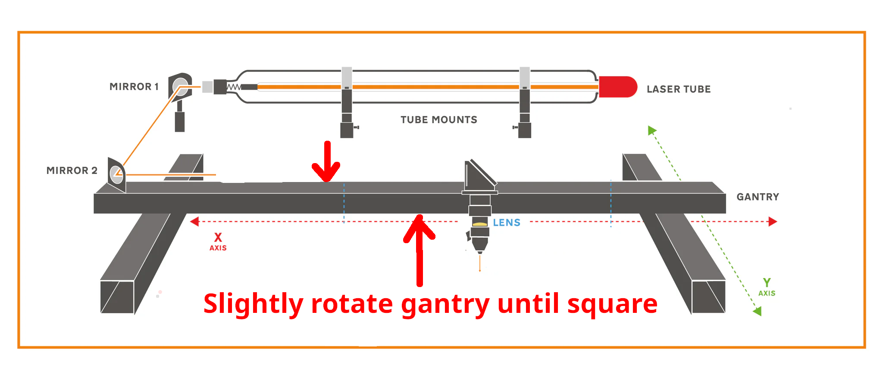
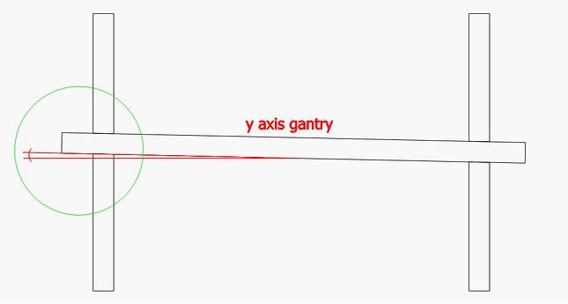


Rather than marking an entire rectangle, it suffices to mark 4 spots at each corner of the bed. This can be done inexpensively by fixing a small piece of cardboard or other sacrificial media at each corner of the bed. The laser can then be test-fired and the diagonal corners can be measured. This avoids the cost of using a very large sacrificial test piece to mark. The only thing that is important is that the points are marked and don’t move between the time they are marked and the time they are measured.

Lens Maintenance
In order to cut efficiently and safely, the lenses should be cleaned regularly. If debris does not come off from lenses during cleaning, they should be replaced. Spares are located in the cabinet on the west wall in the tub marked “laser supplies”.

Cleaning Procedure
Lenses should be cleaned as follows:

- Wear gloves to prevent contamination and body oils from being deposited on the lenses. They also protect the wearer from possible Selenium contamination.
- Lenses should be cleaned using “LA’s Totally Awesome” cleaning fluid or ordinary hand soap if it is not available.
- After cleaning, lenses should be rinsed with 90% Isopropyl alcohol and then lens degrease (if available).

Lens Replacement (Gweike : Crackle)
Lens specifications:
Lens Diameter | 20mm
Lens Thickness | ~2mm nominal
Focal Length | >=2.5in (>=63.5mm)

The focal length of the lens for this machine must be greater than or equal to 2.5 inches because the nozzle itself is only 2 inches long. Shorter focal lengths would result in the focal point being inside the nozzle instead of some distance beneath it. 3 inches is recommended because it gives a more generous tolerance for being out of focus (i.e. the focal cone is sharper, meaning it will cut well even when slightly de-focused).

Lens Replacement (Blue and White: Pop)
Lens specifications:
Lens Diameter | 18mm
Lens Thickness | ~2mm nominal
Focal Length | >=2in (>=63.5mm)

The focal length of the lens for this machine must be greater than or equal to 2 inches because the nozzle itself is only 1.75 inches long. Shorter focal lengths would result in the focal point being inside the nozzle instead of some distance beneath it. 2 inches is recommended because it places the nozzle closer to the work-piece allowing the air-assist to do a better job of pushing air through the nozzle to the work.

Monthly Inspection

The machine should undergo a monthly inspection wherein the working state should be verified. This process consists of verifying the cleanliness of the optics followed by a set of alignment tests to verify and correct any deviations from the last alignment.

1. Inspect and clean optical elements
The first thing to do is to check all 3 mirrors for residue from recent cutting activity. During this inspection, if necessary, clean each of the mirrors with q-tips and “LA’s totally awesome” detergent followed by 97% isopropyl alcohol to ensure that they are clean and free of residue and debris.

Next, the lens should be inspected and cleaned with the same method. Note any pitting or scarring of the lens itself as this could be indicative of damage to the lens from the residue.

As this is being done, if there is more residue than normal, check the operator log sheets to see what has been cut. This may inform future policy on materials, power and speed recommendations.

2. Bed level tests
Check to make sure that the bed is still parallel to the gantry. This is done by placing a small block between the nozzle and the bed at each of the 4 corners. The distance should be the same for all 4 corners. If one or more corners are not aligned to within about 1mm, perform the bed level procedure (See Step 2 in the alignment procedures).

For better accuracy, a dial indicator can be mounted to the laser head and the indicator can be run along the bed (with a suitably flat workpiece on the bed). The dial indicator will help align the bed to a much higher precision. In some cases, precision of about 0.25mm (10 thou inches) can be achieved in this way with a little patience.

3. Laser beam alignment tests
Next, the beam itself can be checked. Using the Laser Beam Alignment worksheet, fire test pulses using the targets with the laser head at each of the locations shown. This alignment worksheet will help visualize how close the beam is to the center of the apertures. Specifically, the Mirror #3 aperture should have test spots as close as possible to the center and within the aperture hole. If any of the spots are more than 2mm from the center, perform the alignment procedures in steps 4-7 depending on how the spots are mis-aligned. Make sure that the set-screws on the mirrors are tight after alignment so that the alignment does not drift during operation.

4. Gantry Square Test
Once the level, optics, and beam have been verified, the machine should be checked as square. This can be done by firing a test pulse at each of the 4 extreme corners of the bed with small pieces of cardboard or other sacrificial medium. The distance between diagonals should be checked to make sure they are equal. If they are not, square the gantry as described in Step 8. Note that this process may upset the alignment of the beam, so if it is found to be out of square, the mirrors may need subsequent alignment.

After all of the alignment tests have been done, file the Laser Beam Alignment worksheet in the folder for the specific machine and note the date and time, your name, and any notes on how you found the condition of the machine to be.

References:
[1] https://smokeandmirrors.store/pages/laser-beam-alignment-guide

[2] https://youtu.be/gCL-B2hnpUc

[3] https://www.youtube.com/watch?v=dyShfEqjyU4

