Read ROM
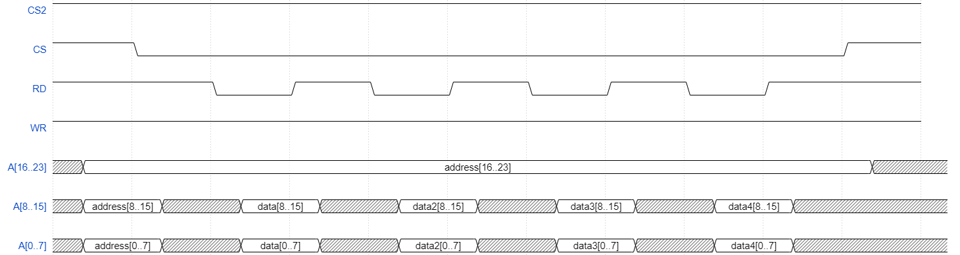
First the two least significant of address have to be latched (CS, falling edge), so the pins A0..15 can be used by the cartridge to send data (RD, falling edge). Any subsequent falling edge of RD (with CS still set to 0) will signal the cartridge to send next 16 bits (the address will be automatically incremented inside). It is important to note that the most significant byte of address should be kept correct at all times by the dumper.

Read RAM
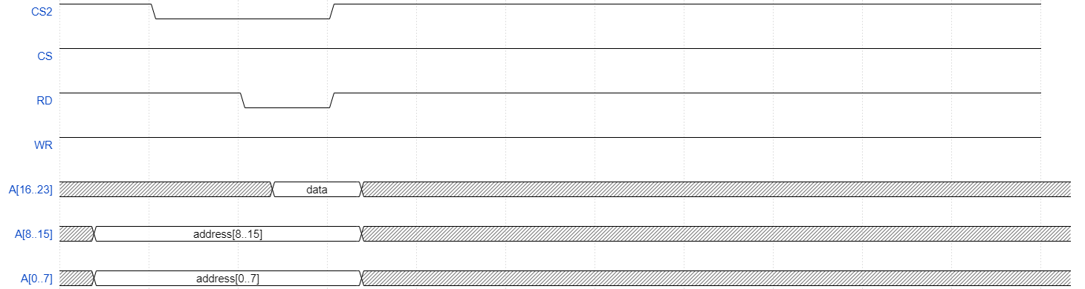
The procedure is very simple, falling edge of CS2 selects RAM. The address should be sent by the dumper via pins A0..15, while pins A16..23 should be in a high impedance state. Falling edge of RD signal the cartridge to sent the data byte (pins A16..23). CS2 should be kept low during the entire process.

Write to RAM (sRAM)/Send a command to RAM (flash)
The data byte and the address should be prepared first on pins A0..23. Then CS2 should be switched to 0 (RAM chip select) and after some time, WR should be lowered as well. The falling edge will send the command to the RAM chip.

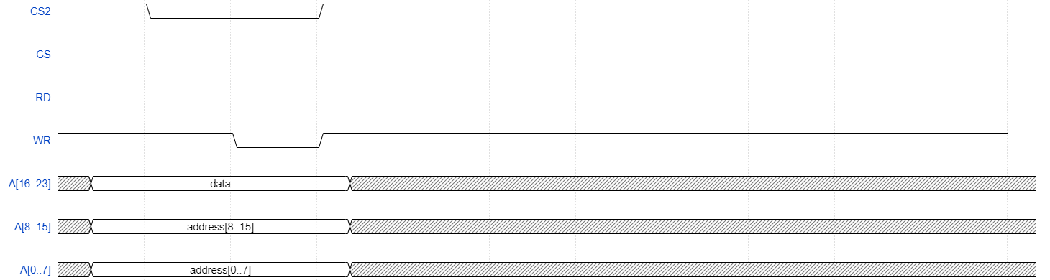
RAM commands (flash, from the official MX29L1611 datasheet)

