// 根据当前人的ID查询
List<Task> todoList = taskService.createTaskQuery().taskAssignee(userId)
.orderByTaskPriority().desc().orderByTaskCreateTime().desc().list();

// 根据当前人未签收的任务
List<Task> unsignedTasks = taskService.createTaskQuery().taskCandidateUser(userId)
.orderByTaskPriority().desc().orderByTaskCreateTime().desc().list();

签收任务
@RequestMapping(value = "task/claim/{id}")
public String claim(@PathVariable("id") String taskId, HttpSession session, RedirectAttributes redirectAttributes) {
String userId = UserUtil.getUserFromSession(session).getId();
taskService.claim(taskId, userId);
redirectAttributes.addFlashAttribute("message", "任务已签收");
return "redirect:/oa/leave/list/task";
}

RedirectAttributes 可以用来传递消息

使用spring data 来简化jpa

签收任务
taskService.claim(taskId, userId);

完成任务
taskService.complete(taskId, variables);

获得节点高亮图
ProcessDiagramGenerator.generateDiagram(def, "png",activitiService.highLight(processInstanceId));
但是生成图片中文会乱码，需要修改源码字体才可以

获得流程当前运行节点高亮的代码 没有完成
public Map<String,Object> getCurrentActivity(String processInstanceId)throws Exception{
Execution execution = runtimeService.createExecutionQuery().executionId(processInstanceId).singleResult();//执行实例
Object property = PropertyUtils.getProperty(execution, "activityId");
String activityId = "";
if (property != null) {
activityId = property.toString();
}
ProcessInstance processInstance = runtimeService.createProcessInstanceQuery().processInstanceId(processInstanceId)
.singleResult();
ProcessDefinitionEntity processDefinition = (ProcessDefinitionEntity) ((RepositoryServiceImpl) repositoryService)
.getDeployedProcessDefinition(processInstance.getProcessDefinitionId());

List<String> ActiveActivityIds = runtimeService
.getActiveActivityIds(processInstanceId);//获取将被执行的活动节点

ExecutionEntity execution1 = (ExecutionEntity) execution;// 执行实例

String activitiId = execution1.getActivityId();

List<ActivityImpl> activitiList = processDefinition.getActivities();//获得当前任务的所有节点
Map<String,Object> result=new HashMap<String,Object>();
for (ActivityImpl activityImpl : activitiList) {
if(activityImpl.getId().equals(activityId)){
result.put("x", activityImpl.getX());
result.put("y", activityImpl.getY());
result.put("width", activityImpl.getWidth());
result.put("height", activityImpl.getHeight());
}
}
return result;
}

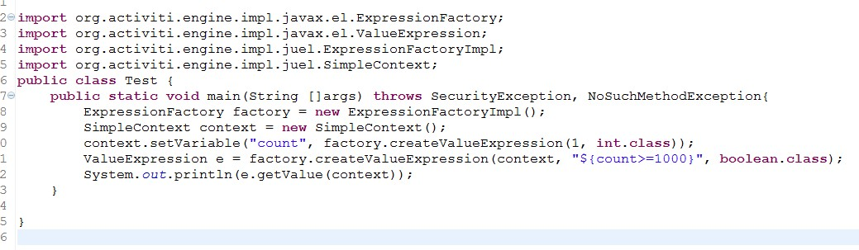

ActivityImpl.getProperties().get("type").toString()
type.equals("userTask")

