int main(int argc, char *argv[]) {
int status;
int save_out = dup(fileno(stdout));
char * cmd1[argc];
char * cmd2[argc];
int cpt = 0;
for (int i = 0; i < argc; i++){
if (strcmp(argv[i+1],"--") == 0){ cmd1[i+1] = NULL; break; }
cmd1[i] = argv[i+1];
cpt++;
}
int j = 0;
for (int i = cpt+1; i < argc-1; i++){
if (i+1 == argc){ cmd2[i+1] = NULL; }
cmd2[j] = argv[i+1];
j++;
}
pid_t exec1 = fork();
if (exec1 == -1) {
perror("fork1");
return EXIT_FAILURE;
}
if (exec1 == 0) {
int output1 = open("output1.txt", O_WRONLY | O_CREAT | O_TRUNC, 0644);
dup2(output1, fileno(stdout));
execvp(cmd1[0], cmd1);
close(output1);
}
waitpid(exec1, &status, 0);
pid_t exec2 = fork();
if (exec2 == -1) {
perror("fork2");
return EXIT_FAILURE;
}
if (exec2 == 0) {
int output2 = open("output2.txt", O_WRONLY | O_CREAT | O_TRUNC, 0644);
dup2(output2, fileno(stdout));
execvp(cmd2[0], cmd2);
close(output2);
}
waitpid(exec2, &status, 0);
pid_t exec3 = fork();
if (exec3 == -1) {
perror("fork3");
return EXIT_FAILURE;œ
}
if (exec3 == 0) {
dup2(save_out, fileno(stdout));
execlp("diff", "diff", "-u", "output1.txt", "output2.txt", NULL);
}
else {
waitpid(exec3, &status, 0);
if (WIFEXITED(status)) {
if (WEXITSTATUS(status) == 0) { printf("Les fichiers sont identiques\n"); }
else { printf("Les fichiers sont différents\n"); }
}
remove("output1.txt");
remove("output2.txt");
return 0;
}
return 0; }
void writeLine(int offset, void *addr, int len) {
int i;
char line[17];
unsigned char *car = addr;
for (i = 0; i < len; i++) {
if ((i % 16) == 0) {
if (i != 0)
printf(" %s\n", line);
printf("%08x: ", offset);
offset += (i % 16 == 0) ? 16 : i % 16;
}
printf("%02x", car[i]);
if ((i % 2) == 1) printf(" ");
if (isprint(car[i])) line[i % 16] = car[i];
else line[i % 16] = '.';
line[(i % 16) + 1] = '\0';
}
while ((i % 16) != 0) {
printf(" ");
if (i % 2 == 1) putchar(' ');
i++;
}
printf(" %s\n", line);
}

int main(int argc, char *argv[]) {
if (argc == 2) {
FILE *FILE = fopen(argv[1], "rb");
fprintf(stderr, "%s: failed to open file '%s' for reading\n", argv[0], argv[1]);
exit(EXIT_FAILURE);
}
char buffer[SIZE];
int n = fread(buffer, 1, SIZE, FILE);
if (n > SIZE) {
fprintf(stderr, "%s: file '%s' is too large, maximum %d character\n", argv[0], argv[1], SIZE);
exit(EXIT_FAILURE);
}
if (n == 0) {
fprintf(stderr, "%s: failed to read file '%s'\n", argv[0], argv[1]);
exit(EXIT_FAILURE);
}
int offset = 0;
writeLine(offset, buffer, n);
fclose(FILE);
}
if (argc == 1) {
char buffer[SIZE];
int i = scanf("%[^\n]", buffer);
if (i == 0) {
fprintf(stderr, "%s: failed to read input\n", argv[0]);
exit(EXIT_FAILURE);
}
int n = strlen(buffer);
if (n > SIZE) {
fprintf(stderr, "%s: text is too large, maximum %d character\n", argv[0], SIZE);
exit(EXIT_FAILURE);
}
int offset = 0;
writeLine(offset, buffer, n);
}
return 0; }
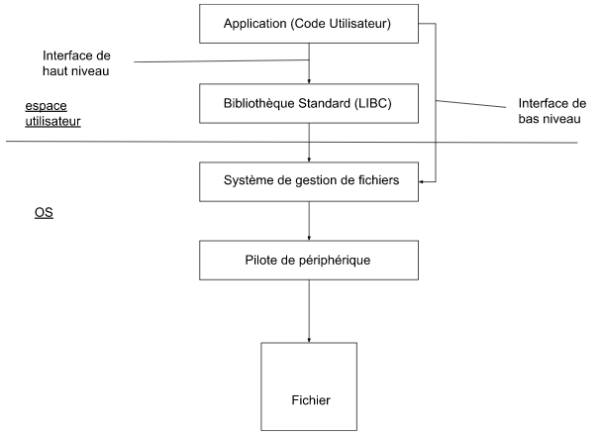
Interface de haut niveau
- Fournie par la bibliothèque standard LIBC
- Indépendante de l’OS (Windows, Linux)
- Utilisation en C : #include <stdio.h>
- Descripteurs de fichiers : type file* et int en haut niveau
- flux standard : stdin, stdout, stderr

Interface de bas niveau
- Fournie par l’OS
- Supporte plus de fonctionnalités (permissions, tubes, …)
- Descripteur de fichiers : type int
- flux standard : 0, 1, 2

