Indiana University Engineering

Final Document

Team: Jarod Saxberg, Tyler Zhang

Project: Light Monitoring System

Date: 5/4/2020

# 1 Table of Contents

1 Table of Contents 2

2 System Executive Summary 3

2.1 Description of the Community Partner 3

2.2 Stakeholders 3

2.3 Project Objectives 3

2.4 Outcomes/Deliverables 3

3 System Description 4

4 Software Design 5

4.1 High Level Block Design 5

4.2 Power Management and Modeling 5

5 Hardware Design 10

5.1 Overview 10

5.2 Processor Core 11

5.3 LPUART Connector 11

5.4 Light Sensor 12

5.5 Oscillator 12

6 Enclosure Design 13

6.1 Description of the Enclosure Design 13

6.2 NEMA Enclosure Level 14

7 System Cost Modeling 15

8 Safety Considerations 17

9 Ethical Considerations 19

10 Future Work 20

10.1 Improvements to Software 20

10.2 Improvements to Hardware 20

11 Team 21

11.1 Team Members 21

11.1.1 Jarod Saxberg 21

11.1.2 Tyler Zhang 21

11.2 Workload 21

11.2.1 Jarod Saxberg 22

11.2.2 Tyler Zhang 22

12 References 23

# 2 System Executive Summary

## 2.1 Description of the Community Partner

The project partner for this project is the Hoosier National Forest. The Hoosier National Forest’s goal is to achieve Dark Skies designation from the International Dark Skies Association (IDA) for its land before the next solar eclipse in 2024. Should they gain this designation, the Hoosier National Forest will benefit immensely from increased eco-tourism. Additionally, the data collected for the project will benefit wildlife and scientists that need the dark sky. The Hoosier National Forest will be the first to receive the project deliverables**.**

## 2.2 Stakeholders

If the project is particularly successful, the IDA may also use our project to assist assigning Dark Sky designation in other locations. Additionally, Professor Himebaugh is significantly interested in the project’s success, as he is concurrently working on similar projects for his research.

## 2.3 Project Objectives

The current method of collecting light data is by sending a ranger out with a handheld light sensor and manually collecting light data. Collecting light data is labor-intensive and costly, and as a result light data is collected infrequently. Our project aims to provide light data every five minutes, which will provide significant improvement over the current light data collection system. Precise light data is a direct requirement for Dark Sky designation, and the data from our project will be used by the IDA to consider Hoosier National Forest for a Dark Skies designation. Additionally, more frequent light data will allow the Hoosier National Forest to study the impact of dark skies on the wildlife.

## 2.4 Outcomes/Deliverables

Our goal is to produce a light monitoring system that improves upon the current light data collection system. Our system will be automated and can collect data more frequently because it will be deployed in the forest. Additionally, we will improve the current prototypes of the light monitoring system with a combination of more efficient code and better hardware. When the project is complete, we hope to leave behind light data and an improved prototype for the system.

# 3 System Description

This project seeks to design a light sensor that can be laid in the Hoosier National Forest for a prolonged period of time. The sensor will collect data on the light conditions during the night in an attempt to obtain a designation from the International Dark Sky Association. The designation is important to attract more people to the Forest, to create community-involved programs regarding data collection from the sensors, and to teach people about what the IDSA association strives to do and why it is important.

The light sensor is designed by taking many different considerations into account. These considerations involve safety, cost, and ethics, and they are all described in more detail later in the document. The software is designed with the help of CubeMX, which provides an extremely helpful starting point for the coding of each feature and includes utilities that help establish timers and explore various power consumption modes. The hardware was designed with KiCad, a user-friendly way to design schematics and pcb layouts. KiCad allows the user to have full control over the lithography of the resulting pcb, and performs electrical rules checking in the schematic to reassure the user that all connections are established. Creating a pcb with KiCad gives the designers more control over the board rather than purchasing a prebuilt board which could have features that are not necessary. More detailed descriptions of the software and hardware design are immediately following this section.

# 4 Software Design

## 4.1 High Level Block Design

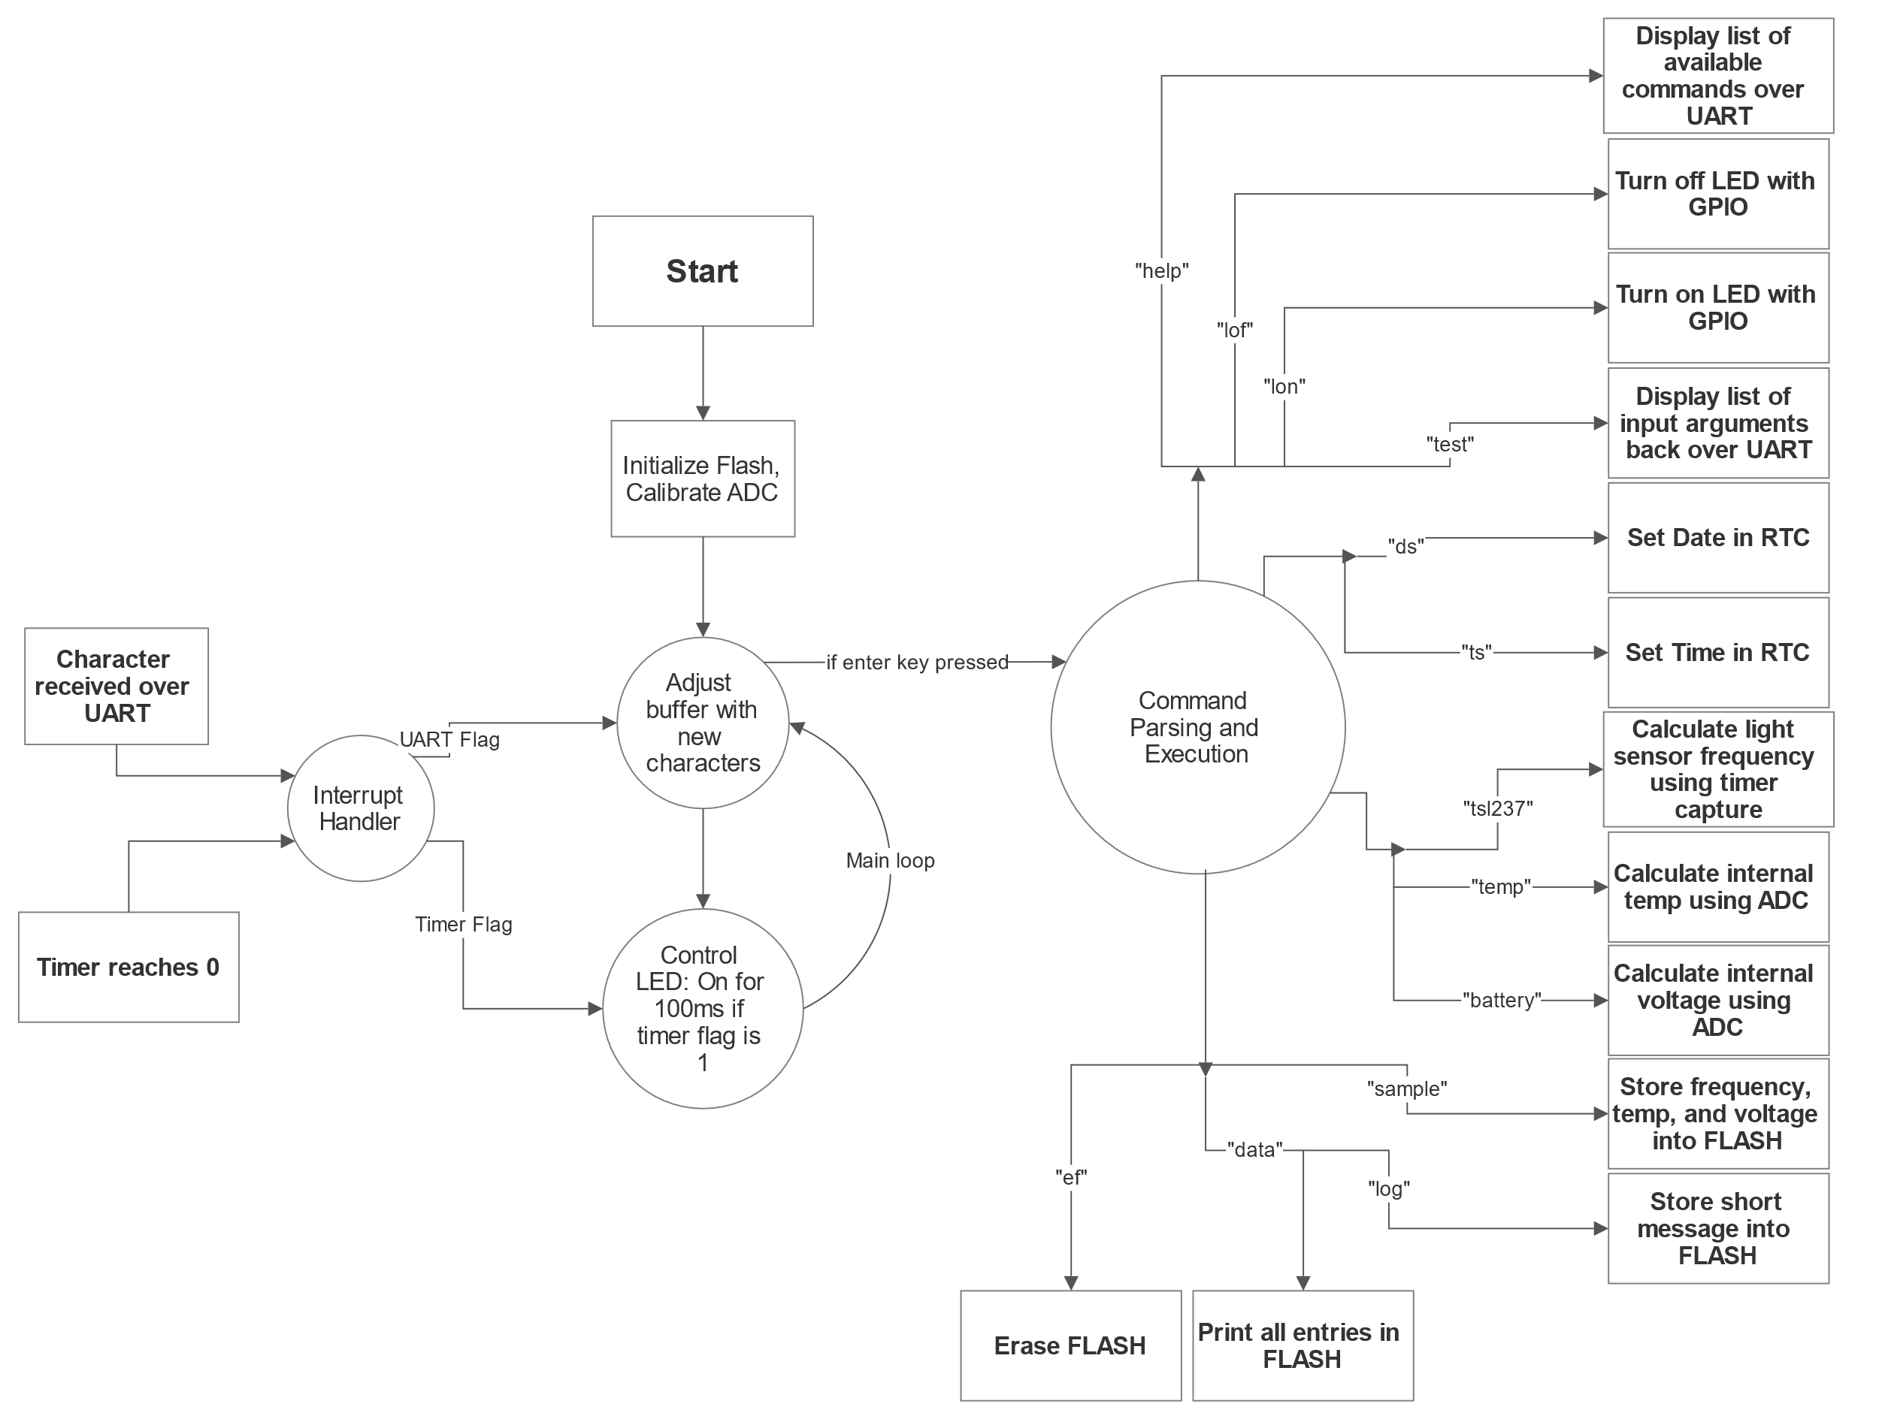

Figure 1: Software block design

Figure 1 shows the flow of our code. The code is mainly event-driven since the main loop waits for input over UART or for the timer to reach 0. Receiving characters over UART modifies an internal buffer, and if the enter key is detected, the system will perform a command. If the connected timer reaches 0, the code will tell an LED to blink on for 100ms. This behavior will eventually be replaced by storing a light sensor reading to flash memory.

## 4.2 Power Management and Modeling

The STM provides several run and low-power modes, each with different features and power consumption. Our goal is to leave the system in the field while requiring as little maintenance as possible. The system is designed to take light samples every 15 minutes for 12 hours a day, with each sample taking up to 15 seconds. When the system is taking a light sample, the STM will be in one of three running modes, and while it is idle, the system will be in one of seven low-power modes.

The following graphs show the power consumption of three promising combinations of run and low-power modes, generated by CubeMX. The rest of the combinations were tested in our full power analysis, which can be located [here](https://github.iu.edu/jsaxberg/ES-SPRING-2020/blob/master/Lab10/e314_power_analysis_final.pdf). We are trying to determine the pair of run and low-power modes that will yield the best battery life estimation with a CR2032 battery.

Figure 2: LPRUN with STOP 1

With these settings, battery life is at nearly 7 months and its wakeup time is 4 us. The LPUART and RTC can still be enabled, and SRAM is retained. These settings give us the best battery life estimation, but the LPRUN only allows the CPU to run at a maximum of 2 MHz, which may not be enough for the software.

Figure 3: RUN1 with STOP 2

With these settings, battery life is at roughly 1.5 months and its wakeup time is 5 us. The LPUART and RTC can still be enabled, and SRAM is retained. However, RUN1 means the CPU is running at 80 MHz, which is unnecessary and draws significantly more power than LPRUN or RUN2.

Figure 4: RUN2 with STOP 2

With these settings, battery life is at 3 months and 25 days and its wakeup time is 5 us. The LPUART and RTC can still be enabled, and SRAM is retained. RUN2 lets caps the CPU frequency at 26 MHz instead of 80 MHz, showing power consumption improvements.

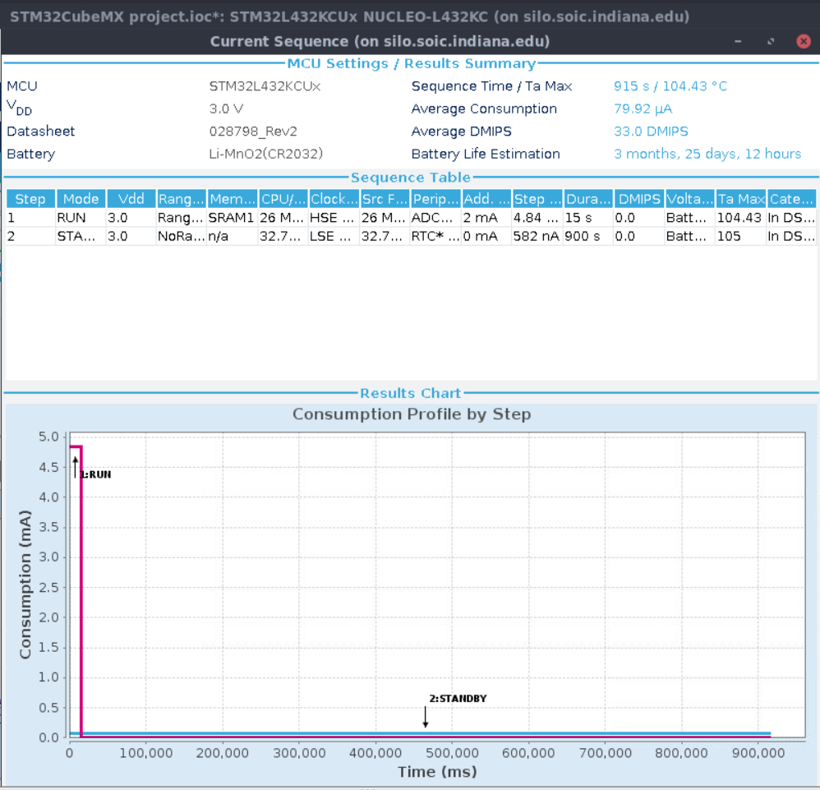

Figure 5: RUN2 with STANDBY + 32KB SRAM

With these settings, battery life is at 3 months and 25 days and its wakeup time is quite high at 14 us. The LPUART can no longer stay enabled, but RTC is still active and SRAM is retained. This means if we want to communicate with the device over UART, we must wait for the 15 second window when the system is back in the run mode.

The power combination that provides the best battery life for the least detrimental effects is RUN2 with STOP 2. The CPU runs at a max of 26 MHz which should be plenty for our code. STOP 2 allows the LPUART to remain on, allowing us to communicate with the device without waiting. It also has decent battery life estimation at 3 months and 23 days.

# 5 Hardware Design

## 5.1 Overview

KiCad was used to create a schematic and pcb layout for the light sensor project. In the design of the hardware, we needed to account for all components included on the board and manage the lithography so everything connects how it should. The design we determined was the best is shown below.

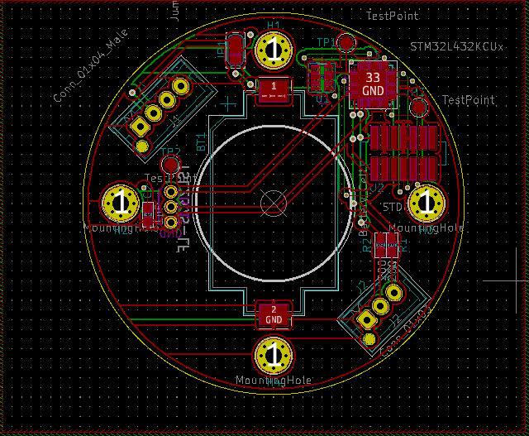

On the design, the red outlines represent lithography done on the top of the board, and the green represents the bottom. A more detailed explanation of certain important parts are included in the next section.

## 5.2 Processor Core

The processor used in the hardware is the STM32L432. This was chosen for its extensive number of timers and general support for the goals of this project. It is only somewhat limited in flash space, as there are other processors out there that have twice the storage space. The test point is to watch the system clock to use in reference with the other test points.

## 5.3 LPUART Connector

The LPUART connector is important as it allows for data to be received from the flash memory of the processor.

## 5.4 Light Sensor

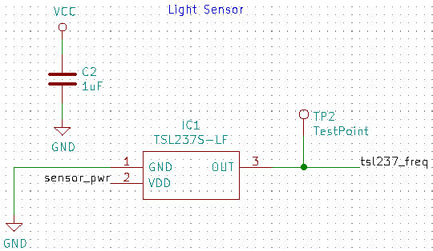

The light sensor is arguably the most important part of this project, as it is the key feature of it. The TSL237S light sensor was picked for the project, and the values it outputs from its readings are in terms of Hz which are processed in the software. The test point is to probe the output frequency.

## 5.5 Oscillator

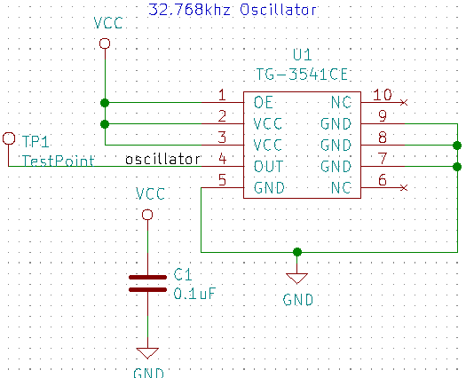

The oscillator is used to control the clock of the system. The test point is useful to see that the system is oscillating correctly.

# 6 Enclosure Design

## 6.1 Description of the Enclosure Design

The enclosure for our PCB is designed to be durable and protect the electronics from moisture. The figures below show the 3D models for our base and lid. The base will be 3D printed and the lid will be laser-cut from acrylic.

Figure 6: Base design, modeled in Autodesk Fusion

The base has standoffs to mount the PCB, and screw holes to secure the lid. The standoffs provide space between the PCB and the bottom of the base for the battery holder. The space can be used to store desiccant beads to reduce moisture in the enclosure. A cutout at the bottom of the base provides easy access to the LPUART connector, and will be filled in with a rubber plug.

Figure 7: Lid design, modeled in Autodesk Fusion

The light sensor will be facing outwards, so the lid must be laser cut from clear acrylic to maintain accurate light readings. Between the lid and the base, there is a groove for the placement of a rubber O-ring to seal the enclosure.

## 6.2 NEMA Enclosure Level

The National Electrical Manufacturers Association provides standards for enclosures in indoor and outdoor locations. For our light monitoring system, our environment will be the Hoosier National Forest, which is considered an outdoor nonhazardous location. The following figure shows the NEMA classification levels for an enclosure in such an environment.

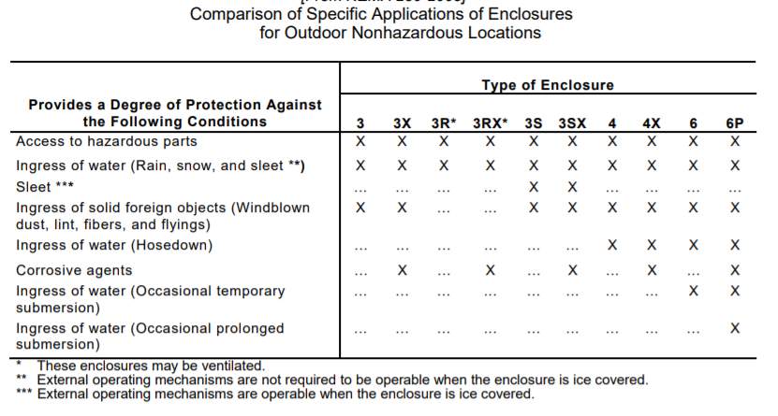

Figure 8: NEMA classification for enclosures in outdoor nonhazardous locations

All the electronics are secured inside the enclosure, so access to hazardous parts is limited. The design protects the electronics from windblown dust, lint, fibers, and flyings. Additionally, with the O-ring seal and the rubber plug, the electronics are protected against ingress of water from rain, snow, and sleet. Ice formation may shut down the electronics, but the enclosure will be intact, and the screws may still be removed. The enclosure is not well-sealed enough to protect against hose downs or any type of submersion. Additionally, corrosive agents may interact negatively with the acrylic and ABS material in our enclosure. With these degrees of protection, the classification of our enclosure type matches Type 3S.

# 7 System Cost Modeling

Background

For the design, we made sure to account for all mounting necessary. The four holes inside are ready for screws that mount the PCB to the base. The base will be 3D printed with a basic plastic material. It does not have to be anything more as plastic will last a while in basic outdoors conditions. The lid will be laser cut from clear acrylic. It must be clear to allow light through for the light sensor. All of the smaller holes in the lid and base are used for connecting the two and including some type of material to seal the two together, whether it be an o-ring or some type of glue. The PCB layout is the same layout that was designed in Lab 8.

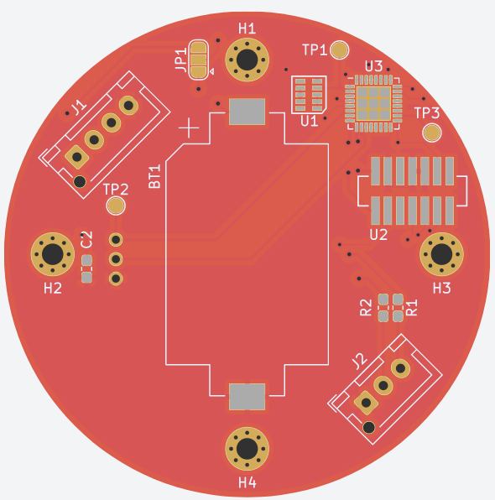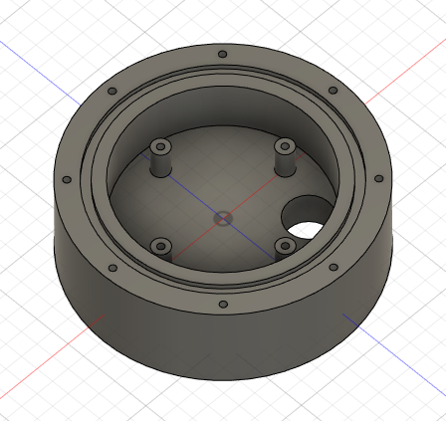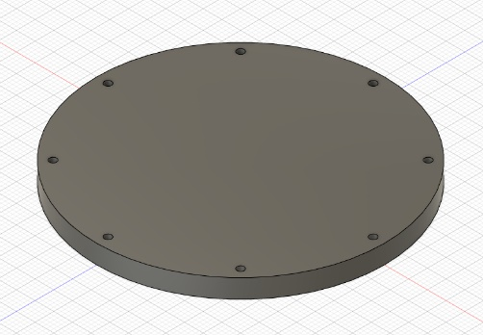

Cost Analysis

Sculpteo

|  |  |  |  |  |
| --- | --- | --- | --- | --- |
|  | 5 | 20 | 50 | 100 |
| Base | $355.60 | $1,890.00 | $4,725.00 | $9,450.00 |
| Lid | $14.35 | $40.00 | $92.50 | $180.00 |
| Total | $369.95 | $1,930.00 | $4,817.50 | $9,630.00 |

Shapeways (not including 15% edu discount) (prices for 3D printing only)

|  |  |  |  |  |
| --- | --- | --- | --- | --- |
|  | 5 | 20 | 50 | 100 |
| Base | $251.95 | $1,007.80 | $2,519.50 | $5,039.00 |
| Lid | $78.90 | $315.60 | $789.00 | $1,578.00 |
| Total | $330.85 | $1,323.40 | $3,308.50 | $6,617.00 |

Macrofab

|  |  |  |  |  |
| --- | --- | --- | --- | --- |
|  | 5 | 20 | 50 | 100 |
| PCB | $143.77 | $532.55 | $834.45 | $1,092.39 |

The above tables show prices to obtain each part from the different companies that offer 3D printing, laser cutting, and PCB printing services. For each company, I chose the most cost-effective solution which involved prioritizing cost over speed. For most of the companies, it would take around 2-4 weeks to receive the components ordered. Speed is not as important of a factor when we are trying to make sure the boards are as low-priced as possible.

Conclusion

Based on the various prices, the best and cheapest way to obtain the base + lid combo would be to use Sculpteo for the lid, Shapeways for the base, and Macrofab for the PCB. The price for Shapeways would also be reduced by taking advantage of the 15% education discount, which was not included in the above graphs. Adding this sum up, with the education discount included, the total for 100 light sensors would be $5,555.54; thus, the price per unit would be $55.55.

# 8 Safety Considerations

This section is a consideration of various possible failure modes and their effects on the system and its environment.

* **Obstruction of acrylic lid**

Any obstruction such as leaves or debris that block the acrylic lid of the enclosure will also block the light sensor, making sensor readings useless. This will likely be a very common occurrence, especially in the fall. Unfortunately, without any mechanism to clear debris, the device will be stuck in this state until a human or some entity clears away the obstruction.

To detect obstructions, we may add some code to check whether our light sensor data makes sense at the given time. For instance, if the system detects darkness during the middle of the day, it could log that an obstruction has been detected, and we can program the system to stop collecting data to preserve battery life.

* **Battery reaches end of life prematurely**

The battery life might be exhausted earlier than predicted due to battery manufacturing errors. Another possibility is that we accidentally programmed the system to stay in running mode instead of switching to low power while idle. When the battery dies, the only rescue is for a human to load the data logs from FLASH and reset the device, since losing battery power prevents the system from logging any more data. However, since our logs should display battery voltage with a timestamp, we can figure out at what time we lost power and attempt to debug our issue.

* **Defective battery connection (short)**

If the battery holder is defective, it may create a short circuit between the leads of the battery. This is quite dangerous as the battery will heat up and potentially cause a small explosion. If this happens inside the enclosure, the hazard will be isolated and will damage the electronics. The coating on the PCB will prevent any fires from starting. However, it is very likely that the short would be caught before the PCB even makes it into the enclosure, because the process happens very quickly once the battery is in place. This failure mode would endanger anyone nearby as well as damage the other electronics on the PCB.

* **Faulty peripherals**

Faulty peripherals on the STM such as the ADC or the RTC or problems with the TSL237 will make the data collected useless. We would need to replace the microcontroller or sensor. Fortunately, this is usually caught by quality assurance during manufacturing, so it is unlikely to become our issue. Additionally, if it happens, it is easy enough to check that the peripherals are working before deploying the system.

* **Rubber plug comes loose**

In our enclosure design, there is a removable rubber plug on the bottom of the base that allows us to access the UART connector. If this plug is loose or removed, it will expose the electronics to the environment, and may allow moisture or water to get inside. Moisture could potentially short or damage the electronics and ruin the collected data. Additionally, if for any reason a fire starts inside the enclosure, the fire will be exposed to the forest if the rubber plug is missing. We must make sure that the plug is properly sealing the hole before deploying the system.

* **Extreme temperature conditions**

With our device outdoors, the system is at the mercy of the elements. The STM and TSL237 function at a relatively wide range of temperatures, but at the extremes, unpredictable behavior can occur. At extremely low temperatures, the battery will not be able to generate enough current, which may shut off the RTC, making future timestamps inaccurate. At extremely high temperatures, the battery will overheat and may catch fire. We must be sure the Hoosier National Forest has temperature ranges that fall within the operating temperature range of our system.

* **Tampering from tourists**

Tourists may be curious about the device if spotted in the forest. They may try to examine the electronics by opening the interior or steal the device. This may affect data quality or cause damage if handled improperly. The closer we deploy the device to a well-travelled path, the more likely we will encounter tourists. We can potentially reduce tampering by letting visitors know what the devices are doing so they do not interfere.

# 9 Ethical Considerations

This section will detail all the various ethical considerations that were considered over the course of the project.

* **Mounting the sensor to the ground**

The grounds of the Hoosier National Forest are protected, and due to these protections, no stakes can be inserted into the ground. To account for this, we must have some way of weighing the sensors down, so they do not get moved by wind or animals. There is only so much we can do to account for this, and the best way to do so is to add some weight to the bottom of the enclosure.

* **Damage to animal and insect ecosystems**

The light sensor could possibly interfere with insects on the ground. We attempt to reduce this impact by placing the sensors far apart from one another and keeping the radius of the sensor and enclosure small.

* **Potential hazardous waste if the sensors are forgotten**

If the light sensors are damaged or moved, it may be difficult to retrieve them from the Forest. The forgotten sensors would be left in the Forest until they happen to be found, or they decompose. The sensors are plastic and metal, both of which take a while to decompose. The battery of the system and the components on the pcb also have toxic materials within them, and they have the potential to release these into the environment. We mitigate this by noting the locations of all the sensors when they are planted and including some form of camouflage to the design to reduce the chance they are found by external people or animals.

* **Increased park traffic will negatively affect the animals**

If the project goes to plan, part of it is trying to attract more people to the Forest. This could negatively affect the natural life there and impact animal habitats. We believe that the increased awareness that this project will bring is of greater importance. The Forest is very large and widespread. An increase of people at the park will not have as great of an effect on the overall park, and while they are there, they will learn about the Dark Sky endeavor and why it is done. This has the potential to affect life outside the park too. If someone learns about the initiative at the park, then goes home and changes their driveway light to a Dark Sky recommended light, it will benefit more than just the park. These people also have the potential to spread the information through work of mouth, further increasing the affect of the community involvement project.

# 10 Future Work

There are several ways to improve the light monitoring system, both in terms of design and software.

## 10.1 Improvements to Software

Currently the software in our system is run in “bare-metal” (i.e. tasks execute one at a time and not concurrently). One improvement is to utilize a real-time operating system (RTOS) to gain access to multiple threads and run tasks concurrently. This would be beneficial for tasks that require any sort of polling, such as calculating frequency, which currently is done by polling an input capture timer for two readings. During that time, the main loop is stopped, which could potentially be long enough to miss important interrupts from UART or other timers. The function printf also has similar behavior, as it calls a function called putchar that also waits for the UART module to receive before returning. Placing command execution and interrupt processing into separate threads or tasks with an RTOS will make the code more robust.

## 10.2 Improvements to Hardware

The light monitoring system currently runs on a button battery, but a possible improvement to extend battery life is to add a solar cell to the system. The solar cell could charge a capacitor during the day and the system could use the capacitor as well as a backup battery during the night to record data. Solar power could make the system sustainable and reduce the number of times we need to replace the battery.

Another addition would be providing adding a Bluetooth module to the system to let users download data from the system without needing to connect with UART. Not only is this more convenient, but also it allows us to take advantage of citizen science by allowing visitors at the Hoosier National Forest collect data for us. We could build an app for visitors to download and let them use the Bluetooth receivers in their phones to retrieve data from our systems. The app could then send us the data when the phone connects to the internet. This would greatly improve the efficiency of data collection for the Hoosier National Forest.

# 11 Team

## 11.1 Team Members

### 11.1.1 Jarod Saxberg

Jarod is a junior at Indiana University pursuing a major in Intelligent Systems Engineering concentrating in Computer Engineering, and two minors in Mathematics and French. He will be working over the summer of 2020 as a security software engineering intern and plans to either continue with a career in cyber security, or work at the intersection of hardware and software.

### 11.1.2 Tyler Zhang

Tyler is a student at Indiana University pursuing a double degree in Mathematics and Intelligent Systems Engineering, with a concentration in Cyber-Physical Systems. Future career goals include obtaining a master’s degree in engineering and working in the field of embedded systems.

## 11.2 Workload

Both individuals contributed significantly to the design and documentation of the project, including the code, the PCB layout, and the enclosure model. The following is the breakdown of specific contributions.

### 11.2.1 Jarod Saxberg

* Both members worked extensively on the code, and focused on the software more than the hardware. One of them would usually get a good start on the code for a lab, then they would get together and work out any bugs and/or finish work that was not started yet. Most progress was made while working together.
* Jarod designed a PCB layout and enclosure model, along with Tyler creating his own too.
* Jarod completed the system cost analysis and was responsible for the odd-numbered sections of the final report. The Bill of Materials was split in half with each member working on their half.

### 11.2.2 Tyler Zhang

* Both individuals contributed significantly to the code. Typically, Tyler would provide a strong starting point for the labs by laying out the framework and structure, setting up functions, creating new files, and experimenting with how best to interact with the hardware and peripherals.
* Tyler designed his own PCB layout and enclosure model, as did Jarod.
* In terms of documentation, Tyler completed the power analysis and is responsible for the even­-numbered sections in the final report. Both individuals picked parts for the bill of materials.

# 12 References

* *NEMA Enclosure Types*, NEMA 250-2013, Nov. 2005. [Online]. Available: <https://www.nema.org/Products/Documents/nema-enclosure-types.pdf>
* *International Dark Sky Places*, IDA [Online]. Available: <https://www.darksky.org/our-work/conservation/idsp/>