Curriculum vitae

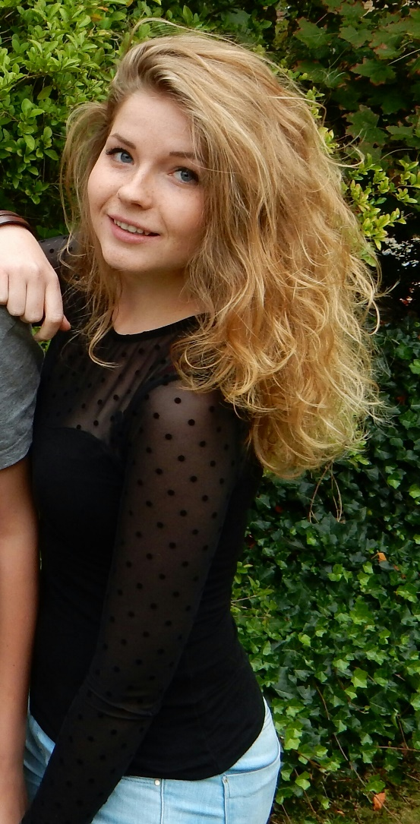Rowan Nijland

*20 november 1995, Deventer*

Kapelstraat 121H, 7811 XZ, Emmen, The Netherlands

Email: [rowanijland@live.nl](mailto:rowanijland@live.nl)

Tel: +31646923269

Education

2008-2014: Twents Carmel College Oldenzaal,

Nature&Health, including: biology, chemistry, art history, German

2014-2016: Stenden University Meppel, ITEPS.

2016-………: Stenden University Emmen, Information Technology.

Work experiences

2010-2012: Event Creators, Weerselo.

Bartender/administration.

2012-2013: Pizzeria Shorty’z, Oldenzaal.

Telephonist.

2013-2013: Pizzeria Santa Maria, Weerselo.

Telephonist.

2013-2013: Fresh butchery, Emté, Oldenzaal.

Sales representative.

2014-2014: Campsite de Molenhof, Weerselo.

Kitchenstaff and shopassistent.

2015-2015: Supermarket Jumbo, Meppel.

Cashier.

Internship

2014 De Johannes Calvijn school, Meppel.

2015 International primary school, The Prinseschool, Enschede.

2015 The International Primary School of Ljubljana, Slovenië.

Languages

* Dutch
* English

Competences

* Independent
* Social
* Creative
* Caring
* Studious

Interests and hobbies

* Painting
* Drawing
* Sports
* Shopping