1 | Measurement Ready  Use the tool, scale, unit, and calculation as one evidence chain.  Name: ____________________ Date: __________ Class Period: ______

LEARNING TARGETS
Match common lab tools to the quantity and unit they measure. • Choose an appropriate tool and justify the choice with visual evidence. • Calculate density and percent error with correct units and reasonable precision.
Three tools, three different jobs
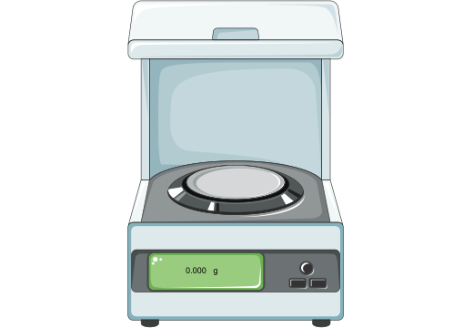  Electronic balance  Measures mass  Typical unit: g | 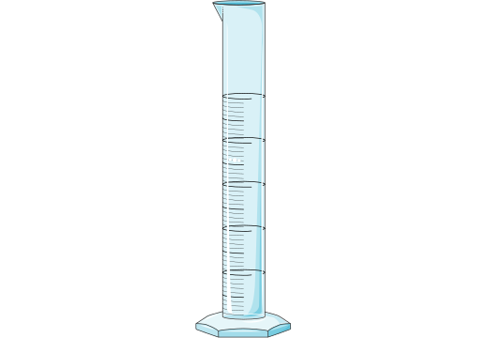  Graduated cylinder  Measures liquid volume  Typical unit: mL | 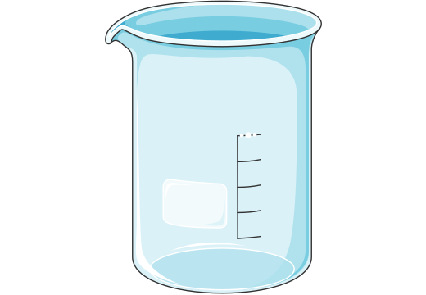  Beaker  Holds and mixes  Volume is approximate
Measurement rules that prevent avoidable errors
- Record the value and the unit together.
- For an analog scale, record all certain digits plus one estimated digit.
- Read a concave liquid meniscus at eye level from its lowest point.
- Keep units through every calculation and round only the final result.
FORMULA TOOLBOX  density = mass / volume  percent error =  |experimental - accepted| / accepted × 100 | UNITS  mass: g  liquid volume: mL  density: g/mL

2 | Choose the Tool  Name what you see, then use visible features to justify the choice.  Name: ____________________ Date: __________ Class Period: ______

A. Identify each instrument
1    Instrument: __________________  Quantity/job: ________________  Unit: _______________________ | 2    Instrument: __________________  Quantity/job: ________________  Unit: _______________________ | 3    Instrument: __________________  Quantity/job: ________________  Unit: _______________________
B. Select and justify
4. You need 18.6 mL of water. Choose a beaker or a graduated cylinder. Explain which visible design features support your choice.
________________________________________________________________________________
________________________________________________________________________________
5. You need about 125 mL of solution and room to stir. Choose a beaker or a graduated cylinder. Explain.
________________________________________________________________________________
________________________________________________________________________________
C. Read visual evidence
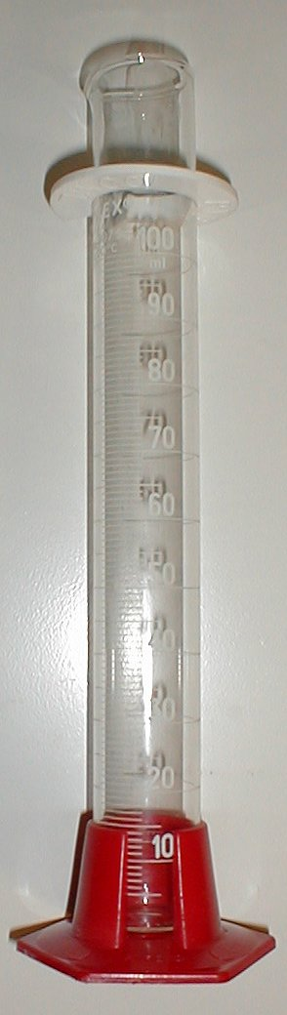 | 6. Identify two visible features that show this vessel was designed to measure liquid volume.  ____________________________________________________________  ____________________________________________________________
Photo: Darrien / Haltopub, Public Domain, Wikimedia Commons

3 | Calculate with Units  Show the formula, substitute values with units, and round only the final answer.  Name: ____________________ Date: __________ Class Period: ______

GUIDED EXAMPLE
A sample has a mass of 36.4 g and a volume of 14.0 mL.
d = m / V = 36.4 g / 14.0 mL = 2.60 g/mL
7. A liquid sample has a mass of 27.0 g and a density of 2.70 g/mL. Calculate its volume.
Work space
8. A liquid has a density of 0.789 g/mL and a volume of 25.0 mL. Calculate its mass.
Work space
9. A student measures 2.58 g/mL. The accepted value is 2.70 g/mL. Calculate percent error.
Work space
10. Accuracy and precision
Accepted density: 2.70 g/mL
Set A | 2.70, 2.71, 2.69 g/mL
Set B | 2.42, 2.41, 2.42 g/mL
Which set is accurate? Which is precise? Explain using the pattern in the data.
________________________________________________________________________________
________________________________________________________________________________

4 | Reason from Evidence  Use the data to build a claim, diagnose the error, and plan a repair.  Name: ____________________ Date: __________ Class Period: ______

LAB CASE: UNKNOWN LIQUID
A student uses an electronic balance and a graduated cylinder. The empty container has a mass of 42.31 g. The container plus liquid has a mass of 67.19 g. The liquid volume is 20.0 mL. The accepted density is 1.25 g/mL.
11. Mass of liquid: ____________________ | 12. Experimental density: ____________________
13. Percent error: ____________________
14. Claim - Evidence - Reasoning
Claim: Is the experimental result close to the accepted value?
________________________________________________________________________________
Evidence: Cite at least two numbers from the case.
________________________________________________________________________________
Reasoning: Explain what percent error tells you and what it does not tell you about precision.
________________________________________________________________________________
________________________________________________________________________________
15. Error diagnosis
Another student reads the liquid above eye level, rounds every intermediate value, and omits units. Name two problems and one exact repair action.
________________________________________________________________________________
________________________________________________________________________________
Item/skill to repair: __________________ | Next action: __________________________
Incorrect idea or step: _______________ | When I will retry: ____________________

1 | Measurement Ready  Use the tool, scale, unit, and calculation as one evidence chain.  TEACHER KEY

LEARNING TARGETS
Match common lab tools to the quantity and unit they measure. • Choose an appropriate tool and justify the choice with visual evidence. • Calculate density and percent error with correct units and reasonable precision.
Three tools, three different jobs
  Electronic balance  Measures mass  Typical unit: g |   Graduated cylinder  Measures liquid volume  Typical unit: mL |   Beaker  Holds and mixes  Volume is approximate
Measurement rules that prevent avoidable errors
- Record the value and the unit together.
- For an analog scale, record all certain digits plus one estimated digit.
- Read a concave liquid meniscus at eye level from its lowest point.
- Keep units through every calculation and round only the final result.
FORMULA TOOLBOX  density = mass / volume  percent error =  |experimental - accepted| / accepted × 100 | UNITS  mass: g  liquid volume: mL  density: g/mL

2 | Choose the Tool  Name what you see, then use visible features to justify the choice.  TEACHER KEY

A. Identify each instrument
1    Electronic balance  mass  g | 2    Graduated cylinder  liquid volume  mL | 3    Beaker  holding/mixing; rough volume only
B. Select and justify
4. You need 18.6 mL of water. Choose a beaker or a graduated cylinder. Explain which visible design features support your choice.
Graduated cylinder. Its narrow shape and graduated scale support a more precise volume reading than a beaker.
5. You need about 125 mL of solution and room to stir. Choose a beaker or a graduated cylinder. Explain.
Beaker. The task asks for an approximate amount and mixing space, not a precise delivered volume.
C. Read visual evidence
 | 6. Identify two visible features that show this vessel was designed to measure liquid volume.  Any two visible features: tall/narrow vessel, graduated marks, numbered scale, stable base, or pouring lip.
Photo: Darrien / Haltopub, Public Domain, Wikimedia Commons

3 | Calculate with Units  Show the formula, substitute values with units, and round only the final answer.  TEACHER KEY

GUIDED EXAMPLE
A sample has a mass of 36.4 g and a volume of 14.0 mL.
d = m / V = 36.4 g / 14.0 mL = 2.60 g/mL
7. A liquid sample has a mass of 27.0 g and a density of 2.70 g/mL. Calculate its volume.
10.0 mL
8. A liquid has a density of 0.789 g/mL and a volume of 25.0 mL. Calculate its mass.
19.7 g
9. A student measures 2.58 g/mL. The accepted value is 2.70 g/mL. Calculate percent error.
4.44%
10. Accuracy and precision
Accepted density: 2.70 g/mL
Set A | 2.70, 2.71, 2.69 g/mL
Set B | 2.42, 2.41, 2.42 g/mL
Which set is accurate? Which is precise? Explain using the pattern in the data.
Set A is accurate and precise. Set B is precise but not accurate.

4 | Reason from Evidence  Use the data to build a claim, diagnose the error, and plan a repair.  TEACHER KEY

LAB CASE: UNKNOWN LIQUID
A student uses an electronic balance and a graduated cylinder. The empty container has a mass of 42.31 g. The container plus liquid has a mass of 67.19 g. The liquid volume is 20.0 mL. The accepted density is 1.25 g/mL.
11. Mass of liquid:  24.88 g | 12. Experimental density:  1.24 g/mL
13. Percent error:
0.480% (0.48% acceptable)
14. Claim - Evidence - Reasoning
Claim: Is the experimental result close to the accepted value?
Evidence: Cite at least two numbers from the case.
Reasoning: Explain what percent error tells you and what it does not tell you about precision.
The result is close to the accepted value, but the student should repeat trials before judging precision. Evidence: 1.244 g/mL before final rounding vs. 1.25 g/mL and 0.48% error.
15. Error diagnosis
Another student reads the liquid above eye level, rounds every intermediate value, and omits units. Name two problems and one exact repair action.
Read the bottom of the meniscus at eye level, record one estimated digit, keep units through every step, and repeat measurements.
Item/skill to repair: __________________ | Next action: __________________________
Incorrect idea or step: _______________ | When I will retry: ____________________

