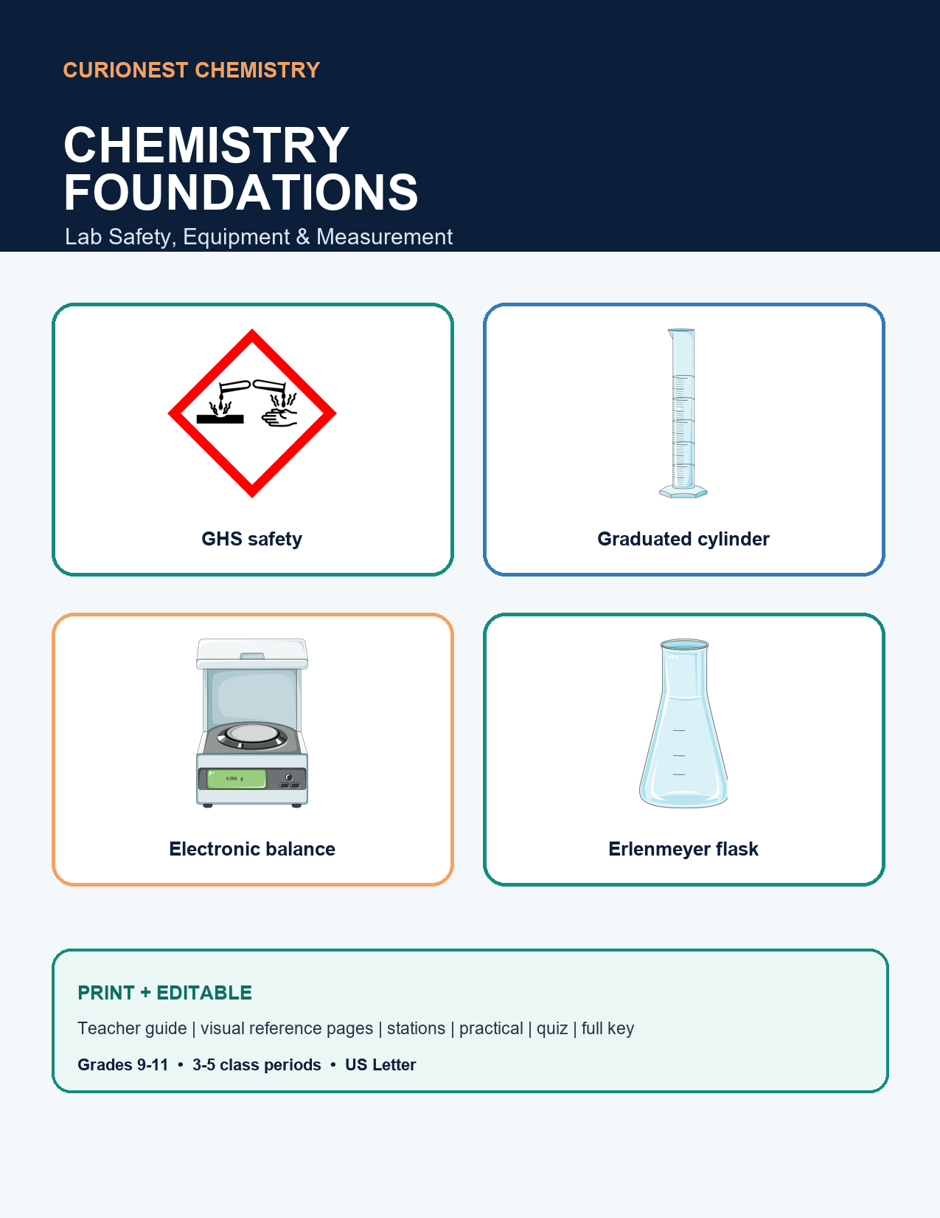

START HERE

Teacher Guide
A flexible 3-5 day launch unit for Grades 9-11
PURPOSE Students build safe lab habits, recognize essential equipment, and make defensible measurements before the first wet lab.

Day | Focus | Suggested evidence
1 | Safety norms + Safety Detective | Correct unsafe actions using evidence
2 | GHS labels + SDS navigation | Locate hazard, PPE, first-aid information
3 | Equipment identification + tool choice | Match tool to task and justify
4 | Measurement stations | Read meniscus; tare and report mass
5 | Practical + quiz | Demonstrate procedures and explain choices

Prep checklist
- Print pages labeled Student Page or Assessment; retain Teacher Page and Teacher Key pages.
- Set out clean, empty equipment only. Do not use chemicals for the identification stations.
- Test the eyewash and safety shower according to school policy; never activate them solely as a student demonstration.
- Use local emergency procedures and the SDS for every chemical used in later labs.
STANDARDS ROLE This foundational skills unit supports NGSS science practices such as planning investigations, analyzing data, and using mathematics. It is not presented as a standalone HS-PS1 performance-expectation unit.

Suggested materials
Goggles, lab apron, beaker, Erlenmeyer flask, graduated cylinder, test tube and rack, dropper, funnel, electronic balance, wash bottle, ring stand, hot plate, and printed station cards.
SAFETY NOTE This resource supports instruction; it does not replace district policy, teacher training, equipment inspection, or chemical-specific SDS review.

STUDENT PAGE 1

Before You Touch the Tools
Student name: __________________ Class: __________ Date: __________
Complete the readiness check. Your teacher may add local procedures.
Readiness area | What safe practice looks like
Eye protection | Wear chemical splash goggles whenever chemicals, heat, or glassware are used as directed.
Clothing | Closed-toe shoes; secure loose hair and clothing; wear the assigned apron.
Behavior | Read the full procedure first. No food, drink, horseplay, or unauthorized experiments.
Emergency | Know exits, gas/electric shutoffs, eyewash, shower, extinguisher, and spill-response procedures.
Chemicals | Read the label and SDS. Never return unused chemical to the stock container.
Incidents | Report every spill, breakage, exposure, injury, or near miss immediately.

Explain, do not just agree
Why must splash goggles remain over the eyes rather than on the forehead?
________________________________________________________________________________
________________________________________________________________________________
Why should unused chemicals never be returned to the stock bottle?
________________________________________________________________________________
________________________________________________________________________________
Student commitment: I will stop and ask when a procedure, label, or safety direction is unclear.
Student signature: __________________________ Date: __________

STUDENT PAGE 2

Lab Safety Detective
Read eight classroom snapshots. Explain the safer action for each.
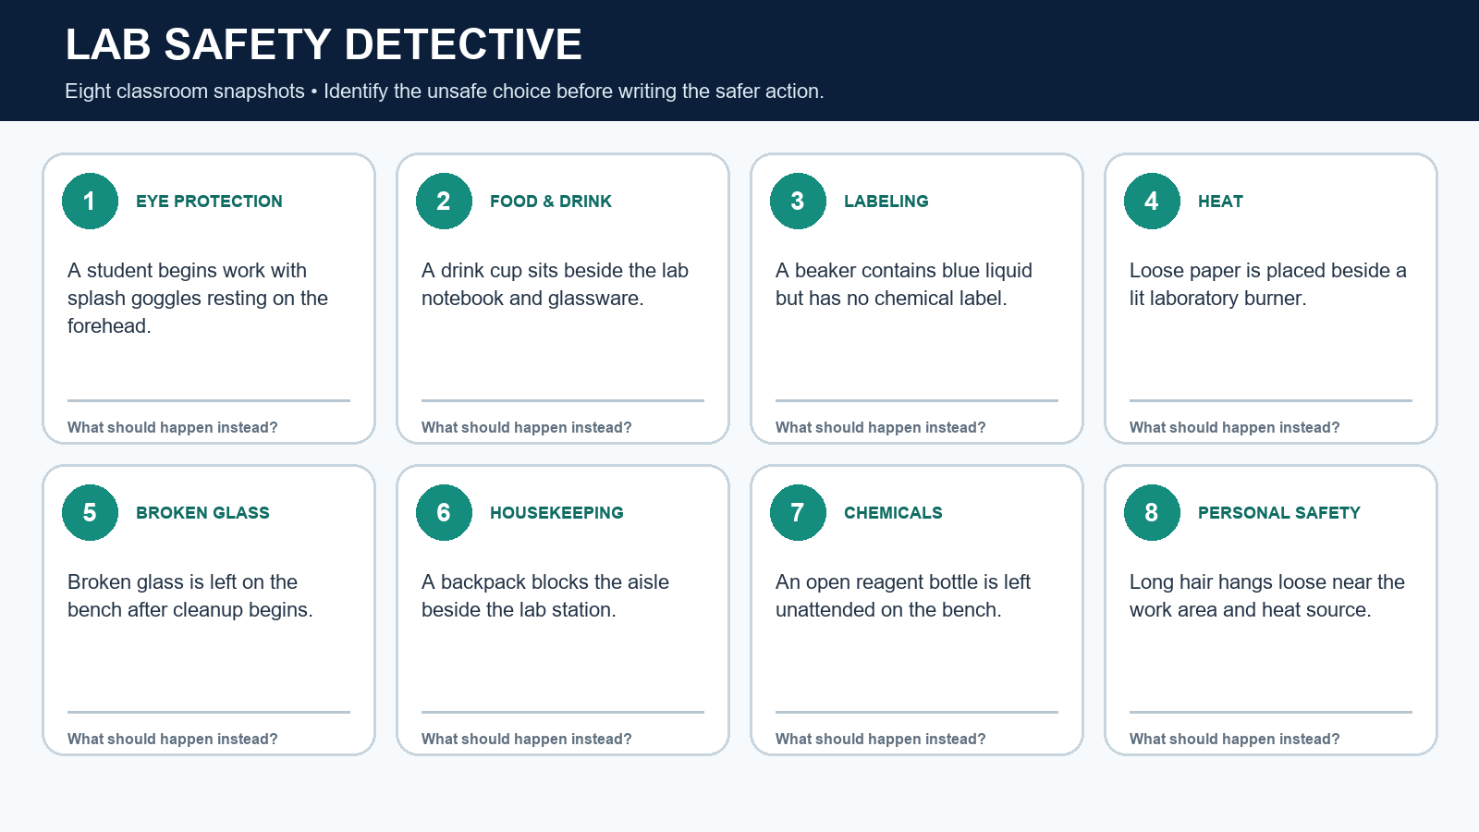
# | Unsafe choice | Safer action
1 |  | ________________________________________
2 |  | ________________________________________
3 |  | ________________________________________
4 |  | ________________________________________
5 |  | ________________________________________
6 |  | ________________________________________
7 |  | ________________________________________
8 |  | ________________________________________

STUDENT PAGE 3

GHS Pictogram Reference
Symbols communicate hazard classes; they do not replace the full label or SDS.
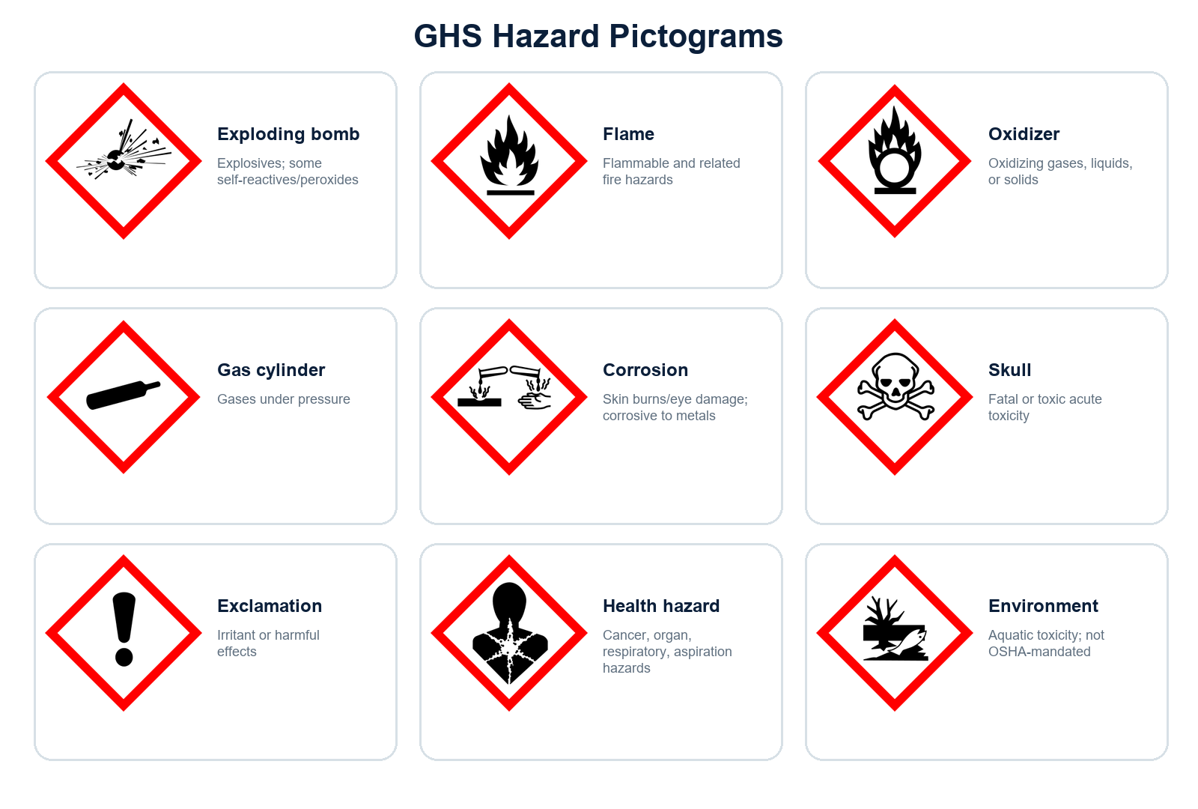
REMEMBER OSHA requires eight pictograms in its Hazard Communication Standard. The environmental pictogram is shown because students may see it, but OSHA does not mandate it.

STUDENT PAGE 4

Read a Chemical Label and SDS
Use the fictional acetone label below, then identify where the SDS supplies more detail.
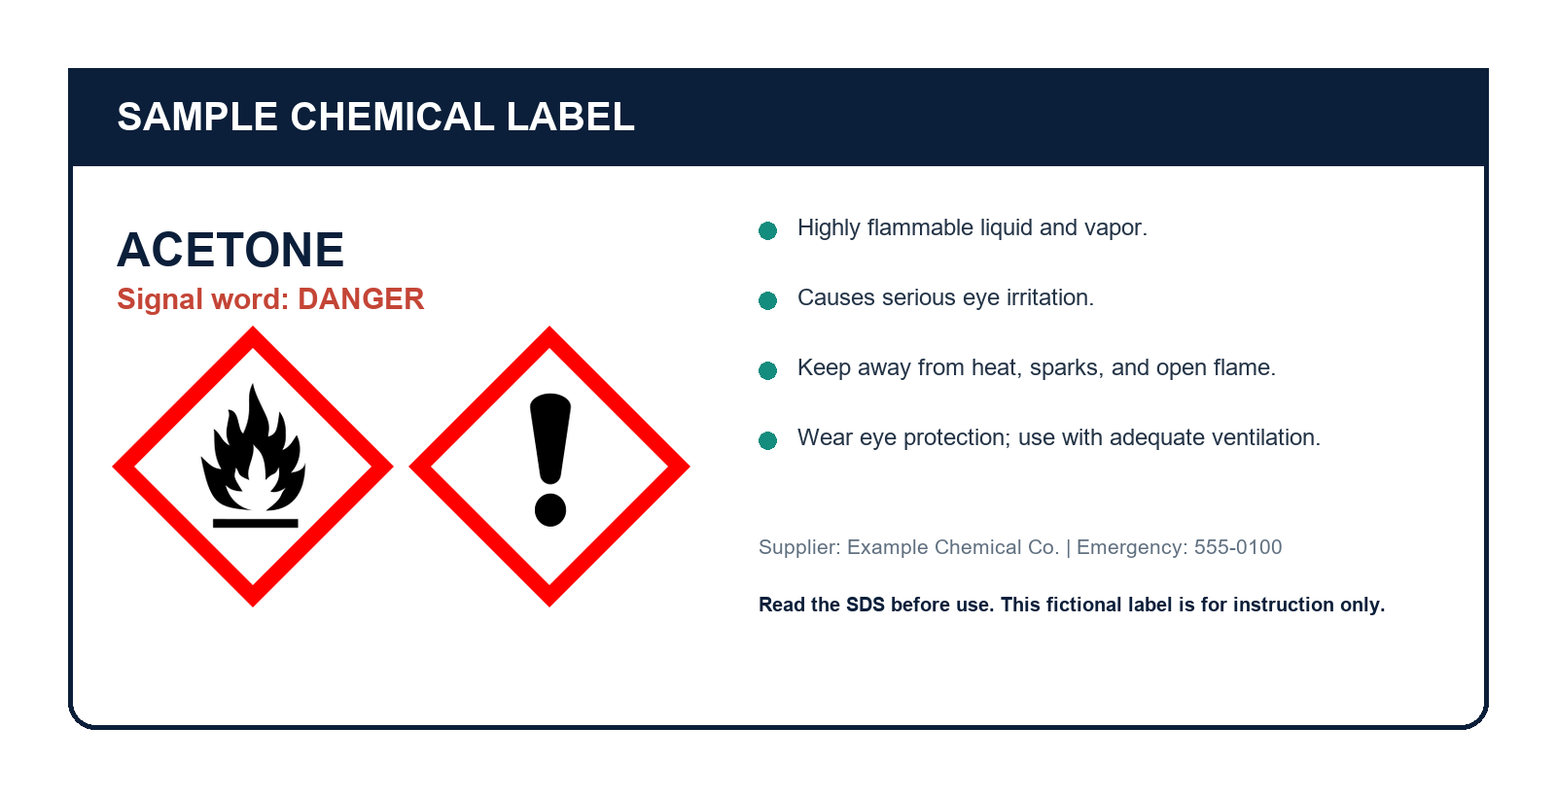
1. Which pictograms appear, and what hazards do they communicate?
________________________________________________________________________________
2. List two precautions stated on the label.
________________________________________________________________________________
3. Which SDS section would you check for first-aid measures?
________________________________________________________________________________
4. Which SDS section describes exposure controls and personal protection?
________________________________________________________________________________
5. Why is a pictogram alone not enough information for safe use?
________________________________________________________________________________
SDS QUICK MAP 1 Identification | 2 Hazard(s) | 4 First aid | 7 Handling/storage | 8 Exposure controls/PPE | 10 Stability/reactivity | 13 Disposal

STUDENT PAGE 5

Equipment Reference
Study the name and function. Circle tools available in your classroom.
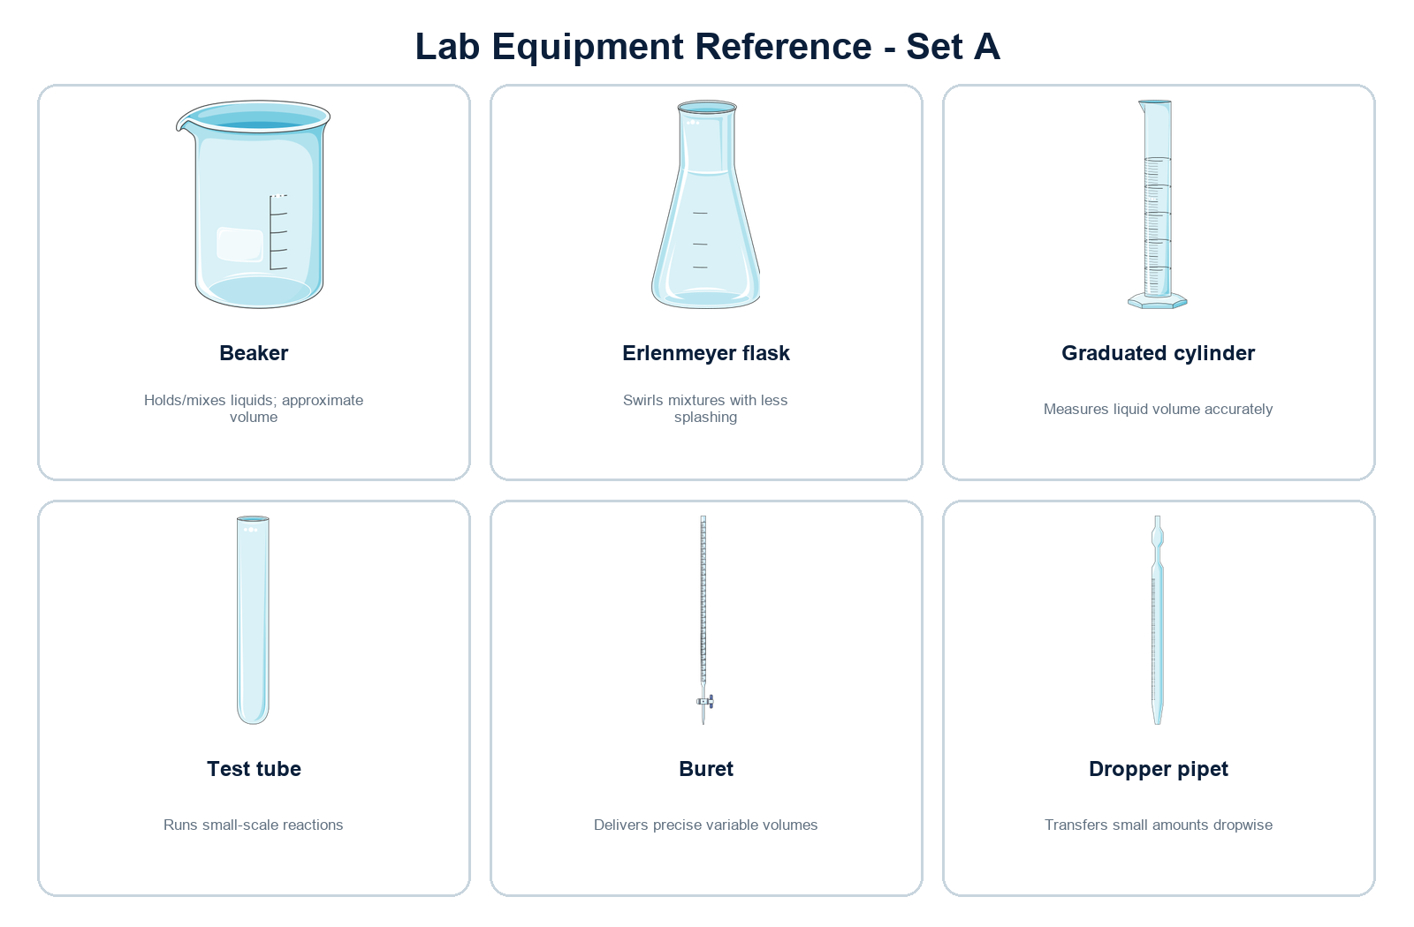

STUDENT PAGE 6

Equipment Reference
Study the name and function. Circle tools available in your classroom.
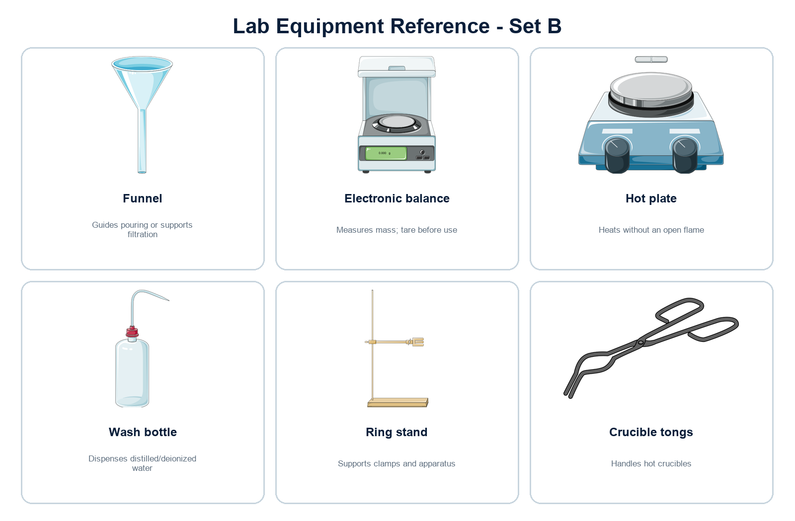

STUDENT PAGE 7

Equipment Identification Challenge
Write the correct name for each numbered tool.
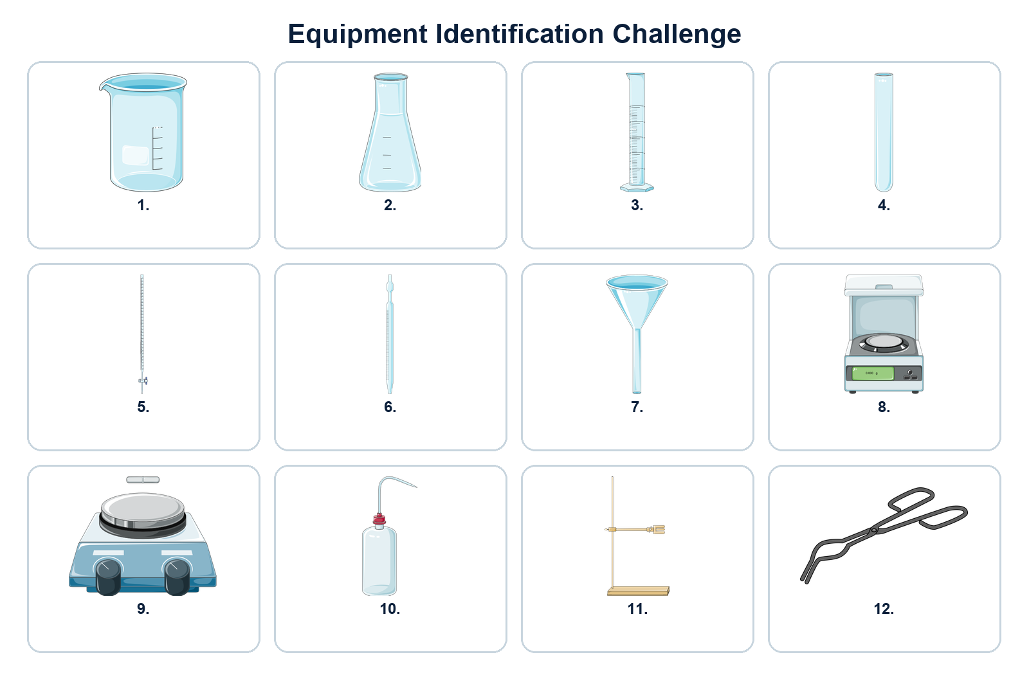
Odd-numbered tools | Even-numbered tools
1. __________________ | 2. __________________
3. __________________ | 4. __________________
5. __________________ | 6. __________________
7. __________________ | 8. __________________
9. __________________ | 10. __________________
11. __________________ | 12. __________________

STUDENT PAGE 8

Choose the Right Tool
Name the best tool and justify why it fits the task.
Task | Best tool | Reason
Measure 24.6 mL of water
Determine the mass of a metal sample
Add liquid one drop at a time
Heat a solution without an open flame
Support a buret during titration
Transfer a solid into a narrow-neck flask
Rinse the inside wall of glassware
Handle hot glassware safely

Compare precision
Rank these from least to most appropriate for measuring 25.0 mL: beaker, graduated cylinder, buret. Explain your ranking.
________________________________________________________________________________
________________________________________________________________________________
________________________________________________________________________________

STUDENT PAGE 9

Measurement Skills
Choose the instrument first; the number of reported digits follows the instrument.
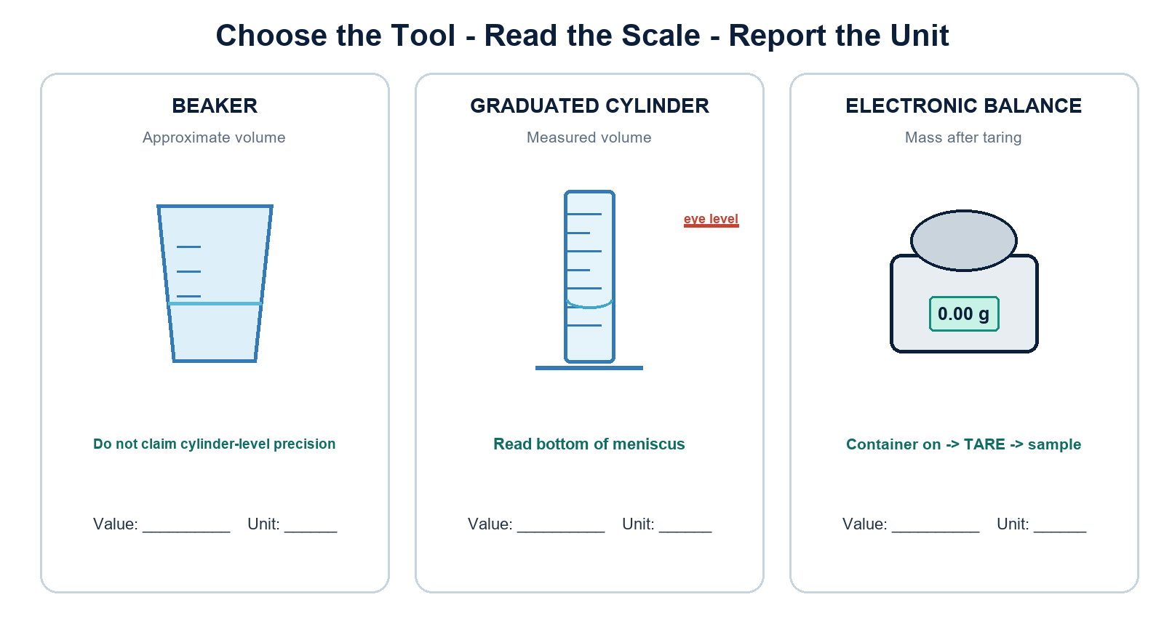
THREE HABITS Read at eye level. Record every certain digit plus one estimated digit for an analog scale. Always include a unit.

STUDENT PAGE 10

Meniscus and Precision Practice
Read the bottom of each meniscus at eye level.
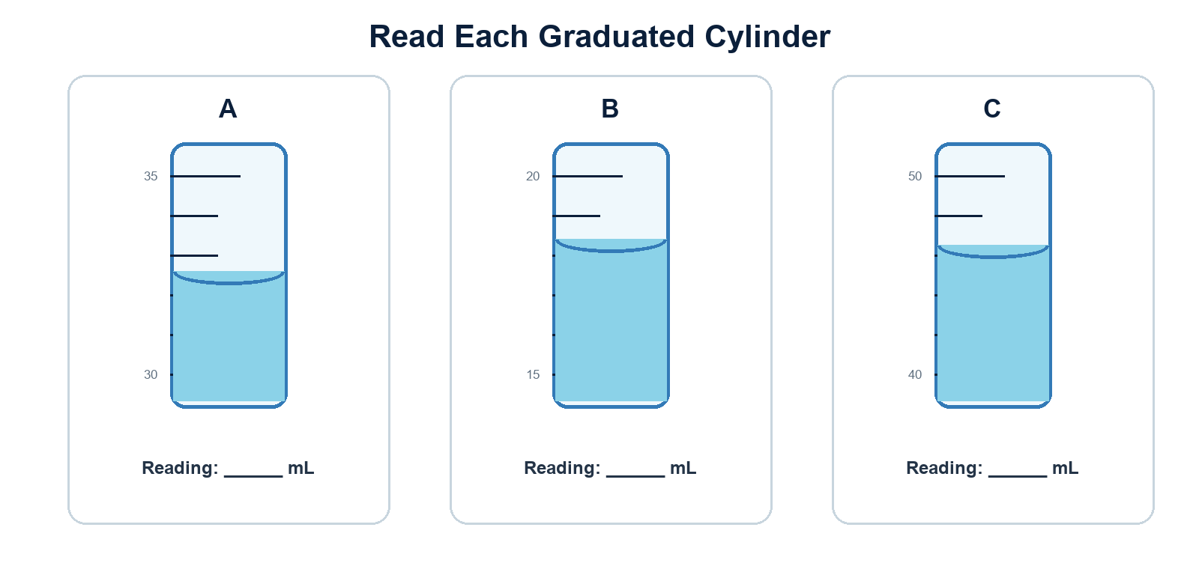
1. Which cylinder permits the most precise reading? Explain using the scale divisions.
________________________________________________________________________________
________________________________________________________________________________
2. A student records Cylinder A as 33 mL. What important measurement information is lost?
________________________________________________________________________________
________________________________________________________________________________
3. Describe one source of parallax error and how to prevent it.
________________________________________________________________________________
________________________________________________________________________________

TEACHER PAGE

Lab Skills Circuit - Teacher Setup
Four low-risk stations using clean equipment and water only.
Station | Setup | Performance evidence
A: Identify | Display 8 tools | Students name each and state one safe use.
B: Volume | Cylinder + colored water | Students read volume at eye level.
C: Mass | Balance + empty container + sample | Students tare, measure, and report unit.
D: Tool choice | Scenario cards | Students select a tool and justify precision/safety.

Teacher moves
- Demonstrate one non-example before students rotate.
- Require students to say both the value and unit aloud.
- Do not place chemicals at these stations.
- Use the practical rubric on page 15 for rapid feedback.
DIFFERENTIATION Provide the reference pages at the first rotation; remove them for the second. For advanced students, add a precision comparison between graduated and volumetric glassware.

STUDENT PAGE 11

Lab Skills Circuit - Student Record
Name: ______________________________ Group: ______
Station | Observation / measurement | Evidence or reason
A | Tool 1: __________ Tool 2: __________ | Safe use: __________________________
B | Volume: __________ mL | Eye-level evidence: _________________
C | Container mass after tare: ______ g  Sample mass: ______ g | Why tare? _________________________
D | Scenario: ________________________  Chosen tool: ______________________ | Why this tool? _____________________

Exit reflection
One habit that prevents an inaccurate measurement is...
________________________________________________________________________________
________________________________________________________________________________
________________________________________________________________________________
One safety action I can now explain—not merely memorize—is...
________________________________________________________________________________
________________________________________________________________________________
________________________________________________________________________________

ASSESSMENT

Lab Skills Practical
Teacher observation rubric; score each criterion 0-2.
Criterion | 2 - Meets | 1 - Developing | 0 - Not yet
PPE and readiness | Correct PPE; area clear; reads task first | Minor prompt needed | Unsafe/not ready
Tool identification | Names tool and appropriate use | Name or use incomplete | Incorrect
Volume technique | Eye level; bottom meniscus; unit | One technique error | Multiple errors
Balance technique | Tares; waits for stable reading; unit | One technique error | Multiple errors
Explanation | Uses safety/precision evidence | Partial reason | No defensible reason
Score: ______ / 10 Teacher feedback: ______________________________________________
________________________________________________________________________________
________________________________________________________________________________
________________________________________________________________________________
________________________________________________________________________________
REASSESSMENT Allow a second attempt after feedback. The goal is safe, repeatable performance—not a one-time score.

ASSESSMENT

Foundations Quiz - Part A
Name: ______________________________ Class: ______
1. Which tool is best for measuring 18.6 mL?
A. Beaker B. Graduated cylinder C. Erlenmeyer flask D. Watch glass
2. What should you do first after a chemical splashes into your eyes?
A. Finish the procedure B. Use the eyewash and alert the teacher C. Wipe eyes with a towel D. Look up the formula
3. Which pictogram indicates an oxidizer?
A. Flame over circle B. Gas cylinder C. Exclamation mark D. Skull and crossbones
4. Why is a balance tared?
A. To heat the sample B. To subtract the container mass C. To change grams to mL D. To increase sample mass
5. Which SDS section contains first-aid measures?
A. Section 1 B. Section 2 C. Section 4 D. Section 10
6. Which action is safest?
A. Smell directly from a bottle B. Return excess chemical to stock C. Tie back loose hair D. Wear goggles on the forehead

Match the tool to the task
Task | Tool
7. Add liquid dropwise | ______________
8. Support a buret | ______________
9. Heat without an open flame | ______________
10. Measure mass | ______________

ASSESSMENT

Foundations Quiz - Part B
Explain your reasoning using safety or measurement evidence.
11. A student reads a graduated cylinder while looking down from above. Identify the likely error and describe the correction.
________________________________________________________________________________
________________________________________________________________________________
________________________________________________________________________________
________________________________________________________________________________
12. The label shows a flame pictogram and the word DANGER. State two precautions that should be checked before use.
________________________________________________________________________________
________________________________________________________________________________
________________________________________________________________________________
________________________________________________________________________________
13. A classmate wants to measure 25.0 mL with a beaker because it is faster. Write a claim, evidence, and reasoning response.
________________________________________________________________________________
________________________________________________________________________________
________________________________________________________________________________
________________________________________________________________________________
14. During cleanup, you find broken glass in the sink. Explain the safe response.
________________________________________________________________________________
________________________________________________________________________________
________________________________________________________________________________
________________________________________________________________________________

TEACHER KEY 1

Answer Key - Safety and GHS
Suggested responses; accept equivalent scientifically sound wording.
Item | Suggested answer
Safety Detective 1-4 | 1 goggles over eyes; 2 remove drink; 3 label container; 4 move paper/flammables away and control flame.
Safety Detective 5-8 | 5 notify teacher; use broken-glass bin with proper tools; 6 remove backpack from aisle; 7 do not leave a reagent container open or unlabeled; 8 secure loose hair.
Label Q1 | Flame = flammable hazard; exclamation = irritant/harmful effects.
Label Q2 | Any two: keep away from ignition; wear eye protection; use adequate ventilation.
Label Q3-4 | First aid = SDS Section 4. Exposure controls/PPE = Section 8.
Label Q5 | The label is a quick warning; the SDS provides detailed controls, first aid, storage, stability, and disposal information.

Readiness explanations
Goggles must cover the eyes to protect against splashes. Chemicals are not returned to stock because they may contaminate the original reagent.

TEACHER KEY 2

Answer Key - Equipment and Measurement
Use the reference pages to reteach before reassessment.
# | Equipment | # | Equipment
1 | Beaker | 7 | Funnel
2 | Erlenmeyer flask | 8 | Electronic balance
3 | Graduated cylinder | 9 | Hot plate
4 | Test tube | 10 | Wash bottle
5 | Buret | 11 | Ring stand
6 | Dropper pipet | 12 | Crucible tongs

Choose the Right Tool
Task | Answer | Reason
24.6 mL | Graduated cylinder | Graduations support a measured volume.
Mass | Electronic balance | Tare container; report g.
Dropwise | Dropper pipet | Controls small additions.
Heat/no flame | Hot plate | No open flame.
Support buret | Ring stand | Holds a clamp and buret upright.
Solid to narrow flask | Funnel | Guides transfer.
Rinse glassware | Wash bottle | Directed stream.
Hot glassware | Crucible tongs | Keep hands away from hot surfaces.
Precision ranking: beaker < graduated cylinder < buret for variable-volume measurement. Suitability still depends on the specific task and required uncertainty.

TEACHER KEY 3

Answer Key - Measurement, Quiz and Sources
Suggested answers and scoring notes for consistent feedback.
Meniscus practice: A = 32.6 mL; B = 18.4 mL; C = 46.5 mL. Cylinder A/B have 1 mL minor divisions, so readings should include an estimated tenths place. Cylinder C has 2 mL divisions and supports an estimated reading between marks. Parallax occurs when the eye is above or below the meniscus; move to eye level.
Quiz | Answer / scoring note
1-6 | B, B, A, B, C, C
7-10 | Dropper pipet; ring stand; hot plate; electronic balance
11 | Viewing from above causes parallax; place eyes level with the meniscus and read the bottom.
12 | Any two defensible label/SDS precautions, such as remove ignition sources, wear goggles, or provide ventilation.
13 | Claim: use a graduated cylinder. Evidence: its scale supports a more precise reading than a beaker. Reasoning links smaller divisions to lower reading uncertainty.
14 | Notify the teacher; do not pick up by hand; use designated tools and place glass in the broken-glass container per local procedure.

Teacher safety references
American Chemical Society. Student Laboratory Code of Conduct; Lab & Safety Equipment; Importance of the Laboratory Experience. OSHA. Hazard Communication Standard / GHS Questions and Answers.
https://institute.acs.org/acs-center/lab-safety/education-training/high-school-labs/student-lab-code-of-conduct.html
https://www.acs.org/education/policies/middle-and-high-school-chemistry/classroom-and-lab-facilities/safety-equipment.html
https://www.osha.gov/hazcom/faq

Visual asset credits
Equipment icons by Servier Medical Art (CC BY 3.0) and OpenClipart contributors (CC0), accessed through Bioicons. GHS pictograms by UNECE (CC0), accessed through Bioicons. Individual file URLs and licenses are recorded in assets-manifest.json.
TERMS OF USE Single-classroom use by the original purchaser. Do not post publicly, resell, or redistribute editable files. School/district licenses require additional permission.

