**INSTRUCTIONS FOR INSTALLING UG4 ON WINDOWS**

Required For installation:

* Install Powershell 7 (Windows PowerShell): <https://docs.microsoft.com/en-us/powershell/scripting/install/installing-powershell-core-on-windows?view=powershell-7>
* Visual Studio 2019: <https://visualstudio.microsoft.com/downloads/>
* CMake: <https://cmake.org/download/>
* Git: <https://git-scm.com/download/win>
* ughub requires *Python* to run (at least version 2.6 should be available, higher is recommended) Windows users can download an installer from <https://www.python.org/downloads/release> (e.g. Python 2.7 or the latest Python 3 installer)

1. Open PowerShell 7 and you should be in your home directory,  
   If you are not in the home directory execute the command cd $HOME
2. Next execute git clone https://github.com/UG4/ughub  
   This will clone the UG4 ughub repository to your local machine, you should see something similar to below when you execute the git clone command: 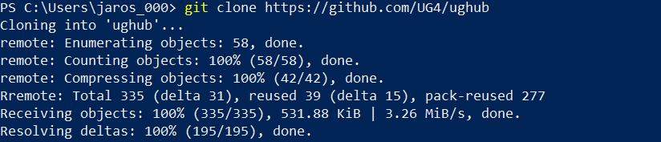
3. Execute cd $HOME/ughub; git pull  
   This will take you inside the ughub folder and then updates the repository on your local machine. If it is already up to date then it will tell you “Already up to date”
4. Next cd $HOME and then execute  
   Set-Item -Path Env:Path -Value($Env:Path + ";$HOME\ughub")  
   This will temporarily set the environment path to include the path to ughub, this means you can execute ughub from within any folder.
5. Next in $HOME we will make the ug4 directory by executing: mkdir ug4  
   This will make the directory “ug4”, if you execute ls the list of all folders will be displayed, you should see the “ug4” and “ughub” folders: 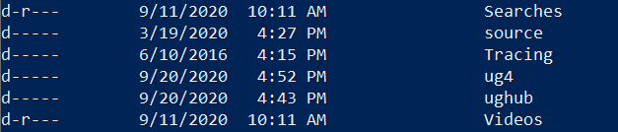
6. Next execute cd $HOME\ug4 this will take you inside the ug4 folder, if you execute ls you will see that nothing is in the folder. Now execute
   1. ughub init this will initialize ughub so that you can install plugins
   2. Then execute ughub install Examples this is will install Example scripts and plugins that are utilized, if you execute ls inside the ug4 folder you should see

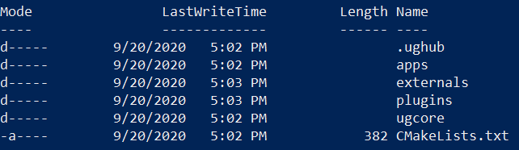

1. Next we will execute   
   ughub addsource neurobox https://github.com/NeuroBox3D/neurobox-packages.git  
   This will add the neurobox source repo to ughub
2. Now execute  
   cd plugins; ughub install cable_neuron neuro_collection MembranePotentialMapping Neurolucida SkinLayerGenerator  
   This will take you to the plugins folder and install the plugins listed above. Once complete execute ls and you should see the list of plugins installed inside the ‘plugins’ folder: 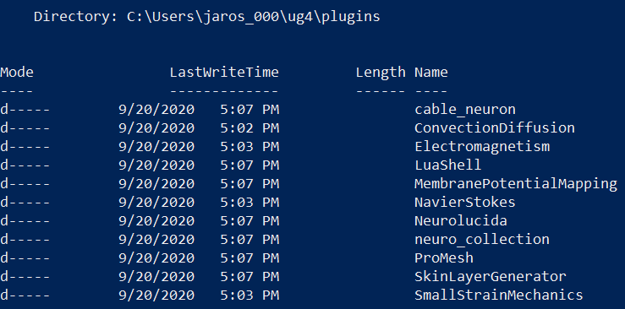
3. Now execute cd ..; cd apps  
   The cd .. will take you back up one folder directory, and cd apps will take you inside the ‘apps’ folder, here we will install the example codes for the plugins, these are codes that you can modify/adapt for your own purposes. Execute  
   ughub install cable_neuron_app calciumDynamics_app MembranePotentialMapping_app NeurolucidaApp SkinLayerGeneratorApp  
   This will install all the example codes for the neuro_collection.
4. Now execute cd $HOME/ug4 to get back into the main ‘ug4’ folder. We will make the ‘build’ folder by executing: mkdir build  
   Then go into that new folder by executing: cd build  
   This folder is empty.
5. Next we will compile the UG4 (make sure you are in the folder build when you do this!), execute  
   cmake -DDIM=ALL -DCPU=1 -DSTATIC_BUILD=ON -DCMAKE_BUILD_TYPE=Release -DLAPACK=OFF -DBLAS=OFF -DEMBEDDED_PLUGINS=ON -DConvectionDiffusion=ON -DElectromagnetism=ON -DNavierStokes=ON -Dneuro_collection=ON -Dcable_neuron=ON -DMembranePotentialMapping=ON -DSmallStrainMechanics=ON ..  
   All in one line, and yes include [space] then the two dots at the end. Once it is complete it should say: 
6. Now we build UG4, to do that, please navigate to the build folder window (not through PowerShell)

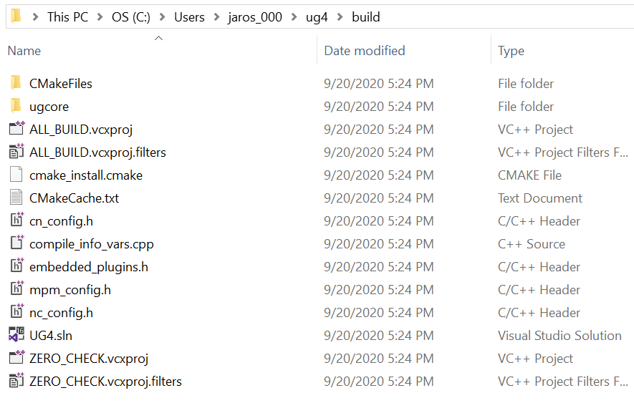

Right click on ‘UG4.sln’ and open it with Visual Studio 2019

Then in the top menu set it to ‘Release’  


Then click ‘Build → Build Solution’ and this will build the ugshell.exe executable. This can take anywhere from 20-40 minutes depending on your machine.

1. Once it is complete navigate to the ‘Release’ folder and you should see ‘ugshell.exe’  
   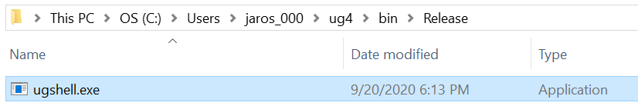
2. Move ugshell.exe from the “Release folder” into the “bin folder” instead (MUST DO THIS)
3. (optional) Now we need to add ‘ugshell.exe’ to the system path environment in order to run the executable from any folder when we are using PowerShell 7. Close PowerShell 7 and re-open PowerShell 7 by right clicking and selecting “Run as administrator”  
   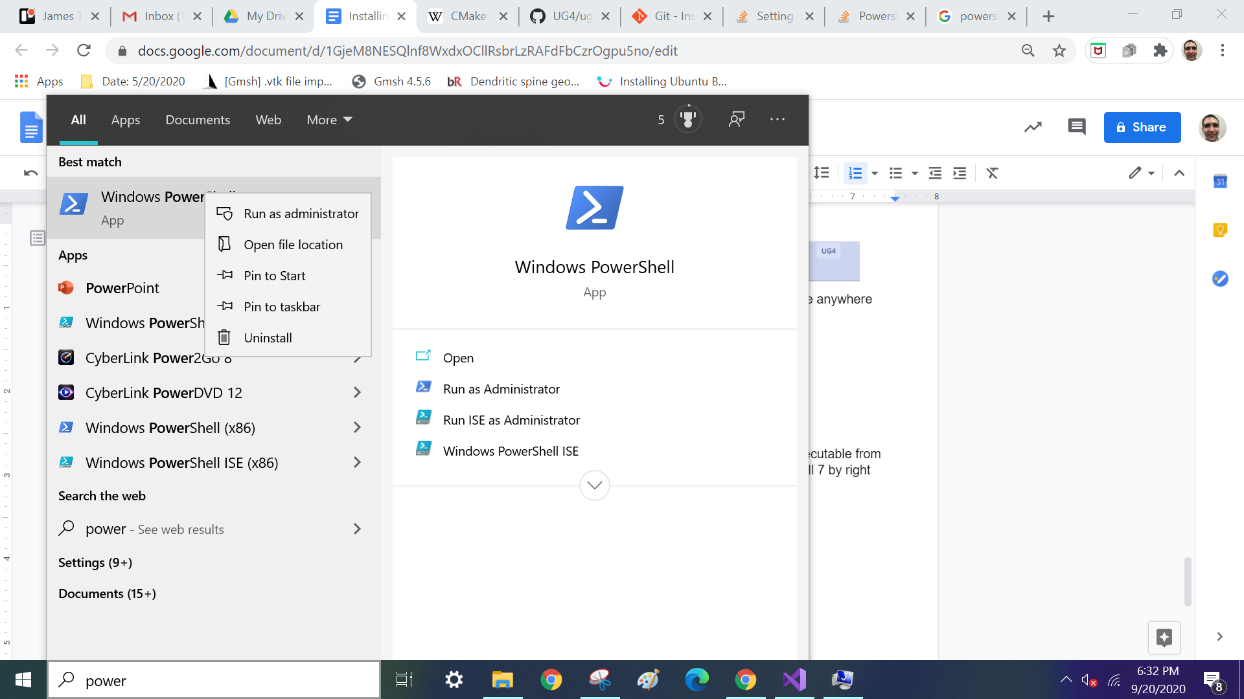

Then execute the following:   
[Environment]::SetEnvironmentVariable("Path", $env:Path + ";C:\path_to_ug4\bin", "Machine")

Where you fill in ‘path_to_ug4’ with the path to the ug4 folder.

Then close PowerShell 7 and reopen it and execute: ugshell.exe

The reason we do step 15 is to make it easier when running ugshell, if we don’t do step 14 then we would have to type the entire file path to ugshell.exe in order to run it.

Alternatively, if step 15 does not work you can call ug4 by specifying the entire path:

**C:/path-to-ug4/ug4/bin/ugshell -ex [scriptname].lua**