Explanatory title related to the content of the work
Yaroslav Shekula, Michał Żarowski, Santiago Rodriguez

Abstract—Lorem ipsum dolor sit amet, consectetur adipiscing elit. In auctor est et lacus luctus eleifend. Duis at tincidunt nibh. Nam sed elementum lorem, eu pretium magna. Vestibulum justo urna, imperdiet eget tristique ut, pellentesque vel turpis. Vivamus et risus tempor, fringilla libero in, semper arcu. Praesent blandit libero vitae rutrum tincidunt. Fusce id justo quis mauris accumsan pellentesque et in massa. Nulla ut eleifend ante. Nunc pretium justo a nibh tincidunt tempus. Fusce auctor tortor nec turpis commodo, vitae posuere nulla mollis. Maecenas non placerat metus. Mauris dolor libero, laoreet quis leo vitae, dignissim lobortis enim. Curabitur in magna nibh. Aenean vel dui eros. Morbi maximus in turpis vitae fermentum.
Duis interdum nisi id sem dictum rhoncus. Duis vitae ante tincidunt, tempor diam quis, tincidunt lorem. Etiam sit amet nisi tempus sapien auctor vestibulum ac eu purus. Curabitur a suscipit urna, sit amet facilisis erat. Morbi iaculis vestibulum tortor, quis varius justo mollis ut. Pellentesque placerat felis pretium, maximus ex quis, rutrum nisi. Sed quis imperdiet nunc. Donec euismod ipsum sed urna semper posuere. Nunc id gravida enim. Suspendisse tortor lectus, tempus tincidunt tellus at, mattis tincidunt tortor. Morbi finibus ultrices bibendum. Morbi ac ipsum eu erat consectetur convallis at.

Keywords—Image classification, noisy web data, CNNs, ubiquitous reweighting

─────── ♦ ───────

1 Introduction
• Context: Automated wildlife monitoring is crucial for biodiversity conservation, ecological research and assisting ornithologists.
A major bottleneck in ecological monitoring is the manual identification of bird species.
• The Problem: Bird classification is challenging due to high intra-class variance (birds of the same species look different due to age, sex, or season) and low inter-class variance (different species can look incredibly similar).
• The Approach: We understand that training a deep learning model from scratch on a satisfying dataset requires massive computing power and data. Therefore, the project will utilise Transfer-Learning: Taking Convolutional Neural Network (CNN) pre-trained on a massive dataset and fine-tuning it for the specific tasks.

• Primary Objective: To develop and evaluate a machine learning pipeline capable of accurately classifying bird species from images using a pre-trained CNN architecture.
• Second Objectives: implementation of data preprocessing and augmentation techniques suitable for avian imagery, apply transfer learning using a well-known architecture.

2 State of the Art

2.1 Subsection example: Merlin Bird ID (Cornell Lab of Ornithology, 2014–present)
Merlin is a real-world deployed application, not a research benchmark. Its core innovation lies not just in the ML model itself, but in the data flywheel that powers it. The system is built on top of eBird, Cornell's global citizen-science platform holding over one billion bird observation records, and the Macaulay Library, the world's largest archive of wildlife audio and imagery. This gives Merlin an unmatched training corpus that grows continuously — users contribute a new image every two seconds.
How it works:
The Photo ID feature uses a deep convolutional neural network (CNN) developed in partnership with the Visipedia research group (Caltech/Cornell). The model is trained on millions of labeled images from the Macaulay Library. A key architectural decision is the integration of geospatial and temporal context: rather than asking the model to rank all ~10,000 known species globally, eBird location and date data pre-filter the candidate species to only those plausibly present at that place and time of year. This dramatically narrows the classification space and is a major reason for the app's high accuracy. The Sound ID feature uses a separate CNN operating on mel-spectrograms of recorded audio, allowing real-time species identification from birdsong. Both models are fine-tuned continuously as new annotated data arrives from the community.
Key metrics: Visual ID accuracy reaches approximately 98%. The app covers all 10,315 known bird species globally and has been installed over 12 million times.

2.2 Subsection example: Caltech-UCSD Birds-200-2011 / CUB-200-2011 (Wah et al., 2011)
CUB-200-2011 is an academic benchmark dataset, not a deployed system. Its purpose is to serve as a standardized testbed for the computer vision subproblem known as fine-grained visual classification (FGVC) — the task of distinguishing between visually similar subcategories (e.g., species within the same genus), which is substantially harder than broad-category recognition.
How it works:
The dataset contains 11,788 images across 200 North American bird species, with an average of ~60 images per class. Each image is annotated with the species label, a bounding box, a binary segmentation mask isolating the bird from the background, and 15 part-level keypoint annotations (crown, beak, belly, wing, tail, etc.). These rich annotations make CUB the standard resource for training and evaluating models that need to focus on discriminative local features — subtle visual differences like beak shape or wing coloring that distinguish closely related species.
The benchmark has driven the development of a wide lineage of architectures: from early part-based models and attention mechanisms, to modern transformer-based approaches such as ViT and DINO. State-of-the-art accuracy on CUB-200-2011 has progressed from roughly 55–65% with early CNN methods to above 92% with recent vision transformer models. Transfer learning from ImageNet pretraining is the standard strategy — models learn general visual features on ImageNet, then are fine-tuned on CUB's 200 classes.

2.3 Examples summary
CUB-200-2011 defines the problem of fine-grained bird classification and provides the controlled environment to measure algorithmic progress. Merlin represents a solution at scale, leveraging contextual priors and massive crowd-sourced data to push accuracy beyond what any pure image classifier can achieve in isolation. A state-of-the-art bird recognition project can draw on both: CUB as a benchmark to evaluate and compare model architectures, and Merlin's design philosophy as inspiration for incorporating contextual metadata and community-driven data collection into the pipeline.

3 Dataset

3.1 Overview of the Dataset
The Caltech-UCSD Birds-200-2011 dataset, commonly abbreviated as CUB-200-2011, is one of the most widely used benchmarks in fine-grained visual categorization. Introduced in 2011 by Wah, Branson, Welinder, Perona, and Belongie at Caltech and the University of California, San Diego, it extended the earlier CUB-200 dataset released in 2010 and has since become a standard reference for evaluating systems that distinguish between visually similar categories. The dataset contains 11,788 photographs distributed across 200 species of North American birds, typically split into roughly 5,994 training and 5,794 test images. The photographs are captured in natural environments rather than studio conditions, producing realistic variation in pose, lighting, and background. What distinguishes CUB-200-2011 from generic datasets such as CIFAR or ImageNet is the density of its annotations. Every image is paired with a species label, a bounding box, fifteen anatomical part locations such as the beak, crown, nape, belly, tail, and wings, and 312 binary attributes describing properties like wing color and bill shape. This layered labeling turns a single dataset into a platform for classification, detection, keypoint localization, segmentation, and attribute prediction.

3.2 Relevance to the Image Processing Course Project
CUB-200-2011 presents the classic problem of fine-grained categorization, where inter-class differences are subtle and intra-class variation is large. Distinguishing two warblers may hinge on a small patch of plumage, while photographs of the same species can vary dramatically in pose and background. This forces models to attend to localized, discriminative cues rather than relying on global appearance, mirroring the kind of reasoning required in many real-world recognition problems. Because the images are captured in cluttered natural settings, the dataset exercises nearly every technique covered in a typical image processing syllabus. Students can apply noise reduction, histogram equalization, color space transformations, segmentation through thresholding or region growing, morphological operations, and contour extraction, then measure how each step affects downstream recognition. The dataset is equally well suited to handcrafted feature descriptors such as color histograms, SIFT, HOG, and local binary patterns, which form the conceptual foundation of modern recognition systems. It has also become a canonical benchmark in the deep learning era, with published results using convolutional networks, attention mechanisms, and vision transformers, giving students a clear reference frame for evaluating their own work. A semester project can therefore progress naturally from handcrafted features fed into a support vector machine, to transfer learning with pretrained backbones like ResNet or EfficientNet, and finally to advanced approaches such as bilinear pooling or part-based attention.

3.3 Practical and Real-World Value
From a practical standpoint, the dataset is freely available for academic use, well documented, and has a clearly defined evaluation protocol that encourages reproducibility. Its metadata is stored in simple text files that can be parsed without specialized tooling, and a full training run is feasible on a modest GPU within a single semester. Beyond technical merit, the subject matter itself is motivating: automated bird identification supports biodiversity monitoring, citizen science platforms such as eBird and Merlin, and ecological research on migration and population health. This grounding gives an otherwise abstract academic exercise a clear connection to the real world. Taken together, CUB-200-2011 combines scale, annotation richness, scientific relevance, and technical difficulty in a way that makes it an ideal foundation for an image processing course project, allowing learning to scaffold from low-level pixel manipulation through mid-level feature engineering to high-level deep recognition, all within a single coherent and meaningful problem.

4 Proposal

4.1 Model Architecture and Training Strategy
For the preliminary development phase, the focus was on establishing a robust baseline using Transfer Learning via a "Linear Probe" approach. A ResNet-50 architecture, pre-trained on the ImageNet1K_V1 dataset, was selected. To adapt this model for the specific task of avian classification, the final fully connected layer (2048 to 1000) was replaced with a new linear layer mapping the 2048 extracted features to the 200 specific bird classes.
To isolate the performance of the pre-trained feature extractor, all backbone parameters of the ResNet-50 were completely frozen. Only the newly initialized 200-class head (comprising 410,200 trainable parameters) was updated during training.

4.2 Hyperparameter Configuration
The model was optimized using the Adam optimizer with a Cross-entropy loss function. The learning rate was set to 1e-3, utilizing a Cosine Annealing schedule (T_max = 10), alongside a weight decay of 1e-4. Training was executed with a batch size of 32 for a duration of 10 epochs.

5 Experiments, results and analysis
Curabitur tempor a augue et vestibulum. Mauris fermentum lorem lectus, vitae vestibulum leo faucibus quis. Mauris non leo ligula. Donec ac egestas orci. Pellentesque rhoncus leo porta augue dictum tristique. Nam ullamcorper egestas sem, a posuere dui placerat nec. Vivamus eget dictum sem. Aliquam bibendum dui auctor tellus viverra, eu molestie leo consectetur. Duis tristique elit velit, aliquam posuere risus condimentum ac.
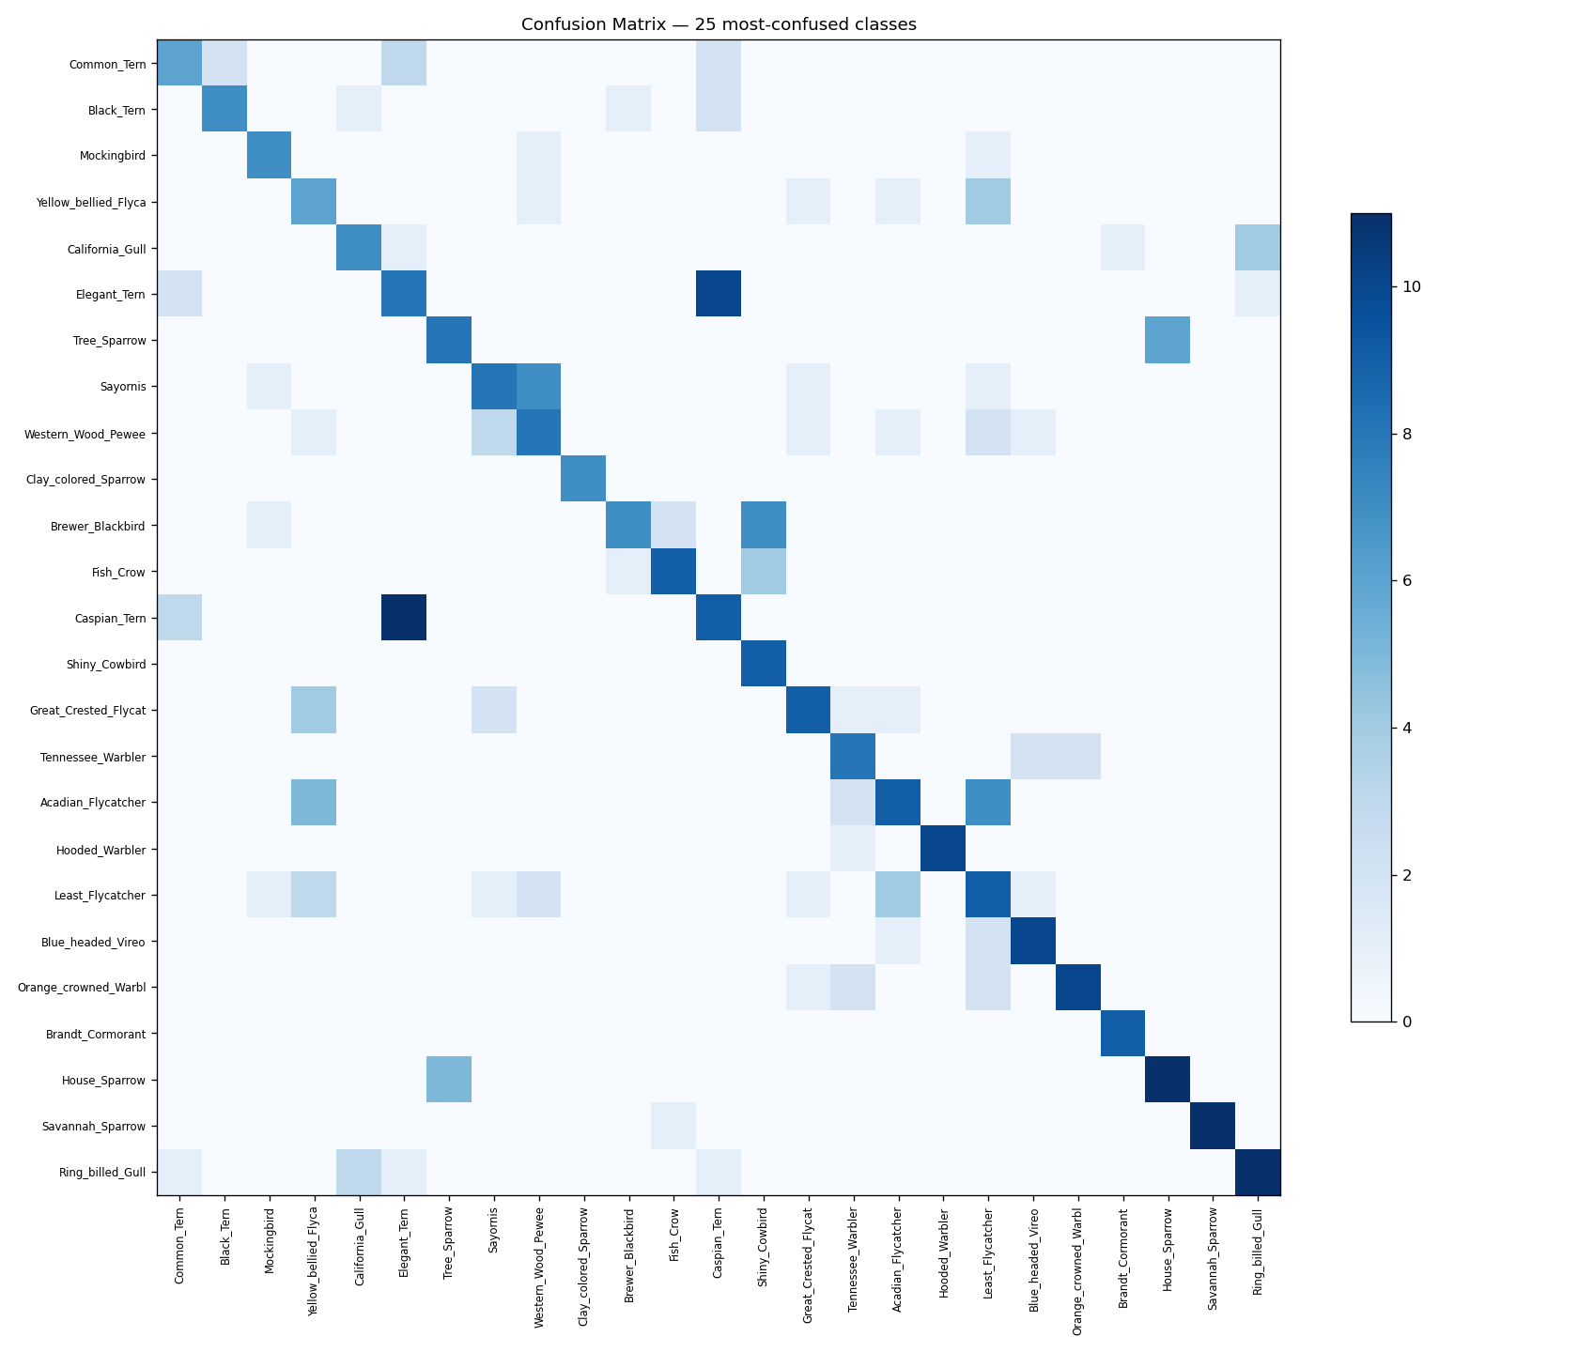
Ut hendrerit porttitor metus, nec elementum sem. Proin quis purus elit. Vivamus eu aliquam nulla. Duis consectetur neque cursus nibh fermentum, eget facilisis sapien fringilla. In luctus massa vitae blandit pharetra. Suspendisse et sem nunc. Integer rutrum tellus id volutpat pellentesque. Mauris vulputate quam sit amet mollis luctus. Nam facilisis fringilla venenatis. Aliquam turpis lacus, euismod ac lorem nec, rutrum congue sem. Donec et consequat turpis. Etiam a mauris lorem. Duis pharetra rutrum magna, a placerat diam blandit nec. Proin turpis nunc, ultricies vel rutrum quis, sollicitudin eget leo. Nullam at semper ex. Pellentesque a purus lacus. Vestibulum porttitor bibendum neque.

5.1 Quantitative Performance
The preliminary model achieved performance consistent with expected theoretical ceilings for a frozen-backbone ResNet-50 on the CUB-200 dataset. Training ran efficiently on a CUDA-enabled GPU in approximately 13 minutes. The best checkpoint, selected via validation accuracy, achieved a Top-1 Accuracy of 63.57% and a Top-5 Accuracy of 89.13%on the final test set.

Epoch | Train Loss | Train Acc | Val Acc | LR
1 | 4.351 | 14.8% | 37.0% | 9.76e-4
2 | 2.379 | 45.9% | 49.8% | 9.05e-4
3 | 1.655 | 61.7% | 51.8% | 7.94e-4
4 | 1.332 | 68.3% | 57.0% | 6.55e-4
5 | 1.094 | 74.2% | 55.8% | 5.00e-4
6 | 0.951 | 79.2% | 61.2% | 3.45e-4
7 | 0.824 | 83.5% | 62.0% | 2.06e-4
8 | 0.766 | 85.5% | 63.8% | 9.55e-5
9 | 0.731 | 86.8% | 64.0% | 2.45e-5
10 | 0.695 | 87.7% | 64.3% | 0.00e+0

Table 1. Training Curve metrics across the 10 epochs

5.2 Qualitative Analysis and Bottlenecks
An analysis of the confusion matrix reveals critical insights into the limitations of utilizing frozen, global features for fine-grained tasks. Visually unique species achieved near-perfect recognition; for instance, the White Pelican and Roadrunner both achieved 100% Top-1 accuracy. However, the model struggled significantly with species characterized by low inter-class variance, such as the Common Tern (20.0%) and Yellow-bellied Flycatcher (20.7%).
The confusion matrix shows dense error clusters among similar species (e.g., Terns vs. Gulls). Because these birds differ primarily in localized features—such as subtle bill shapes—a frozen linear probe utilizing global average-pooled features cannot capture these discriminative visual cues.

Fig. 1. Confusion Matrix


Curabitur pretium semper sem sed posuere. Quisque pretium

6 Conclusions
Aliquam erat volutpat. Pellentesque habitant morbi tristique senectus et netus et malesuada fames ac turpis egestas. Donec ut sapien nec turpis placerat maximus. Quisque porttitor nulla ex, vel finibus nisi commodo in. Vivamus fringilla diam eget est egestas, id hendrerit leo tincidunt. Mauris tincidunt iaculis ornare. Curabitur pulvinar, dolor amet ultrices porttitor, odio nisl tincidunt magna, sed dapibus elit tellus vel mauris. Proin faucibus scelerisque orci vitae aliquet. Nulla ullamcorper tincidunt nisl, sit amet mollis mi pretium sit amet. Fusce sagittis vehicula nibh, ut pulvinar magna vestibulum eget. Praesent vulputate accumsan eros sed porttitor.
Quisque consectetur justo a mi porta, id varius nisi posuere. Morbi tristique orci nec dolor aliquet venenatis. Integer malesuada tincidunt dignissim. Cras lobortis metus tristique erat placerat, nec rutrum justo pretium. Integer faucibus aliquet commodo. Integer non quam nec lectus. Sed in leo rhoncus, gravida elit vel, tristique quam. Nullam auctor mi in tortor mollis ullamcorper.
Nunc dictum ipsum quis egestas scelerisque. Vestibulum rutrum tempor posuere. Praesent varius libero odio, ac bibendum arcu tempus quis. Pellentesque habitant morbi tristique senectus et netus et malesuada fames ac turpis egestas. Sed eget ex risus. Integer metus velit, viverra ac fringilla sit amet, laoreet eget lacus. Nulla rutrum mollis elit et maximus. Nulla sed aliquet elit. Sed libero justo, porta ut vulputate eget, suscipit faucibus sem. Sed at quam ut justo vestibulum vehicula non sed ligula.
Nulla facilisi. Curabitur pulvinar, dolor amet ultrices porttitor, odio nisl tincidunt magna, cras lobortis metus tristique erat placerat, sed dapibus elit tellus vel mauris. Phasellus vitae purus gravida, rutrum ante vel, vestibulum mauris.

Bibliografy
[1] O. Russakovskyet al., “ImageNet large scale visual recognition challenge,” Int. J. Comput. Vis., vol. 115, no. 3, pp. 211–252, 2015.
[2] A. Krizhevsky, I. Sutskever, and G. E. Hinton, “ImageNet classificationwith deep convolutional neural networks,” inProc. Int. Conf. Neural Inf.Process. Syst., 2012, pp. 1097–1105.
[3] K. Simonyan and A. Zisserman, “Very deep convolutional networks forlarge-scale image recognition,” inProc. Int. Conf. Learn. Representations,2014.
[4] C. Szegedyet al., “Going deeper with convolutions,” inProc. IEEE Conf.Comput. Vis. Pattern Recognit., Jun. 2015, pp. 1–9.
[5] K. He, X. Zhang, S. Ren, and J. Sun, “Deep residual learning for imagerecognition,” inProc. IEEEConf. Comput. Vis. PatternRecognit., 2016, pp. 770–778.

