Level Control of a Two Tanks System. Case study
Description of the TwoTanks.mlapp file
File written by Ruth Bars and Gyula Max, Budapest University of Technology and Economics.
Similar files and the toolbox: See website below for more files like this. https://sites.google.com/sheffield.ac.uk/controleducation/matlabresources/section-6-11-community-control-toolbox
This group of files can be downloaded through MATLAB add-ons with the toolbox name: control101
Note: This file only uses a linearised model of the two tank system. For files using a Simulink model of the non-linear system, please see the livescript twotanks_control101.mlx.

1. Two tanks model

We investigate the level control of a two-tank system. The model of the system is given by the physical equations describing its behavior. In order to handle the level control more easily, the model is linearized around the working points. The goal is to control the level of the lower tank. The liquid level of the lower tank is controlled by the liquid flow into the upper tank. We design and apply PI(D) control for the system.

The scheme of the system is given in Fig.1. The inlet liquid quantity is denoted by u1, the outlet liquid outflow quantities are y1 and y2 respectively. The liquid levels are denoted by h1 and h2. The cross sections of the tanks are A1 and A2. The cross sections of the outlet tubes are denoted by "a".

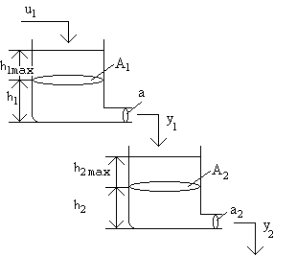
Figure 1. The scheme of the two tanks system

Figure 1. shows the geometry of the model. The model is implemented on two pages (Define two tank parameters and Closed-loop simulation). On the Define two tank parameters sheet, the working point of the model is determined by taking into account the given physical basic data. By linearizing the environment around the working point, we can not only use the equations describing the system, but also work with the transfer function of the linearized model. Later, on the Closed-loop simulation sheet we can design or specify a feedback PI(D) controller using the known transfer function of the system.

2. The mathematical model of the two tanks system
The mathematical description of the model can be derived understanding its behaviour and describing it by mathematical relationships. From the balance of the potential energy and the motion energy the velocity of the outlet liquid is obtained as
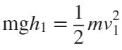 (1)
Using (1) for the upper tank the quantity of the outlet liquid is given by (2).
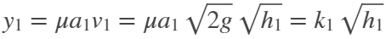, where μ is the viscosity factor. (2)
The changes in the levels in the two tanks can be written as
(3)
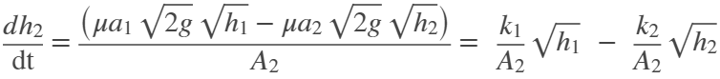 (4)
(3) and (4) can be solved i.e. by ode.. functions.
The solution is simpler if relative units are introduced as it is done in (5). Using this method, the variables are in range of [0,1].
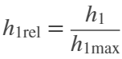 , 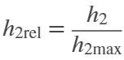 and 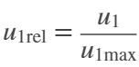 (5)
Divide (3) by h_{1max} and (4) by h_{2max}
(6)
(7)
Note that if 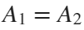 and 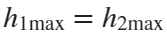, then 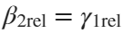 as well as β-s and γ-s depend on just geometrical data. The dimensions of the parameters shown by (8) are
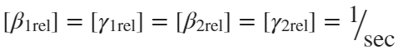 (8)
We can see that if the necessary 9 parameters of the model
- maximal heights of the upper and lower tanks [ h_{1max}, h_{2max} ]
- surfaces of the upper and lower tanks [ A_{1max}, A_{2max} ]
- outlet surfaces of the upper and lower tanks [ a_{1max}, a_{2max} ]
- viscosity of the liquid [ in case of water [μ = 1 ]
- the maximum value of the inlet liquid [ u_{1max} ]
- the relative value of the actual inlet liquid [ u_{1rel} ]
are given, then all the parameters can be calculated.

3. Linearisation of the model

Our model is nonlinear because of the variables of h₁, h₂. It can be linearised around the working point using the first two terms of the Taylor expansion.
Linearisation (9) of a function f(x) around the working point x₀:
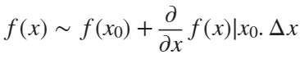 (9)
Applying (9) for the square root nonlinearity equation (10) is obtained, where x₀ ₌ h₀:
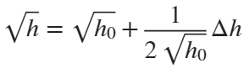 or i.e 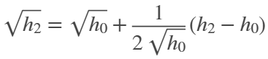 (10)
Substitute (10) into (6) and (7):
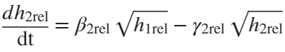 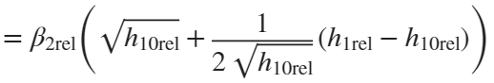 - 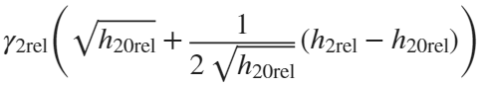 (11 – 12)
The physical variables can be expressed as their working points plus a small variation around it, as
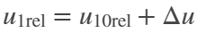 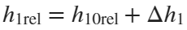 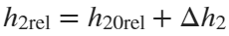 (13)
Taking (13) into considerations
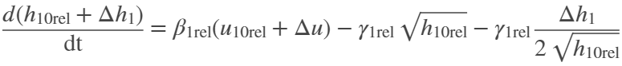 (14)
(15)
Hence the relationship between the working points is
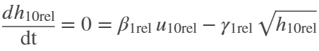 (16)
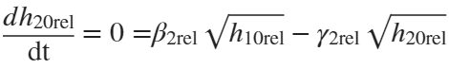 (17)
It is seen that the working points are not independent, the inlet flow determines the working point of the upper tank, which influences the working point level of the lower tank.
The relationship between the small variations around the working points:
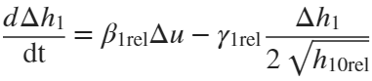 (18)
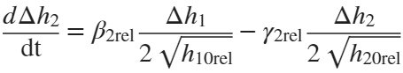
or in state space representation
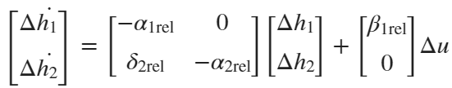 (19)
where
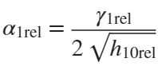, 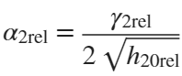, 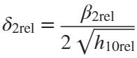.
Remember that these equations are only valid in the vicinity of an existing operating point due to linearization. Figure 2 gives the block diagram of the linearised model.
Figure 2. Block diagram of the linearised model

4. Working points and transfer function of the linearised two-tank model
The transfer function of the model derived from the Laplace transforms of the state equation:
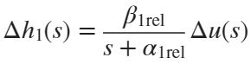 (20)
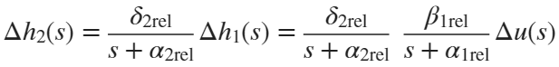
The system is characterised by a second order lag element between the change of the liquid level in the lower tank and the inlet flow in the upper tank. Its transfer function is (21)
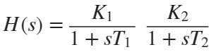 , where 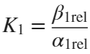, 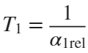 and 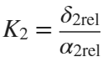, 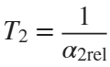 (21).
Using (16) and (17) the working points (22) can be calculated. These equations are only valid in the vicinity of the existing working points.

I.e. 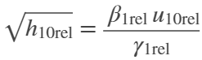 or 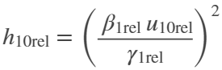 (22)

5. Define two tank parameters: working point determination

The calculations described in chapter 4. can be performed on the first sheet of the model. As it can be seen in Fig. 3, the specification of the model parameters can be selected using the Upper Tank or Lower Tank buttons. On Two Tanks sheet that appear, in two steps we can specify 9 physical parameters of the model. With these, several internal parameters can be defined, as described above or see in the Twotanks.mlx file. These 9 parameters are changeable while the values ​​of the two lower parameters cannot be changed. They are just for information.
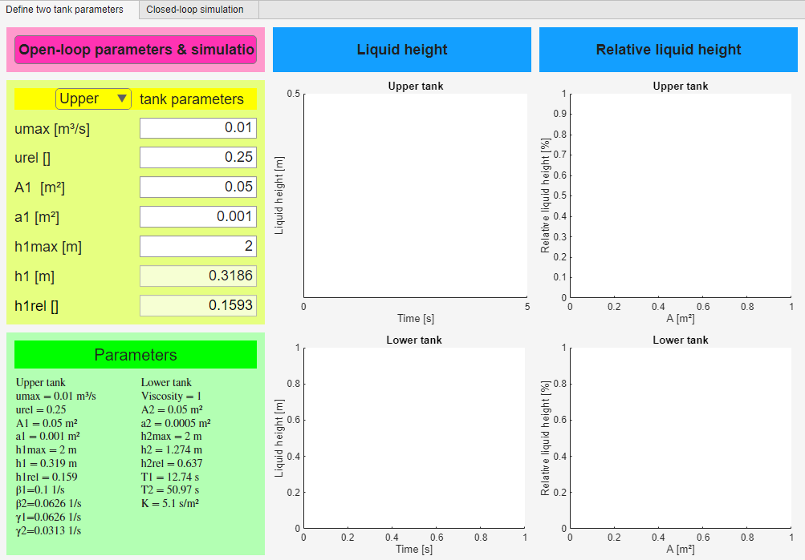

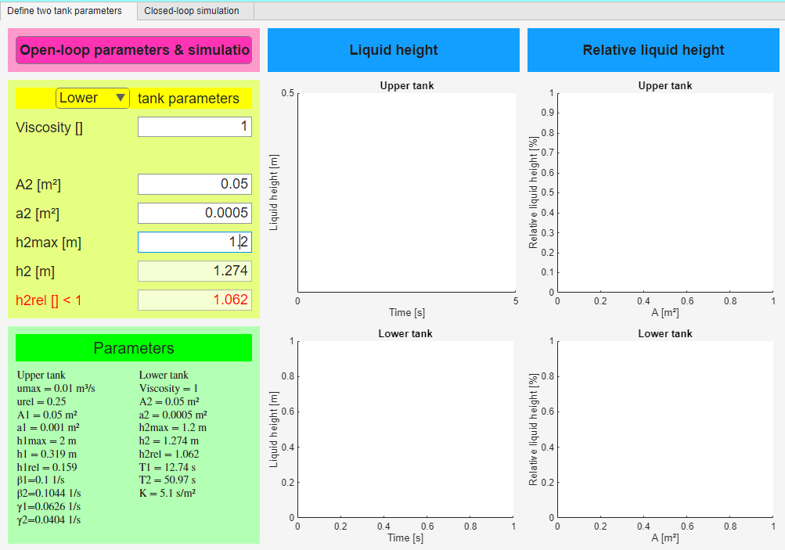
Figure 3. Input sheets of the two-tank model

On Upper/Lower tank panel a red caption indicates error. For example, if the liquid height calculated from the given parameters is greater than the height of the tank the last row of Lower tank panel appears in red. The default ​​and calculated values ​​are displayed under the Parameters caption. Among the basic parameters the parameters (gain, time constants) of the transfer function of the linearized model are also displayed.

The calculation of the working point can be started by clicking Define two tank parameters sheet. The program plots the output results in both relative and absolute units. On the right side of the screen, the animations show the changes in the liquid level of each tank. The other two diagrams also perform relative and absolute figures. The blue lines show the relative height changes, consistent with the figures on the right, while the color curves (red, green) show the absolute changes (Fig. 4.). The model uses equations (6) and (7). For more information see TwoTanks.mlx file.

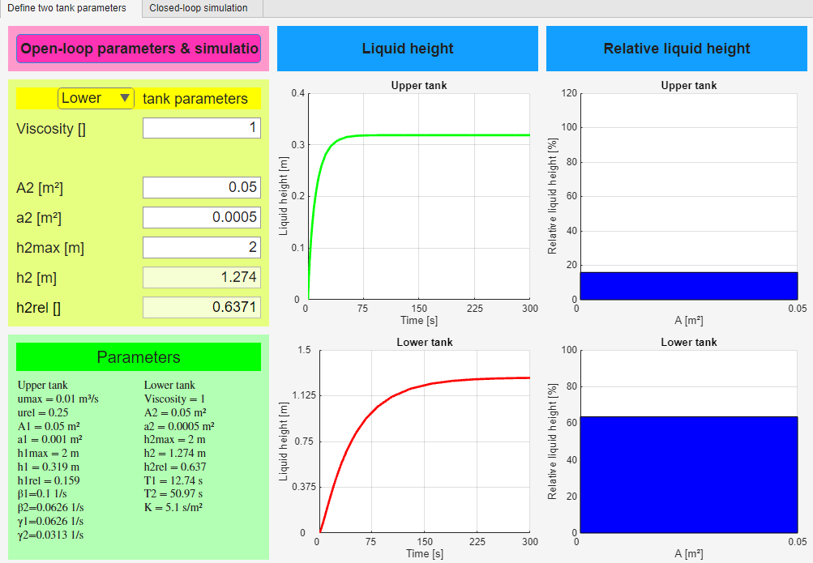

Figure 4: Results of Two Tanks sheet

6. Closed-loop simulation: environment of the working point

Once the working point has been calculated, we can move on to the second page.
Here we can set the desired liquid height in one of the tanks, if it is less than the height of the tank. This value should be within the linearized range around the working point. By pressing the Create closed-loop responses button, we determine the transfer function of a possible PI controller using the pole cancellation method (see PID_Cont_Controller_Design_with_Pole_Cancellation.mlx). At the same time the sliders are set to these PI parameters. Fig.5. shows the change in the height of the two tanks and the output of the controller. Using rigid feedback, we determine the transfer functions of the closed control loop. They are also displayed:

Y_{c}(s): the relation between the control signal and the reference signal
Y_{u}(s): the relation between the output of the upper tank and the reference signal
Y_{l}(s): the relation between the output of the lower tank and the reference signal

We can also see the results based on differential equations without feedback in this figure. The transfer functions that appear in the lower right part of the screen help in interpreting the results of each output (see on Fig. 5.).

In the first step, we determine whether we want to set the liquid level of the upper or the lower tank using the Target depth of h1/h2 buttons. If we do not enter a value, we will receive an error message. Either the value of h1 or h2 can be controlled. If we set the value of h1, the feedback will be from the upper tank, while in the other case it will be from the lower tank. Therefore, in the first case we cannot design a PID controller, only a PI controller.

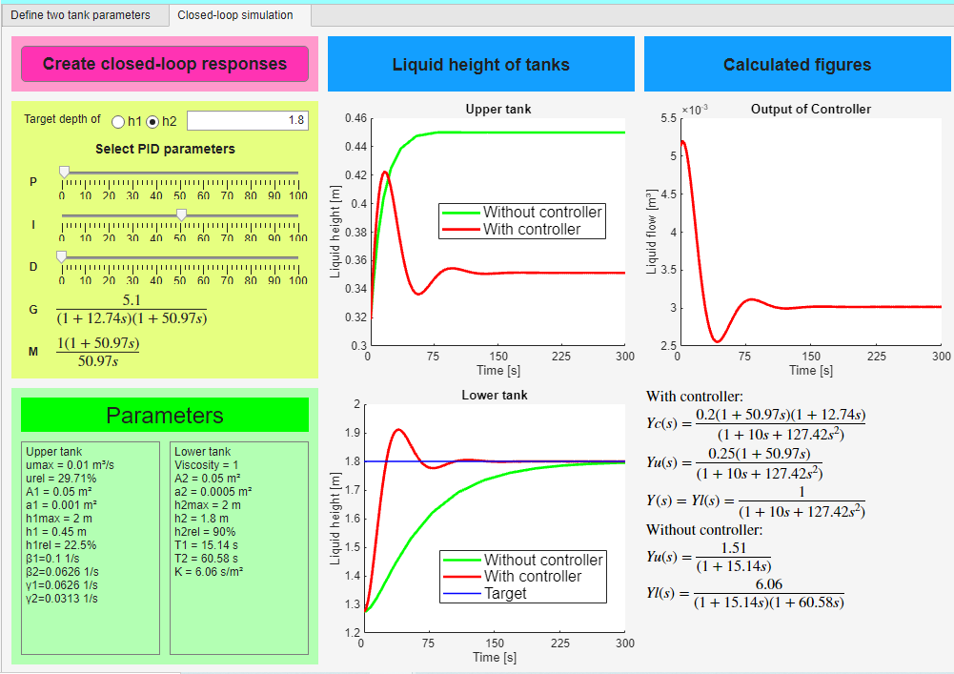

Figure 5. Two tanks control

The block diagram of the control system when the level of the lower tank is controlled is shown on Fig. 6,
Figure 6. Block diagram of control of the level of the lower tank

while in case of control of the level of the upper tank is shown in Fig. 7.
Figure 7. Block diagram of control of the level of the upper tank

After entering the required liquid height, we press the Create closed-loop responses button. As a result, the output diagram of the two tanks and the output of the controller will appear. At the same time, the values ​​of the sliders will take on the values ​​of the controller parameters. If the values ​​of the sliders are different from zero, then to try a new controller, it is enough to change the values ​​of the sliders. In addition, the transfer functions of the model will also be displayed on the screen. Red lines show the results of the model with the controller, while green lines show the results of the model without the controller. Green lines use equations (6) and (7), while red lines use equations (18). The Create closed-loop responses sheet is shown on Fig. 5.

If you want to refine the result, you can do so using the sliders. The effects of the changed parameters can be seen immediately on the screen.

Warnings:
- The changes always start from the working point calculated on the Define two tank parameters sheet.
- Starting from the initial values, using the linear model, it is NOT certain that the result will be located on the linear section. Namely, because of the integrator (PI or PID) the output will always set to the desired result if our system is stable.
- However, if we significantly reduce the value of P and/or I, our closed system may become unstable. We can follow the changes on the Bode diagram.
- If the system finds an error, it does not perform any calculations, but only sends an error message as it can be seen on Fig. 8.

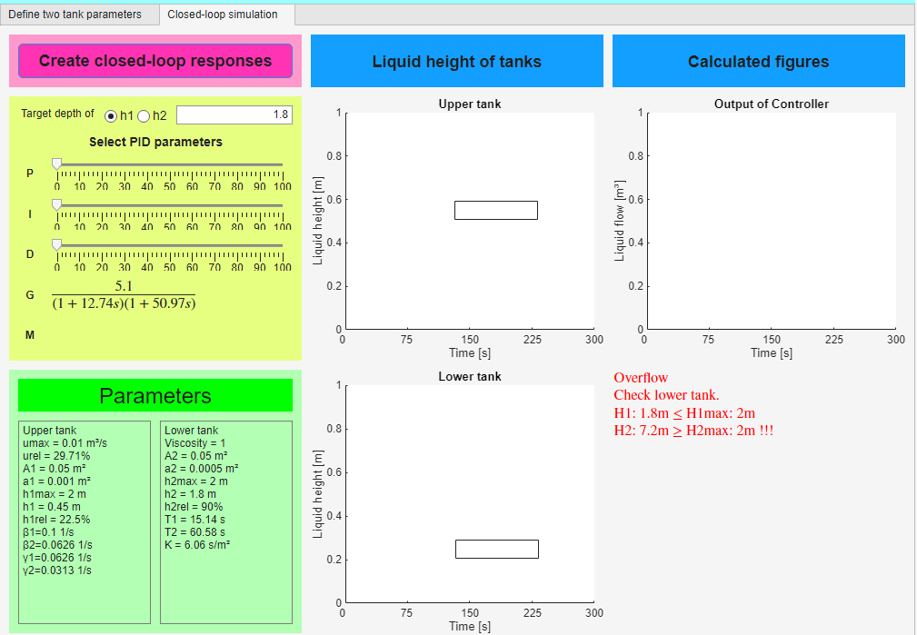
Figure 8. Error message because of height required

Note
As we noted in Chapter 6, the program uses the pole cancellation method. This method uses the time-constant form in the calculations. It is important to note that the normal form and the time-constant form are not the same.
In the case of a PI term, the transfer function of the controller in time constant form is e.g.:
$$M_{PI}=K\left(1+\frac{1}{sT_{I}}\right)=K\frac{1+sT_{I}}{sT_{I}}$$
while the normal form is
$$M_{PI}^{'}=K+\frac{K}{T_{I}} \frac{1}{s}=K\frac{s+\frac{1}{T_{I}}}{s}$$
This latter form is advantageous e.g. in drawing the Bode diagram, the time constant form is useful in pole cancellation method.

If the integrator (I) or the derivation (D) slider values are set to zero, this means that these effects are missing from the transfer function of the controller.
In pole cancellation instead of the conventional PID form the PIPD form can be used, cancelling the largest time constant of the system and introducing an integrating effect instead, and cancelling also the second largest time constant introducing a 3 times smaller time constant instead
$$M_{PID}=K\frac{1+sT_{1}}{sT_{1}} \frac{1+sT_{2}}{1+sT_{3}}$$
$$T_{1}>T_{2}>T_{3}$$
If all sliders are set to zero, the program designs a PI controller again.
(see also PID_Cont_Controller_Design_with_Pole_Cancellation.mlx).

