Layer 2.5 Network Coding Specifications and Design Doc

Jarrett Gaddy

Contents

1. Introduction 2

2. MAC Frame 2

3. Logical Link Control 2

4. Access Point Layer 2.5 3

5. Client Layer 2.5 4

6. Layer 2.5 Acknowledgement 5

# Introduction

This document will describe the details of 802.11 wireless layer 2.5 network coding. Layer 2.5 network coding is a technique used in a wireless network to combine multiple network layer datagrams in to a single 802.11 MAC frame. By combining network layer datagrams, the overall throughput of an 802.11 network is increased from when operating 802.11 without network coding. The number of frame transmissions to send some data is also reduced by adding layer 2.5 network coding to 802.11. Layer 2.5 network coding exists between the OSI data link layer (layer 2) and the OSI network layer (layer 3) and is therefore referred to as layer 2.5. A layer 2.5 end point behaves differently depending on whether it is a client or an access point. A layer 2.5 datagram encapsulates 1 or 2 layer 3 datagrams coded together using XOR. Layer 2.5 utilizes the logical link control segment of layer 2 to specify that a layer 2 frame encapsulates a layer 2.5 coded frame. A layer 2.5 frame begins with a layer 2.5 header which is followed by its payload of 1 or 2 coded layer 3 datagrams.

# MAC Frame

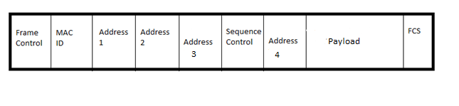

A layer 2 MAC frame contains the following in order:

* 2 bytes of Frame Control information
* 2 bytes for Duration and ID number
* 6 bytes for Address 1
* 6 bytes for Address 2
* 6 bytes for Address 3
* 2 bytes for sequence control
* 6 bytes for Address 4
* 0 to 2312 bytes for Payload
* 4 bytes for frame check sequence

The variable length from 0 to 2312 byte payload contains the 802.2 logical link control header. If the MAC frame contains coded data then a layer 2.5 datagram follows the logical link control header, if the data is not coded, a layer datagram will immediately follow the logical link control header. The frame check sequence FCS is used to ensure that there are no bit errors in the received MAC frame.

# Logical Link Control

The logical link control header is the upper part of the data link layer which is layer 2 of the OSI model. The logical link control header can be used to notify a layer 2 service point what higher layer protocol is encapsulated by the layer 2 frame. This is important to layer 2.5 network coding because a node in the 802.11 network needs to be informed of whether a received frame is a network coded frame or not. The logical link control frame is mandatory in all 802.11 transmissions. The logical link control 802.2 specification allows vendors to specify their own protocol to operate on top of the data link layer. Layer 2.5 network coding is specified as a proprietary protocol operating on top of the 802 data link layer. As a stand in the 3 byte organizational unique identifier OUI used for layer 2.5 network coding is 0xAAAAAA. The OUI is not registered with any registration authority and therefore is not a valid OUI but for experimenting any value other than 0x000000 which specifies ether type can be used.

The logical link control header contains the following values in order for a coded frame:

* 1 byte for Source Service Access Point SSAP containing 0xAA
* 1 byte for Destination Service Access Point DSAP containing 0xAA
* 1 or 2 bytes for Control field (still working on understanding this field. uses high-level data link control specification) should contain 1 byte 0x03
* 3 bytes for OUI containing 0xAAAAAA
* 2 bytes for Protocol ID containing 0xAAAA
* 0 to 2304 bytes for layer 2.5 payload

# Access Point Layer 2.5

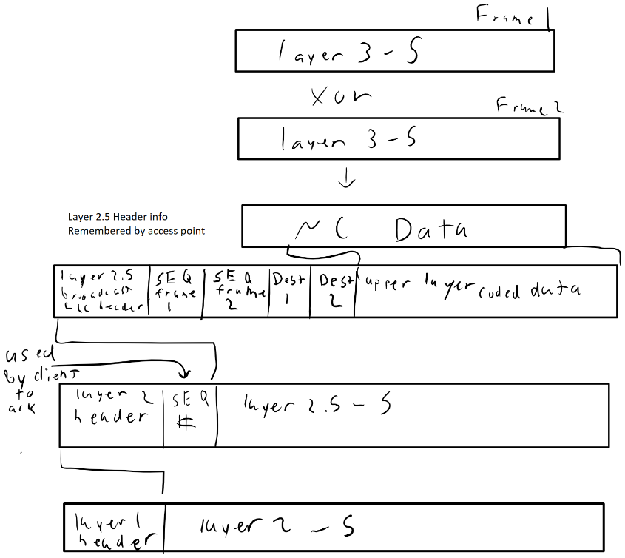

When the access point on an 802.11 network intends to send data it must determine whether or not there is enough data stored in the network to preform network coding. If the access point determines that it can do network coding it will first create a layer 2.5 frame.

The layer 2.5 frame created will have a layer 2.5 header with the following information in order:

* 6 bytes for MAC address of destination 1
* 2 bytes for sequence control taken from frame intended for destination 1
* 6 bytes for MAC address of destination 2
* 2 bytes for sequence control taken from frame intended for destination 2
* 0 to 2288 bytes for payload which will contain 2 layer 3 datagrams XOR together

The layer 2.5 frame is then encapsulated with a logical link control header as described in section 3 of this document. The logical link control header and layer 2.5 frame is then encapsulated into the payload of an 802.11 MAC frame. The MAC frame is given a MAC address of FF:FF:FF:FF:FF:FF in the Address 1 field in order to send a broadcast transmission. The MAC address of the access point is placed in Address 2. Address 3 contains the BSSID of the 802.11 network and Address 4 is not used. The frame type is set to be a data frame and the remaining fields are set as specified in IEEE 802.11 depending on the network configuration. The access point must remember which higher layer frames were sent and which clients have been recipients to network coded frames to ensure reliable data transmission. The access point must remember the most recent coded frame sent to each associated client until that client has acknowledged receiving the decoded frame intended for it. The access point may send a network coded frame to a client that currently has an un-acknowledged network coded frame previously sent.



The above figure shows a flowchart of the operation of the transmit loop for an access point using layer 2.5 network coding. The AP must first determine which data it will transmit on the next transmission. The AP then checks if it has recently sent layer 2.5 coded frames to the destination of the data. If the AP has sent a coded frame recently and it has not been Acked yet, then the destination is not available to use with network coding, so the AP will send a unicast layer 2 frame. If the destination is available for network coding, then the AP must find a suitable candidate data to code with the current data. A candidate is suitable if its destination is available for network coding, and its destination is the source of the current data. The candidate data must also have been sent from the client that the current data is intended for. If the coding criteria is met, then the AP can construct a layer 2.5 header, and send the layer 2.5 coded frame in a layer 2 broadcast. If there are no valid candidate data, the current data will be sent as a unicast layer 2 frame.

# Client Layer 2.5

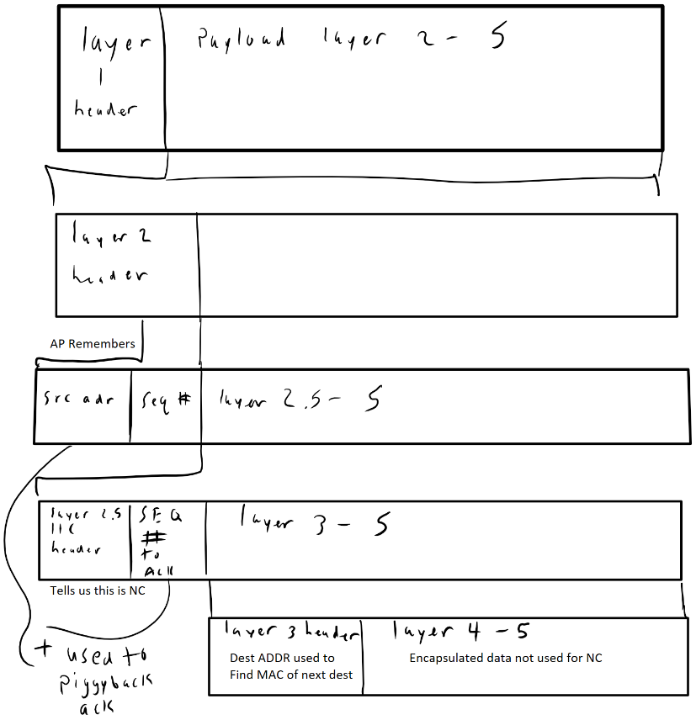

A client on the 802.11 network does not code data frames together, however, it can send a layer 2.5 frame in order to acknowledge receiving and correctly decoding a layer 2.5 frame sent to it by the access point. When an access point sends a layer 2.5 coded frame, all clients on the network will receive the frame because it is sent as a broadcast. Each client will use the layer 2.5 header to determine if it is an intended destination of the frame. When a client is an intended destination the client must try to decode the coded layer 3 datagram and then acknowledge that it has received the frame. Acknowledgment is important because all unicast data frames sent over 802.11 must be acknowledged or retransmitted until acknowledged successfully. In 802.11 broadcast signals do not follow the same acknowledgement strategy because all clients would attempt to acknowledge at the same time and many collisions would occur. In order to ensure data is not lost, layer 2.5 network coded frames coming from an access point to a client must be acknowledged by the intended destination clients. The client cannot use an 802.11 MAC acknowledgment to avoid collisions so layer 2.5 acknowledgments must be used. To improve throughput and reduce number of transmissions, a layer 2.5 acknowledgment will be included in the next unicast data transmission from the client to the access point. The Layer 2.5 payload will contain a single un-coded layer 3 datagram.

The layer 2.5 acknowledgment frame will have a layer 2.5 header as follows in order:

* 2 bytes for ACK number field sequence control field taken from the frame being acknowledged
* 0 to 2302 bytes of payload for layer 3 un-coded datagram

The layer 2.5 frame is then encapsulated by a logical link control header as specified in section 3 of this document. The logical link control and layer 2.5 frame is encapsulated in the payload of an 802.11 MAC frame. The MAC frame is given the MAC address of the access point for Address 1. The MAC address of the client sending the frame is placed in Address 2. Address 3 contains the BSSID of the 802.11 network and Address 4 is not used. The frame type is set to be a data frame and the remaining fields are set as specified in IEEE 802.11 depending on the network configuration.



The above figure shows a flowchart of the operation of the transmit loop for a client using layer 2.5 network coding. The client is responsible for determining if it needs to send a frame with a layer 2.5 Ack piggybacked. An Ack is only required if the client has received a network coded frame that it has not Acked yet. If an Ack is not required, then the data can be sent as a typical 802.11 frame.

# Layer 2.5 Acknowledgement

I will only discuss the 3rd of the proposed Ack strategy from my thesis document. Option 1 is to simply never acknowledge and accept the errors. Option 2 involves immediately sending a layer 2.5 Ack with empty data field. This section will discuss the specifications for piggyback acknowledgment.

All layer 2.5 data frames must be acknowledged (Ack/Acked) by both of the destinations of the coded layer 2.5 data frame. Each destination individually Acks upon receiving and decoding the message within the coded payload section of the layer 2.5 data frame.

The process of a client node Acking starts upon receiving and decoding a layer 2.5 data frame and is as follows:

1. The client will construct a layer 2.5 header as described in section 5 of this document for a layer 2.5 ACK frame, while leaving the payload empty and filling the Ack number field with the sequence control number from the layer 2 frame that contained the information being Acked.
2. The client will wait up to 500 ms before transmitting the layer 2.5 Ack with an empty payload.
3. If the client has upper layer information to send within the 500 ms window, the client will put the upper layer datagram in the payload of the layer 2.5 ACK frame and send the layer 2.5 Ack frame as a layer 2 frame as described in section 2 of this document.
4. If the client does not have upper layer information to send within 500 ms then the layer 2.5 frame constructed in step 1 is transmitted as a layer 2 frame.

At the Access Point when a layer 2.5 data frame is sent to 2 destinations, both of those destinations are locked from being used in layer 2.5 network coding until either:

1. A layer 2.5 Ack with the correct sequence control number has been received at the access point from the destination.
2. 1 second has passed since the last layer 2.5 data frame was sent to the destination.

Each destination associated with the access point is locked individually (2 at a time though) as layer 2.5 data frames are sent to them and unlocked when a correct Ack is received from a locked destination, or after a destination has been locked for 1 second. While a destination is locked, no layer 2.5 frames can be sent with that client as its destination. Layer 2 frames sending non layer 2.5 frames can still be sent to the locked destinations. If a destination is unlocked by a timeout, the next frame that is sent to that destination must contain the upper layer datagram that was coded in the most recent layer 2.5 data frame to that destination. This is a retransmission of the information that was not Acked. The retransmission can be a unicast Layer 2 frame without a layer 2.5 data frame encapsulated, or it can be retransmitted in a layer 2.5 data frame with the upper layer datagram coded with some other destinations upper layer datagram and sent as a layer 2.5 data frame as described in section 4.



Figure 1: Timing diagram of ACK strategy with no ACK received at the AP from client B.

The diagram in *Figure 1* shows 2 clients exchanging messages through the access point. The access point then codes the 2 messages together and sends a layer 2.5 data frame to both clients. The clients must Ack the layer 2.5 data frame. Client B does not Ack the layer 2.5 data frame so the access point retransmits the message intended for client B after 1 second.