

SCi-Toolset Data Coverage Visualiser

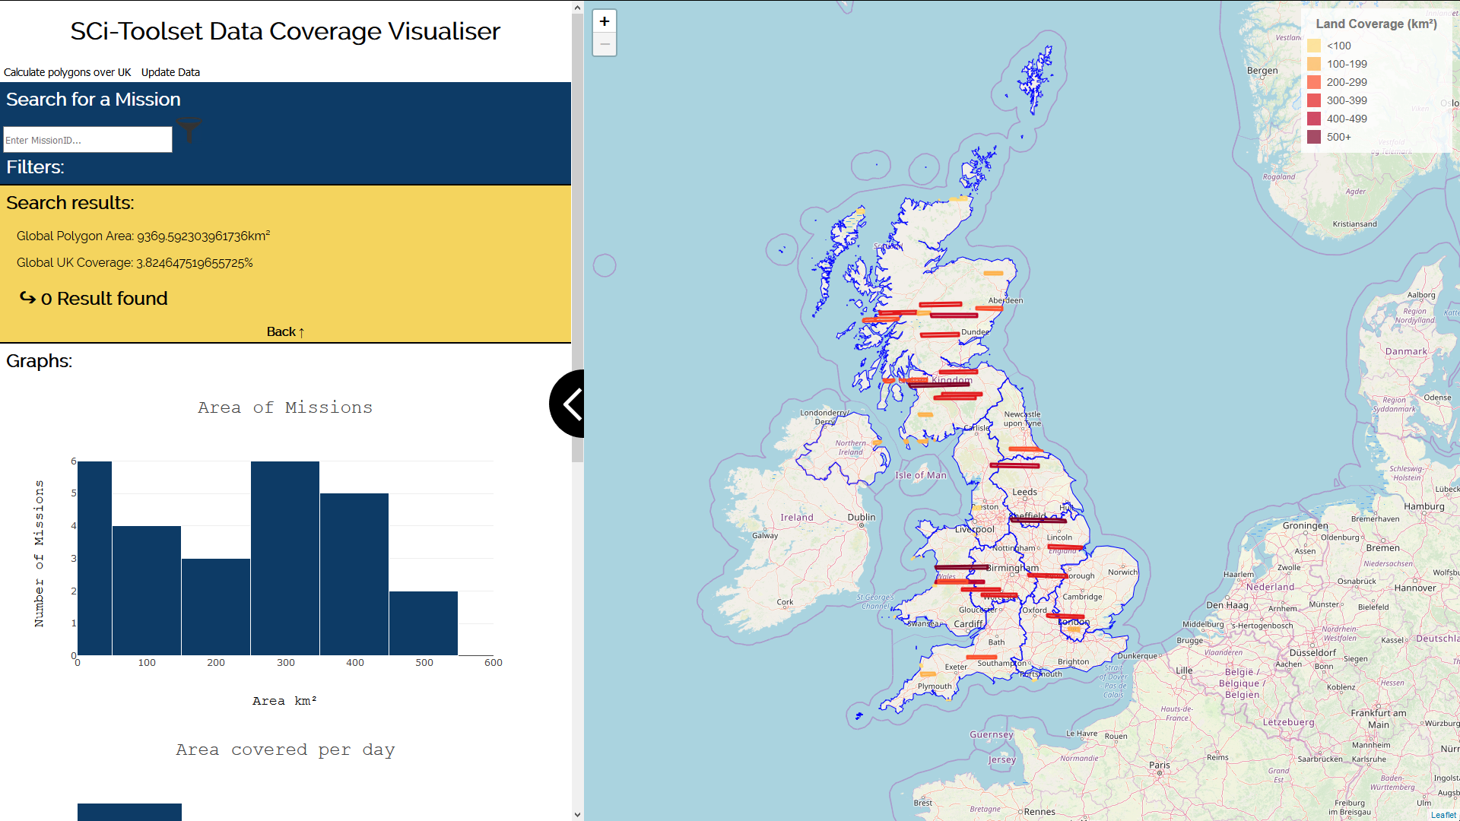

Contents

Data Shown 3

Updating the data 3

Finding the images that only go over the UK 3

Images/Coloured Polygons 3

Clicking the Images 3

Regions 3

Clicking the Regions 3

Legend 4

Search Bar 4

Searching 4

Filtering 4

Data from a search 4

Graphs 5

Graphs 5

Area of Missions 5

Area covered per day 5

Area covered per day (Cumulative) 5

# Data Shown

## Updating the data

Data is cached in the file “data/images.json”. To update the data:

* Press the “Update Data” button, the data will be loaded in as raw data.

## Finding the images that only go over the UK

Prerequisites: Ensure the data you are calculating has been updated

This will go over every point loaded working out the intersection which county the points belong to.

**Warning: The process is run in the background and will take a while. The data will automatically update when finished**

* Press the “Calculate Polygons over UK”.

## Images/Coloured Polygons

The “Coloured bars” each represent an image taken from the SCi-Toolset Discover API. The colour of the images represent the area they cover. See the legend.

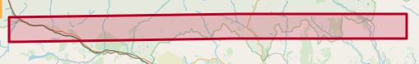

### Clicking the Images

Clicking the images will show a popup displaying data about the selected image. The search functions relate to the search bar.

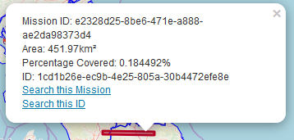

## Regions

The regions are displayed by blue outlines. These are visual representations of how the data is categorised into regions.

### Clicking the Regions

Clicking in a region’s area will display a popup of which region you are viewing.

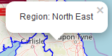

# Legend

The legend explains the colours behind the images. The legend uses kilometer squared, displaying which colour is shown for the corresponding area.

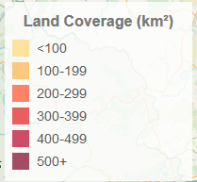

# Search Bar

The search bar allows a mission ID and a polygon ID to be searched. Entering a valid ID will result in the corresponding data being displayed on the map. These are indicated via markers.

## Searching

To perform a search:

* Enter the ID into the search bar and press enter
* OR click an image and select the search functions at the bottom of the popup.

To clear a search:

* Double click on the search bar



## Filtering

Before or after a search, the data shown can be filtered.

To filter:

* Click the filters panel
* Drag and drop the marker along the slider

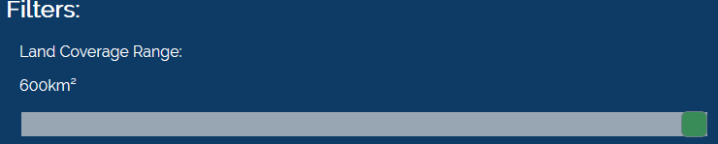

## Data from a search

#### Mission Search

When searching a mission, the search results will display mission meta data. Below this, each image in the mission is listed in a table.

Clicking on view next to an entity in the table will perform an Image Search

#### Image Search

When searching an image, the search results will display important meta data.

## Graphs

When searching, the graphs will display data relating to the search. See graphs for what they mean.

# Graphs

The graphs relating to the data are shown in the graphs panel.

## Area of Missions

The data represents the number of images there are relating to the area they cover.

## Area covered per day

The data represents the number of images there are relating to the area they cover.

## Area covered per day (Cumulative)

The data represents the number of images there are relating to the area they cover.