RMarkdown Tutorial

Jarrod Olson

Someone Else

04/11/2015

This describes how to use RMarkdown for the things I care about.

# Introduction

This tutorial provides useful information that I use while producing RMarkdown reports. A template will be saved in the same directory as this project. I drew heavily from [Markdown Basics](http://rmarkdown.rstudio.com/authoring_basics.html). We can reference documents using any number of reference formats for example, see Olson and Stone (2014). The bibliography is the last thing put into the document, so it's not even needed to be called. Citation styles can be specified from a list given at this location: <https://github.com/citation-style-language/styles>. To get author affiliations, the template in use must be altered to handle author affiliation, etc, then the YAML modified so it is - name: 'person name' - affilitation: place, etc.

Might be able to do math? $2+2=4$

# Text Formatting

## Sections

Headers are specified using "#"

# Header 1  
## Header 2  
### Header 3

## Emphasis

**This is bold:** **bold**

*This is italic:* *italic*

*This is also italic:* _italic_

**This is also bold:** __bold__

## Lists

An unordered list looks like this:

* item 1
* item 2

An unordered list looks like this (note the line break between this level and first list item):  
  
* item 1  
* item 2

An ordered list looks like this:

1. item 1
2. item 2

An ordered list looks like this (note the line break between this level and first list item):  
  
1) item 1  
2) item 2

# Code Blocks

Code blocks are interepreted based on being inside of a code block. R code must be designated. first a code block with no content is created like this (Ignore the \, which functions as an escape):

```  
Some content here  
```

Inline content:

We can also do in-line code using `content here`, e.g. 2+2=4

2+2=4

There are several elements to an r code block. {contains the options, r needed}

# Figures

We can create figures using normal plotting functions as desired:

library(ggplot2)  
ggplot(cars, aes(x=speed, y=dist))+geom_point()

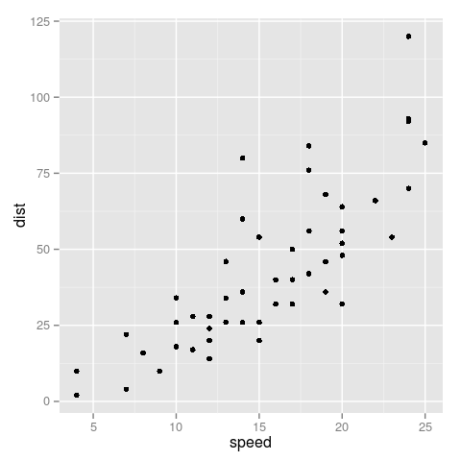

Fig. 1 - Showing how to do a caption

We can also insert pictures, but in word format, we can't caption these.

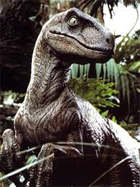

This is a raptor.

# Bibliography

Olson, Jarrod, and Daniel F. Stone. 2014. “Suspense-Optimal College Football Play-Offs.” *Journal of Sports Economics*. <http://jse.sagepub.com/content/early/2014/07/15/1527002514541040.abstract>.