Jarron Bailey

Final

Date: May 6th, 2019

**Test 1: Invalid characters for name, should only be a-z or A-Z**

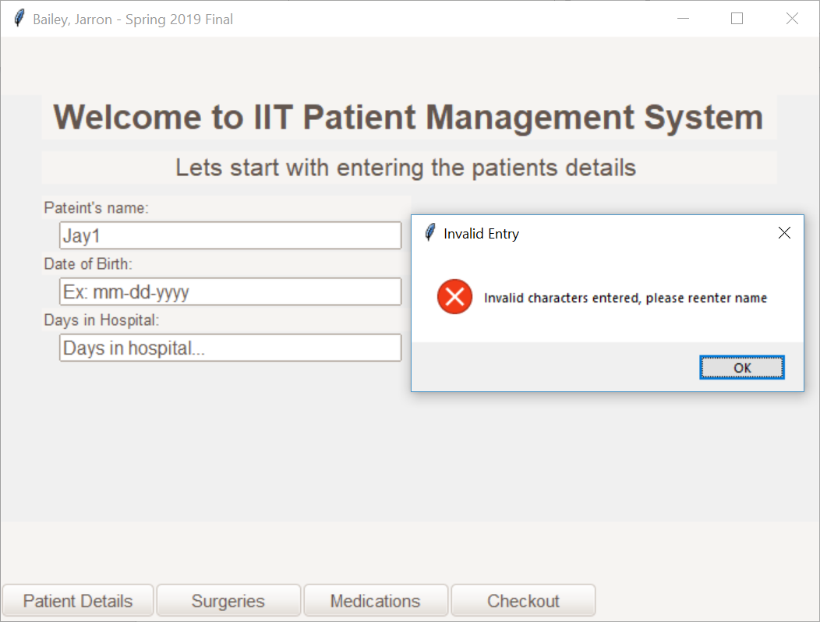

**Test 2: Invalid date format:**

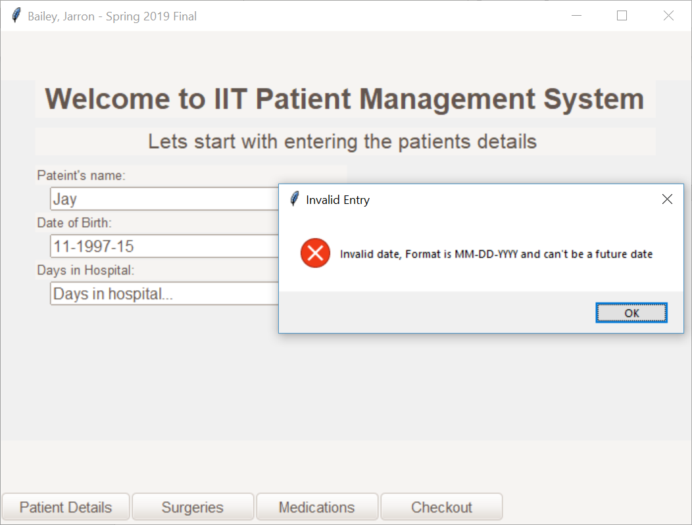

**Test 3: Birth date is in the future**

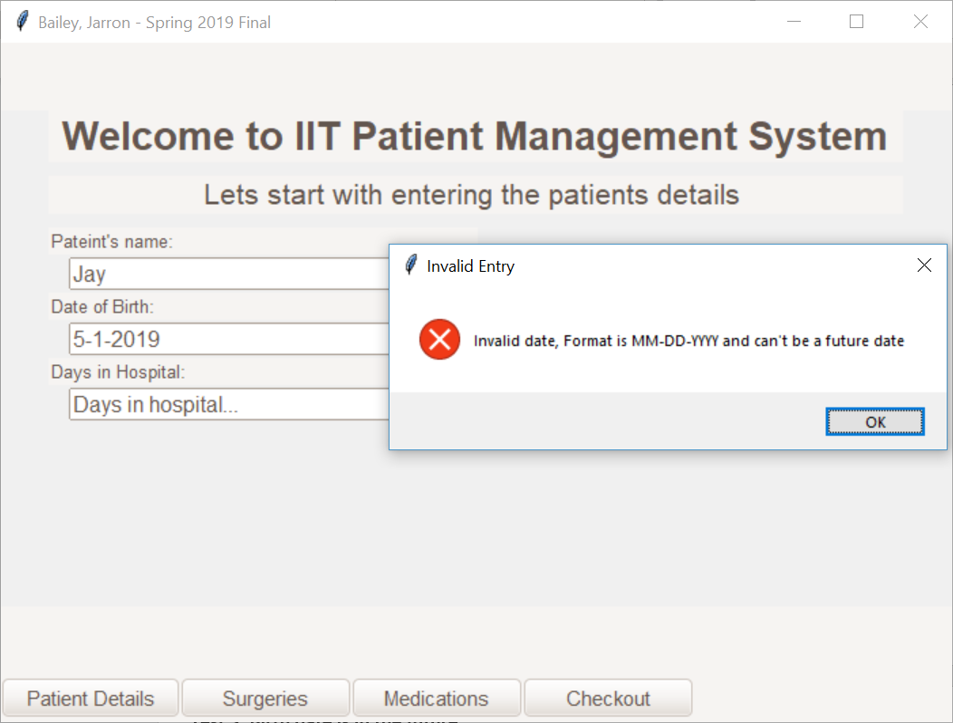

**Test 4: Days in hospital == 0**

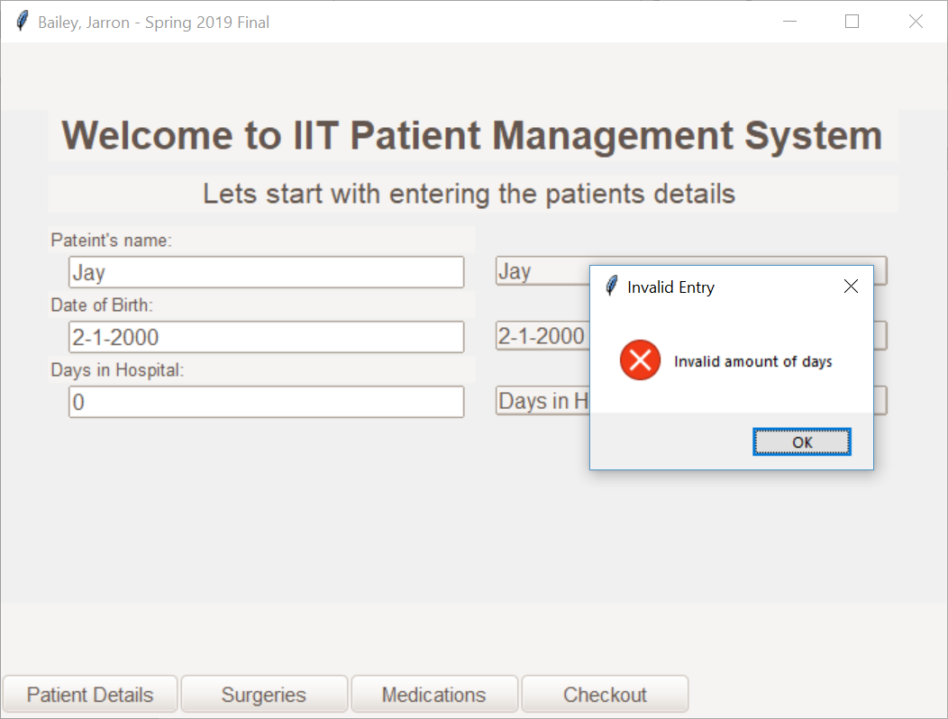

**Test 5: Days in hospital < 0**

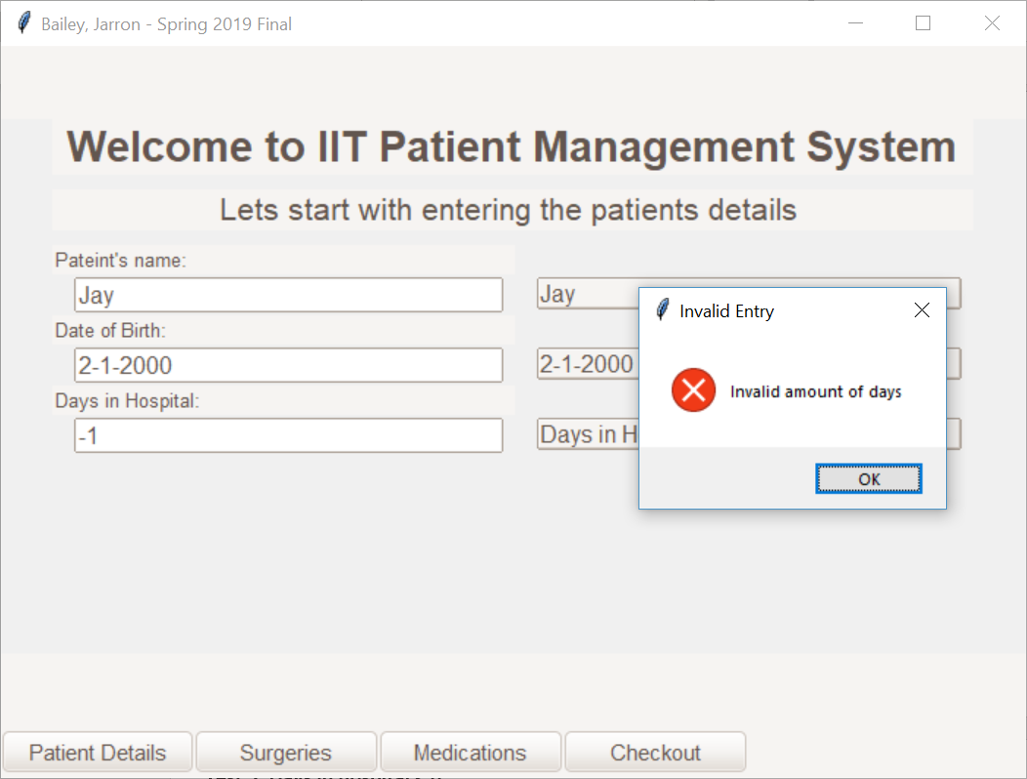

**Test 6: All valid patient details = Details are set**

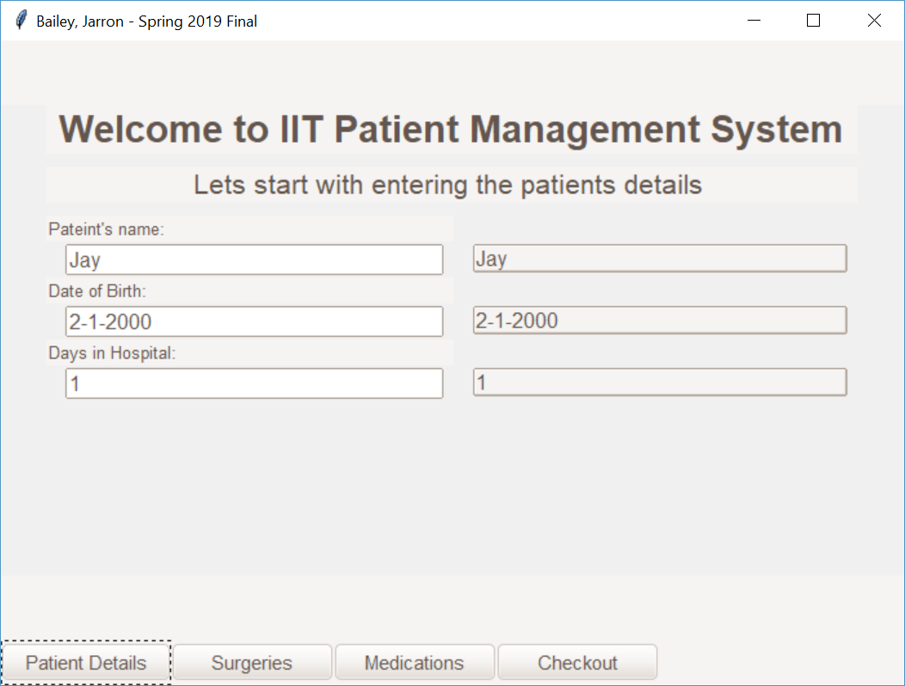

**Test 7: Details are set > no product selected > try to checkout**

**Checkout Page**

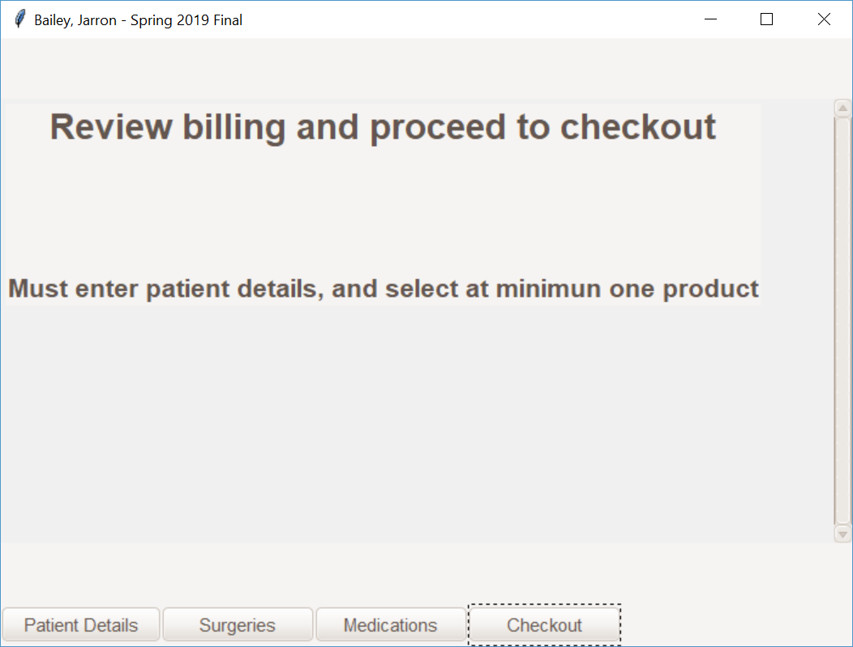

**Test 8: Details are set > surgery selected > try to checkout**

**Selected Products**

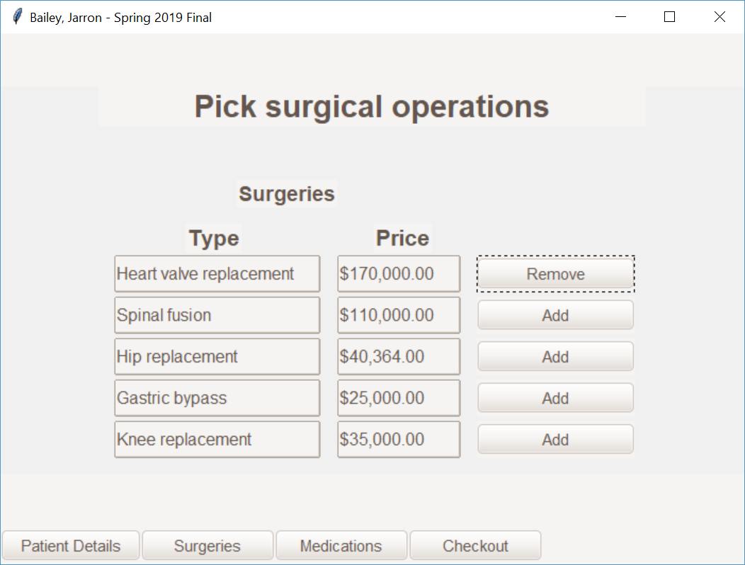

**Checkout Page**

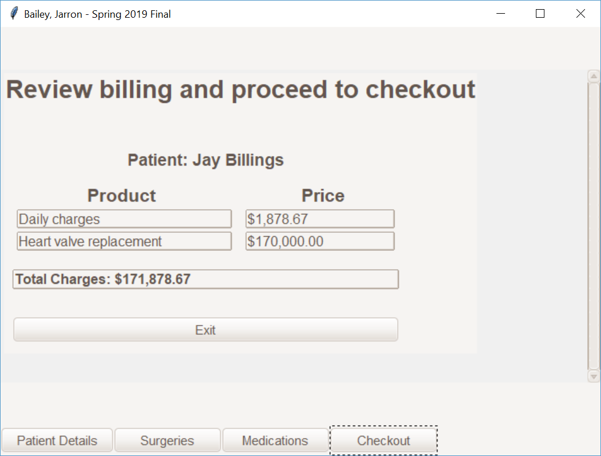

**Test 9: Details are set > medication selected > try to checkout**

**Selected products**

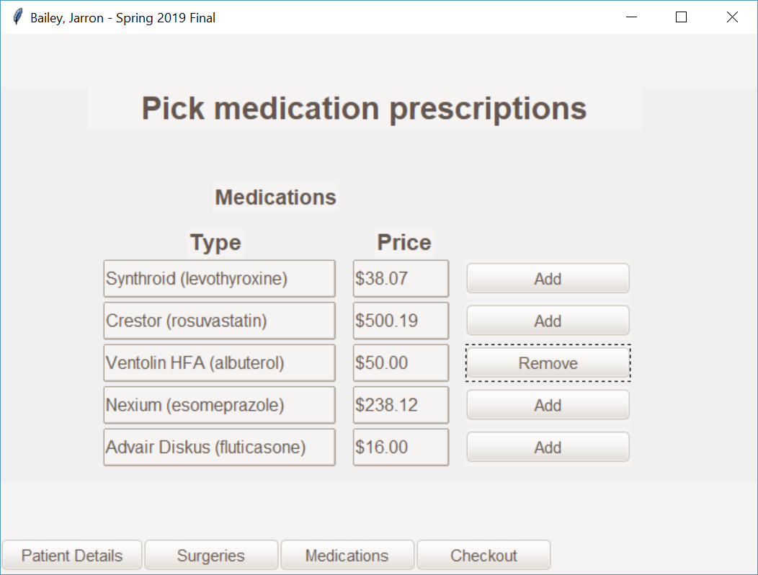

**Checkout page**

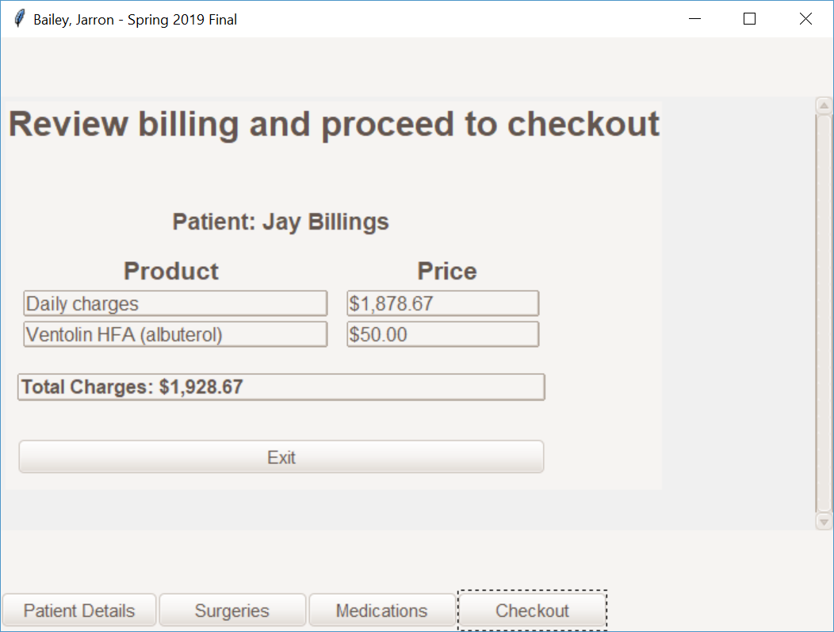

**Test 10: Details are not set > Product is selected > Try to checkout**

**Not set details**

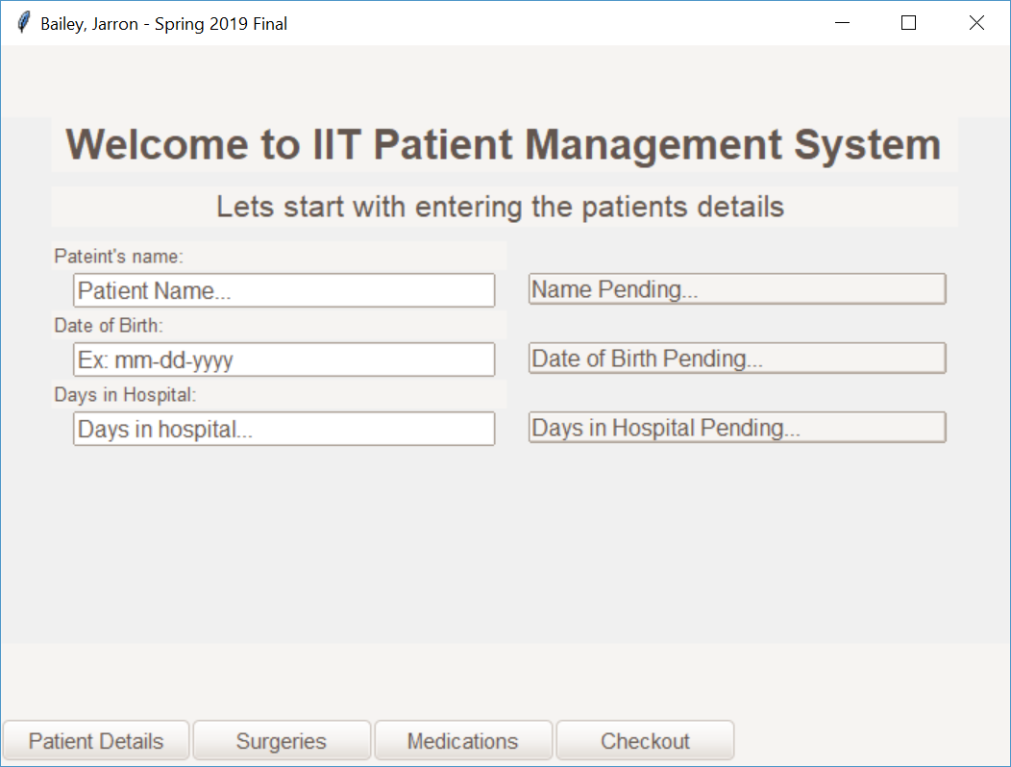

**Selected products**

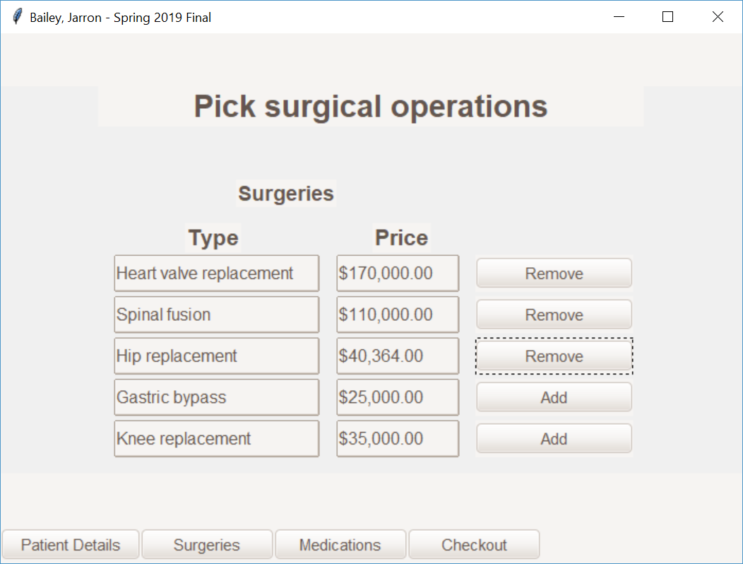

**Checkout page**



**Test 11: Setting details > Selected surgeries and medications > Checkout**

**Patient details**

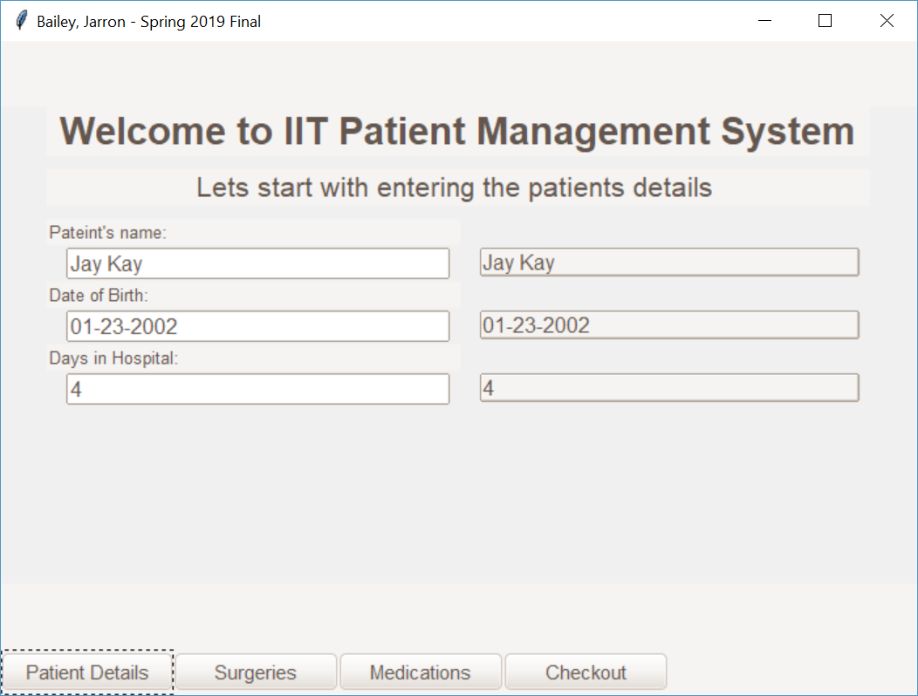

**Surgeries Selected**

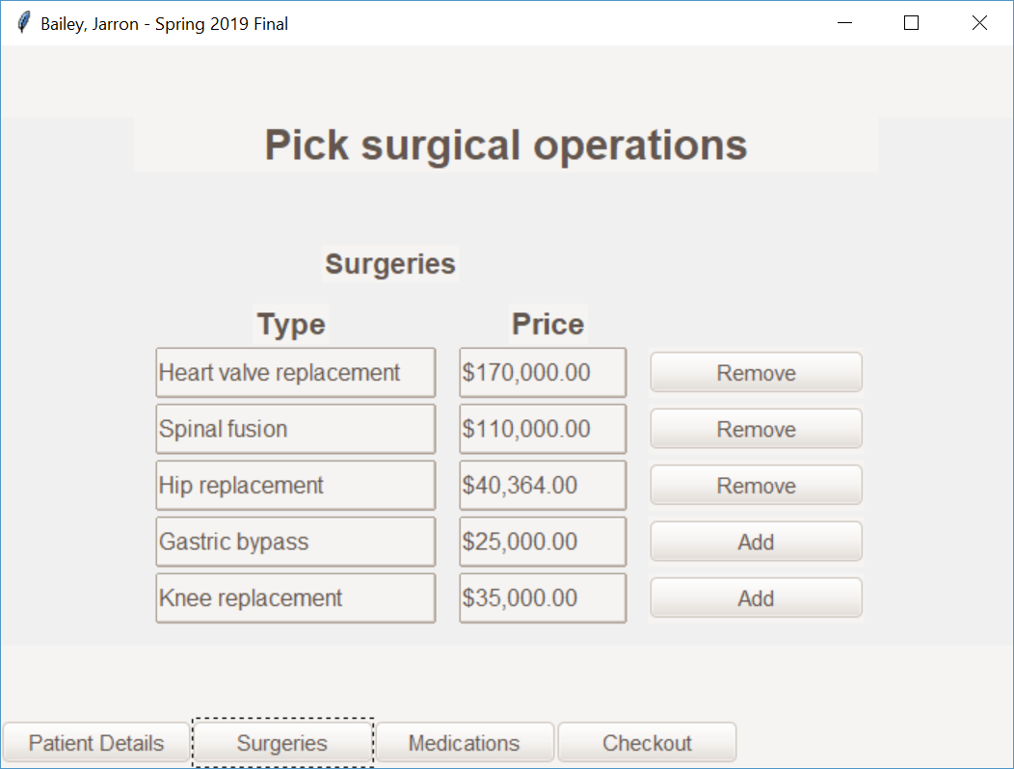

**Medications Selected**

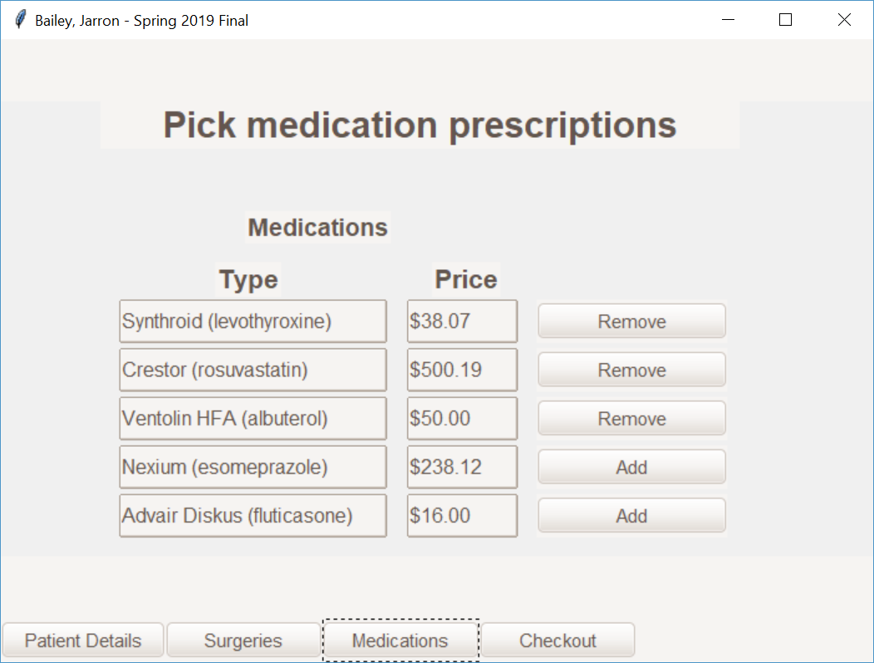

**Checkout Page**

