Jarron Bailey

Homework 5

**Sorted List Program**

**Test 1: Sorted list, invalid list of numbers containing spaces:**

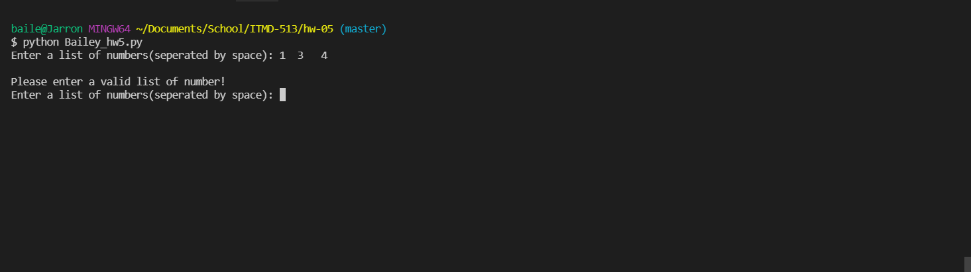

**Test 2: Sorted list, within invalid list of numbers containing letters**

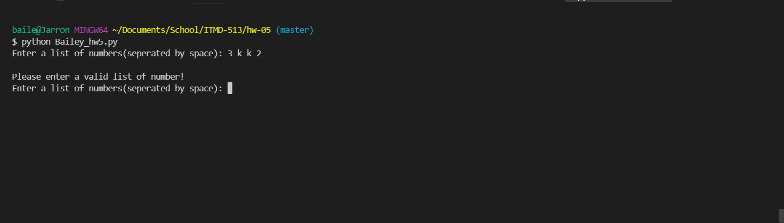

**Test 3: Sorted list, with valid list:**

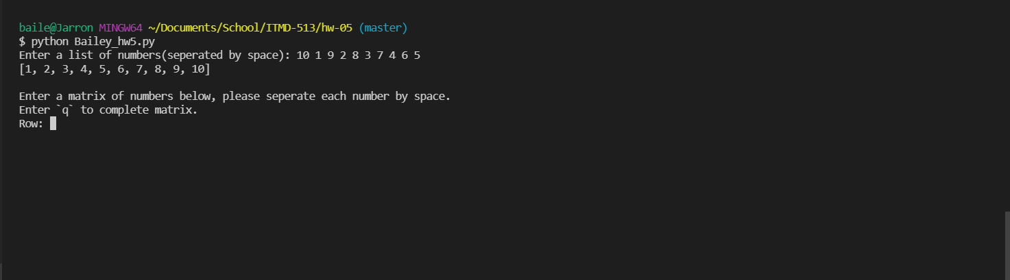

**Matrix Program**

**Test 1: Invalid matrix row containing too many spaces**

**Test 2: Invalid matrix row containing letters**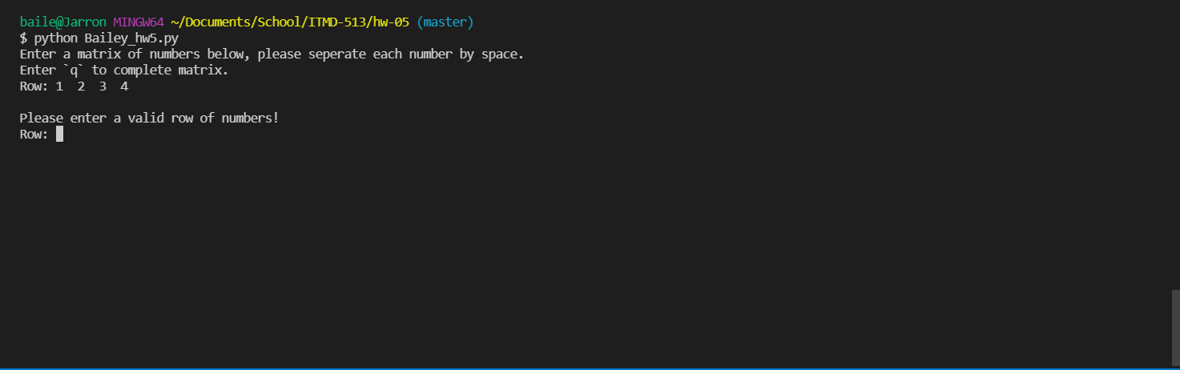

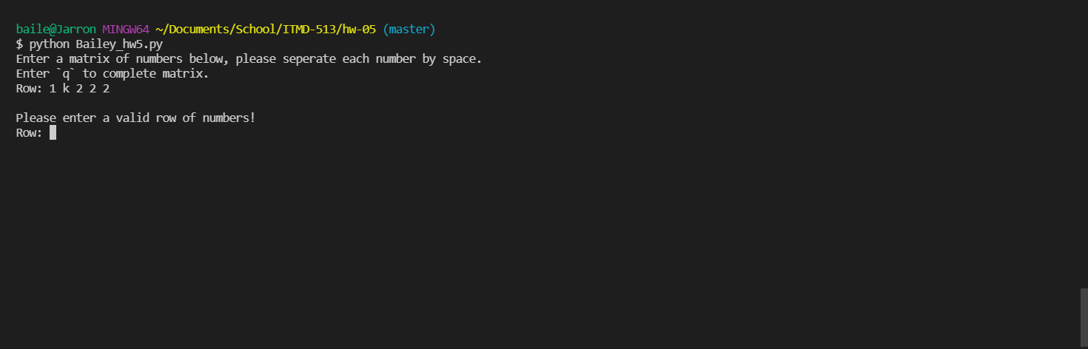

**Test 3: Enter empty row**

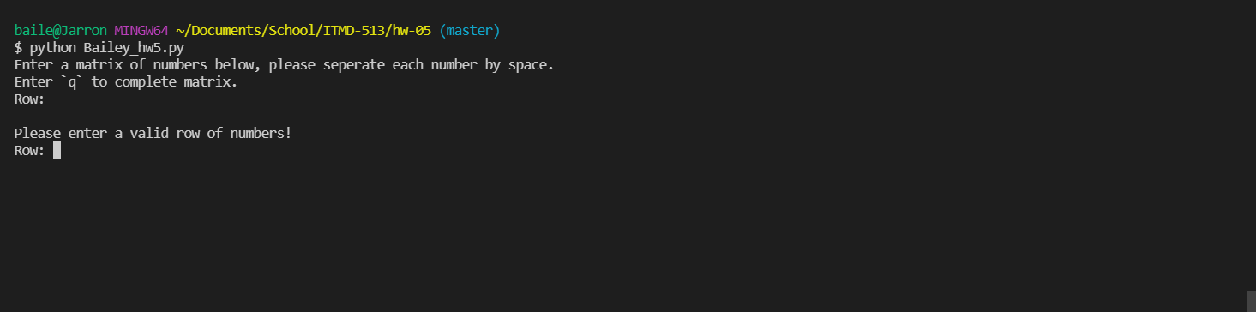

**Test 4: Matrix 2 exceeds matrix 1 row length**

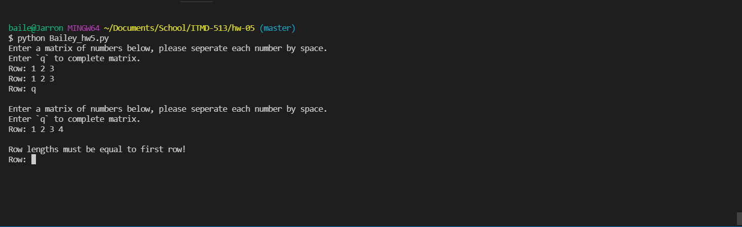

**Test 5: Valid two matrixes**

