Jarron Bailey

Homework 10

Date: April 15th, 2019

**Test 1: Employee name empty**

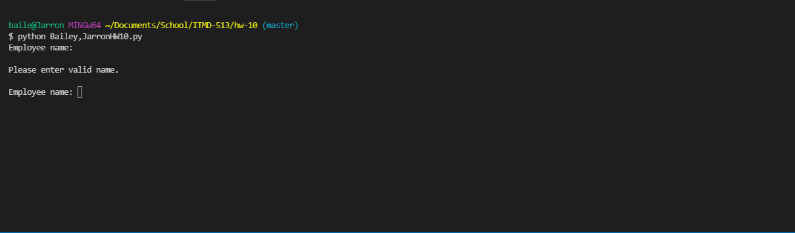

**Test 2: Employee name containing number**

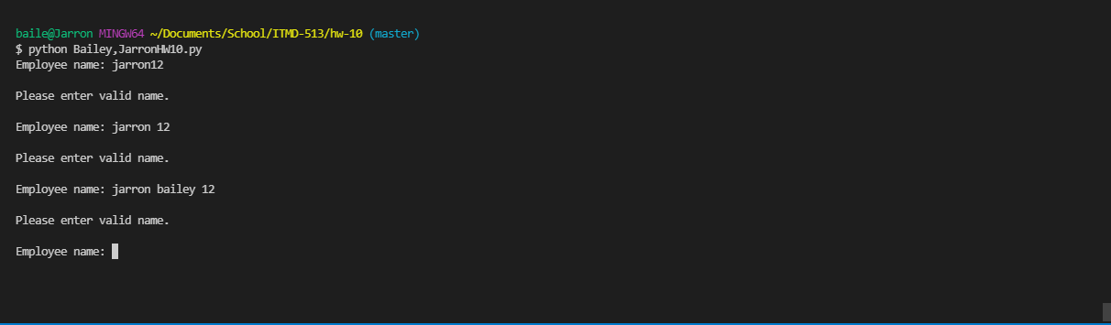

**Test 3: Employee name containing only letters:**

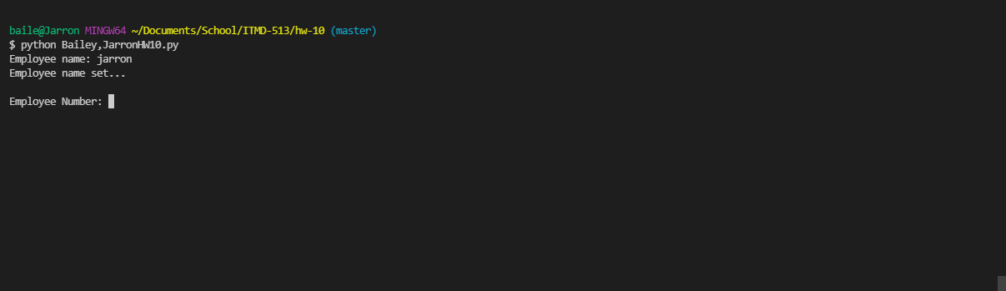

**Test 4: Employee name containing letters and space:**

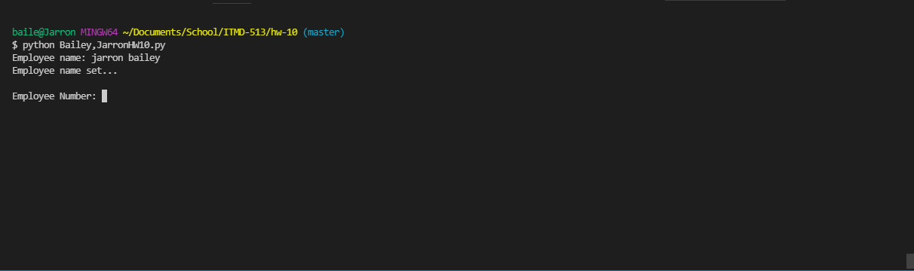

**Test 5: Employee number containing string:**

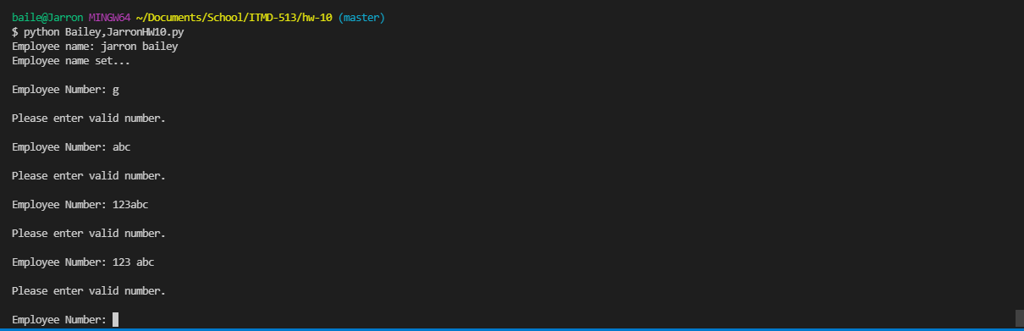

**Test 6: Employee number as a float:**

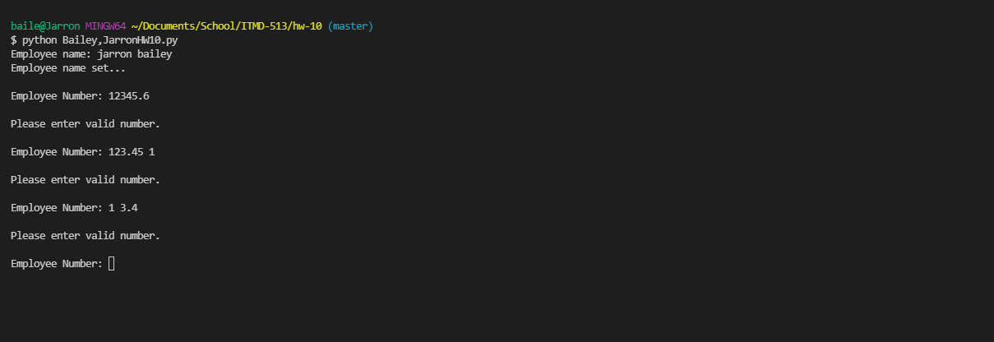

**Test 7: Employer number as integer**

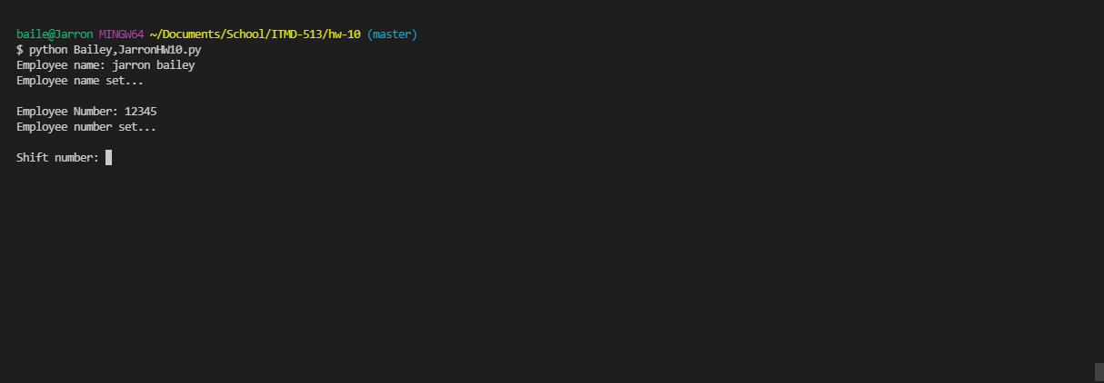

**Test 8: Shift number as string**

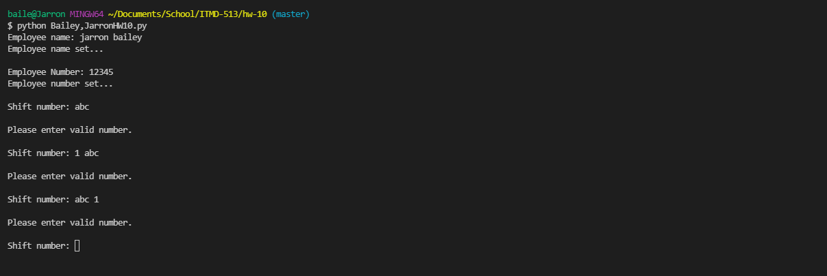

**Test 9: Shift number as a float**

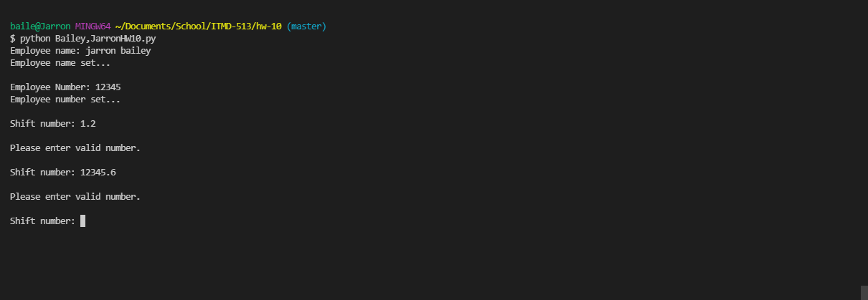

**Test 10: Shift number as integer outside 1 or 2**

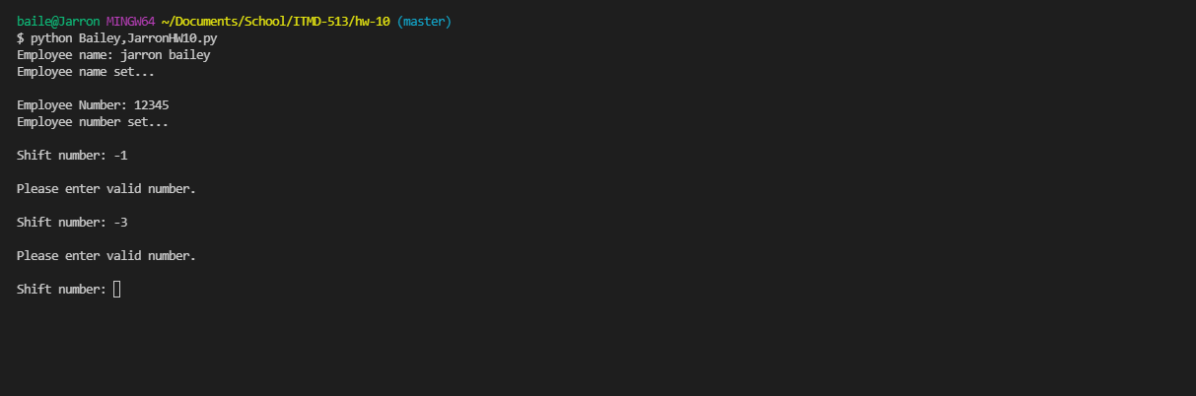

**Test 11: Shift number as 1**

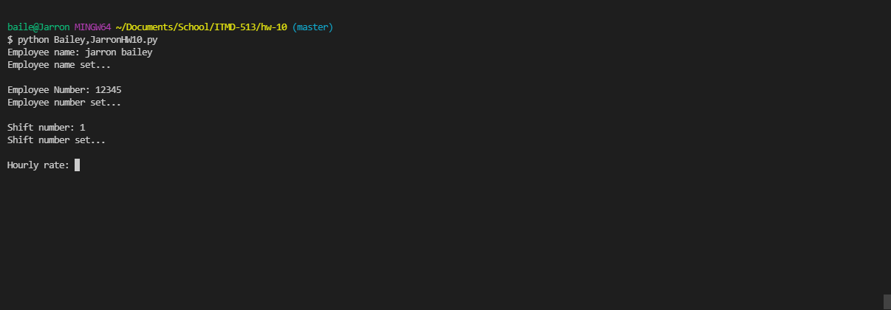

**Test 12: Shift number as 2**

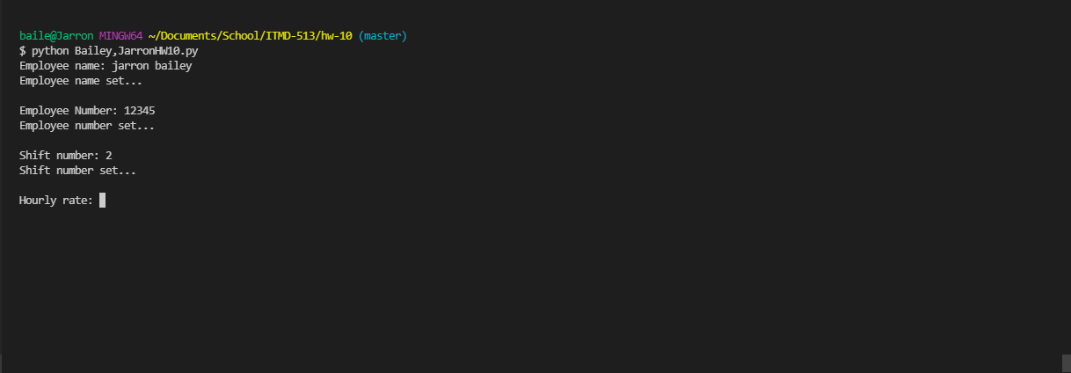

**Test 13: Hourly rate as a string**

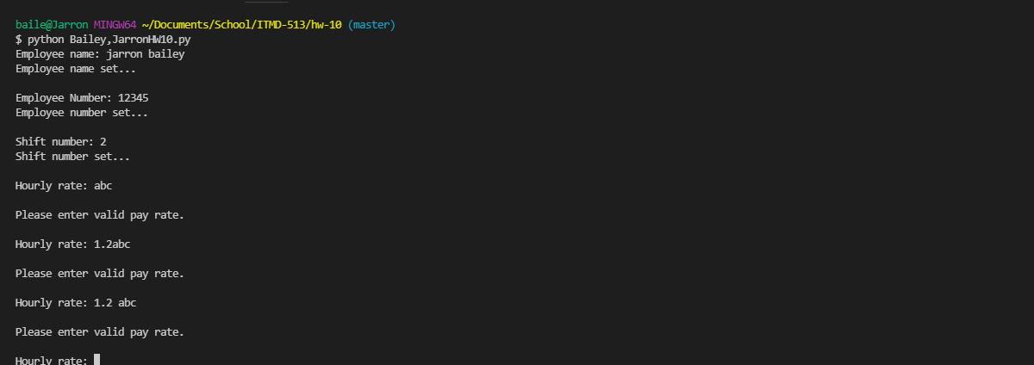

**Test 14: Hourly rate as an int:**

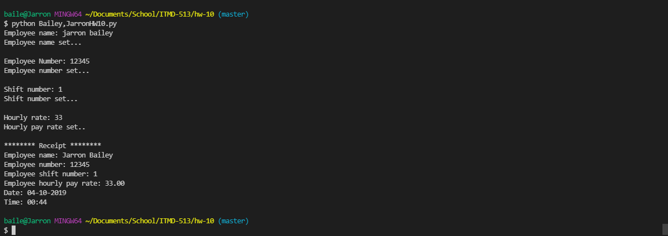

**Test 15: Hourly rate as a string:**

