Jarron Bailey

Homework 11

Date: April 22nd, 2019

**Test 1: Valid Regular ship name and ship year**

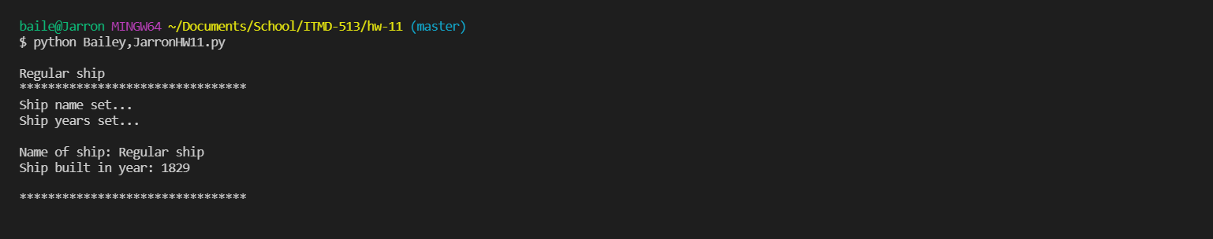

**Test 2: Valid Cargo ship name and capacity**

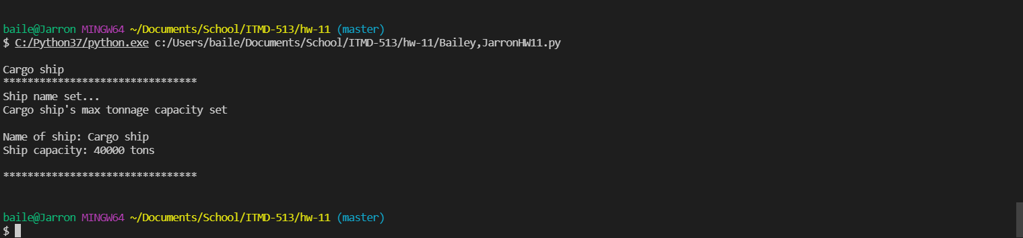

**Test 3: Valid Cruise ship name and capacity**

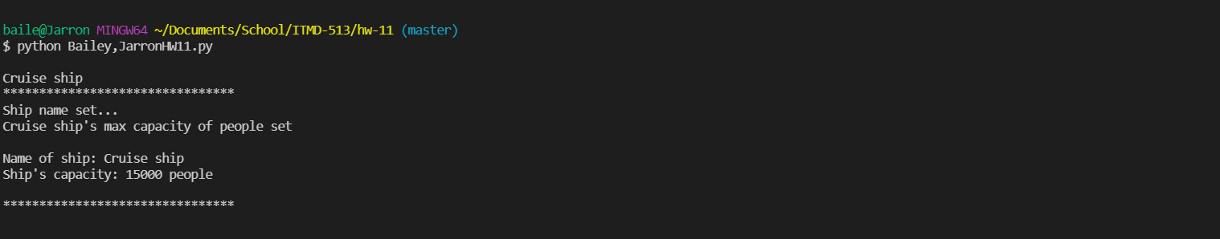

**Test 4: Ship’s invalid name(Str of letters and/or two words)**

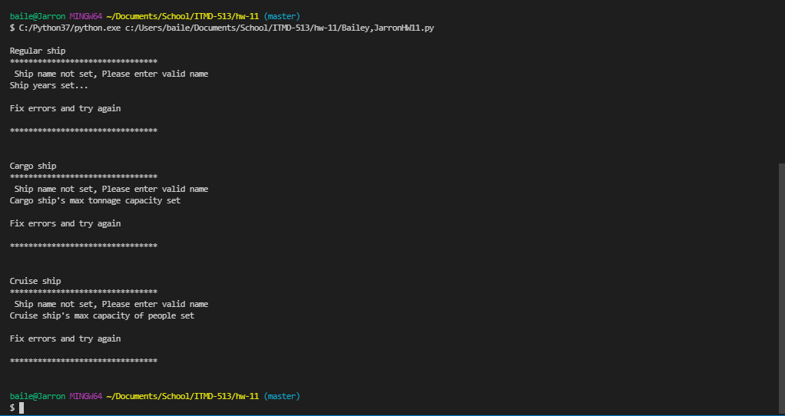

**Test 5: Regular ship invalid year(integer)**

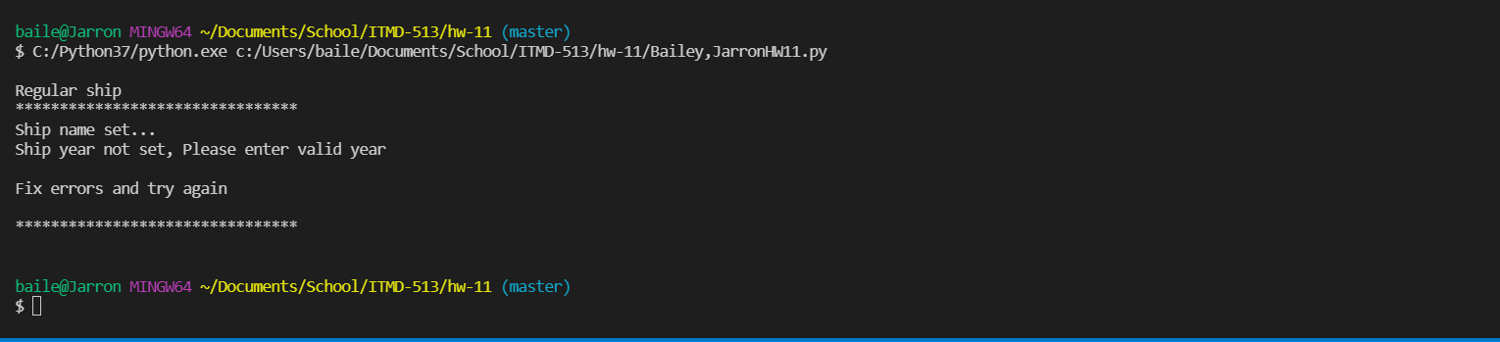

**Test 6: Cargo and Cruise ships capacity invalid integer**

