Jarron Bailey

Homework 12

Date: April 29nd, 2019

**Test 1: Enter string vars**

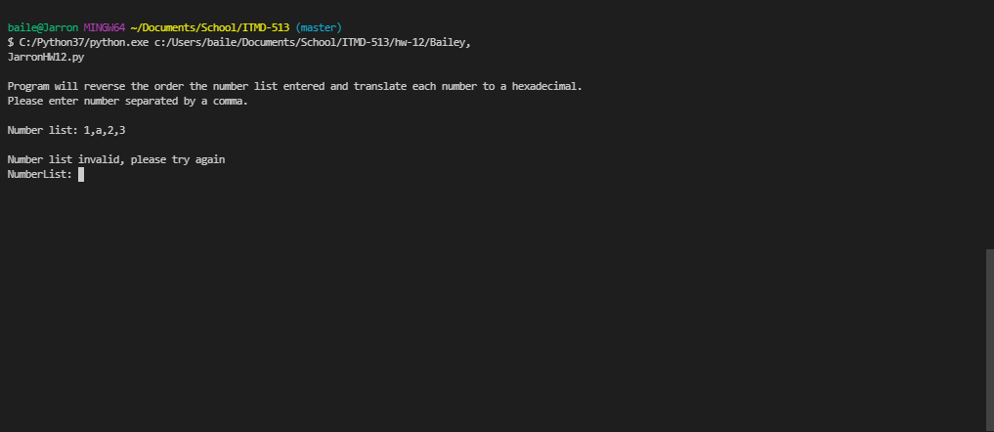

**Test 2: Extra comma’s**

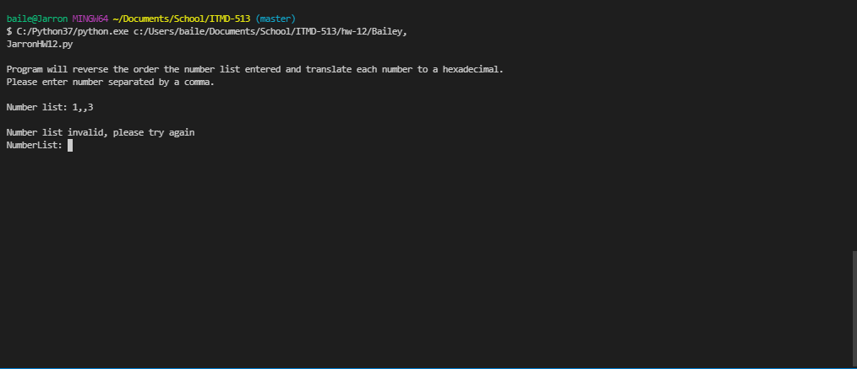

**Test 3: Floats**

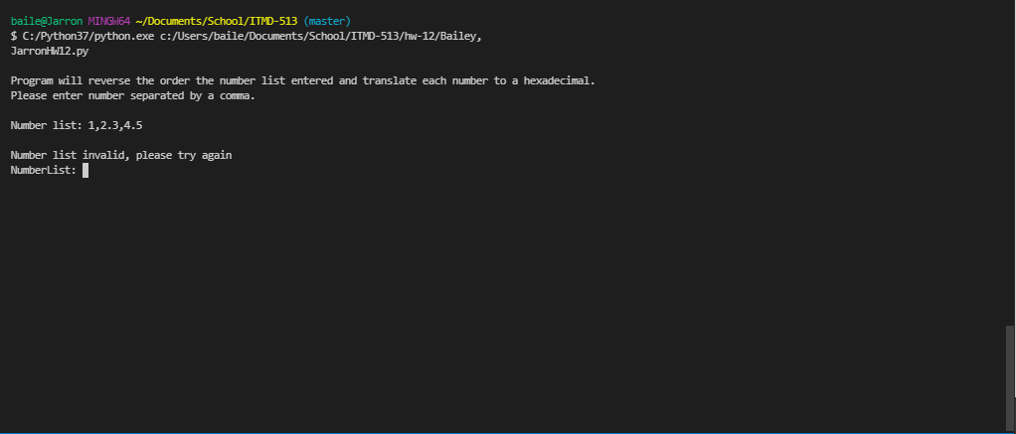

**Test 4: Valid integers 1-9**

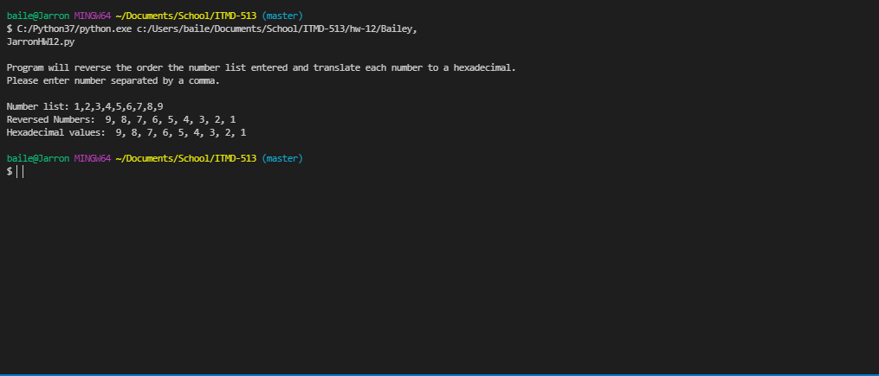

**Test 5: Valid integers 10-20**

