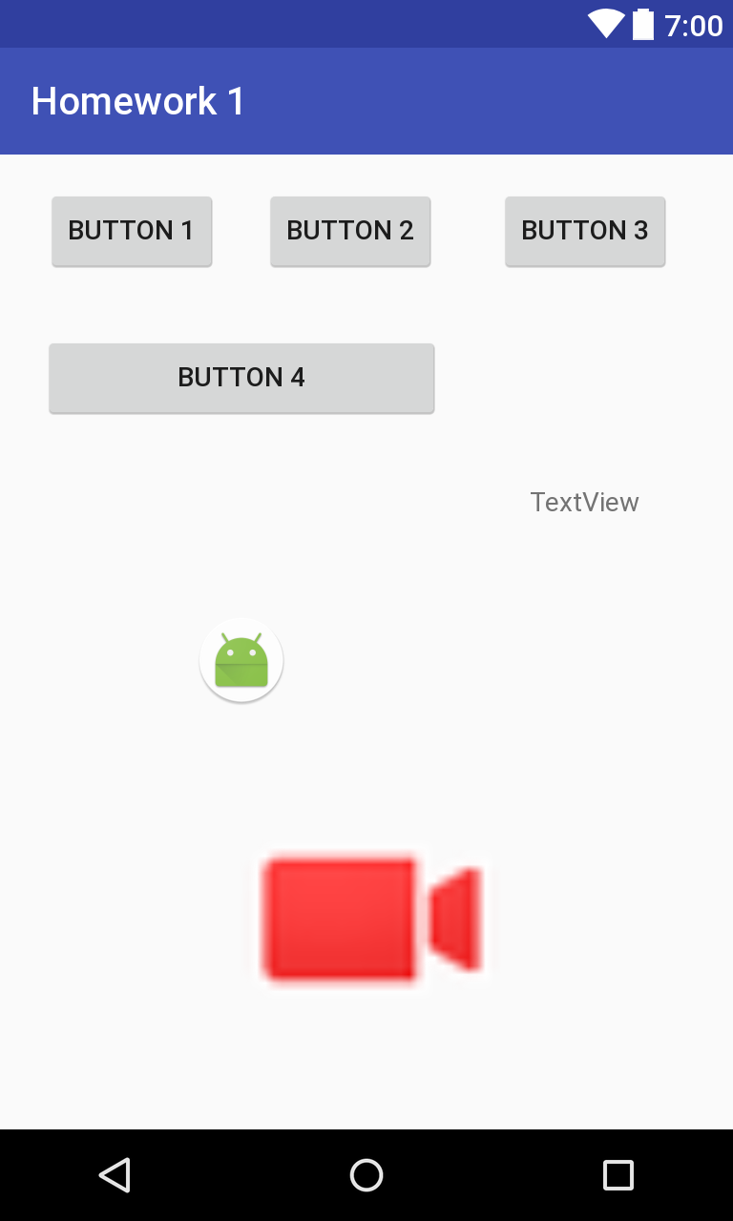

*<?***xml version="1.0" encoding="utf-8"***?>*<**android.support.constraint.ConstraintLayout xmlns:android="http://schemas.android.com/apk/res/android"  
 xmlns:app="http://schemas.android.com/apk/res-auto"  
 xmlns:tools="http://schemas.android.com/tools"  
 android:layout_width="match_parent"  
 android:layout_height="match_parent"  
 tools:context="com.example.bailey.homework1.Homework1"**>  
  
 <**Button  
 android:id="@+id/button2"  
 android:layout_width="wrap_content"  
 android:layout_height="wrap_content"  
 android:layout_marginRight="32dp"  
 android:text="Button 3"  
 app:layout_constraintRight_toRightOf="parent"  
 tools:layout_editor_absoluteY="16dp"  
 android:layout_marginEnd="32dp"** />  
  
 <**Button  
 android:id="@+id/button3"  
 android:layout_width="wrap_content"  
 android:layout_height="wrap_content"  
 android:layout_marginRight="32dp"  
 android:text="Button 2"  
 app:layout_constraintRight_toLeftOf="@+id/button2"  
 tools:layout_editor_absoluteY="16dp"  
 android:layout_marginEnd="32dp"** />  
  
 <**Button  
 android:id="@+id/button"  
 android:layout_width="wrap_content"  
 android:layout_height="wrap_content"  
 android:layout_marginLeft="32dp"  
 android:layout_marginRight="32dp"  
 android:text="Button 1"  
 app:layout_constraintLeft_toLeftOf="parent"  
 app:layout_constraintRight_toLeftOf="@+id/button3"  
 tools:layout_editor_absoluteY="16dp"  
 android:layout_marginStart="32dp"  
 android:layout_marginEnd="32dp"** />  
  
 <**Button  
 android:id="@+id/button4"  
 android:layout_width="209dp"  
 android:layout_height="48dp"  
 android:layout_marginLeft="8dp"  
 android:layout_marginRight="8dp"  
 android:text="Button 4"  
 app:layout_constraintLeft_toLeftOf="@+id/button"  
 app:layout_constraintRight_toRightOf="@+id/button3"  
 tools:layout_editor_absoluteY="93dp"  
 android:layout_marginStart="8dp"  
 android:layout_marginEnd="8dp"** />  
  
 <**TextView  
 android:id="@+id/textView"  
 android:layout_width="wrap_content"  
 android:layout_height="wrap_content"  
 android:text="TextView"  
 android:layout_marginTop="110dp"  
 app:layout_constraintTop_toBottomOf="@+id/button2"  
 android:layout_marginRight="8dp"  
 app:layout_constraintRight_toRightOf="@+id/button2"  
 android:layout_marginLeft="8dp"  
 app:layout_constraintLeft_toLeftOf="@+id/button2"  
 android:layout_marginStart="8dp"  
 android:layout_marginEnd="8dp"** />  
  
 <**ImageView  
 android:id="@+id/imageView"  
 android:layout_width="wrap_content"  
 android:layout_height="wrap_content"  
 app:srcCompat="@mipmap/ic_launcher_round"  
 android:layout_marginTop="100dp"  
 app:layout_constraintTop_toBottomOf="@+id/button4"  
 android:layout_marginLeft="8dp"  
 app:layout_constraintLeft_toLeftOf="@+id/button4"  
 android:layout_marginRight="8dp"  
 app:layout_constraintRight_toRightOf="@+id/button4"  
 app:layout_constraintHorizontal_bias="0.503"  
 android:layout_marginStart="8dp"  
 android:layout_marginEnd="8dp"** />  
  
 <**ImageView  
 android:id="@+id/imageView5"  
 android:layout_width="328dp"  
 android:layout_height="142dp"  
 app:srcCompat="@android:drawable/presence_video_busy"  
 app:layout_constraintRight_toRightOf="parent"  
 app:layout_constraintLeft_toLeftOf="parent"  
 app:layout_constraintBottom_toBottomOf="parent"  
 app:layout_constraintTop_toBottomOf="@+id/imageView"  
 app:layout_constraintVertical_bias="0.512"  
 android:layout_marginLeft="16dp"  
 app:layout_constraintHorizontal_bias="0.6"  
 android:layout_marginRight="16dp"** />  
  
</**android.support.constraint.ConstraintLayout**>

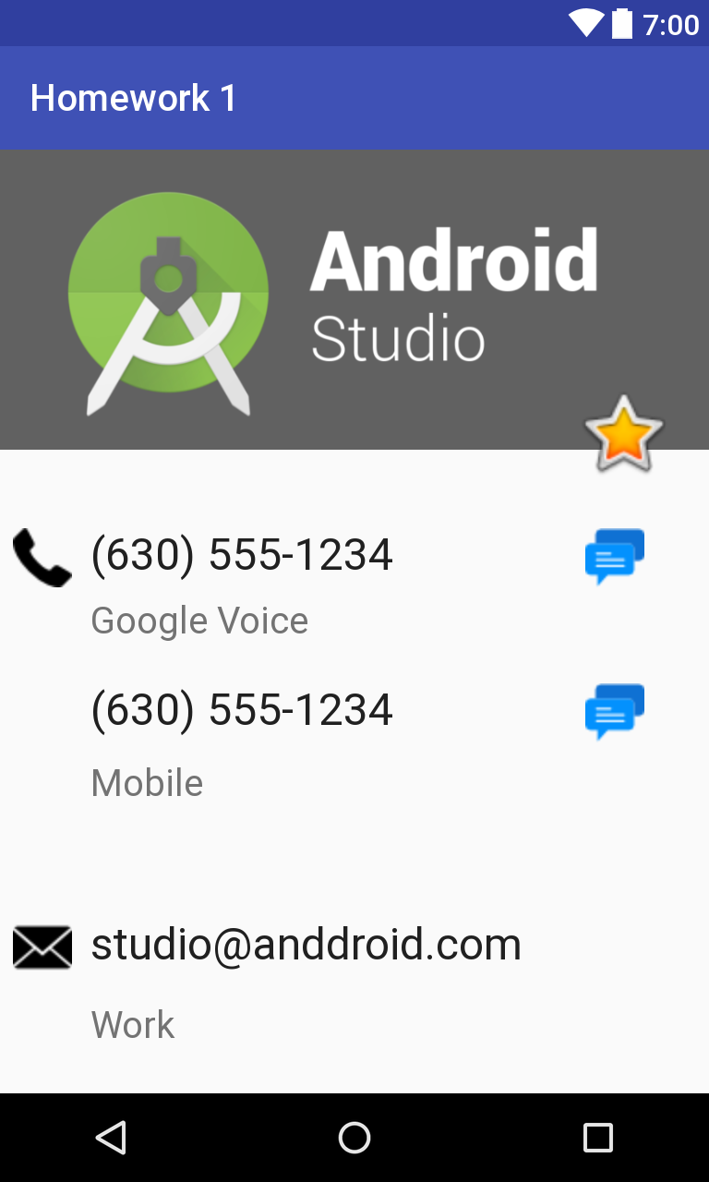

*<?***xml version="1.0" encoding="utf-8"***?>*<**android.support.constraint.ConstraintLayout xmlns:android="http://schemas.android.com/apk/res/android"  
 xmlns:app="http://schemas.android.com/apk/res-auto"  
 xmlns:tools="http://schemas.android.com/tools"  
 android:layout_width="match_parent"  
 android:layout_height="match_parent"  
 tools:context="com.example.bailey.homework1.Homework2"**>  
  
 <**ImageView  
 android:id="@+id/imageView9"  
 android:layout_width="wrap_content"  
 android:layout_height="wrap_content"  
 app:srcCompat="@drawable/messeges"  
 tools:layout_editor_absoluteX="317dp"  
 tools:layout_editor_absoluteY="205dp"** />  
  
 <**TextView  
 android:id="@+id/textView8"  
 android:layout_width="wrap_content"  
 android:layout_height="wrap_content"  
 android:text="Google Voice"  
 android:textSize="20sp"  
 tools:layout_editor_absoluteX="49dp"  
 tools:layout_editor_absoluteY="243dp"** />  
  
 <**TextView  
 android:id="@+id/textView7"  
 android:layout_width="wrap_content"  
 android:layout_height="wrap_content"  
 android:text="Work"  
 android:textSize="20sp"  
 tools:layout_editor_absoluteX="49dp"  
 tools:layout_editor_absoluteY="462dp"** />  
  
 <**TextView  
 android:id="@+id/textView4"  
 android:layout_width="wrap_content"  
 android:layout_height="wrap_content"  
 android:text="studio@anddroid.com"  
 android:textAppearance="@style/TextAppearance.AppCompat"  
 android:textSize="24sp"  
 tools:layout_editor_absoluteX="49dp"  
 tools:layout_editor_absoluteY="416dp"** />  
  
 <**TextView  
 android:id="@+id/textView3"  
 android:layout_width="wrap_content"  
 android:layout_height="wrap_content"  
 android:text="(630) 555-1234"  
 android:textAppearance="@style/TextAppearance.AppCompat"  
 android:textSize="24sp"  
 tools:layout_editor_absoluteX="49dp"  
 tools:layout_editor_absoluteY="205dp"** />  
  
 <**ImageView  
 android:id="@+id/imageView3"  
 android:layout_width="wrap_content"  
 android:layout_height="wrap_content"  
 android:contentDescription="kk"  
 app:srcCompat="@drawable/andriodLogo"  
 tools:layout_editor_absoluteX="902dp"  
 tools:layout_editor_absoluteY="-447dp"** />  
  
 <**ImageView  
 android:id="@+id/imageView4"  
 android:layout_width="61dp"  
 android:layout_height="54dp"  
 app:srcCompat="@android:drawable/btn_star_big_on"  
 tools:layout_editor_absoluteX="307dp"  
 tools:layout_editor_absoluteY="126dp"** />  
  
 <**TextView  
 android:id="@+id/textView2"  
 android:layout_width="wrap_content"  
 android:layout_height="wrap_content"  
 android:text="(630) 555-1234"  
 android:textAppearance="@style/TextAppearance.AppCompat"  
 android:textSize="24sp"  
 tools:layout_editor_absoluteX="49dp"  
 tools:layout_editor_absoluteY="289dp"** />  
  
 <**TextView  
 android:id="@+id/textView5"  
 android:layout_width="wrap_content"  
 android:layout_height="wrap_content"  
 android:text="Mobile"  
 android:textSize="20sp"  
 tools:layout_editor_absoluteX="49dp"  
 tools:layout_editor_absoluteY="331dp"** />  
  
 <**ImageView  
 android:id="@+id/imageView7"  
 android:layout_width="wrap_content"  
 android:layout_height="wrap_content"  
 app:srcCompat="@drawable/email"  
 tools:layout_editor_absoluteY="416dp"  
 tools:layout_editor_absoluteX="7dp"** />  
  
 <**ImageView  
 android:id="@+id/imageView8"  
 android:layout_width="wrap_content"  
 android:layout_height="wrap_content"  
 app:srcCompat="@drawable/messeges"  
 tools:layout_editor_absoluteX="317dp"  
 tools:layout_editor_absoluteY="289dp"** />  
  
 <**ImageView  
 android:id="@+id/imageView10"  
 android:layout_width="wrap_content"  
 android:layout_height="wrap_content"  
 app:srcCompat="@drawable/phone"  
 tools:layout_editor_absoluteX="7dp"  
 tools:layout_editor_absoluteY="205dp"** />  
</**android.support.constraint.ConstraintLayout**>